What Is an Exception?

The term exception is shorthand for the phrase "exceptional event." (olağanüstü / sıradışı olay durum)

Definition: An exception is an event, which occurs during the execution of a program, that disrupts the normal flow of the program's instructions.

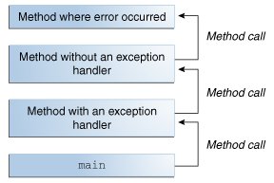
When an error occurs within a method, the method creates an object and hands it off to the runtime system. The object, called an exception object, contains information about the error, including its type and the state of the program when the error occurred. Creating an exception object and handing it to the runtime system is called throwing an exception.

After a method throws an exception, the runtime system attempts to find something to handle it. The set of possible "somethings" to handle the exception is the ordered list of methods that had been called to get to the method where the error occurred. The list of methods is known as the call stack (see the next figure).

The runtime system searches the call stack for a method that contains a block of code that can handle the exception. This block of code is called an exception handler. The search begins with the method in which the error occurred and proceeds through the call stack in the reverse order in which the methods were called. When an appropriate handler is found, the runtime system passes the exception to the handler. An exception handler is considered appropriate if the type of the exception object thrown matches the type that can be handled by the handler.
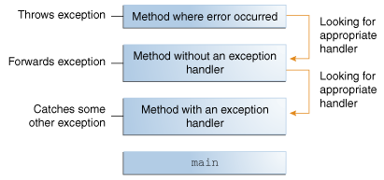
The exception handler chosen is said to catch the exception. If the runtime system exhaustively searches all the methods on the call stack without finding an appropriate exception handler, as shown in the next figure, the runtime system (and, consequently, the program) terminates.

The Catch or Specify Requirement

Valid Java programming language code must honor the Catch or Specify Requirement. This means that code that might throw certain exceptions must be enclosed by either of the following:

- A try statement that catches the exception. The try must provide a handler for the exception.
- A method that specifies that it can throw the exception. The method must provide a throws clause that lists the exception, as described in Specifying the Exceptions Thrown by a Method.

Code that fails to honor the Catch or Specify Requirement will not compile.
Not all exceptions are subject to the Catch or Specify Requirement. To understand why, we need to look at the three basic categories of exceptions, only one of which is subject to the Requirement.

The Three Kinds of Exceptions

The first kind of exception is the checked exception. These are exceptional conditions that a well-written application should anticipate and recover from. For example, suppose an application prompts a user for an input file name, then opens the file by passing the name to the constructor for java.io.FileReader. Normally, the user provides the name of an existing, readable file, so the construction of the FileReader object succeeds, and the execution of the application proceeds normally. But sometimes the user supplies the name of a nonexistent file, and the constructor throws java.io.FileNotFoundException. A well-written program will catch this exception and notify the user of the mistake, possibly prompting for a corrected file name.

Checked exceptions are subject to the Catch or Specify Requirement. All exceptions are checked exceptions, except for those indicated by Error, RuntimeException, and their subclasses.

The second kind of exception is the error. These are exceptional conditions that are external to the application, and that the application usually cannot anticipate or recover from. For example, suppose that an application successfully opens a file for input, but is unable to read the file because of a hardware or system malfunction. The unsuccessful read will throw java.io.IOError. An application might choose to catch this exception, in order to notify the user of the problem — but it also might make sense for the program to print a stack trace and exit.
Errors are not subject to the Catch or Specify Requirement. Errors are those exceptions indicated by Error and its subclasses.

The third kind of exception is the runtime exception. These are exceptional conditions that are internal to the application, and that the application usually cannot anticipate or recover from. These usually indicate programming bugs, such as logic errors or improper use of an API. For example, consider the application described previously that passes a file name to the constructor for FileReader. If a logic error causes a null to be passed to the constructor, the constructor will throw NullPointerException. The application can catch this exception, but it probably makes more sense to eliminate the bug that caused the exception to occur.
Runtime exceptions are not subject to the Catch or Specify Requirement. Runtime exceptions are those indicated by RuntimeException and its subclasses.

- Errors and runtime exceptions are collectively known as unchecked exceptions.

Catching and Handling Exceptions

The following example defines and implements a class named ListOfNumbers. When constructed, ListOfNumbers creates an ArrayList that contains 10 Integer elements with sequential values 0 through 9. The ListOfNumbers class also defines a method named writeList, which writes the list of numbers into a text file called OutFile.txt.

The first line in boldface is a call to a constructor. The constructor initializes an output stream on a file. If the file cannot be opened, the constructor throws an IOException. The second boldface line is a call to the ArrayList class's get method, which throws an IndexOutOfBoundsException if the value of its argument is too small (less than 0) or too large (more than the number of elements currently contained by the ArrayList).

If you try to compile the ListOfNumbers class, the compiler prints an error message about the exception thrown by the FileWriter constructor. However, it does not display an error message about the exception thrown by get. The reason is that the exception thrown by the constructor, IOException, is a checked exception, and the one thrown by the get method, IndexOutOfBoundsException, is an unchecked exception.

try and catch blocks
- The first step in constructing an exception handler is to enclose the code that might throw an exception within a try block.

To construct an exception handler for the writeList method from the ListOfNumbers class, enclose the exception-throwing statements of the writeList method within a try block.
There is more than one way to do this. You can put each line of code that might throw an exception within its own try block and provide separate exception handlers for each. Or, you can put all the writeList code within a single try block and associate multiple handlers with it.

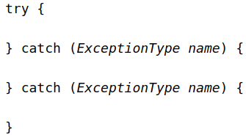
If an exception occurs within the try block, that exception is handled by an exception handler associated with it. To associate an exception handler with a try block, you must put a catch block after it
- You associate exception handlers with a try block by providing one or more catch blocks directly after the try block. No code can be between the end of the try block and the beginning of the first catch block

Each catch block is an exception handler that handles the type of exception indicated by its argument. The argument type, ExceptionType, declares the type of exception that the handler can handle and must be the name of a class that inherits from the Throwable class. The handler can refer to the exception with name.

The catch block contains code that is executed if and when the exception handler is invoked. The runtime system invokes the exception handler when the handler is the first one in the call stack whose ExceptionType matches the type of the exception thrown. The system considers it a match if the thrown object can legally be assigned to the exception handler's argument.

The following are two exception handlers for the writeList method: (in the try block is the 4 lines of code code, shown in the previous page)
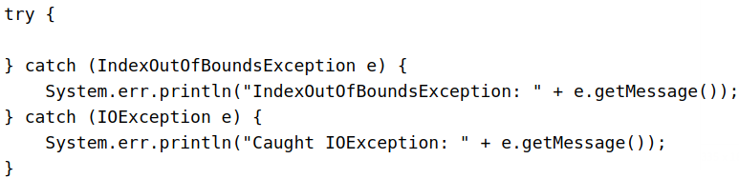

Exception handlers can do more than just print error messages or halt the program.
They can do :
- error recovery,
- prompt the user to make a decision,
- or propagate the error up to a higher-level handler using chained exceptions
Catching More Than One Type of Exception with One Exception Handler

In Java SE 7 and later, a single catch block can handle more than one type of exception. This feature can reduce code duplication and lessen the temptation to catch an overly broad exception.
In the catch clause, specify the types of exceptions that block can handle, and separate each exception type with a vertical bar (|):
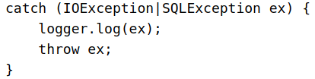

Note: If a catch block handles more than one exception type, then the catch parameter is implicitly final. In this example, the catch parameter ex is final and therefore you cannot assign any values to it within the catch block.

The finally Block

The finally block always executes when the try block exits. This ensures that the finally block is executed even if an unexpected exception occurs. But finally is useful for more than just exception handling — it allows the programmer to avoid having cleanup code accidentally bypassed by a return, continue, or break. Putting cleanup code in a finally block is always a good practice, even when no exceptions are anticipated.

Note: If the JVM exits while the try or catch code is being executed, then the finally block may not execute. Likewise, if the thread executing the try or catch code is interrupted or killed, the finally block may not execute even though the application as a whole continues.

The try block of the writeList method that you've been working with here opens a PrintWriter. The program should close that stream before exiting the writeList method. This poses a somewhat complicated problem because writeList's try block can exit in one of three ways.
- The new FileWriter statement fails and throws an IOException.
- The list.get(i) statement fails and throws an IndexOutOfBoundsException.
- Everything succeeds and the try block exits normally.

The runtime system always executes the statements within the finally block regardless of what happens within the try block. So it's the perfect place to perform cleanup.
The following finally block for the writeList method cleans up and then closes the PrintWriter.
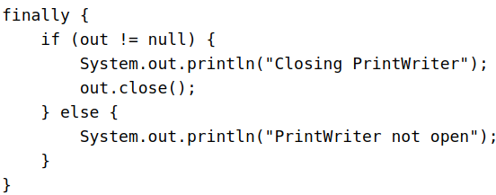

Important: The finally block is a key tool for preventing resource leaks. When closing a file or otherwise recovering resources, place the code in a finally block to ensure that resource is always recovered.
Consider using the try-with-resources statement in these situations, which automatically releases system resources when no longer needed.
The try-with-resources Statement

Try-with-resources in Java 7 is a new exception handling mechanism that makes it easier to correctly close resources that are used within a try-catch block.
The try-with-resources statement is a try statement that declares one or more resources. A resource is an object that must be closed after the program is finished with it. The try-with-resources statement ensures that each resource is closed at the end of the statement. Any object that implements java.lang.AutoCloseable, which includes all objects which implement java.io.Closeable, can be used as a resource.

The following example reads the first line from a file. It uses an instance of BufferedReader to read data from the file. BufferedReader is a resource that must be closed after the program is finished with it:
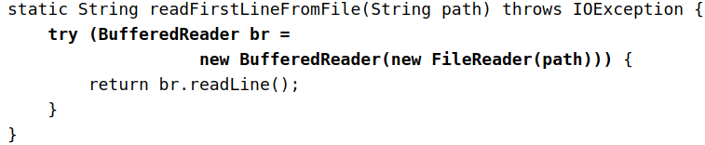

Prior to Java SE 7, you can use a finally block to ensure that a resource is closed regardless of whether the try statement completes normally or abruptly. The following example uses a finally block instead of a try-with-resources statement:

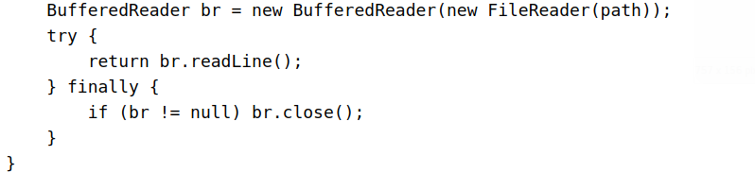

You may declare one or more resources in a try-with-resources statement. The following example retrieves the names of the files packaged in the zip file zipFileName and creates a text file that contains the names of these files:
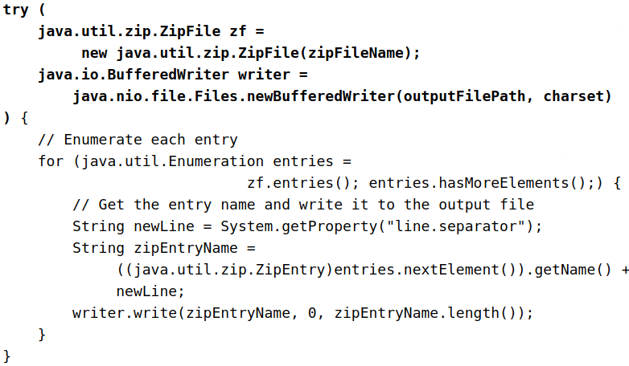

In this example, the try-with-resources statement contains two declarations that are separated by a semicolon: ZipFile and BufferedWriter. When the block of code that directly follows it terminates, either normally or because of an exception, the close methods of the BufferedWriter and ZipFile objects are automatically called in this order. Note that the close methods of resources are called in the opposite order of their creation.
The following example uses a try-with-resources statement to automatically close a java.sql.Statement object:
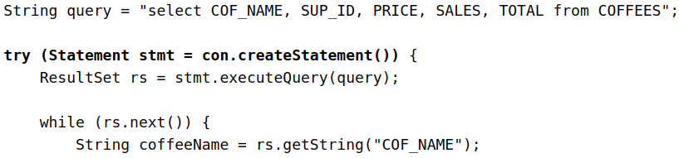

Note: A try-with-resources statement can have catch and finally blocks just like an ordinary try statement. In a try-with-resources statement, any catch or finally block is run after the resources declared have been closed. (The code in (classic try catch finally block) Java 6 executes the catch and afterwards the finally block. This causes the resources to be still potentially opened in the catch block. ) [catch will always ? Execute before the final block if we use classic try-catch block] ?

(Rewind) Resource Management With Try-Catch-Finally,

Old School Style Managing resources that need to be explicitly closed is somewhat tedious before Java 7. Look at the following method which reads a file and prints it to the System.out:
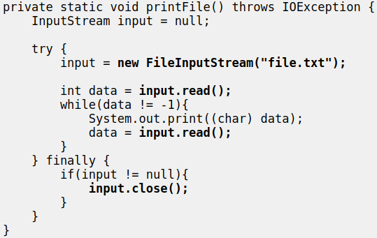

The code marked in bold is where the code can throw an Exception. As you can see, that can happen in 3 places inside the try-block, and 1 place inside the finally-block.
The finally block is always executed no matter if an exception is thrown from the try block or not. That means, that the InputStream is closed no matter what happens in the try block. Or, attempted closed that is. The InputStream's close() method may throw an exception too, if closing it fails.
Imagine that an exception is thrown from inside the try block. Then the finally block is executed. Imagine then, that an exception is also thrown from the finally block. Which exception do you think is propagated up the call stack?
The exception thrown from the finally block would be propagated up the call stack, even if the exception thrown from the try block would probably be more relevant to propagate.

Try-with-resources

In Java 7 you can write the code from the example above using the try-with-resource construct like this:
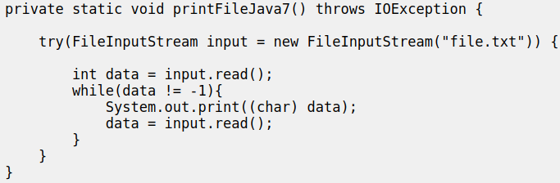

Notice the first line inside the method, This is the try-with-resources construct. The FileInputStream variable is declared inside the parentheses after the try keyword. Additionally, a FileInputStream is instantiated and assigned to the variable.
When the try block finishes, the FileInputStream will be closed automatically. This is possible because FileInputStream implements the Java interface java.lang.AutoCloseable. All classes implementing this interface can be used inside the try-with-resources construct.
If an exception is thrown both from inside the try-with-resources block, and when the FileInputStream is closed (when close() is called), the exception thrown inside the try block is thrown to the outside world. The exception thrown when the FileInputStream was closed is suppressed. This is opposite of what happens in the example first in this text, using the old style exception handling (closing the resources in the finally block).

Custom AutoClosable Implementations

The try-with-resources construct does not just work with Java's built-in classes. You can also implement the java.lang.AutoCloseable interface in your own classes, and use them with the try-with-resources construct. The AutoClosable interface only has a single method called close(). Here is how the interface looks:

- Any class that implements this interface can be used with the try-with-resources construct. Here is a simple example implementation:
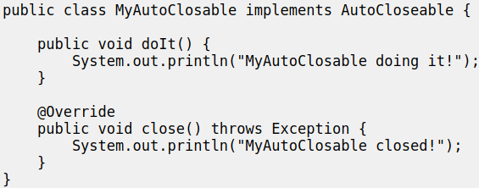
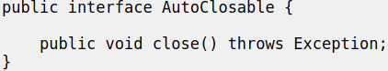

The doIt() method is not part of the AutoClosable interface. It is there because we want to be able to do something more than just closing the object. Here is an example of how the MyAutoClosable is used with the try-with-resources construct:

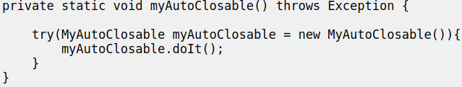

Here is the output printed to System.out when the method myAutoClosable() is called:
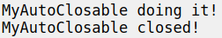

Suppressed Exceptions

If an exception is thrown from the try block and one or more exceptions are thrown from the try-with-resources statement, then those exceptions thrown from the try-with-resources statement are suppressed, and the exception thrown by the block is the one that is thrown by the writeToFileZipFileContents method. You can retrieve these suppressed exceptions by calling the Throwable.getSuppressed method from the exception thrown by the try block.

Putting It All Together

The previous sections described how to construct the try, catch, and finally code blocks for the writeList method in the ListOfNumbers class.

Now, let's walk through the code and investigate what can happen. When all the components are put together, the writeList method looks like the following.

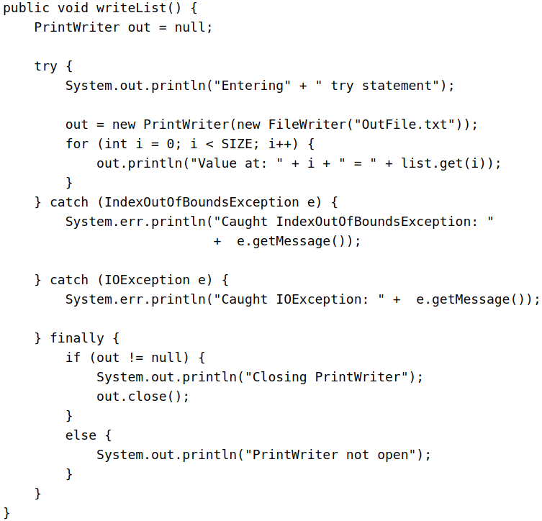

As mentioned previously, this method's try block has three different exit possibilities; here are two of them.
- Code in the try statement fails and throws an exception. This could be an IOException caused by the new FileWriter statement or an IndexOutOfBoundsException caused by a wrong index value in the for loop.
- Everything succeeds and the try statement exits normally. Let's look at what happens in the writeList method during these two exit possibilities.

Scenario 1: An Exception Occurs

The statement that creates a FileWriter can fail for a number of reasons. For example, the constructor for the FileWriter throws an IOException if the program cannot create or write to the file indicated.

When FileWriter throws an IOException, the runtime system immediately stops executing the try block; method calls being executed are not completed. The runtime system then starts searching at the top of the method call stack for an appropriate exception handler. In this example, when the IOException occurs, the FileWriter constructor is at the top of the call stack. However, the FileWriter constructor doesn't have an appropriate exception handler, so the runtime system checks the next method — the writeList method — in the method call stack. The writeList method has two exception handlers: one for IOException and one for IndexOutOfBoundsException.

The runtime system checks writeList's handlers in the order in which they appear after the try statement. The argument to the first exception handler is IndexOutOfBoundsException. This does not match the type of exception thrown, so the runtime system checks the next exception handler — IOException. This matches the type of exception that was thrown, so the runtime system ends its search for an appropriate exception handler. Now that the runtime has found an appropriate handler, the code in that catch block is executed.

After the exception handler executes, the runtime system passes control to the finally block. Code in the finally block executes regardless of the exception caught above it. In this scenario, the FileWriter was never opened and doesn't need to be closed. After the finally block finishes executing, the program continues with the first statement after the finally block.

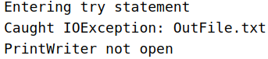
Here's the complete output from the ListOfNumbers program that appears when an IOException is thrown.

The boldface code in the following listing shows the statements that get executed during this scenario:
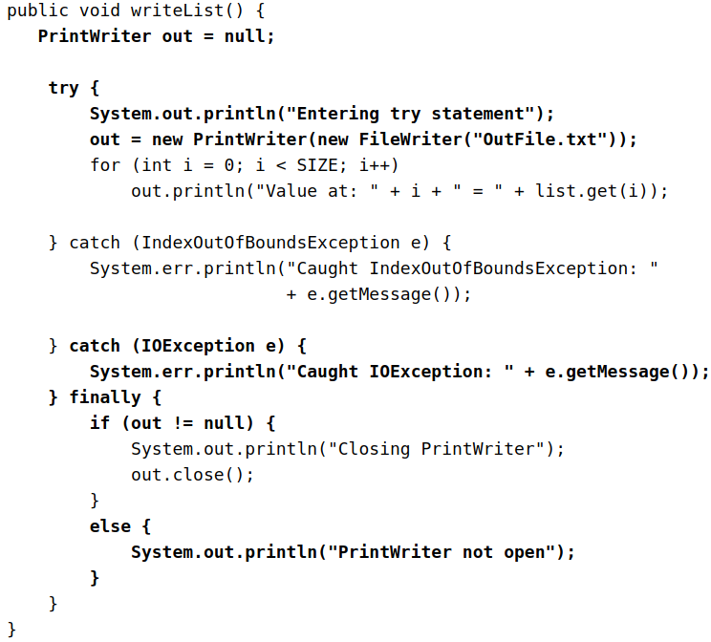

Scenario 2: An exception occurs from list.get(i)

Everything will be almost the same . The runtime system checks writeList's handlers in the order in which they appear after the try statement. The argument to the first exception handler is IndexOutOfBoundsException. This will match and it will execute this catch block .

BUT ! The problem : the out.println("Value at: " + i + " = " + list.get(i)); line comes after we have opened our file . That means our resource is still open when this statement throws an exception. So during the execution of the catch block the resource might be still open , when the catch block is finished then it will continue with the finally block and there the resource will be closed. (Some unknown problems could occur)
As we remember with a try-with-resources block resources are close before the catch block is executed . So keep that in mind !

Scenario 3: The try Block Exits Normally

In this scenario, all the statements within the scope of the try block execute successfully and throw no exceptions. Execution falls off the end of the try block, and the runtime system passes control to the finally block. Because everything was successful, the PrintWriter is open when control reaches the finally block, which closes the PrintWriter. Again, after the finally block finishes executing, the program continues with the first statement after the finally block.

Specifying the Exceptions Thrown by a Method

The previous section showed how to write an exception handler for the writeList method in the ListOfNumbers class. Sometimes, it's appropriate for code to catch exceptions that can occur within it. In other cases, however, it's better to let a method further up the call stack handle the exception. For example, if you were providing the ListOfNumbers class as part of a package of classes, you probably couldn't anticipate the needs of all the users of your package. In this case, it's better to not catch the exception and to allow a method further up the call stack to handle it.

If the writeList method doesn't catch the checked exceptions that can occur within it, the writeList method must specify that it can throw these exceptions. Let's modify the original writeList method to specify the exceptions it can throw instead of catching them.

To specify that writeList can throw two exceptions, add a throws clause to the method declaration for the writeList method. The throws clause comprises the throws keyword followed by a comma-separated list of all the exceptions thrown by that method. The clause goes after the method name and argument list and before the brace that defines the scope of the method; here's an example.

Remember that IndexOutOfBoundsException is an unchecked exception; including it in the throws clause is not mandatory. You could just write the following.

Advantages of Exceptions

Advantage 1: Separating Error-Handling Code from "Regular" Code

Exceptions provide the means to separate the details of what to do when something out of the ordinary happens from the main logic of a program. In traditional programming, error detection, reporting, and handling often lead to confusing spaghetti code. For example, consider the pseudocode method here that reads an entire file into memory.
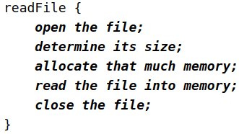

At first glance, this function seems simple enough, but it ignores all the following potential errors.
- What happens if the file can't be opened?
- What happens if the length of the file can't be determined?
- What happens if enough memory can't be allocated?
- What happens if the read fails?
- What happens if the file can't be closed?

To handle such cases, the readFile function must have more code to do error detection, reporting, and handling. Here is an example of what the function might look like.

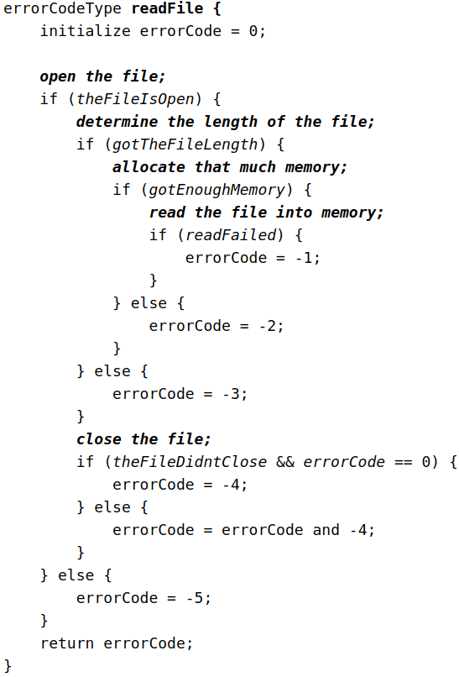

There's so much error detection, reporting, and returning here that the original seven lines of code are lost in the clutter. Worse yet, the logical flow of the code has also been lost, thus making it difficult to tell whether the code is doing the right thing:

Is the file really being closed if the function fails to allocate enough memory?

It's even more difficult to ensure that the code continues to do the right thing when you modify the method three months after writing it. Many programmers solve this problem by simply ignoring it — errors are reported when their programs crash.

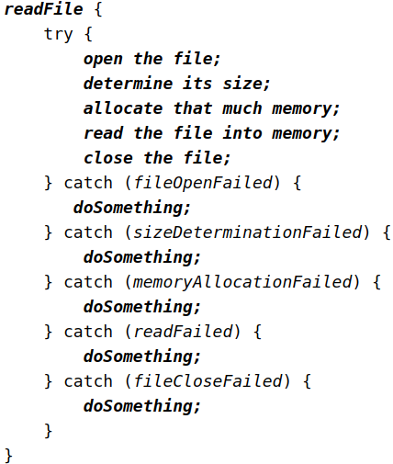
Exceptions enable you to write the main flow of your code and to deal with the exceptional cases elsewhere. If the readFile function used exceptions instead of traditional error-management techniques, it would look more like the following.

Note that exceptions don't spare you the effort of doing the work of detecting, reporting, and handling errors, but they do help you organize the work more effectively.

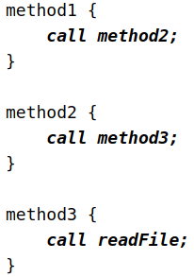
Advantage 2: Propagating Errors Up the Call Stack

A second advantage of exceptions is the ability to propagate error reporting up the call stack of methods. Suppose that the readFile method is the fourth method in a series of nested method calls made by the main program: method1 calls method2, which calls method3, which finally calls readFile.

Suppose also that method1 is the only method interested in the errors that might occur within readFile. Traditional error-notification techniques force method2 and method3 to propagate the error codes returned by readFile up the call stack until the error codes finally reach method1—the only method that is interested in them.

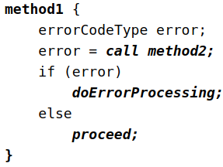
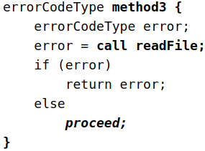
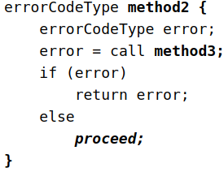

Recall that the Java runtime environment searches backward through the call stack to find any methods that are interested in handling a particular exception. A method can duck any exceptions thrown within it, thereby allowing a method farther up the call stack to catch it. Hence, only the methods that care about errors have to worry about detecting errors.
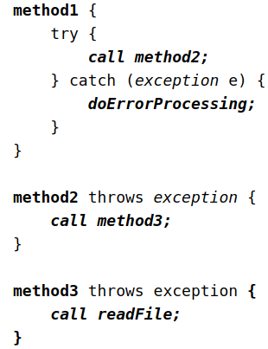

However, as the pseudocode shows, ducking an exception requires some effort on the part of the middleman methods. Any checked exceptions that can be thrown within a method must be specified in its throws clause.

Advantage 3: Grouping and Differentiating Error Types

Because all exceptions thrown within a program are objects, the grouping or categorizing of exceptions is a natural outcome of the class hierarchy. An example of a group of related exception classes in the Java platform are those defined in java.io — IOException and its descendants. IOException is the most general and represents any type of error that can occur when performing I/O. Its descendants represent more specific errors. For example, FileNotFoundException means that a file could not be located on disk.

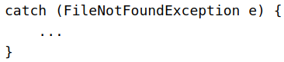
A method can write specific handlers that can handle a very specific exception. The FileNotFoundException class has no descendants, so the following handler can handle only one type of exception.

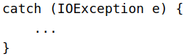
A method can catch an exception based on its group or general type by specifying any of the exception's superclasses in the catch statement. For example, to catch all I/O exceptions, regardless of their specific type, an exception handler specifies an IOException argument.

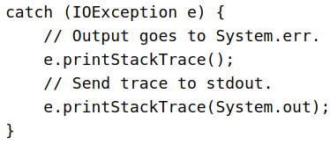
This handler (yukardaki ve sağdaki aynı) will be able to catch all I/O exceptions, including FileNotFoundException, EOFException, and so on. You can find details about what occurred by querying the argument passed to the exception handler. For example, use the following to print the stack trace.

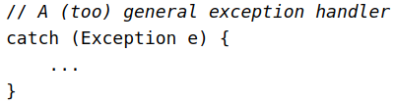
You could even set up an exception handler that handles any Exception with the handler here.

The Exception class is close to the top of the Throwable class hierarchy. Therefore, this handler will catch many other exceptions in addition to those that the handler is intended to catch. You may want to handle exceptions this way if all you want your program to do, for example, is print out an error message for the user and then exit.

In most situations, however, you want exception handlers to be as specific as possible. The reason is that the first thing a handler must do is determine what type of exception occurred before it can decide on the best recovery strategy. In effect, by not catching specific errors, the handler must accommodate any possibility. Exception handlers that are too general can make code more error-prone by catching and handling exceptions that weren't anticipated by the programmer and for which the handler was not intended.

As noted, you can create groups of exceptions and handle exceptions in a general fashion, or you can use the specific exception type to differentiate exceptions and handle exceptions in an exact fashion.
How to Throw Exceptions

How to Throw Exceptions Before you can catch an exception, some code somewhere must throw one. Any code can throw an exception: your code, code from a package written by someone else such as the packages that come with the Java platform, or the Java runtime environment. Regardless of what throws the exception, it's always thrown with the throw statement.

As you have probably noticed, the Java platform provides numerous exception classes. All the classes are descendants of the Throwable class, and all allow programs to differentiate among the various types of exceptions that can occur during the execution of a program.

You can also create your own exception classes to represent problems that can occur within the classes you write. In fact, if you are a package developer, you might have to create your own set of exception classes to allow users to differentiate an error that can occur in your package from errors that occur in the Java platform or other packages. You can also create chained exceptions.

The throw Statement

All methods use the throw statement to throw an exception. The throw statement requires a single argument: a throwable object. Throwable objects are instances of any subclass of the Throwable class.

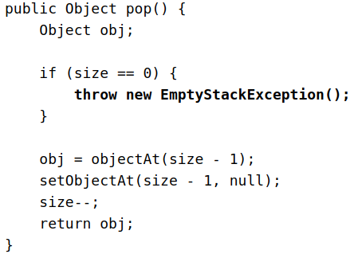

The pop method checks to see whether any elements are on the stack. If the stack is empty (its size is equal to 0), pop instantiates a new EmptyStackException object (a member of java.util) and throws it. The Creating Exception Classes section in this chapter explains how to create your own exception classes. For now, all you need to remember is that you can throw only objects that inherit from the java.lang.Throwable class.

- Note that the declaration of the pop method does not contain a throws clause. EmptyStackException is not a checked exception, so pop is not required to state that it might occur.

Throwable Class and Its Subclasses
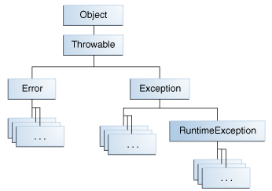

Error Class
When a dynamic linking failure or other hard failure in the Java virtual machine occurs, the virtual machine throws an Error. Simple programs typically do not catch or throw Errors.

Exception Class
Most programs throw and catch objects that derive from the Exception class. An Exception indicates that a problem occurred, but it is not a serious system problem. Most programs you write will throw and catch Exceptions as opposed to Errors.

The Java platform defines the many descendants of the Exception class. These descendants indicate various types of exceptions that can occur. For example, IllegalAccessException signals that a particular method could not be found, and NegativeArraySizeException indicates that a program attempted to create an array with a negative size.

One Exception subclass, RuntimeException, is reserved for exceptions that indicate incorrect use of an API. An example of a runtime exception is NullPointerException, which occurs when a method tries to access a member of an object through a null reference. The section Unchecked Exceptions — The Controversy discusses why most applications shouldn't throw runtime exceptions or subclass RuntimeException.

When to catch java.lang.Error?

Generally, never. However, sometimes you need to catch specific Errors.

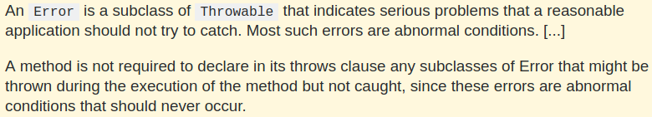

Chained Exceptions

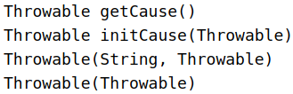
An application often responds to an exception by throwing another exception. In effect, the first exception causes the second exception. It can be very helpful to know when one exception causes another. Chained Exceptions help the programmer do this.
The following are the methods and constructors in Throwable that support chained exceptions.

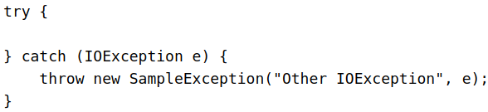
The Throwable argument to initCause and the Throwable constructors is the exception that caused the current exception. getCause returns the exception that caused the current exception, and initCause sets the current exception's cause. The following example shows how to use a chained exception.

In this example, when an IOException is caught, a new SampleException exception is created with the original cause attached and the chain of exceptions is thrown up to the next higher level exception handler.

Accessing Stack Trace Information

Now let's suppose that the higher-level exception handler wants to dump the stack trace in its own format.

- Definition: A stack trace provides information on the execution history of the current thread and lists the names of the classes and methods that were called at the point when the exception occurred. A stack trace is a useful debugging tool that you'll normally take advantage of when an exception has been thrown.

The following code shows how to call the getStackTrace method on the exception object.

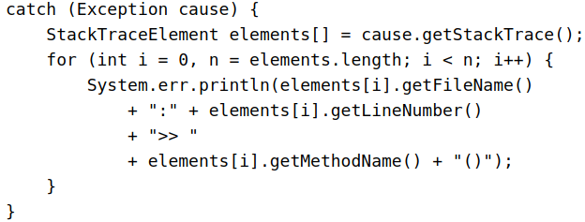

Creating Exception Classes

When faced with choosing the type of exception to throw, you can either use one written by someone else — the Java platform provides a lot of exception classes you can use — or you can write one of your own. You should write your own exception classes if you answer yes to any of the following questions; otherwise, you can probably use someone else's.
- Do you need an exception type that isn't represented by those in the Java platform?
- Would it help users if they could differentiate your exceptions from those thrown by classes written by other vendors?
- Does your code throw more than one related exception?
- If you use someone else's exceptions, will users have access to those exceptions? A similar question is, should your package be independent and self-contained?

An Example

Suppose you are writing a linked list class. The class supports the following methods, among others:
- objectAt(int n) — Returns the object in the nth position in the list. Throws an exception if the argument is less than 0 or more than the number of objects currently in the list.
- firstObject() — Returns the first object in the list. Throws an exception if the list contains no objects.
- indexOf(Object o) — Searches the list for the specified Object and returns its position in the list. Throws an exception if the object passed into the method is not in the list.

The linked list class can throw multiple exceptions, and it would be convenient to be able to catch all exceptions thrown by the linked list with one exception handler. Also, if you plan to distribute your linked list in a package, all related code should be packaged together. Thus, the linked list should provide its own set of exception classes.

The next figure illustrates one possible class hierarchy for the exceptions thrown by the linked list.

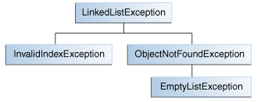

Choosing a Superclass

Any Exception subclass can be used as the parent class of LinkedListException. However, a quick perusal of those subclasses shows that they are inappropriate because they are either too specialized or completely unrelated to LinkedListException. Therefore, the parent class of LinkedListException should be Exception.

Most applets and applications you write will throw objects that are Exceptions. Errors are normally used for serious, hard errors in the system, such as those that prevent the JVM from running.

- Note: For readable code, it's good practice to append the string Exception to the names of all classes that inherit (directly or indirectly) from the Exception class.
Unchecked Exceptions — The Controversy

Because the Java programming language does not require methods to catch or to specify unchecked exceptions (RuntimeException, Error, and their subclasses), programmers may be tempted to write code that throws only unchecked exceptions or to make all their exception subclasses inherit from RuntimeException. Both of these shortcuts allow programmers to write code without bothering with compiler errors and without bothering to specify or to catch any exceptions. Although this may seem convenient to the programmer, it sidesteps the intent of the catch or specify requirement and can cause problems for others using your classes.

- Why did the designers decide to force a method to specify all uncaught checked exceptions that can be thrown within its scope?

Any Exception that can be thrown by a method is part of the method's public programming interface. Those who call a method must know about the exceptions that a method can throw so that they can decide what to do about them. These exceptions are as much a part of that method's programming interface as its parameters and return value.

- The next question might be: "If it's so good to document a method's API, including the exceptions it can throw, why not specify runtime exceptions too?"

Runtime exceptions represent problems that are the result of a programming problem, and as such, the API client code cannot reasonably be expected to recover from them or to handle them in any way. Such problems include arithmetic exceptions, such as dividing by zero; pointer exceptions, such as trying to access an object through a null reference; and indexing exceptions, such as attempting to access an array element through an index that is too large or too small.

Runtime exceptions can occur anywhere in a program, and in a typical one they can be very numerous. Having to add runtime exceptions in every method declaration would reduce a program's clarity. Thus, the compiler does not require that you catch or specify runtime exceptions (although you can).

One case where it is common practice to throw a RuntimeException is when the user calls a method incorrectly. For example, a method can check if one of its arguments is incorrectly null. If an argument is null, the method might throw a NullPointerException, which is an unchecked exception.

Generally speaking, do not throw a RuntimeException or create a subclass of RuntimeException simply because you don't want to be bothered with specifying the exceptions your methods can throw.

Here's the bottom line guideline: If a client can reasonably be expected to recover from an exception, make it a checked exception. If a client cannot do anything to recover from the exception, make it an unchecked exception.

