

Investigation of Social Physique Anxiety as a Mediator of the Relationship between Body Dissatisfaction and Exercise Avoidance.

Jakub Kowalczyk

170006757

Supervisor: Dr. Kimberly More

Division of Psychology, School of Social Sciences, University of Dundee.

Word Count: 7247

2021

Table of Contents

Acknowledgments 2

Abstract 3

Introduction 4

Hypotheses 11

Methods 13

Design 13

Participants 13

Measures 16

Results 20

Discussion 33

Summary of findings 33

Evaluation 34

Conclusion 38

Appendices 39

References 68

# Acknowledgments

Without a doubt this has been an incredibly tough year. As challenging as it may have been, it was made a lot easier by a number of people who have gone above and beyond of what is expected of them.

Firstly, thank you to my supervisor, Dr. Kimberly More, who has been nothing short of amazing. Her engagement and hard work have made this all an invaluable and positive learning experience. The guidance and support she provided were instrumental to the ability of completing this project and in gaining confidence in conducting research. I would also like to thank my friends and flatmates; Alistair, Henri, Jamie, and Karim, who for better or for worse, were stuck with me for the majority of the year. Having people to talk to and to eat evening meals with has helped me keep my sanity. Big thank you to Holly for the sage advice and proof reading. Finally, I would also like to thank my parents, who have been ever supportive and the best teachers in life I have.

# Abstract

Body dissatisfaction is a prevalent issue that is associated with adverse physical and mental health outcomes, possibly due to reduction and avoidance of exercise; however, little research has been conducted exploring the underlying mechanisms of the relationship between body dissatisfaction and exercise avoidance. Additionally, the majority of research conducted on the relationship between body dissatisfaction and exercise utilise general measures of body dissatisfaction, which do not encompass the differences between genders.

Here, evidence from a cross-sectional observational study (N = 302) is presented suggesting that social physique anxiety, a previously unexplored factor, mediates the relationship between body dissatisfaction and exercise avoidance, acting as a barrier to exercise. Tested models indicated a mediational effect for both muscle body dissatisfaction (b = -.159, SE = .034, 95% BCa CI = [-.225 to -.092]) and fat body dissatisfaction (b = -.0.298, SE = .035, 95% BCa CI = [-.367 to -.231]).

These findings demonstrate the mediating role of social physique anxiety in the relationship between body dissatisfaction and exercise avoidance. With the prevalence of body dissatisfaction and its associated negative effects on both physical and mental health, it is important to understand the mechanisms through which it exerts influence of health behaviours, such as physical exercise. These findings could be used to inform interventions aiming to ameliorate the negative effects associated with body dissatisfaction.

# Introduction

Body dissatisfaction is a prevalent issue for both females and males (Neighbors & Sobal, 2007; Fiske et al., 2014) which has been associated with adverse physical and mental health outcomes, even after controlling for physical health markers, such as obesity (Černelič-Bizjak & Jenko-Pražnikar, 2014). This relationship has been suggested due to body dissatisfaction reducing the amount of exercise an individual performs (Neumark-Sztainer et al., 2006; Brudzynski & Ebben, 2010), increasing active avoidance of exercise (More et al., 2019) and the associated mental and physical outcomes (Penedo & Dahn, 2005). However, little is known about the relationship between body dissatisfaction and exercise avoidance.

With a high prevalence of body dissatisfaction (Neighbors & Sobal, 2007; Fiske et al., 2014), it is important to understand the relationship between body dissatisfaction and health behaviours, especially exercise due to its importance in physical (Penedo & Dahn, 2005; Ruegsegger & Booth, 2018) and mental health (Morres et al., 2019). Better understanding of body dissatisfaction could ameliorate its negative effects by informing intervention research.

This study aims to examine the relationship between body dissatisfaction and exercise avoidance in the context of social physique anxiety as a mediating factor. Secondly, it aims to examine whether differences in subject of body dissatisfaction (muscle or fat body dissatisfaction) between genders would direct the type of exercise, such as cardiovascular or muscle building exercise, an individual would actively avoid.

**Importance of exercise**

In populations of people suffering from chronic diseases like diabetes, cardiovascular disease, and obesity, exercise yields multiple health benefits (Penedo & Dahn, 2005; Ruegsegger & Booth, 2018) and is associated with greater increases in health-related quality of life in contrast to other factors such as diet or smoking (Blachard et al., 2008).

Exercise has also been associated with positive mental health outcomes. Engagement in moderate-to-vigorous intensity exercise has shown efficacy in reducing self-reported measures of depression (Schuch et al., 2016; Morress et al., 2019), and symptoms of anxiety disorders (Jayakodyet al., 2012; Oeland et al., 2009).

**Body Image and Exercise**

Exercise is also an influential factor in body image, which can be defined as “a person’s perceptions, thoughts and feelings about their body” (Grogan, 2016). This can encompass a range of elements such as the individual’s perception of body size, and evaluation of attractiveness (Schilder, 1950).

An important aspect of body image is perceptions of an ideal body. This differs between men and women. Western society places emphasis on female ideal body shape and type being thin (Groesz et al., 2002), however contemporary studies have suggested that more athletic body standards, highlighting lean and thin bodies have emerged (Tiggemann & Zaccardo, 2015; Robinson et al., 2017).

In contrast, the ideal male body has been perceived to be muscular and confirming to that of the mesomorphic body type (Furnham et al, 2002; Grogan & Richards, 2002). While muscularity is an overarching theme, research highlights the importance of leanness and tall hight (Ridgeway & Tylka, 2005).

Individuals who exercise report better body image than non-exercisers and exercise interventions have shown significant improvements in body image scores (Hausenblas & Fallon, 2004; Campbell & Hausenblas, 2009).

**Body dissatisfaction and Wellbeing**

Negative body image, in the form of body dissatisfaction, can have an opposite negative effect on exercise behaviour. Body dissatisfaction can be conceptualised as a discrepancy between an individual’s current and ideal body weight and shape (Wade et al., 2009; Cash & Szymanski, 1995). The nature of body dissatisfaction between genders can differ due to differences in ideal bodies, yet its negative effects on wellbeing can be observed universally. Body dissatisfaction has been found to predict negative physical health outcomes independently of health markers.

A study by Černelič-Bizjak and Jenko-Pražnikar (2014) found that body dissatisfaction predicted inflammation biomarkers, even when physical health outcomes like obesity were controlled for, independently linking body dissatisfaction to inflammation processes. Body dissatisfaction can also have an impact on health behaviours, such as an increase in dieting, unhealthy weight controlling behaviour, binge eating, smoking and lower levels of physical activity (Neumark-Sztainer et al., 2006) as well as the use of anabolic steroids (Griffiths et al., 2017).

Body dissatisfaction has also been linked to negative mental health outcomes, as a predictor of depression onset (Bornioli et al., 2020; Bearman & Stice, 2008) and as a cause of impairments of quality of life (Mond et al., 2013).

**Prevalence of Body Dissatisfaction**

Issues regarding negative body image and body dissatisfaction are prevalent amongst young adults. A study by Neighbors and Sobal (2007) indicated in a sample of university students, 87% of a females expressed a desire to lose weight. Similarly, 20% of males expressed a desire to gain weight, and 48% expressed a desire to lose weight.

With a high prevalence of body dissatisfaction amongst adults (Fiske et al., 2014), it is becoming more important to understand the nature of the relations between body dissatisfaction and health behaviours, especially exercise, considering its significance in physical and mental wellbeing. Obtaining a better scope of the magnitude and mechanisms of body dissatisfaction could help prevent and ameliorate its negative effects by informing intervention research.

**Body Dissatisfaction and Exercise**

One of the proposed explanations for the relationship between body dissatisfaction and negative physical and mental health outcomes is body dissatisfaction reducing engagement in physical exercise (Neumark-Sztainer et al., 2006).

Body dissatisfaction has been identified as a barrier to exercise. In a study conducted by Brudzynski and Ebben (2010) examining the relationship between body dissatisfaction and exercise in context of regulatory behaviour, evidence suggests that individuals with higher levels of body dissatisfaction exercise less and experience less autonomously regulated behaviours regarding exercise, which results less physical exercise in the long-term.

In another study, More & Philips (2019) examined the influence of body dissatisfaction on both strength-based and cardiovascular exercise moderated by gender. The results found for both men and women, body dissatisfaction was associated with less frequent cardiovascular and strength-based physical activity, with this relationship being partially mediated by controlled regulations, and no moderation effect of gender.

The relationship between body dissatisfaction and exercise behaviours has also been found to be mediated by exercise avoidance, suggesting that increased levels of body dissatisfaction led to lower levels of physical exercise, through active avoidance of exercise (More et al., 2019). Furthermore, the relationship between body dissatisfaction and exercise avoidance was mediated by embarrassment and fatigue. This demonstrates how multiple pathways can underly the relationship between body dissatisfaction and exercise avoidance, outside of behavioural motivations. However, the relationship concerning body dissatisfaction and active exercise avoidance has largely been unexplored, and little is known about the underlying mechanisms linking the two.

In addition, the research investigating the mechanisms underpinning the relationship between body dissatisfaction and exercise behaviour face the limitation of only using a general body dissatisfaction measures (Neumark-Sztainer et al., 2006; More & Phillips, 2019; More et al., 2019), which may not be valid methods of capturing body dissatisfaction, as they fail to encapsulate the gender differences in ideal body types. Because of this, the type of body dissatisfaction an individual displays may depend on gender and research that compares male and female body dissatisfaction should account for this (Furnham et al., 2002).

While general measures of body dissatisfaction may capture negative body image, they may not encompass motivations for exercise targeted at the subject of body dissatisfaction. Furthermore, no study to my knowledge has examined whether specific types of body dissatisfaction, such as muscle or fat body dissatisfaction, direct the type of exercise an individual engages in or avoids, such as cardiovascular or muscle-building exercise. As pointed out by More and Phillips (2019), the different pressures placed on males and females may result in different behavioural regulations, which could potentially include exercise avoidance.

**Mechanisms unexplored**

While little research on the relationship between body dissatisfaction and exercise avoidance has been conducted, there are potential mechanisms that have been unexplored. An example of this is anxiety sensitivity, which has been linked to exercise avoidance. Anxiety sensitivity refers to the tendency of experiencing fear in response to anxiety-related bodily sensations such as those experienced during exercise, such as sweating and elevated heart rate (Reiss, 1991). Individuals with higher anxiety sensitivity have been found to engage in lower levels of exercise compared to those with low levels of anxiety sensitivity. (Sabourin et al., 2011; Hearon et al., 2014; Smits et al., 2010).

A potential reason for this relationship could be social physique anxiety, which refers to the anxiety and fear of having their physique evaluated (Hart et al, 1989). Body related embarrassment often occurs in physical exercise settings and is preceded by fear of negative evaluation (Vani et al., 2020). Additionally, embarrassment has been shown to mediate the relationship between body dissatisfaction and exercise avoidance (More et al., 2019) demonstrating the link between social physique anxiety and embarrassment.

Social physique anxiety is a consistent correlate of body dissatisfaction (Thompson & Chad, 2002; Atalay & Gencoz, 2008) which has also been linked to behavioural and cognitive avoidance of physical activity (Sabiston et al., 2007), however, to my knowledge, it has yet to be explored in terms of differing types of body dissatisfaction as well as active exercise avoidance.

**Motivation of Study**

In summary, research into body dissatisfaction and its relationship to exercise behaviour has been systematically studied in terms of general body dissatisfaction. Limited research has been conducted on the relationship between body dissatisfaction and exercise avoidance using measures accounting for differences in idealised body types between genders.

Primarily, this study aims to examine the relationship between muscle and fat body dissatisfaction and exercise avoidance, as mediated by social physique. This aims to contribute to the literature by exploring a potentially novel factor underpinning the relationship between body dissatisfaction and exercise avoidance in the form of social physique anxiety. Furthermore, it aims to do so while using measures of body dissatisfaction which account for differences in ideal bodies between genders.

Secondly, the aim of the research is to expand on the findings of More, Phillips and Eisenberg Colman (2019) by examining whether the type of body dissatisfaction displayed (muscle or fat dissatisfaction) directs the type of exercise an individual actively avoids (strength training or cardiovascular exercise) as moderated by gender.

# Hypotheses

Hypotheses have been pre-registered in the Open Science Framework directory as well as with the University of Dundee (see Appendix 9 & Appendix 10).

Firstly, it is hypothesised that there will be a significant difference in the body dissatisfaction type displayed between males and females. Namely, males will display a significantly higher mean level of muscle body dissatisfaction compared to females. In contrast, females will display a significantly higher mean level of body fat dissatisfaction compared to males.

Secondly, it is hypothesised that the relationship between body dissatisfaction and exercise avoidance will be mediated by social physique anxiety. Individuals with high levels of body dissatisfaction for both muscle and fat dissatisfaction will have higher levels of exercise avoidance due to being more anxious about their bodies.

Finally, the third hypothesis that this study will examine is that the type of body dissatisfaction an individual displays will direct the type of exercise they actively avoid. Individuals high in muscle body dissatisfaction will engage in less strength-based exercise because they are avoiding exercise. The relationship between muscle body dissatisfaction and weightlifting exercise will be moderated by gender insofar that these relationships should be stronger for males in comparison with females. Further, we expect that the direct relationship between body dissatisfaction and exercise will be nonsignificant in comparable models, where cardiovascular exercise is specified as the outcome.

Similarly, there will be a relationship between individuals who are high in fat body dissatisfaction and higher levels of exercise avoidance for cardiovascular exercise in comparison to strength training due to active avoidance of cardiovascular exercise. The relationship between body fat dissatisfaction and cardiovascular exercise will be moderated by gender insofar that these relationships should be stronger for females in comparison to males. Further, we expect that the direct relationship between body dissatisfaction and exercise will be nonsignificant in comparable models, where strength-based exercise is specified as the outcome.

# Methods

This project was granted ethical approval from the University of Dundee Social Sciences Ethics Committee (UoD-SoSS-PSY-UG-2020-145).

## Design

A cross-sectional observational design was utilised. Participants were recruited to take part in an online survey. Eligible participants reported on measures of body dissatisfaction, social physique anxiety, exercise, and exercise avoidance. Data was collected over a 10-week period.

Two random response checks were included which required participants to select an answer specified in the question to ensure responses are not made at random. Random response checks were included one-third and two-thirds throughout the questionnaire as random responding has been demonstrated to have a large impact on effect sizes (Credé, 2010). Incorrect answers to these questions were prompted with a reminder to read questions thoroughly before answering. Participants who failed both random response checks were excluded from the analysis.

## Participants

Volunteer sampling was utilised to recruit participants for the study through social media sites affiliated with the University of Dundee. The study was also shared on the ‘Scottish Universities Participant Pool’ website. Due to the nature of the hypotheses hinging on stereotypical body ideals and aiming to investigate young adults in the UK between the age of 18-30, a pre-screening form was included in the survey to ensure participant eligibility. An exclusion criteria were included for participants who identified as non-binary, currently resided outside of the UK, or outside the age range of 18-30 years. Participants who did not fulfil the eligibility criteria had their survey terminated and thanked for their time.

Following exclusion for invalid data entry on measurement scales (N = 2), or random response check fails (N = 12). 302 participants were included for analysis.

**Analysis**

A power analysis using G*Power 3.1 software was conducted to perform an a-prior calculation of required sample. Using the F-Test family, linear multiple regression, fixed model, R2 increase test, given f2 = .15, power =.90 and an alpha level of .05. For hypothesis two, using two tested predictors, and two predictors in total, a total sample size of 88 was required.

For the moderated mediation analysis, a power analysis using G*Power 3.1 was done to conduct an a-prior calculation of required sample using the F-Test family, linear multiple regression, fixed model, R2 increase test, given f2 = .02, power =.80 and an alpha level of .05. Using four tested predictors, and five predictors in total, a total sample size of 602 was required.

Effect sizes outlined above are small in order to obtain a conservative estimate of minimum number of participants required for adequate power.

Analysis was conducted using SPSS 25 and the PROCESS macro by A. Hayes (2012). The first hypothesis was analysed using an Independent samples t-test. The second hypothesis has been tested using a mediational analysis using model 4 from PROCESS using 5000 bootstrapped samples and for the third hypothesis will utilize a moderated mediational analysis using model 5 from PROCESS likewise using 5000 bootstrapped samples.

Tests of assumptions were conducted prior to analysis and are reported in the results section. Assumptions of linearity, normality, homogeneity of error variance, independence of errors, multicollinearity, and outliers must be met for the analysis to be valid. This was done by running collinearity diagnostics, the Durbin-Watson test for independence of errors (according to recommendations by Field (2009), values below 1 and above 3 would be classed as cause for concern and would indicate a violation), casewise diagnostics and Cook’s distance to detect any outliers and the Shapiro-Wilk test (p value equal to or below .05 indicating a violation) for normality. Histograms and scatterplots will also be used to check for normality.

Further, certain items used on the Social Physique Anxiety Questionnaire and a single item on the Exercise Avoidance measures refer to thin body ideals, which could potentially cause issues regarding multicollinearity in both of the body dissatisfaction scales used. A multiverse analysis was conducted (Steegen et al., 2016) where analysis was done both with and without the items and results for both will be reported if there is a significant difference between the two to investigate whether the choices to exclude certain items have influenced the results as well as to increase the transparency of the analysis procedure.

## Measures

**Body Dissatisfaction**

Body dissatisfaction was measured through muscle and body fat dissatisfaction pictorial rating scales. Each participant was presented with a scale corresponding to the disclosed gender in the pre-screening form. For males, the Male Body Scale (Ralph-Nearman & Filik, 2018) was used to measure fat body dissatisfaction and the Male Body Fit Scale (Ralph-Nearman & Filik, 2018) was used to measure muscle body dissatisfaction. Likewise for females, the Female Body Scale (Ralph-Nearman & Filik, 2020) was used to measure fat body dissatisfaction and the Female Fit Body Scale (Ralph-Nearman & Filik, 2020) to measure muscle body dissatisfaction. These scales are 9-figure pictorial scales ascending in 10% increments. For each scale, participants are asked to select what they believe to be most representative of their body currently, and secondly select their ideal physique. Body dissatisfaction was calculated as the difference between ideal and current body disclosed by the participant (see Appendix 11 for the scale used).

The authors of this scale blurred the facial features and hair of the figures with a 10-pixel Gaussian blur to be diversity friendly but also maintains the definition of the cheeks and neck lines of the figures (Ralph-Nearman, 2020). These figures have been shown to be the best representative of current and ideal body size compared to other popular measures of body dissatisfaction as well as show high construct validity in relation to actual body measures. Further, these figures have shown better test-retest reliability figures when compared with similar body dissatisfaction measurement scales (Ralph-Nearman & Filik, 2018; Ralph-Nearman & Filik, 2020).

**Social Physique Anxiety**

Social physique anxiety was measured using the Social Physique/Appearance Anxiety Scale (Hart et al., 1989), a 12-item measurement instrument which aims to directly captures a measurement of anxiety in regard to an individuals’ physique. This is measured on a scale of 1-5 indicative of how closely the participant thinks the statement is characteristic of them. This includes items such as “I am comfortable with the appearance of my physique or figure; when I look in the mirror, I feel good about my physique or figure; In the presence of others, I feel apprehensive about my physique or figure” (see Appendix 12 for the scale used). Final Social Physique Anxiety score was calculated as the sum of positive minus negative items. This measurement instrument has reported good construct validity (Hart et al., 1989).

Items relating to thin or muscular ideals such as “I would never worry about wearing clothes that might make me look thin or overweight” or “There are times when I am bothered by thoughts that other people are evaluating my weight or muscular development negatively” were removed for multivariate analysis ( Items 2 ,4 ,8 & 12).

The measurement scale included items that were bi-directional, where some items at one end of the scale indicated high social physique anxiety, and on other items, this indicated low social physique anxiety. Items relating to low social physique anxiety were inverse coded, so that larger positive scores indicated higher social physique anxiety. The scale showed high internal reliability (α = .779).

**Exercise**

Exercise behaviour was measured using the short version International Physical Activity Questionnaire (The International Physical Activity Questionnaire, 2005) adapted specifically for cardiovascular and strength/weight training exercise in order to capture moderate to vigorous-intensity exercise which is more likely to represent purposeful activity (More & Phillips, 2019).

Weightlifting exercise was defined as “weightlifting or muscle building activities like bodyweight exercises, squats, push-ups, pull-ups or bicep curls”. Vigorous exercise was defined as “Activities such as heavy lifting, digging, aerobics, or fast bicycling”. Moderate exercise was defined as “activities like brisk walking, cycling at a regular pace, or swimming at a regular pace”. Participants were asked to disclose the number of days in a week they perform the respective type of exercise, and how many minutes they spend on said exercise per day. Final score was calculated as the weekly number of minutes spent on each type of exercise. (see Appendix 13 for the scale used)

**Exercise Avoidance**

Exercise avoidance was measured using items for exercise avoidance from Vartanian and Novak (2011), which includes items such as “I feel uncomfortable going to a gym where there are a lot of mirrors; I avoid going to the gym when I know there will be a lot of thin people there; and I am too embarrassed to participate in physical activity in public places”. These are rated on a seven-point Likert scale ranging from 1= Not true at all, to 7 = Completely true. Exercise avoidance score was calculated as the sum of these three items (see Appendix 14 for the scale used). The second item “I avoid going to the gym when I know there will be a lot of thin people there” was excluded for the multivariate analysis. The scale showed good internal reliability (α = .765).

# Results

**Descriptives**

From a sample of 314, a total of 302 participants were included in the analysis following exclusions for invalid data entry (N = 2), or random response check fails (N = 12). 208 (68.4%) identified as female, and 94 (31.2%) identified as male.

Cases with missing data (Social Physique Anxiety Questionnaire (N = 3), exercise avoidance items (N = 3), weightlifting exercise (N = 158), vigorous exercise (N =69), and moderate exercise (N = 47)) were omitted from analysis. A summary can be found below in table 1.

Because the minimum sample size was not acquired to test hypothesis 3 with adequate power, the analysis is disclosed in the results section with the acknowledgement that it is underpowered and should be interpreted with caution.

**Tests of Assumptions**

***Hypothesis 1***

For hypothesis 1, homogeneity of variance for all analyses has not been met. When relevant, results will be reported with the equality of variance not assumed. The normality of the dependent variables can be assumed from histograms (see Appendix 1).

***Hypothesis 2 & 3***

For both hypothesis 2 & 3 respectively, Collinearity diagnostics displayed no correlations above the value of 0.8, suggesting no issues of multicollinearity. There was no value observed for the Durbin-Watson test for independence of errors that fell outside of the range of 1-3, indicating no violations for independence of errors. For casewise diagnostics, a maximum of 13 cases were detected which were lay between the less than 3 and more than -3, indicating no value fell outside of 3 standard deviations of the mean. This constituted 4.305% of the total population. For Cook’s distance, there was no value observed that exceeded 1, thus, it has been deemed as acceptable. Scatterplots of standardised residuals display an inequality of variances, indicating a violation of homoscedasticity (see Appendix 2). Due to the violation of this assumption, Heteroscedasticity consistent standard errors were used (HC3, Davidson-MacKinnon). To ensure that the analysis conducted is as robust as possible, analysis was conducted with a 5000 bootstrapping sample and bias corrected accelerated (BCa) 95% confidence intervals.

**Multiverse Analysis**

A multiverse analysis was conducted for hypothesis 2 and 3 to investigate whether the specific items on measurement scales used on the Social Physique Anxiety Questionnaire and Exercise Avoidance items that pertained to body ideals had an effect on the results. A researcher has degrees of freedom in the decision to include these items in the study, and in order to investigate whether these decisions are impactful on the results, analysis was conducted with and without the aforementioned items in all possible variations in order to reduce possible Type I and Type II errors.

In the multiverse analysis, alternative models with the specified items excluded are reported. Any differences between the multiverse variation models and the analysis are reported and explored to highlight how decisions made by the researcher during the analysis can influence the results. For figures depicting the multiverse analysis variations, refer to Appendices 4 and 5, for hypothesis 2 and 3, respectively.

**Table 1**

Descriptive statistics for men and women on body dissatisfaction, social physique anxiety, exercise avoidance and measures of exercise.

|  |  |  |  |  |  |  |  |  |  |  |  |  |  |
| --- | --- | --- | --- | --- | --- | --- | --- | --- | --- | --- | --- | --- | --- |
|  | **Male** | | | | | |  | **Female** | | | | | |
|  | ***N*** |  | ***M*** | ***S.D*** | ***Min. Observed*** | ***Max. Observed*** |  | ***N*** |  | ***Mean*** | ***S.D*** | ***Min*** | ***Max*** |
| **Muscle** |  |  |  |  |  |  |  |  |  |  |  |  |  |
| Body Dissatisfaction | 94 |  | 0.79 (.218) | 2.128 | -8 | 6 |  | 207 |  | -.106(.107) | 1.541 | -8 | 4 |
| Current Body |  |  | 4.2(.155) | 1.506 | 0 | 9 |  |  |  | 4.019(.094) | 1.35 | 0 | 9 |
| Ideal Body |  |  | 5.679(.151) | 1.473 | 0 | 9 |  |  |  | 3.913(.077) | 1.107 | 0 | 8 |
|  |  |  |  |  |  |  |  |  |  |  |  |  |  |
| **Fat** |  |  |  |  |  |  |  |  |  |  |  |  |  |
| Body Dissatisfaction |  |  | -0.337(0.148) | 1.441 | -4 | 3 |  |  |  | -1.473(.099) | 1.417 | -8 | 3 |
| Current Body |  |  | 5.190(.162) | 1.58 | 3 | 9 |  |  |  | 5.1(.105) | 1.516 | 1 | 9 |
| Ideal Body |  |  | 4.853(.086) | 0.838 | 3 | 8 |  |  |  | 3.657(.066) | 0.947 | 1 | 9 |
|  |  |  |  |  |  |  |  |  |  |  |  |  |  |
|  |  |  |  |  |  |  |  |  |  |  |  |  |  |
| Social Physique Anxiety Score | 93 |  | 3.57(1.012) | 9.76 | -14 | 29 |  | 205 |  | 12.317(.722) | 10.339 | -14 | 30 |
|  |  |  |  |  |  |  |  |  |  |  |  |  |  |
|  |  |  |  |  |  |  |  |  |  |  |  |  |  |
| Exercise Avoidance Score | 93 |  | 6.828(.440) | 4.244 | 1 | 21 |  | 205 |  | 10.517(.361) | 5.173 | 2 | 21 |
|  |  |  |  |  |  |  |  |  |  |  |  |  |  |
|  |  |  |  |  |  |  |  |  |  |  |  |  |  |
| Weekly Weightlifting Exercise (minutes) | 51 |  | 148.245(15.749) | 112.469 | 20 | 540 |  | 93 |  | 96.532(10.377) | 100.069 | 10 | 600 |
| Weekly Vigorous Exercise (minutes) | 69 |  | 188.623(29.9) | 248.377 | 10 | 1920 |  | 115 |  | 125.787(10.388) | 111.394 | 10 | 600 |
| Weekly Moderate Exercise (minutes) | 80 |  | 205.538(23.722) | 212.178 | 3 | 1260 |  | 175 |  | 231.406(15.629) | 206.747 | 4 | 1440 |
|  |  |  |  |  |  |  |  |  |  |  |  |  |  |

*Note:* Body Dissatisfaction is calculated as ideal body minus current body scores

**Hypothesis 1**

Hypothesis 1 was tested using an independent samples t-test.

For fat body dissatisfaction, male participants (N = 95) reported a mean score of 5.190 (SD = 1.579) for current body ratings and 4.853 (SD = 0.837) for ideal body rating. In comparison, female (N = 207) participants reported a mean score of 5.130 (SD = 1.516) for current body ratings and 3.6570 (SD = 0.947) for ideal body ratings. Female participants reported a significantly lower fat body ideal compared to male participants t (204.489) = 11.047, p <.001) (equal variances not assumed following Levene’s test for equality of variances (F = 7.981, p = .005)*.* In line with the hypothesis, female participants reported a statistically significant higher level of fat body dissatisfaction (M = -1.466, SD = 1.) compared to male participants (M = -0.337, SD = 1.441), t(300) = 10.557, p <.001.

For muscle body dissatisfaction, male participants on average reported a score of 4.200 (SD = 1.506) for current muscle body ratings and 5.979 (SD = 1.473) for ideal body ratings. In comparison, female participants on average reported 4.019 (SD = 1.350) for current muscle body ratings and 3.913 (SD = 1.107) for ideal muscle body ratings. Male participants reported a significantly higher body muscle ideal compared to female participants t (144.610) = 12.182, p <.01) (equal variances not assumed following Levene’s test for equality of variances (F = 5.048, p = .025)*.* Scores across muscle body dissatisfaction also showed support for the hypothesis, where male participants reported a higher muscle dissatisfaction (M = 0.790, SD = 2.128) compared to female participants (M = -1.058, SD = 1.538) t (140.559) = 3.684, p <.001) (equal variances not assumed following Levene’s test for equality of variances (F = 7.981, p = .005)*.*

**Hypothesis 2**

To test hypothesis 2, a mediation analysis using Preacher and Hayes indirect technique was conducted with the Andrew Hayes PROCESS add-on for SPSS using model 4 (see Appendix 1 for figure of model used to test the hypothesis).

**Table 2**

Mediation Analysis Results for Muscle Body Dissatisfaction

|  |  |  |  |  |  |  |  |  |
| --- | --- | --- | --- | --- | --- | --- | --- | --- |
|  | ***b*** | | ***Beta*** | ***SE*** | ***t*** | ***p*** | ***Lower Limits of 95% CI*** | ***Upper Limits of 95% CI*** |
|  |  | |  |  |  |  |  |  |
| **Muscle Body Dissatisfaction** | |  | | |  |  |  |  |
| Path a | -1.762 | | -0.285 | 0.352 | -5.00 | .000 | -2.456 | -1.069 |
| Path b | 0.265 | | 0.558 | 0.23 | 11.638 | .000 | 0.22 | 0.31 |
| Path c | -0.762 | | -0.26 | 0.18 | -4.237 | .000 | -1.117 | -0.408 |
| Path c' | -0.295 | | -0.101 | 0.154 | -1.917 | .056 | -0.599 | 0.008 |

*Note:* The path c coefficient represents the total effect of body dissatisfaction on exercise avoidance and the path c’ represents the direct effect of body dissatisfaction on exercise avoidance

**Table 3**

Mediation Analysis Results for Fat Muscle Dissatisfaction

|  |  |  |  |  |  |  |  |  |
| --- | --- | --- | --- | --- | --- | --- | --- | --- |
|  | ***b*** | ***Beta*** | ***SE*** | ***t*** | ***p*** | ***Lower Limits of 95% CI*** | ***Upper Limits of 95% CI*** | |
|  |  |  |  |  |  |  | |  |
| **Body Fat Dissatisfaction** |  | |  |  |  |  | |  |
| Path a | -3.971 | -0.549 | 0.386 | -10.295 | .000 | -4.73 | | -3.212 |
| Path b | 0.259 | 0.543 | 0.026 | 10.035 | .000 | 0.207 | | 0.308 |
| Path c | -1.3 | -0.378 | 0.195 | -6.661 | .000 | -1.684 | | -0.916 |
| Path c' | -0.276 | -0.81 | 0.189 | -1.465 | .144 | -0.648 | | 0.095 |
|  |  |  |  |  |  |  | |  |

*Note:* The path c coefficient represents the total effect of body dissatisfaction on exercise avoidance and the path c’ represents the direct effect of body dissatisfaction on exercise avoidance.

Results from the mediation analysis showed that muscle body dissatisfaction exerted a statistically significant indirect effect on exercise avoidance through social physique anxiety (*b* = -467, *SE* = .100, 95% BootCI = [-.672 to -.277]). To determine the effect size of this mediation, the completely standardised indirect effect was computed: (b = -.159, SE = .034, 95% BootCI = [-.225 to -.092]).

Likewise, fat body dissatisfaction exerted a statistically significant indirect effect on exercise avoidance through social physique anxiety. (*b* = -1.023, *SE* = .133, 95% BootCI = [-1.298 to -.775]). To determine the effect size of this mediation, the completely standardised indirect effect was computed: (*b* = -.0.298, *SE* = .035, 95% BootCI = [-.367 to -.231]).

**Multiverse Variation**

All of the multiverse models (100%) matched the mediation analysis (for figures illustrating the multiverse model variations, see Appendix 4). 2 of the multiverse models (66%) showed no difference in significance levels compared to the main analysis. 1 (33%) model however showed only partial mediation. For results of the multiverse analysis, see Appendix 6

**Hypothesis 3**

To test hypothesis 3, a moderated mediation analysis was conducted using Preacher and Hayes indirect technique and Andrew Hayes PROCESS (2012) add-on for SPSS using model 5 (see Appendix 5 for the model used to test the hypothesis). Results of these are outlined below with a summary of the main pathways in Table 5. Coefficients are reported as their unstandardised version.

**Table 5**

Moderated mediation analysis results for muscle and fat body dissatisfaction

|  |  |  |  |  |  |  |  |  |  |  |  |  |  |  |  |  |
| --- | --- | --- | --- | --- | --- | --- | --- | --- | --- | --- | --- | --- | --- | --- | --- | --- |
|  |  |  |  | **Muscle Body Dissatisfaction** | | | | | |  | **Fat Body Dissatisfaction** | | | | | |
|  |  | ***N*** |  | ***B*** | ***SE*** | ***t*** | ***p*** | ***Lower Limits of 95% CI*** | ***Upper Limits of 95% CI*** |  | ***B*** | ***SE*** | ***t*** | ***p*** | ***Lower Limits of 95% CI*** | ***Upper Limits of 95% CI*** |
| **Weightlifting Exercise** | | 144 |  |  |  |  |  |  |  |  |  |  |  |  |  |  |
| Path a |  |  |  | -0.726 | 0.219 | -3.318 | .001 | -1.158 | -0.293 |  | -0.912 | 0.305 | -2.992 | .003 | -1.515 | -0.31 |
| Path b |  |  |  | -2.706 | 1.788 | -1.513 | .132 | -6.24 | 0.0829 |  | -2.303 | 1.748 | -1.318 | .190 | -5.759 | 1.153 |
| Path c |  |  |  | 11.681 | 3.659 | 3.192 | .002 | 4.48 | 18.881 |  | 16.913 | 4.297 | 3.936 | .000 | 8.457 | 25.37 |
| Path c' |  |  |  | 4.685 | 5.141 | 0.91 | .364 | -5.48 | 14.85 |  | 15.089 | 6.378 | 2.366 | .019 | 2.479 | 27.699 |
| Gender |  |  |  | -35.457 | 21.283 | -1.666 | .098 | -77.537 | 6.622 |  | -24.096 | 19.606 | -1.229 | .221 | -62.861 | 14.67 |
| Interaction |  |  |  | -5.757 | 10.405 | -0.553 | .581 | -26.329 | 14.816 |  | -9.615 | 11.818 | -.814 | .417 | -32.981 | 13.751 |
|  |  |  |  |  |  |  |  |  |  |  |  |  |  |  |  |  |
| **Vigorous Exercise** | | 233 |  |  |  |  |  |  |  |  |  |  |  |  |  |  |
| Path a |  |  |  | -0.698 | 0.196 | -3.558 | .000 | -1.084 | -0.311 |  | -1.218 | 0.223 | -5.47 | .000 | -1.657 | -0.779 |
| Path b |  |  |  | -4.892 | 1.867 | -2.62 | .009 | -8.571 | -1.213 |  | -5.398 | 2.101 | -2.569 | .011 | -9.538 | -0.1258 |
| Path c |  |  |  | 13.36 | 7.51 | 1.1779 | .077 | -1.437 | 28.157 |  | 20.63 | 8.752 | 2.357 | .019 | 3.386 | 37.873 |
| Path c' |  |  |  | 1.804 | 5.79 | 0.312 | .756 | -9.604 | 13.213 |  | 7.508 | 6.839 | 1.098 | .273 | -5.967 | 20.983 |
| Gender |  |  |  | -66.871 | 38.651 | -1.73 | .085 | -143.03 | 9.288 |  | -54.723 | 35.673 | -1.534 | .126 | -125.013 | 15.568 |
| Interaction term |  |  |  | -23.079 | 11.518 | -2.004 | .046 | -45.775 | -0.384 |  | -25.815 | 15.209 | -1.697 | .091 | -55.784 | 4.154 |
|  |  |  |  |  |  |  |  |  |  |  |  |  |  |  |  |  |
| **Moderate Exercise** | | 255 |  |  |  |  |  |  |  |  |  |  |  |  |  |  |
| Path a |  |  |  | 9.145 | 0.307 | 29.749 | .000 | 8.54 | 9.751 |  | -1.248 | 0.205 | -6.088 | .000 | -1.652 | -0.844 |
| Path b |  |  |  | -1.568 | 2.712 | -0.578 | .564 | -6.91 | 3.773 |  | -0.017 | 2.924 | -0.006 | .995 | -5.777 | 5.742 |
| Path c |  |  |  | -20.317 | 10.414 | -1.951 | .052 | -40.827 | 0.193 |  | -10.164 | 10.007 | -1.016 | .311 | -29.873 | 9.544 |
| Path c' |  |  |  | -27.307 | 8.375 | -3.26 | .001 | -43.795 | -10.818 |  | -13.189 | 10.086 | -1.308 | .192 | -33.046 | 6.667 |
| Gender |  |  |  | -2.326 | 34.244 | -0.068 | .946 | -69.769 | 65.117 |  | 0.195 | 39.631 | 0.005 | .996 | -77.857 | 78.248 |
| Interaction term |  |  |  | 36.508 | 23.491 | 1.554 | .121 | 9.758 | 82.774 |  | 34.915 | 23.202 | 1.505 | .134 | -10.782 | 80.612 |

*Note:* The interaction term was calculated as the product of Path c’ and Gender

**Muscle Body Dissatisfaction**

The relationship between muscle body dissatisfaction and weight training exercise was tested using a sample size of 144. No moderation effect by gender was observed (b = -.5.757, SE = 10.405, 95% BootCI = [-26.329 to 14.816]). This relationship was not mediated by exercise avoidance for male (b = -.646, SE = 8.565, 95% BootCI = [-8.531 to 25.336]) or for female participants (b = .354 , SE = 6.248, 95% BootCI = [-9.708 to 15.00]).

Despite the lack of significance in conditional effects of muscle dissatisfaction on vigorous exercise, a trend is visible in gender differences. Males who reported body dissatisfaction in wanting to gain muscle exhibit higher levels of self-reported weight training exercise compared to males who indicated wanting to lose muscle mass. No difference was found amongst females (see Appendix 6, Figure 1).

The relationship between muscle body dissatisfaction and vigorous exercise was tested using a sample size of 184 participants. A moderation effect of gender was observed (b = -23.079, SE = 11.518, 95% BootCI = [-45.775 to -0.384]). However, this relationship was not mediated by exercise avoidance for male (b = -.625, SE = 9,819, 95% BootCI = [-8.733 to 30.019]) or female participants (b = .375, SE = 8.048, 95% CI = [-18.405 to 13.356]).

Males who reported body dissatisfaction in the direction of wanting to lose muscle mass reported lower mean levels of vigorous exercise compared to males who reported wanting to gain muscle mass. Females who reported body dissatisfaction in the direction of wanting to lose muscle mass reported higher levels of mean vigorous exercise compared to females who reported body dissatisfaction in the direction of wanting to gain muscle mass (see Appendix 6, Figure 2).

The relationship between muscle body dissatisfaction and moderate exercise was tested using a sample size of 255 participants. No moderation effect of gender was observed (b = -.36.508, SE = 23.491, 95% BootCI = [--9.758 to 82.774]). This relationship was mediated by exercise avoidance for male (b = -.686, SE = 20.366, 95% BootCI = [-85.482 to -5.261]) but not for female participants (b = .314, SE = 11.897, 95% BootCI = [-32.295 to 14.568]).

Both males and females who reported body dissatisfaction in the direction of wanting to lose muscle mass reported higher mean levels of vigorous exercise compared to males and who reported wanting to gain muscle mass (see Appendix 6, Figure 3).

**Fat Body Dissatisfaction**

The relationship between fat body dissatisfaction and weight training exercise was tested with a sample size of 144 participants. No moderation effect of gender was observed (b = -9.615, SE = 11.818, 95% BootCI = [-32.9811 to 13.751]). This relationship was mediated by exercise avoidance for male (b = -.646, SE = 8.565, 95% BootCI = [4.363 to 38.234]) but not for female participants (b = .354 , SE = 11.684, 95% BootCI = [-5.118 to 28.485]).

While significance in conditional effects of fat body dissatisfaction on weight training exercise was only visible for male participants, a trend is visible in gender differences (see Appendix 6, Figure 4). Males who reported body dissatisfaction in wanting to gain fat exhibit higher levels of self-reported weight training exercise compared to males who indicated wanting to lose muscle mass. A similar trend, but to a lesser effect is also present in female participants.

The relationship between fat body dissatisfaction and vigorous exercise was tested using a sample size of 184 participants. No moderation effect of gender was observed (b = -.25.815, SE = 15.209, 95% BootCI = [-55.784 to 4.154]). This relationship was not mediated by exercise avoidance for male (b = -.625, SE = 11.892, 95% BootCI = [-4.855 to 42.077]) or female participants (b = .375, SE = 7.877, 95% BootCI = [-16.293 to 14.795]).

Males who reported fat body dissatisfaction in the direction of wanting to lose fat reported lower mean levels of vigorous exercise compared to males who reported wanting to gain muscle mass. No difference can be seen amongst female participants (see Appendix 6, Figure 5).

The relationship between fat body dissatisfaction and moderate exercise was tested using a sample size of 255 participants. No moderation effect of gender was observed (b = -34.915, SE = 23.202, 95% BootCI = [-10.782 to 80.612]). This relationship was not mediated by exercise avoidance for male (b = -.686, SE = 20.767, 95% BootCI = [-75.027 to 6.775]) or female participants (b = .314, SE = 10.847, 95% BootCI = [-20.574to 22.152]).

Male participants who reported fat body dissatisfaction in the direction of wanting to lose body fat reported a larger amount of mean moderate exercise compared to individuals who reported body dissatisfaction in the direction of wanting to gain weight. No difference was found amongst female participants (see Appendix 6, Figure 6).

**Multiverse Variations**

All of the multiverse models analysed (100%) showed no statistically significant moderation effects of gender when items for exercise avoidance were excluded for both muscle and fat dissatisfaction, likely due to lack of power. Results of the multiverse analysis can be found in Appendix 7.

# Discussion

## Summary of findings

This study’s primary aim was to examine whether the relationship between body dissatisfaction and exercise avoidance is mediated by social physique anxiety with the use of muscle and fat body dissatisfaction scales to account for the differences in body genders. Secondly, the study aimed to expand on previous findings by investigating whether the type of body dissatisfaction an individual displays directs the type of exercise an individual actively avoids.

To that extent, the primary aim of the study was achieved by demonstrating the mediating role of social physique anxiety, exerting a statistically significant indirect effect on the relationship between body dissatisfaction and exercise avoidance. Results also showed that male participants idealised muscular bodies more compared to female participants, and conversely, female participants idealise low-fat body ideals compared to males. This was reflected in levels of body dissatisfaction, where male participants reported higher levels of muscle body dissatisfaction, and female participants reported higher levels of body fat dissatisfaction. The results would suggest that individuals who evaluate their physique negatively avoid exercise out of fear of having their physique evaluated negatively by others.

Conversely, limited support was found for the hypothesis that the type of body dissatisfaction an individual displays would direct the relationship between body dissatisfaction and exercise type. Results suggest that gender does not moderate the relationship between muscle body dissatisfaction and weight training as mediated by exercise avoidance.

Males who reported muscle dissatisfaction in the direction of wanting to gain muscle mass reported higher levels of weight training than males who reported wanting to lose muscle mass. Similarly, the trend in the data suggested that males wanting to gain muscle mass reported more vigorous exercise than males who wanted to lose muscle mass. This was the only pathway that was significantly moderated by gender. When moderate exercise was specified as the outcome, higher levels of body dissatisfaction showed lower levels of moderate exercise.

Gender also did not significantly moderate the relationship between fat body dissatisfaction and exercise as mediated by exercise avoidance. Trends in the data suggest that female participants who indicate body dissatisfaction in the direction of wanting to lose body fat reported lower levels of weightlifting exercise compared to participants who reported wanting to gain body fat. When vigorous and moderate exercise were specified as outcomes, there was no difference in the amount of exercise regardless of levels or direction of body dissatisfaction.

## Evaluation

Previous literature examining the relationship between body dissatisfaction and exercise behaviour has been conducted in terms of general body dissatisfaction (Neumark-Sztainer et al., 2006; More & Phillips, 2019; More et al.., 2019), which is not representative of the differences in the subject of body dissatisfaction between genders. It is unclear how specific types of body dissatisfaction, such as muscle and fat body dissatisfaction affect exercise behaviour. Furthermore, little research has examined body the underlying mechanisms between body dissatisfaction and exercise avoidance (More et al., 2019).

In evaluation of the presented study, it improves on previous literature by measuring body dissatisfaction in a manner encompassing the differences in the subject of body dissatisfaction between genders. The benefit of measuring the differences between current and ideal body shape and weight across dimensions of muscularity and body-fat percentage is the ability to demonstrate the differing subject of body dissatisfaction between genders. The findings of this study support the hypothesis and demonstrate how differences in socially perceived ideals for body shapes and sizes between genders can influence body dissatisfaction.

Body dissatisfaction has been previously described as a barrier to exercise (Brudzynski & Ebben, 2010). This study demonstrates how social physique anxiety could be a potential barrier to exercise. However, it is unclear whether social physique anxiety is the driving factor behind this. Previous studies have also suggested factors of embarrassment and fatigue (More et al., 2019), however, no systematic comparison of such factors has been conducted. Future research should compare and contrast the mediating variables in the relationship between body dissatisfaction and exercise avoidance in order to investigate whether there is a primary factor, or if individual differences exist. This would be invaluable in informing intervention researcher aiming to ameliorate the negative effects of body dissatisfaction, as individuals who have high body dissatisfaction could be harder to reach by such interventions as they actively avoid exercise (More et al., 2019). By understanding what underpins active avoidance of exercise, it is possible to address these factors in interventions as well as improve participation in individuals who are most at risk. This could not only extend the reach of such interventions, but also increase their efficacy, providing a larger impact.

Another strong point of this study was the emphasis on Open-Science practice. Pre-registration of the study, power analysis and random response checking have contributed positively to the study’s validity and reliability. Furthermore, a multiverse analysis approach allowed to check whether researcher degrees of freedom influenced the findings, further highlighting the results’ robustness and demonstrating transparency of the analysis procedure.

**Limitations**

The extent to which the findings can be generalised are limited by several factors. In terms of the methodology of the study, a cross-sectional design limits the possibility of drawing conclusions about the effects of body dissatisfaction on exercise behaviour, as it may only represent the short-term effects.

Potential limitations also lie within the sample. Invalid data entry and missing entries limited the number of cases eligible for analysis, specifically for hypothesis 3. Consequently, the required sample size for adequate power was not attained, increasing the probability of Type I and Type II errors occurring. This is a major limitation of the study as no definitive conclusions can be made, and the results should be interpreted with this in mind. To improve on this, future studies would have to collect sample sizes required for adequate sample size.

The study can also be criticised for its samples as no demographic information apart from gender was collected. This makes it impossible to make any inferences about the constituting demographic of our sample. However, considering that this survey was disseminated through social media channels specific to the University of Dundee, it can be argued that this could be the representative demographic. If a majority of the sample does consist of students, then consequently, the results would only be representative to this specific group, which may not be representative of the general population (Peterson, 2001), further constricting the generalisability of the findings. Future studies are needed to see if similar results can be replicate in different populations, such as children and young-people, or adults Furthermore, cross-cultural variations in levels of body dissatisfaction have been demonstrated between Western and Eastern cultures (Brockhoff et al., 2016). Future studies should potentially explore whether the findings can be replicated on a cross-cultural level and explore any causes for variations.

Additionally, a limitation of this study is the exclusive focus on cis-gendered participants due to the use of body ideals that are cis-gendered stereotypical. Transgender individuals are an understudied sample within the literature and require representation. Future research is needed to explore the effects of body dissatisfaction in a non-binary population.

The study is also limited by the measures utilised. Self-reported measures of exercise are problematic, as findings indicate these tend to be over inflated and do not accurately reflect participant activity. A systematic review of the validity of the short-form International Physical Activity Questionnaire (SF IPAQ) used in this study has shown that the measurement can over-estimate physical activity levels by 36-173% (Lee et al., 2011).

One approach that has been employed in other studies that could tackle this issue is through either logging exercise over an extended period of time (More et al., 2019), or alternatively using wearable activity trackers (Freedson & Miller, 2000). The use of exercise logs or activity trackers allows for longitudinal data collection that is less fallible to response bias, which would significantly increase the validity of the measurements taken. However, considering the time constraint and resources of this study, the IPAQ remains the most effective option for measuring physical activity due to easy administration to a large quantity of participants over the internet.

Another measure related drawback is the use of the exercise avoidance questions from Vartanian and Novak (2011). A point of concern is that the items on this scale pertain to indoor exercise in gyms, which may be reflective of weightlifting or hypertrophy exercise, but it could not be fully representative of cardiovascular exercise that could be done outdoors, such as running. Furthermore, it is unclear how the ongoing COVID-19 pandemic has influenced exercise behaviour and avoidance, especially considering the closing of gyms, which further questions the validity of the scale used and the temporal validity of the findings. Future studies could attempt to develop comprehensive scales for exercise avoidance that would be able to encapsulate an adequate range of physical activity and be able to discern how the place in which a person exercises could influence exercise avoidance.

## Conclusion

In conclusion, this study demonstrates the mediating role of social physique anxiety in the relationship between body dissatisfaction and exercise avoidance. Conclusions on whether body dissatisfaction directs specific types of exercise an individual avoids cannot be made due to inadequate power. Future studies could aim to replicate the study with a larger sample size and sufficient power in order to address the limitations faced in this study. With the prevalence of body dissatisfaction and its adverse effects on physical and mental health, it is increasingly important to ameliorate the negative effects. The findings of this study could inform interventions aiming to reduce the negative effects associated with body dissatisfaction in young adults through targeting factors acting as barriers to physical exercise participation, such as social physique anxiety.

# Appendices

**Appendix 1**

Histograms to show the normal distribution of the dependent variables for hypothesis 1.

**Figure 1:**

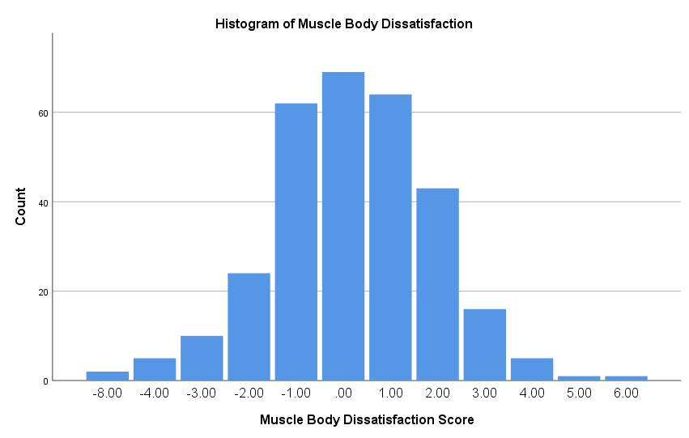

**Figure 2:**

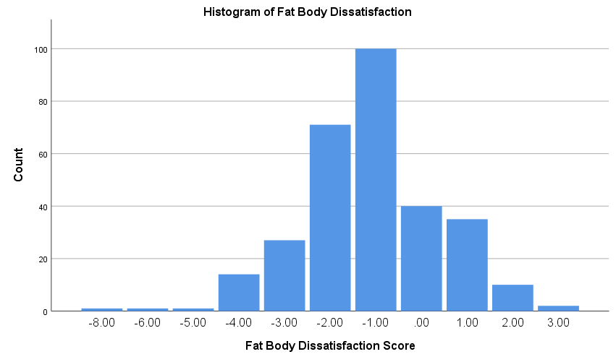

**Appendix 2**

Scatterplots to show violations of heteroscedasticity for hypothesis 2

**Figure 1:**

**Figure 2:**

**Appendix 3:**

Figures to show the mediation model and moderated mediation model used to test hypothesis 2 and hypothesis 3, respectively.

**Figure 1:**

Figure to show the mediation model used to test hypothesis 2

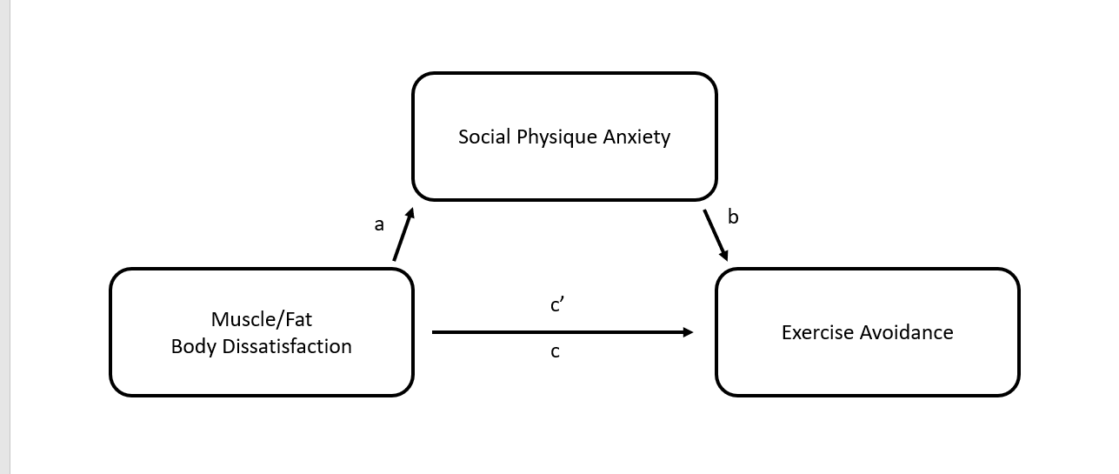

**Figure 2:**

Figure to show the moderated mediation model used to test hypothesis 3

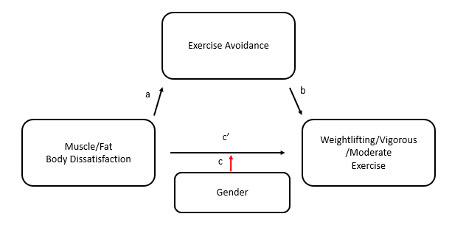

**Appendix 4**

Figures to show the multiverse analysis variations for hypothesis 2

**Figure 1:**

Figure depicting the main mediation analysis

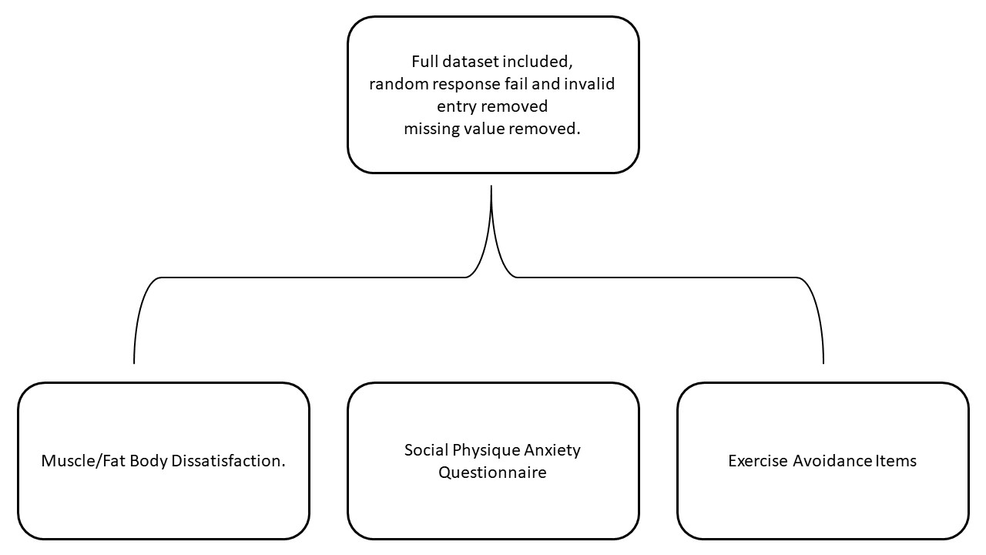

**Figure 2**

Multiverse analysis with adjusted Social Physique Anxiety Questionnaire measures

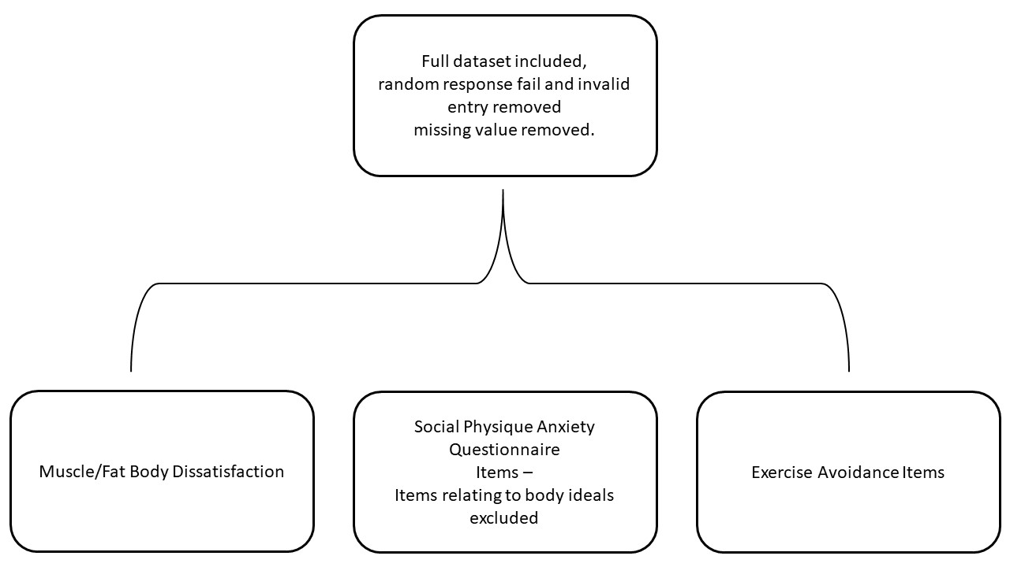

**Figure 3**

Multiverse Analysis with adjusted Exercise Avoidance items

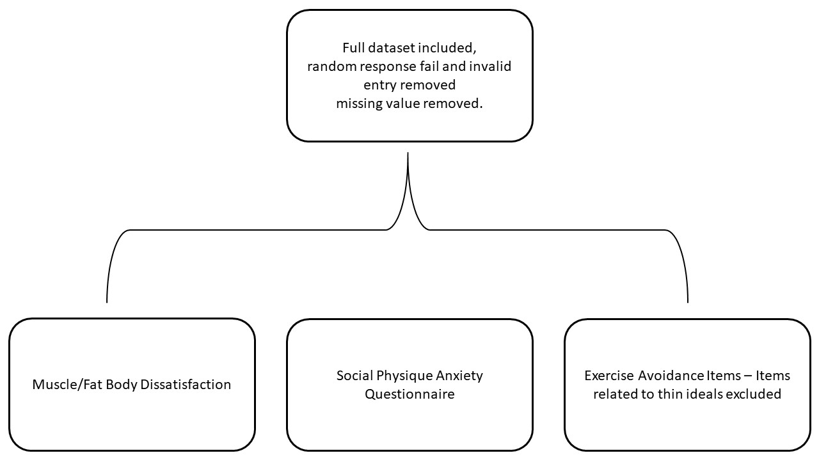

**Figure 4**

Multiverse analysis with both adjusted Social Physique Anxiety Questionnaire and Exercise Avoidance Items

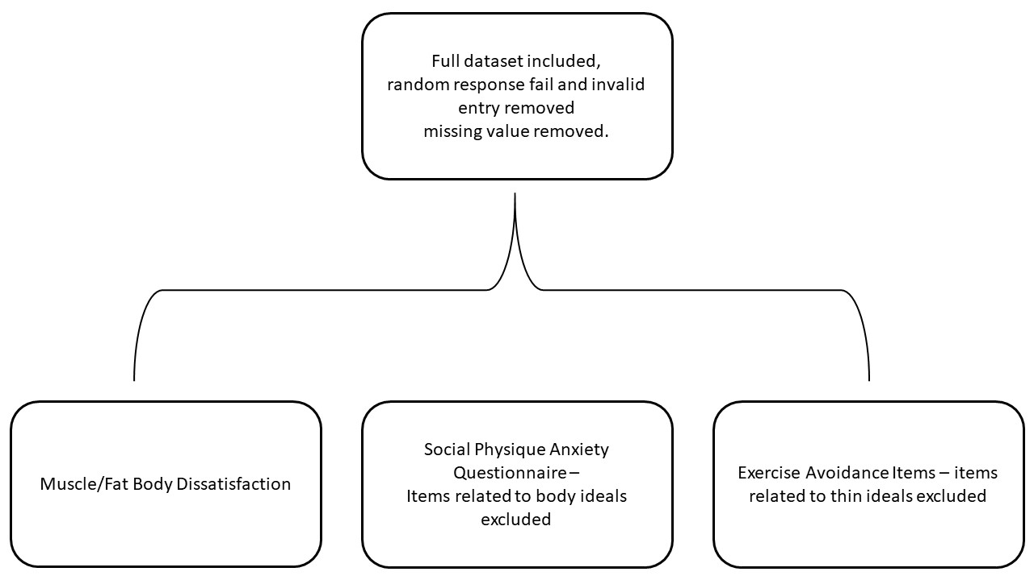

**Appendix 5**

Figures to show the multiverse variations for hypothesis 3

**Figure 1**

Figure depicting the main moderated mediation analysis

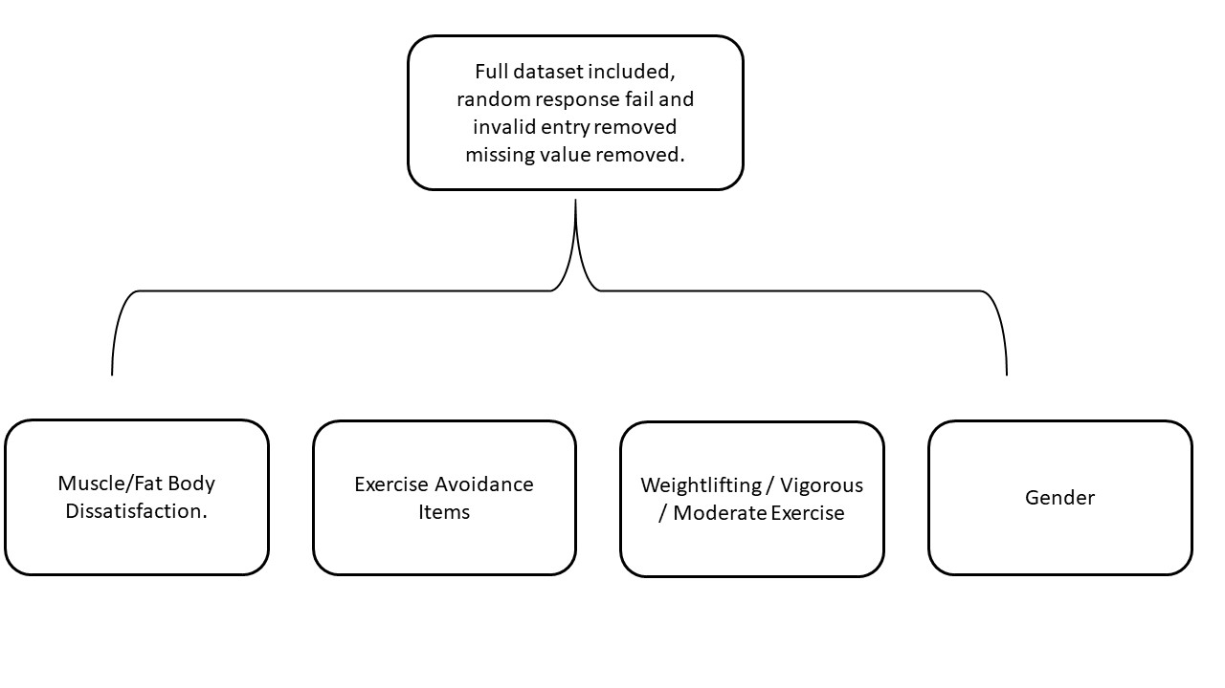

**Figure 2**

Figure depicting multiverse analysis with adjusted exercise avoidance items

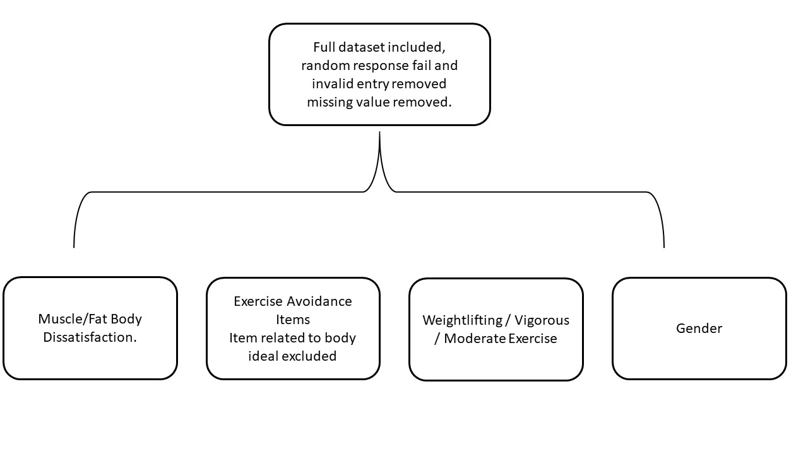

**Appendix 6**

Results of multiverse analysis for hypothesis 2

**Multiverse Variation**

In a model where items for exercise avoidance were excluded and, in a model, where both items for exercise avoidance and social physique anxiety were excluded together, there was no difference in the significance of the a, b c and c’.

The model with both adjusted social physique anxiety and exercise avoidance measures remained significant for both muscle body dissatisfaction (b = -.132, SE = .0297, 95% BootCI = [-.190 to -.074]) and fat body dissatisfaction (b = -.258, SE = .035, 95% BootCI = [-.327 to -.189]).

However, in the model with only the items from the Social Physique Anxiety Questionnaire, only partial mediation could be observed for both muscle b = -.145, SE = .032, 95% BootCI = [-.207 to -.079] and fat body dissatisfaction b = -.270, SE = .033, 95% BootCI = [-.337 to -.207] where the path c’ remained significant even when the mediator was included in the model as shown in table 4.

**Table 4**

Multiverse analysis results with items relating to body ideals excluded only on the Social Physique Anxiety Questionnaire

|  |  |  |  |  |  |  |  |
| --- | --- | --- | --- | --- | --- | --- | --- |
|  |  |  |  |  |  |  |  |
|  | ***B*** | ***Beta*** | ***SE*** | ***t*** | ***p*** | ***Lower Limits of 95% CI*** | ***Upper Limits of 95% CI*** |
| **Muscle Body Dissatisfaction** | | | |  |  |  |  |
| Path a | -1.124 | -0.268 | 0.231 | -4.867 | .000 | -1.578 | -0.669 |
| Path b | 0.373 | 0.541 | 0.033 | 11.27 | .000 | 0.308 | 0.439 |
| Path c | -761 | -0.262 | 0.176 | -4.333 | .000 | -1.107 | -0.415 |
| Path c' | -0.341 | -0.118 | 0.148 | -2.307 | .022 | -0.633 | -0.05 |
|  |  |  |  |  |  |  |  |
| **Fat Body Dissatisfaction** | | | |  |  |  |  |
| Path a | -2.603 | -0.525 | 0.266 | -9.786 | .000 | -3.126 | -2.079 |
| Path b | 0.355 | 0.514 | 0.037 | 9.639 | .000 | 0.283 | 0.428 |
| Path c | -1.302 | -0.38 | 0.194 | -6.712 | .000 | -1.683 | -0.92 |
| Path c' | -0.377 | -0.1 | 0.183 | -2.065 | .040 | -0.736 | -0.018 |

*Note:* The path c coefficient represents the total effect of body dissatisfaction on exercise avoidance and the path c’ represents the direct effect of body dissatisfaction on exercise avoidance.

**Appendix 7**

**Figure 1:**

Table to show the results of the multiverse variation of the moderated mediation analysis for hypothesis 3

|  |  |  |  |  |  |  |  |  |  |  |  |  |  |  |  |  |  |
| --- | --- | --- | --- | --- | --- | --- | --- | --- | --- | --- | --- | --- | --- | --- | --- | --- | --- |
|  |  | |  |  | **Muscle Body Dissatisfaction** | | | | | |  | **Fat Body Dissatisfaction** | | | | | |
|  |  | | ***N*** |  | ***B*** | ***SE*** | ***t*** | ***p*** | ***Lower Limits of 95% CI*** | ***Upper Limits of 95% CI*** |  | ***B*** | ***SE*** | ***t*** | ***p*** | ***Lower Limits of 95% CI*** | ***Upper Limits of 95% CI*** |
| **Weightlifting Exercise** | | 144 | |  |  |  |  |  |  |  |  |  |  |  |  |  |  |
| Path a |  | |  |  | -0.360 | 0.151 | -2.384 | .018 | -0.659 | -0.061 |  | -0.427 | 0.217 | -1.972 | .051 | -8.55 | 0.001 |
| Path b |  | |  |  | -2.055 | 2.643 | -0.778 | .438 | -7.289 | 3.170 |  | -1.853 | 2.615 | -709 | .480 | -7.023 | 3.317 |
| Path c' |  | |  |  | 5.557 | 5.051 | 1.100 | .273 | -4.430 | 15.543 |  | 16.097 | 6.369 | 2.527 | .013 | 3.504 | 28.689 |
| Gender |  | |  |  | -38.378 | 21.267 | -1.805 | .073 | -80.427 | 3.670 |  | -26.638 | 19.412 | -0.372 | .172 | -65.019 | 11.742 |
| Interaction |  | |  |  | -5.854 | 10.561 | -.554 | .580 | -26.734 | 15.027 |  | -8.789 | 12.087 | -0.727 | .468 | -32.687 | 15.110 |
| **Vigorous Exercise** | | 184 | |  |  |  |  |  |  |  |  |  |  |  |  |  |  |
| Path a |  | |  |  | -0.405 | 0.133 | -3.051 | .003 | -0.667 | -0.143 |  | -0.572 | 0.192 | -2.974 | .003 | -0.951 | -0.192 |
| Path b |  | |  |  | -2.453 | 2.643 | -0.928 | .355 | -7.668 | 2.763 |  | -2.911 | 2.589 | -1.124 | .262 | -8.019 | 2.197 |
| Path c' |  | |  |  | 2.99 | 6.381 | .376 | .707 | -10.193 | 14.991 |  | 6.991 | 6.402 | 1.092 | .276 | -5.642 | 19.623 |
| Gender |  | |  |  | -50.451 | 35.841 | -1.408 | .161 | -121.177 | 20.276 |  | -42.447 | 31.529 | -1.346 | .180 | -104.663 | 19.770 |
| Interaction term |  | |  |  | 13.117 | 12.844 | -1.026 | .306 | -38.521 | 12.171 |  | -19.352 | 14.361 | -1.348 | .180 | -47.691 | 8.986 |
| **Moderate Exercise** | | 255 | |  |  |  |  |  |  |  |  |  |  |  |  |  |  |
| Path a |  | |  |  | -0.435 | 1.24 | -3.506 | .001 | -0.679 | -0.190 |  | -0.700 | 0.146 | -4.801 | .000 | -0.987 | -0.413 |
| Path b |  | |  |  | -1.814 | 3.696 | -0.491 | .624 | -9.93 | 5.465 |  | 0.616 | 3.846 | 0.161 | .873 | -6.938 | 8.170 |
| Path c' |  | |  |  | -20.030 | 10.478 | -1.912 | .057 | -40.665 | 0.606 |  | -9.803 | 9.846 | -0.996 | .320 | -29.195 | 9.589 |
| Gender |  | |  |  | -3.750 | 34.220 | -0.110 | .913 | -71.146 | 63.645 |  | -0.788 | 39.604 | -0.020 | .984 | -78.788 | 77.213 |
| Interaction term |  | |  |  | 36.663 | 23.669 | 1.549 | .123 | -9.954 | 83.280 |  | 35.269 | 23.243 | 1.517 | .130 | -10.509 | 81.047 |

*Note:* The interaction term was calculated as the product of Path c’ and Gender

The results of the multiverse moderated mediation analysis showed no statistically significant moderation effect of gender, due to a low number of participants and the consequent lack of power in the analysis. The trends for the data remain the same as the main analysis, which are discussed in the results section.

**Appendix 8:**

Simple slope graphs of interaction between exercise types and body dissatisfaction types by gender

**Figure 1:**

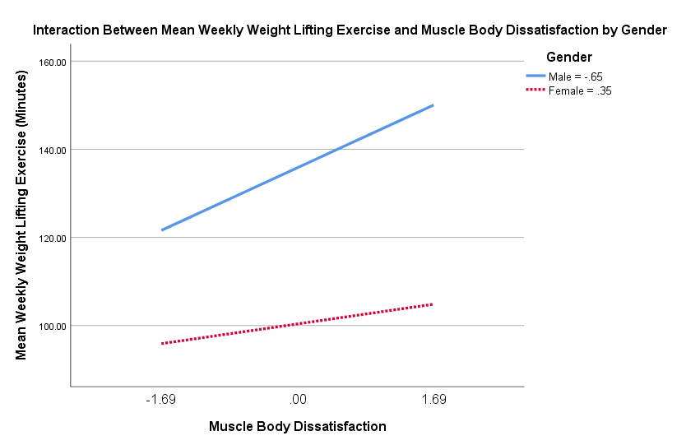

**Figure 2:** 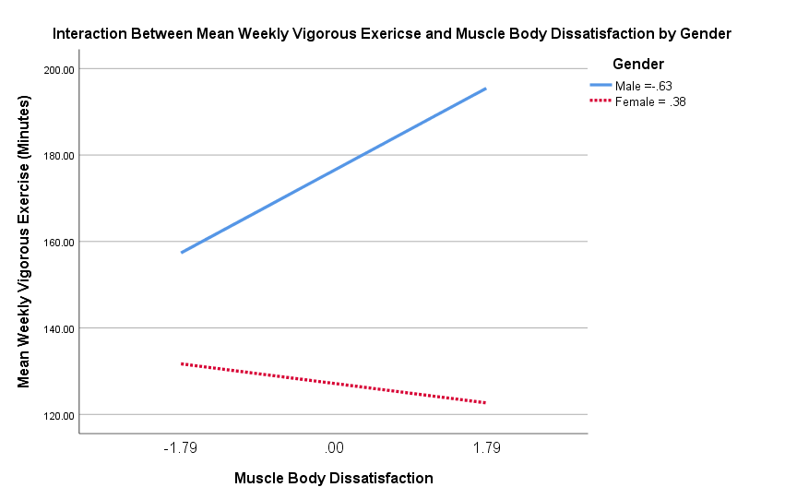

**Figure 3:**

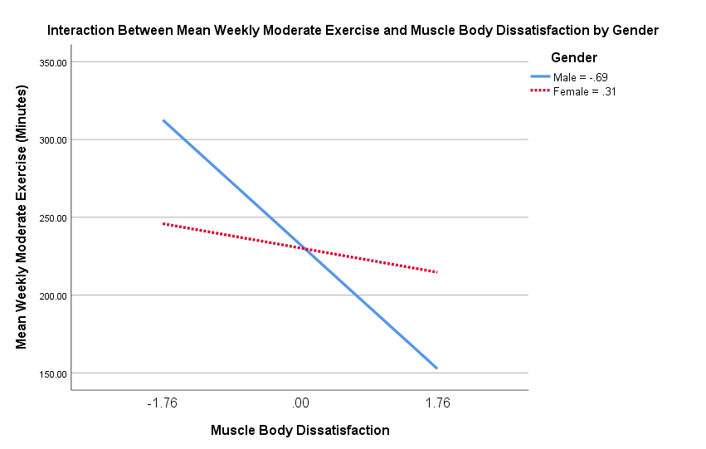

**Figure 4:**

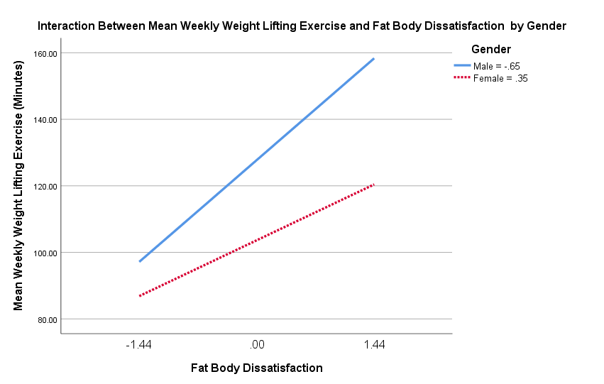

**Figure 5:**

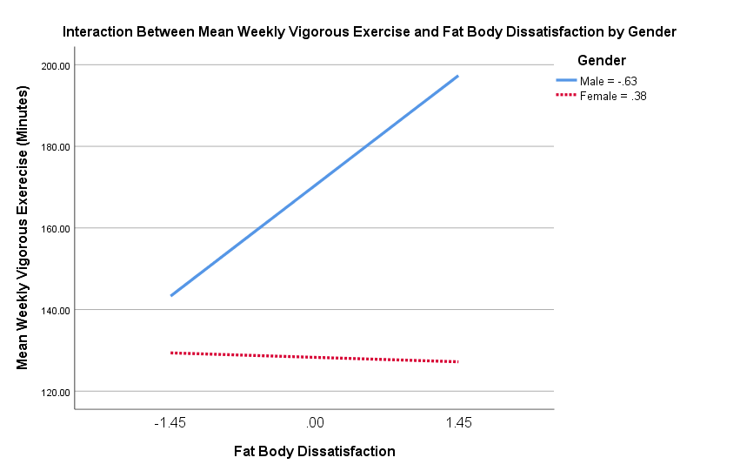

**Figure 6:** 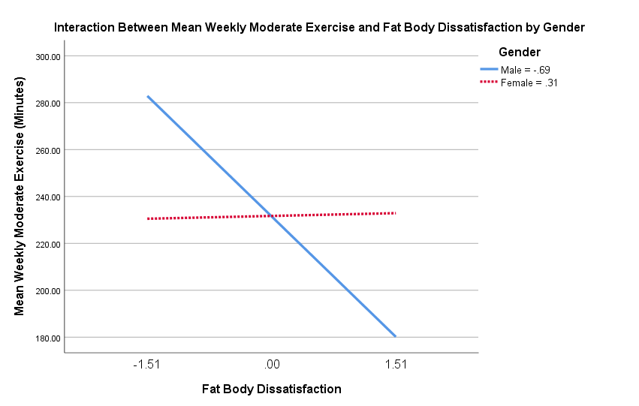

**Appendix 9:**

Pre-registration of the study submitted to the University of Dundee and on the OSF

**As Predicted registration: Jakub Kowalczyk**

1. **Have any data been collected for this study already?**

No data has been collected for this study yet.

1. **What is the main question being asked, or hypothesis being tested in this study?**

The primary aim of the project is to investigate the relationship between body dissatisfaction and exercise avoidance and examine whether it is mediated by social physique anxiety. The secondary aim of the project is to examine whether the type of body dissatisfaction an individual displays directs the type of exercise an individual actively avoids as moderated by gender.

H1 - There will be a significant difference in the average body dissatisfaction type displayed between males and females. Males will display a significantly higher average level of muscle dissatisfaction compared to females. Females will display a significantly higher average level of fat dissatisfaction compared to males

H2 - The relationship between body dissatisfaction and exercise avoidance will be mediated by social physique anxiety regarding body dissatisfaction. Individuals with high levels of body dissatisfaction for both muscle and fat dissatisfaction will have higher levels of exercise avoidance due to being more anxious about their bodies.

H3 - The type of body dissatisfaction an individual displays will direct the type of exercise they actively avoid.

Individuals high in muscle body dissatisfaction will engage in less strength-based exercise due to active avoidance of strength-based exercise. The relationship between muscle body dissatisfaction and strength-based exercise will be moderated by gender, where individuals with higher muscles body dissatisfaction will engage in less strength-based exercise and this relationship should be stronger for males in comparison with females. Furthermore, we expect that the direct relationship between body dissatisfaction and exercise will be nonsignificant in comparable models, where cardiovascular exercise is specified as the outcome

Similarly, there will be a relationship between individuals who are high in fat body dissatisfaction and lower levels of cardiovascular exercise in comparison to strength training due to active avoidance of cardiovascular exercise. The relationship between fat body dissatisfaction and cardiovascular exercise will be moderated by gender, where individuals with higher fat body dissatisfaction will engage in less cardiovascular exercise and this relationship should be stronger for females in comparison with males.

1. **Describe the key dependent variable(s) specifying how they will be measured.**

The independent variables of this study are Muscle body dissatisfaction and Fat body dissatisfaction. They will be measured by these scales, which are 9-figure pictorial scales ascending in 10% increments. Participants will be asked to select from a scale of 1-9 a) which figure they feel accurately represents them currently and b) what figure accurately represents their ideal body.

Muscle Body Dissatisfaction will be measured using the Male/Female Fit Body Scale (Ralph-Nearman & Filik, 2018) (Ralph-Nearman & Filik, 2020)

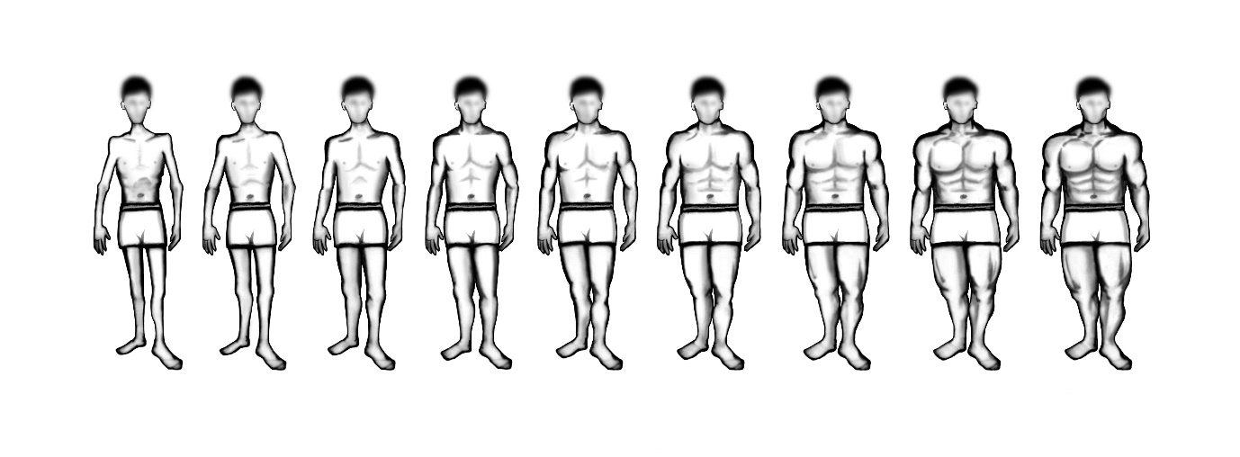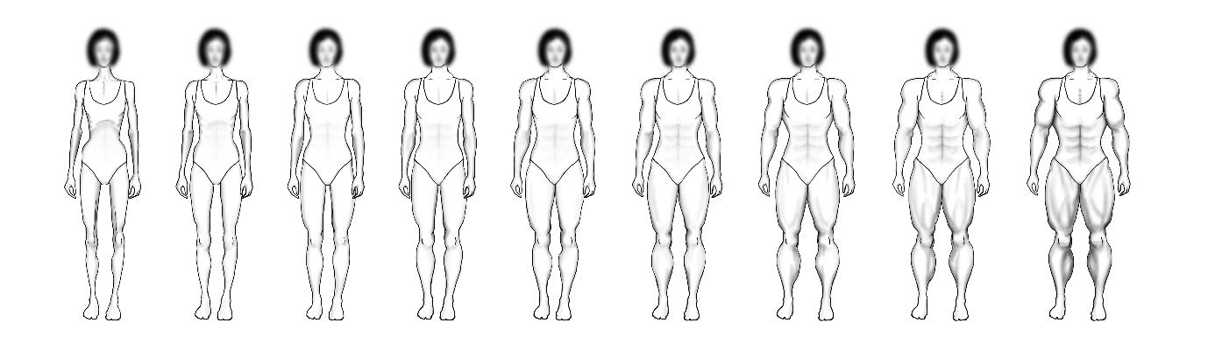

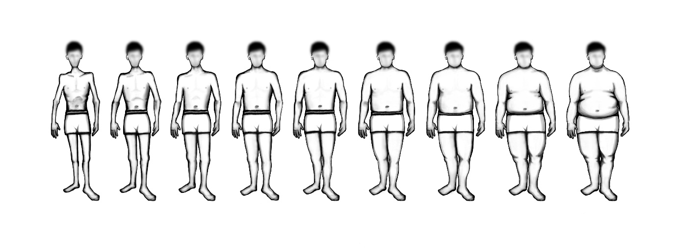Fat Body Dissatisfaction will be measured using the Male/Female Body Scale (Ralph-Nearman & Filik, 2018) (Ralph-Nearman & Filik, 2020) 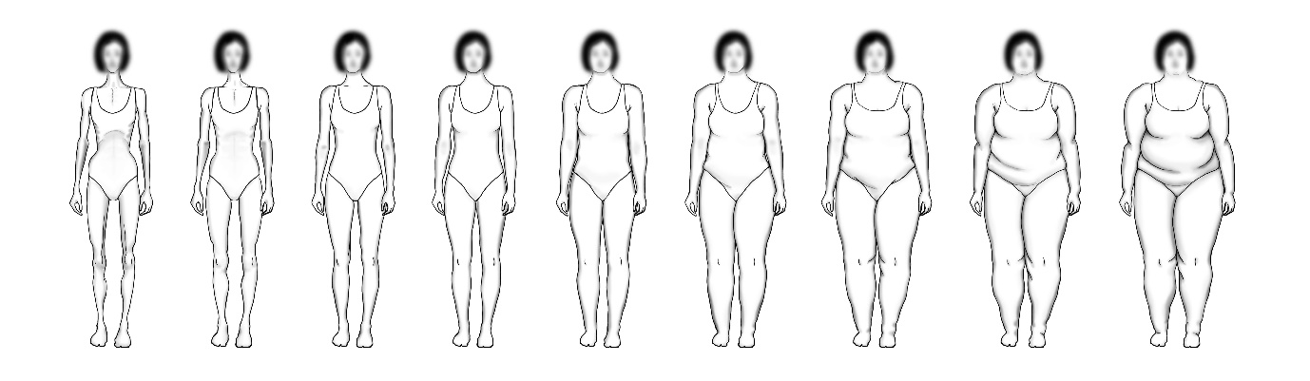

They will be measured by these scales, which are 9-figure pictorial scales ascending in 10% increments. The authors of this scale have also blurred the facial features and hair of the figures with a 10-pixel Gaussian blur to be diversity friendly but also maintains the definition of the cheeks and neck lines of the figures. Participants will be asked to select from a scale of 1-9 a) which figure they feel accurately represents them currently and b) what figure accurately represents their ideal body.

Social Physique Anxiety will be measured using the Social Physique/Appearance Anxiety Scale (Hart, Leary & Rejeski, 1989). This questionnaire asks participants to answer 12 questions on a scale of 1-5 (1=Not characteristic of me at all, and 5= Very characteristic of me).

Active Exercise Avoidance will be measured using a 3-item scale for exercise avoidance from (Vartanian and Novak, 2011) scored on a 7-poin Likert scale (1= Not true at all, 7= Completely true).

Exercise will be measured using the International Physical Activity Questionnaire (The International Physical Activity Questionnaire, 2005), which measures number of days and time spent doing vigorous and moderate exercise. This is adapted specifically for cardiovascular and strength/weight training exercise to specifically capture moderate-intensity to vigorous-intensity exercise as it is more likely to capture purposeful activity (More, Phillips, 2019).

1. **How many and which conditions will participants be assigned to?**

All participants will participate in one condition, however, depending on disclosed gender (male or female condition), they will be shown the equivalent male or female body dissatisfaction scales.

1. **Specify exactly which analyses you will conduct to examine the main question/hypothesis.**

Analysis will be carried out using SPSS 25 with the addition of the PROCESS macro by A. Hayes (2012). The first hypothesis will be analyzed using an Independent samples T-test. The second hypothesis will be tested using a mediational analysis using model 4 and for the third hypothesis will utilize a moderated mediational analysis using model 5.

Assumptions of linearity, normality and homogeneity of error variance, independence of errors, multicollinearity, outliers must be met for the analysis to be valid. This will be done by reconstructing all models ran by process individually in SPSS and running

collinearity diagnostics, the Durbin-Watson test for independence of errors (according to recommendations by Field (2009), values below 1 and above 3 would be classed as cause for concern and would indicate a violation), casewise diagnostics and Cook’s (distance to detect any outliers and the Shapiro-Wilk test (p value equal to or below .05 indicating a violation) for normality. Histograms and scatterplots will also be used to check for normality.

Output from SPSS will be compared to the one produced by PROCESS to ensure calculation was done correctly. If any of the assumptions are not met prior to analysis, this will be reported, and adjustments to accommodate this will be made and reported accordingly.

1. **Any secondary analyses?**

No secondary analyses are planned

1. **How many observations will be collected or what will determine the sample size? No need to justify decision but be precise about exactly how the number will be determined.**

A power analysis using G*Power 3.1 software was conducted to perform an a-prior calculation of required sample using the F-Test family, linear multiple regression, fixed model, R2 increase test, given f2 = .15, power =.90 and an alpha level of .05.

Using two tested predictors, and two predictors in total, the output from G*Power suggests a required total sample size of 88.

For the moderated mediation analysis, required software for a Monte Carlo simulation is not available so it has been substituted similarly by G*Power 3.1 to conduct an a-prior calculation of required sample using the F-Test family, linear multiple regression, fixed model, R2 increase test, given f2 = .02, power =.80 and an alpha level of .05.

Using two tested predictors, and three predictors in total, the output from G*Power suggests a required total sample size of 485.

If this minimum will not be achieved for the moderated mediation analysis, analysis will still be conducted for the mediation only, and the moderated mediation analysis will be included as supplementary material, but the write-up will acknowledge the smaller than planned sample and its effects on the power of the analysis.

Data collection is planned to last 6/7 weeks. If the desired sample size is not achieved by the end of this period, the project will proceed with the acknowledgement of this limitation

1. **Anything else you would like to pre-register? (e.g., data exclusions, variables collected for exploratory purposes, unusual analyses planned?)**

A pre-screening of participants based on answers to demographic questions will also take place. Due to the hypotheses of this research hinging on body ideals stereotypical to gender, an exclusion measure will be implemented for participants who identify with non-binary genders. In the pre-screening questionnaire, participants will be asked what gender they identify with e.g. male (he/him pronouns) or female (she/her pronouns) and those who identify as non-binary would have their questionnaire terminated by the pre-screening measure and thanked for their time.

2 random response items to confirm the participant is actively engage and aware of what they are responding to will be displayed roughly a quarter way and three-quarter ways through the experiment. Participants who fail the first random response test will be presented with a screen informing them of the importance of reading the questions asked accurately and to pay attention closely. Participants who fail both random response tests will have their data excluded.

**Appendix 10:**

Amendments made to the pre-registration form

**Open-ended registrations:**

Summary (optional): This registration contains an amendment to the prior registration in the contents of its power analysis and the target sample size for the corresponding hypothesis.

For the moderated mediation analysis, a power analysis using G*Power 3.1was done to conduct an a-prior calculation of required sample using the F-Test family, linear multiple regression, fixed model, R2 increase test, given f2 = .02, power =.80 and an alpha level of .05. Using four tested predictors, and five predictors in total, the output from G*Power suggests a required total sample size of 602.

**Appendix 11:**

Measurement scales used for measuring body dissatisfaction

**Figure 1**:

Female Body Scale (Ralph-Nearman & Filik, 2020)

**Figure 2**:

****Female Fit Body Scale (Ralph-Nearman & Filik, 2020)

**Figure 3**:

****Male Body Scale (Ralph-Nearman & Filik, 2018)

**Figure 4**:

Male Fit Body Scale (Ralph-Nearman & Filik, 2018)

**Appendix 12:**

Measurement scale used for measuring social physique anxiety

**Figure 1:** Social Physique Anxiety Scale (Hart, Leary, & Rejeski, 1989):

The following questionnaire contains statements concerning your body physique or figure. By physique or figure we mean your body’s form and structure; specifically, body fat, muscular tone, and general body proportions.

Instructions: Read each item carefully and indicate how characteristic it is of you according to the following scale.

1 = Not at all characteristic of me

2 = Slightly characteristic of me

3 = Moderately characteristic of me

4 = Very characteristic of me

5 = Extremely characteristic of me

1. I am comfortable with the appearance of my physique or figure.

2. I would never worry about wearing clothes that might make me look too thin or overweight.

3. I wish I wasn't so up-tight about my physique or figure.

4. There are times when I am bothered by thoughts that other people are evaluating my

weight or muscular development negatively.

5. When I look in the mirror, I feel good about my physique or figure.

6. Unattractive features of my physique or figure make me nervous in certain social settings.

7. In the presence of others, I feel apprehensive about my physique or figure.

8. I am comfortable with how fit my body appears to others.

9. It would make me uncomfortable to know others were evaluating my physique or figure.

10. When it comes to displaying my physique or figure to others, I am a shy person.

11. I usually feel relaxed when it's obvious that others are looking at my physique or figure.

12. When in a bathing suit, I often feel nervous about how well proportioned my body is.

**Appendix 13:**

Measurement scale used to measure physical exercise

**Figure 1:**

International Physical Activity Questionnaire – Short Form

We are interested in finding out about the kinds of physical activities that people do as part of their everyday lives. The questions will ask you about the time you spent being physically active in the **last 7 days**. Please answer each question even if you do not consider yourself to be an active person. Please think about the activities you do at work, as part of your house and yard work, to get from place to place, and in your spare time for recreation, exercise, or sport.

Think about all the **vigorous** activities that you did in the **last 7 days**. **Vigorous** physical activities refer to activities that take hard physical effort and make you breathe much harder than normal. Think *only* about those physical activities that you did for at least 10 minutes at a time.

1. During the **last 7 days**, on how many days did you do **vigorous** physical activities like heavy lifting, digging, aerobics, or fast bicycling?

_____ **days per week**

No vigorous physical activities ***Skip to question 3***

1. How much time did you usually spend doing **vigorous** physical activities on one of those days?

_____ **hours per day**

_____ **minutes per day**

Don’t know/Not sure

Think about all the **moderate** activities that you did in the **last 7 days**. **Moderate** activities refer to activities that take moderate physical effort and make you breathe somewhat harder than normal. Think only about those physical activities that you did for at least 10 minutes at a time.

1. During the **last 7 days**, on how many days did you do **moderate** physical activities like carrying light loads, bicycling at a regular pace, or doubles tennis? Do not include walking.

_____ **days per week**

No moderate physical activities ***Skip to question 5***

1. How much time did you usually spend doing **moderate** physical activities on one of those days?

_____ **hours per day**

_____ **minutes per day**

Don’t know/Not sure

1. During the last 7 days, on how many days did you do weight lifting or other muscle building (anaerobic) activities like bodyweight exercises, squats, push-ups, pull-ups, or bicep curls in your leisure time?

_____ **days per week**

1. How much time did you usually spend doing muscle-building physical activities on one of those days (for example, if you typically spend 20 minutes doing weightlifting or muscle-building activities on a day in which you engage in weight lifting or muscle-building activities, please write 20 minutes here)?

_____ **hours per day**

_____ **minutes per day**

Don’t know/Not sure

**This is the end of the questionnaire, thank you for participating.**

**Appendix 14:**

Measurement scaled used to measure exercise avoidance.

**Figure 1:**

Exercise Avoidance Scale (Vartanian & Novak, 2011)

1. I feel uncomfortable going to a gym where there are a lot of mirrors
2. I avoid going to the gym when I know there will be a lot of thin people there
3. I am too embarrassed to participate in physical activity in public places

For each item, participants are asked to consider the statements above and rate them on a 7-point Likert scale (1= Not true at all, 7= Completely true)

# References

Atalay, A. A., & Gencoz, T. (2008). Critical factors of social physique anxiety: Exercising and body image satisfaction. *Behaviour Change*, 25(3), 178. <https://doi.org/10.1375/bech.25.3.178>

Bearman, S. K., & Stice, E. (2008). Testing a gender additive model: The role of body image in adolescent depression. *Journal of abnormal child psychology*, *36*(8), 1251-1263. https://doi.org/10.1007/s10802-008-9248-2

Blanchard, C. M., Courneya, K. S., & Stein, K. (2008). Cancer survivors’ adherence to lifestyle behavior recommendations and associations with health-related quality of life: results from the American Cancer Society's SCS-II. *Journal of Clinical Oncology*, *26*(13), 2198-2204. https://doi.org/10.1200/jco.2007.14.6217

Bornioli, A., Lewis-Smith, H., Slater, A., & Bray, I. (2021). Body dissatisfaction predicts the onset of depression among adolescent females and males: a prospective study. *J Epidemiol Community Health*, *75*(4), 343-348. https://doi.org/10.1136/jech-2019-213033

Brockhoff, M., Mussap, A. J., Fuller‐Tyszkiewicz, M., Mellor, D., Skouteris, H., McCabe, M. P., & Ricciardelli, L. A. (2016). Cultural differences in body dissatisfaction: Japanese adolescents compared with adolescents from China, Malaysia, Australia, Tonga, and Fiji. *Asian Journal of Social Psychology*, *19*(4), 385-394. https://doi.org/10.1111/ajsp.12150

Brudzynski, L. R., & Ebben, W. (2010). Body image as a motivator and barrier to exercise participation. *International Journal of Exercise Science*, *3*(1), 3. Available at: https://digitalcommons.wku.edu/ijes/vol3/iss1/3

Campbell, A., & Hausenblas, H. A. (2009). Effects of exercise interventions on body image: A meta-analysis. *Journal of health psychology*, *14*(6), 780-793. https://doi.org/10.1177/1359105309338977

Cash, T. F., & Szymanski, M. L. (1995). The development and validation of the Body-Image Ideals Questionnaire. *Journal of personality assessment*, *64*(3), 466-477. https://doi.org/10.1207/s15327752jpa6403_6

Černelič-Bizjak, M., & Jenko-Pražnikar, Z. (2014). Impact of negative cognitions about body image on inflammatory status in relation to health. *Psychology & Health*, 29(3), 264-278. https://doi.org/10.1080/08870446.2013.844807

Cred_e, M. (2010). Random responding as a threat to the validity of effect size estimates in correlational research. *Educational and Psychological Measurement*, 70, 596–612. doi:10.1177/0013164410366686

Field, A., & SPSS, D. S. U. (2009). SAGE Publications Ltd. *Thousand Oaks*, 457-505.

Fiske, L., Fallon, E. A., Blissmer, B., & Redding, C. A. (2014). Prevalence of body dissatisfaction among United States adults: Review and recommendations for future research. *Eating Behaviors*, 15(3), 357-365. https://doi.org/10.1016/j.eatbeh.2014.04.010

Freedson, P. S., & Miller, K. (2000). Objective monitoring of physical activity using motion sensors and heart rate. *Research quarterly for exercise and sport*, *71*(sup2), 21-29 http://doi.org/10.1080/02701367.2000.11082782

Furnham, A., Badmin, N., & Sneade, I. (2002). Body image dissatisfaction: Gender differences in eating attitudes, self-esteem, and reasons for exercise. *The Journal of Psychology*, *136*(6), 581-596. https://doi.org/10.1080/00223980209604820

Griffiths, S., Murray, S. B., Dunn, M., & Blashill, A. J. (2017). Anabolic steroid use among gay and bisexual men living in Australia and New Zealand: Associations with demographics, body dissatisfaction, eating disorder psychopathology, and quality of life. *Drug and alcohol dependence*, *181*, 170-176. https://doi.org/10.1016/j.drugalcdep.2017.10.003

Groesz, L. M., Levine, M. P., & Murnen, S. K. (2002). The effect of experimental presentation of thin media images on body satisfaction: A meta‐analytic review. *International Journal of Eating Disorders*, *31*(1), 1-16. https://doi.org/10.1002/eat.10005

Grogan, S. (2016). *Body image: Understanding body dissatisfaction in men, women and children*.

Grogan, S., & Richards, H. (2002). Body image: Focus groups with boys and men. *Men and masculinities*, *4*(3), 219-232. https://doi.org/10.1177/1097184x02004003001

Hart, E. A., Leary, M. R., & Rejeski, W. J. (1989). The measurement of social physique anxiety. *Journal of Sport and Exercise Psychology*, 11, 94-104. https://doi.org/10.1123/jsep.11.1.94

Hausenblas, H. A., & Fallon, E. A. (2006). Exercise and body image: A meta-analysis. *Psychology and health*, *21*(1), 33-47. https://doi.org/10.1080/14768320500105270

Hayes, A. F. (2012). PROCESS: A versatile computational tool for observed variable mediation, moderation, and conditional process modelling. Retrieved from http://www.afhayes.com/ public/process2012.pdf

Hearon, B. A., Quatromoni, P. A., Mascoop, J. L., & Otto, M. W. (2014). The role of anxiety sensitivity in daily physical activity and eating behavior. *Eating behaviors*, *15*(2), 255-258. https://doi.org/10.1016/j.eatbeh.2014.03.007

Heider, N., Spruyt, A., & De Houwer, J. (2015). Implicit beliefs about ideal body image predict body image dissatisfaction. *Frontiers in Psychology*, 6, 1402. https://doi.org/10.3389/fpsyg.2015.01402

Jayakody, K., Gunadasa, S., & Hosker, C. (2013). Exercise for anxiety disorders: systematic review. *British journal of sports medicine*, *48*(3), 187-196. https://doi.org/10.1136/bjsports-2012-091287

Lee, P. H., Macfarlane, D. J., Lam, T. H., & Stewart, S. M. (2011). Validity of the international physical activity questionnaire short form (IPAQ-SF): A systematic review. *International Journal of Behavioral Nutrition and Physical Activity*, *8*(1), 1-11. https://doi.org/10.1186/1479-5868-8-115

Mond, J., Mitchison, D., Latner, J., Hay, P., Owen, C., & Rodgers, B. (2013). Quality of life impairment associated with body dissatisfaction in a general population sample of women. *BMC Public Health*, *13*(1), 1-11. https://doi.org/10.1186/1471-2458-13-920

More, K. R., & Phillips, L. A. (2019). The influence of body dissatisfaction on cardiovascular and strength-based physical activity by gender: a self-determination theory approach. *Psychology & Health*, *34*(12), 1437-1450. https://doi.org/10.1080/08870446.2019.1614587

More, K. R., Phillips, L. A., & Colman, M. H. E. (2019). Evaluating the potential roles of body dissatisfaction in exercise avoidance. *Body Image*, *28*, 110-114. https://doi.org/10.1016/j.bodyim.2019.01.003

Morres, I. D., Hatzigeorgiadis, A., Stathi, A., Comoutos, N., Arpin‐Cribbie, C., Krommidas, C., & Theodorakis, Y. (2019). Aerobic exercise for adult patients with major depressive disorder in mental health services: A systematic review and meta‐analysis. *Depression and anxiety*, *36*(1), 39-53. https://doi.org/10.1002/da.22842

Neighbors, L. A., & Sobal, J. (2007). Prevalence and magnitude of body weight and shape dissatisfaction among university students. *Eating Behaviors*, *8*(4), 429-439. https://doi.org/10.1016/j.eatbeh.2007.03.003

Neumark-Sztainer, D., Paxton, S. J., Hannan, P. J., Haines, J., & Story, M. (2006). Does body satisfaction matter? Five-year longitudinal associations between body satisfaction and health behaviors in adolescent females and males. *Journal of Adolescent Health*, 39(2), 244-251. https://doi.org/10.1016/j.jadohealth.2005.12.001

Oeland, A. M., Laessoe, U., Olesen, A. V., & Munk-Jørgensen, P. (2010). Impact of exercise on patients with depression and anxiety. *Nordic journal of psychiatry*, *64*(3), 210-217. Oeland, https://doi.org/10.3109/08039480903511373

Penedo, F. J., & Dahn, J. R. (2005). Exercise and well-being: a review of mental and physical health benefits associated with physical activity. *Current Opinion in Psychiatry,* 18(2), 189-193. https://doi.org/10.1097/00001504-200503000-00013

Peterson, R. A. (2001). On the use of college students in social science research: Insights from a second-order meta-analysis. *Journal of consumer research*, *28*(3), 450-461. https://doi.org/10.1086/323732

Ralph-Nearman, C. (2020). Permission to use figural scales for male and female thinness & muscle dissatisfaction [Email].

Ralph-Nearman, C., & Filik, R. (2018). New body scales reveal body dissatisfactionn, thin-ideal, and muscularity-ideal in males. *American Journal of Men's Health*, 12(4), 740-750. https://doi.org/10.1177/1557988318763516

Ralph-Nearman, C., & Filik, R. (2020). Development and validation of new figural scales for female body dissatisfaction assessment on two dimensions: thin-ideal and muscularity-ideal. *BMC Public Health*, *20*(1), 1-11. https://doi.org/10.1186/s12889-020-09094-6

Reiss, S. (1991). Expectancy model of fear, anxiety, and panic. Clinical Psychology Review, 11(2), 141-153. https://doi.org/10.1016/0272-7358(91)90092-9

Ridgeway, R. T., & Tylka, T. L. (2005). College Men's Perceptions of Ideal Body Composition and Shape. *Psychology of Men & Masculinity*, *6*(3), 209. https://doi.org/10.1037/1524-9220.6.3.209

Robinson, L., Prichard, I., Nikolaidis, A., Drummond, C., Drummond, M., & Tiggemann, M. (2017). Idealised media images: The effect of fitspiration imagery on body satisfaction and exercise behaviour. *Body Image*, 22, 65-71. https://doi.org/10.1016/j.bodyim.2017.06.001

Ruegsegger, G. N., & Booth, F. W. (2018). Health benefits of exercise. *Cold Spring Harbor perspectives in medicine*, *8*(7), a029694. https://doi.org/10.1101/cshperspect.a029694

Sabiston, C. M., Sedgwick, W. A., Crocker, P. R. E., Kowalski, K. C., & Mack, D. E. (2007). Social physique anxiety in adolescence: An exploration of influences, coping strategies, and health behaviors*. Journal of Adolescent Research*, 22(1), 78-101. https://doi.org/10.1177/0743558406294628

Sabourin, B. C., Hilchey, C. A., Lefaivre, M. J., Watt, M. C., & Stewart, S. H. (2011). Why do they exercise less? Barriers to exercise in high-anxiety-sensitive women. *Cognitive Behaviour Therapy*, *40*(3), 206-215. https://doi.org/10.1080/16506073.2011.573572

Schilder, I. (1950) The Language and appearance of the human body. London: Kegan Paul, Trench, Trubner.

Schuch, F. B., Vancampfort, D., Richards, J., Rosenbaum, S., Ward, P. B., & Stubbs, B. (2016). Exercise as a treatment for depression: a meta-analysis adjusting for publication bias. *Journal of psychiatric research*, *77*, 42-51. https://doi.org/10.1016/j.jpsychires.2016.02.023

Smits, J. A., Tart, C. D., Presnell, K., Rosenfield, D., & Otto, M. W. (2010). Identifying potential barriers to physical activity adherence: Anxiety sensitivity and body mass as predictors of fear during exercise. *Cognitive Behaviour Therapy*, *39*(1), 28-36. https://doi.org/10.1080/16506070902915261

Steegen, S., Tuerlinckx, F., Gelman, A., & Vanpaemel, W. (2016). Increasing Transparency Through a Multiverse Analysis. Perspectives on Psychological Science: *A Journal of the Association for Psychological Science*, 11(5), 702–712. https://doi.org/10.1177/1745691616658637

The International Physical Activity Questionnaire, 2005 (Retrieved from <http://www.ipaq.ki.se/> at 10:30 A.M. on 30/09/2020)

Thompson, A. M., & Chad, K. E. (2002). The relationship of social physique anxiety to risk for developing an eating disorder in young females. *Journal of Adolescent Health*, 31(2), 183-189. https://doi.org/10.1016/s1054-139x(01)00397-4

Tiggemann, M., & Zaccardo, M. (2015). “Exercise to be fit, not skinny”: The effect of fitspiration imagery on women's body image. *Body Image*, 15, 61-67 https://doi.org/10.1016/j.bodyim.2015.06.003

Vani, M. F., Pila, E., Willson, E., & Sabiston, C. M. (2020). Body-related embarrassment: The overlooked self-conscious emotion. Body image, 32, 14-23. https://doi.org/10.1016/j.bodyim.2019.10.007

Vartanian, L. R., & Novak, S. A. (2011). Internalized societal attitudes moderate the impact of weight stigma on avoidance of exercise. *Obesity*, *19*(4), 757-762. https://doi.org/10.1038/oby.2010.234

Wade, T., George, W. M., & Atkinson, M. (2009). A randomized controlled trial of brief interventions for body dissatisfaction. *Journal of Consulting and Clinical Psychology*, *77*(5), 845. https://doi.org/10.1037/a0016879