**Reward Ready**

**Problem Statement**

Given a user intending to shop a product on a specific merchant, design a system to maximize the additional savings for him/her based on a combination of credit and loyalty card rewards and online coupons.

**Description**

The RewardReady app works by having the registered users store information regarding the name and type of different credit or loyalty cards they currently own. From this point, the app can be used by the user to maximize his rewards/additional savings when trying to purchase a product from a merchant. A user can either manually enter the product name/category and merchant name or use the app to automatically detect the merchant based on his/her current geolocation. Based on the entered data, the app provides the user with information regarding the best card option to make the purchase from his/her bouquet of cards and other online deals/coupons available for the product/merchant (in general).

**Goals**

Web Based application that can register users, store card types, and recommend a card based on their current shopping location. The app will also be able to provide coupons for the current purchase, display current sales or deals for the item or type of item, and recommend new loyalty cards that the user might like based on user activity.

**Team**

The team and their related roles are as follows:

| Name | Roles |
| --- | --- |
| Jackson Prillaman | Project Manager |
| Jacob Kubik | Tech Lead (backend) |
| Rohit Rane | Tech/Cloud Lead |
| Diego Espinoza | Tech Lead (frontend) |
| Ayush Sahay | Design |
| Anurag Saroha | Design/Writer |

**Timeline**

| Week | Tasks |
| --- | --- |
| 9/5 | * Discussion of Idea * Group dynamics set up |
| 9/12 | * Phase 1 Deliverable Completed (9/18) |
| 9/19 | * Gitlab Repo * Use Case Diagram * User Personas * User Stories: System main services |
| 9/26 | * Product Backlog * Product Roadmap * Product Burndown Chart * Phase 2 Deliverable Completed |
| **10/3 -** **Sprint 1 Start** | * Sprint Planning * Training on chosen Front-End and Back-End frameworks * Setting up the db schema * Research responsive CSS frameworks |
| 10/10 | * Wireframe of Front-End Design, Breaking down components of the website * Begin implementing Front-End and Back-End design * Create Unit Tests |
| 10/17 | * Test implemented features * Sprint Review & Retrospective * Sprint 1 Deliverable Completed |
| **10/24 - Sprint 2 Start\*** | * Sprint Planning * Backend API integrations * CRUD operations implemented with chosen Back-End framework * Create layout |
| 10/31 | * Begin creating reusable components * Begin creating page views * Focus on page routes |
| 11/7 | * Sprint Review & Retrospective * Add to Unit Tests * Sprint 2 Deliverable Completed |
| **11/14 -** **Sprint 3 Start\*** | * Sprint Planning * BugFixes * Finalize development |
| 11/21 | * Add to Unit Tests * Continue BugFixes * Finalize development |
| 11/28 | * Deployment to Docker (containerize application) * Work on demo and final presentation * Sprint Review & Retrospective * Sprint 3 Deliverable Completed |
| 12/5 | * Final Presentation Given |

*If tasks for a sprint are finished early, then the next week’s sprint tasks are started

**Communication**

The team will coordinate and communicate using Discord as our primary platform. Team members are expected to attend relevant standups and group meetings. The weekly meeting is from 4pm until 6:45pm on Mondays as long as class is not occurring. Additional or makeup meetings will be scheduled using When2Meet if necessary. In the case a team member is unable to attend, they will be filled in and updated.

Group project management for development purposes will be conducted using Gitlab’s built-in agile project management system.

**The Case for the System**

**Need for the system**

*Why do we need this product? What purpose does it serve?*

With companies fiercely competing against each other to attract consumers and increase their market share, the end user stands to gain in the form of lower prices/discounts, cashback, and other deals and rewards. The deals are offered not only on the product but also on the purchase option used to make payment. However, with such a huge number of players in the market, it is not an easy task for a consumer to get the best deal for his purchase.

For the payment options, the issue is that many people these days have multiple credit cards. In fact, a [study](https://www.experian.com/blogs/ask-experian/average-number-of-credit-cards-a-person-has/) by Experian indicated that Americans on average hold 4 credit cards. If loyalty cards such as those provided by gas stations, coffee shops, travel companies etc. are also considered, then this figure rises to a much higher number. To take full advantage, the consumer must always remember all the benefits associated with all the cards he/she holds. However, in the current scenario where people hold multiple cards, this is practically impossible. Similarly, getting the information related to the additional discount and other deals offered on a product by a retailer is also often not easy because of the reasons such information not emphasized enough by merchants, information overlooked by users, or not having an idea where to look for the required info, etc.

Hence, having an app that recommends which credit card to use for payment at a specific retailer and what coupons are available for the purchased product can really help users in maximizing their rewards.

*Who are the main stakeholders and end users?*

The app will be primarily built to serve any consumer/user who wishes to look for deals or coupons related to a merchant store and It will provide additional features for users with credit cards and other loyalty cards. Other stakeholders include Dr. Sara Hooshangi, all the team members of the project, credit card companies, companies with loyalty cards, and retailers where users will shop.

*If your system is an app, why does it have to be a mobile app (not a desktop or a web application)?*

Our system will be designed to serve as a web app for a variety of reasons. Firstly, a web app has far greater reach than a mobile app because many potential users still do not have access to smartphones. Secondly, there could be many scenarios where a user would want to shop online, and a laptop/desktop is more suitable to serve his needs. For example, when the user is at home and already surfing the internet or wants to view items on a bigger screen before buying. Finally, a web app can also run on any device that has a browser app installed including mobile phones. On the other hand, a mobile app can only run on a selected set of devices that support the operating system that the app is designed for, say iOS or Android.

**Current Market**

*What are the other systems that have goals similar to your system (mention some examples)?*

There are quite a few systems available in the market whose goals are similar to our app, namely, to save money and maximize rewards for the consumer. The most popular among these are Award Wallet, PayPal Honey, and Groupon.

AwardWallet is a finance management app that keeps track of your points and miles balances with hotels, airlines, and credit card companies, and also lets you know when those points expire. App has a special feature called “Merchant Lookup” where a user can search for any place they're about to spend money on, for example, a restaurant, grocery store, gas station, or coffee spot. Based on the merchant search, the app provides information on points or rewards offered by almost every major U.S. credit card. This information is beneficial for users in selecting appropriate cards from their bouquet for reward maximization.

PayPal Honey works a bit differently to achieve the goal of money saving by looking for deals and coupons online for a large number (30k+) of retailers. During online checkout, the system automatically applies the different coupon codes found and retains the one which is working and gives the highest saving for the user.

Similarly, Groupon helps consumers by finding coupons, cashback on purchases, and group deals. Restaurants, stores, and businesses that produce goods or services use Groupon platform to entice customers to visit their locations or buy their products, by providing rewards or coupons.

*What criticism do you have about them?*

The mentioned apps, although quite useful for consumers, have certain missing features which could be worked upon. For example, Award Wallet doesn’t provide personalized rewards information based on the cards the user possesses. It provides a generic list of the rewards associated with all the cards in the market for the selected merchant. While this may be beneficial for someone who doesn’t own a card yet and wants to select an appropriate card for himself based on his shopping habits or for someone who doesn’t have an account with the app. Others would need to scroll down the entire list to search for the card they possess and then compare different cards.

Moving further, PayPal Honey has its service solely focused on coupons. Credit card rewards are nowhere factored in this money-saving tool. This is the same case for Groupon, where additionally narrowing the search is a bit difficult sometimes. This is because of the huge coupon data and the broad nature of search terms specified by the consumer.

**Competitive Analysis**

*What is "new" about the system? Is it the idea, or is it the way it approaches a solution that already exists?*

*How do you think your system will be different or better than existing products?*

Although the system envisioned by us is not new per se in its idea and there already exists different systems sharing many of the features similar to the ones contemplated by us. However, the system is unique in the sense that it aggregates different features from already existing systems (sharing the same goals) under one roof and integrates them with some of its own to better serve the customer’s needs. The idea is to build on the comparative strengths of these apps with some customizations and slight new features to design a better system.

For example, our system will not only provide coupon info similar to PayPal Honey and Groupon but will also recommend what is the best card option available for the user to make the purchase. And, unlike AwardWallet, our system will be designed to provide personalized card recommendations (only amongst the cards owned by the user) for purchase at outlets instead of generic ones. Also, to make the tasks easier for the customer our app will also support services based on geolocation to automatically identify the name of the merchant the user is shopping at and then generate card recommendations and coupon info based on that. To the best of our knowledge, such a feature is non-existent in the apps currently available in the market. As such our app will work to provide services that are currently isolated in different systems under a single architecture and also include some of its own to provide a better money-saving tool for the users.

**System Description**

*Technical, Business or Administrative Problem Addressed*

The application addresses the problem that current market applications typically only focus on one aspect of the reward market. To take advantage of a complete set of rewards, users must possess multiple different apps from multiple companies. This also means a lack of interconnectivity, multiple accounts, and loss of overall functionality. Our application solves this problem by incorporating multiple reward management systems into one.

*Data Flow Diagrams (DFD) – Context, Level-0 (Provide only two levels)*

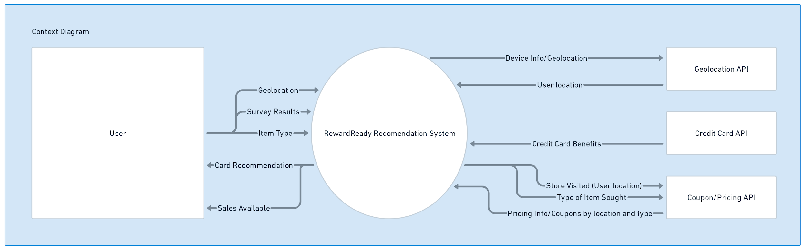

Figure 1: Context Diagram for RewardReady

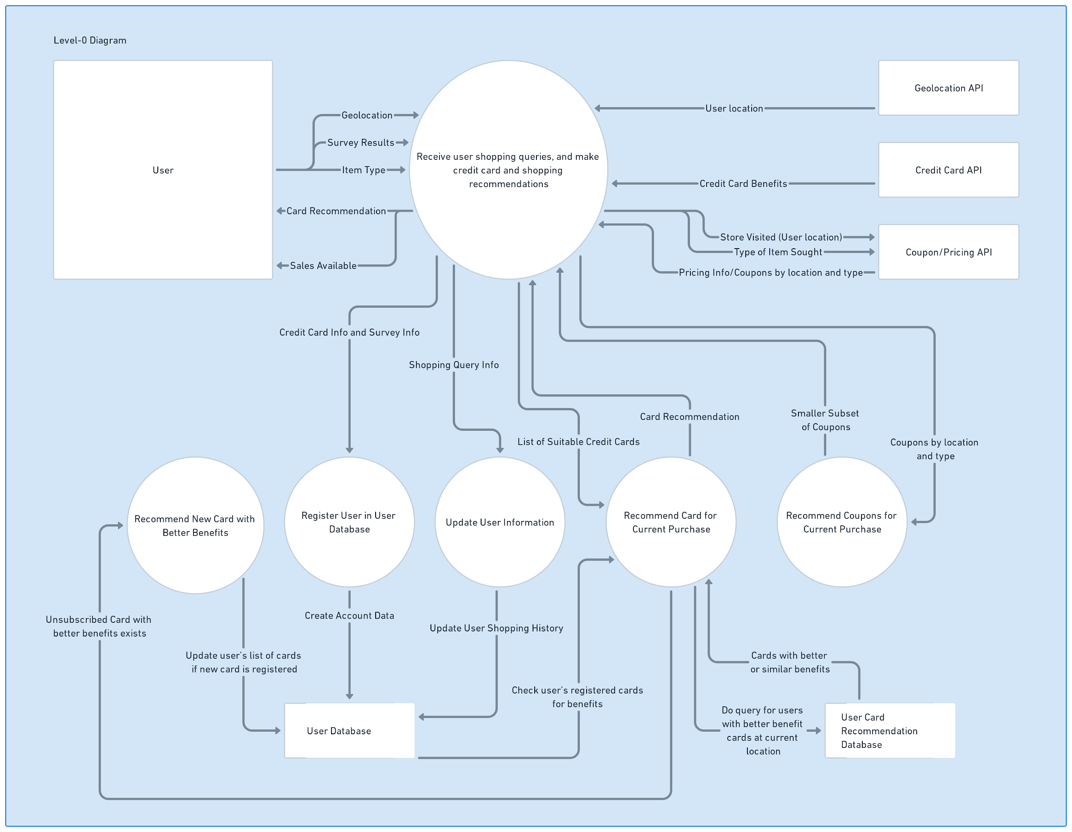

Figure 2: Level-0 Diagram for RewardReady

*Assumptions and Risks*

In creating our application, we make a number of assumptions:

* The user has access to the internet to use our application and that they will have internet access at the time of purchase.
* If the user is using the geolocation feature, it is assumed that they are visiting a physical store with a smart device
* Users possess some form of credit card or loyalty card in order to take advantage of the functionality of the app.
* Users are able to apply and be chosen for the various cards.
* Information gathered from public APIs is accurate.

Our team also takes on the following risks:

* Coupons and sales delivered to users may have previously been valid, but are now out of date

**Team Dynamic**

*What skills do your team members bring to this project?*

*What skills are missing and you'll need to learn to deliver the system?*

*How are you planning to obtain such missing skills?*

Our project team consists of software developers with varied specializations ranging from front-end, back-end, and full-stack developers and data scientists.

Jackson, the Project Manager, is skilled not only in agile methodologies and software project management but also has ample Machine Learning and Software Engineering experience. He’s good development experience in Java, Python, JavaScript, and PostgreSQL languages. Further, to fulfill his role well, he also seeks to further sharpen his project management skills by researching the academia and contacting experienced project managers.

Almost all the members have beginner to advanced level front-end experience. Diego, the Front-End Tech Lead, is a seasoned developer and has extensive experience coding in React, Vue, Next.js, Bootstrap, and Tailwind frameworks. Besides, he has experience in developing Python apps in Django and Flask, and starter experience in UX/UI design. For the quality delivery of the proposed system, he intends to hone his UX/UI design skills and also dive deep into Bootstrap and other frameworks.

Jacob, and Anurag, too, have significant front-end experience. Both are skilled in software development using React, Vue, JS, Html, CSS, Python, and Java. Additionally, Jacob has experience in using databases, agile methodologies, and project management, while Anurag has experience in Machine Learning. However, both have a few missing skills required for the execution of the project. Jacob, the Backend Tech Lead, has identified backend frameworks as his bottleneck. He will be relying on additional classes that he is taking in school and online tutorials to fill in the missing information. While Anurag, working as a Designer, has identified insufficient knowledge of UML diagrams and no experience with the production and deployment of software as his missing skills. This void is intended to be filled by referring to various sources such as online documentation, tutorials, past coursework, and consultation with working software professionals.

Ayush and Rohit, have beginner-level front-end experience, but have strong Machine Learning experience. Additionally, Rohit is a seasoned backend developer. Both have rich theoretical as well as practical data science knowledge and are skilled in all the state-of-the-art technologies used in Machine Learning such as CNNs, LSTM, and Transformers. In addition, Ayush has experience in creating dashboards and demos using the Streamlit library. Likewise, Rohit, the Technical Cloud Lead, has skills as a backend developer in the usage of several popular libraries from Java, Kotlin, and Python. Moreover, he is equally versed in database management using both SQL and NoSQL.

So, in a nutshell, the team as a whole has diversified and relevant skills to ensure quality delivery of the system/app proposed by us. There are a few missing skills with each team member which have been planned to be filled through individual strategies for each member. Also, as working in a team involves cooperation, there is also a plan to support the skill advancement of all team members by building on the comparative skill level of each member to mentor, guide, and instruct others requiring skill acquisition or upgradation.