JOHN CLIENT B. IGOT BSIS IV-1 10/15/24

ACT 6

1. Prepare the optimal layout for stakeholders.

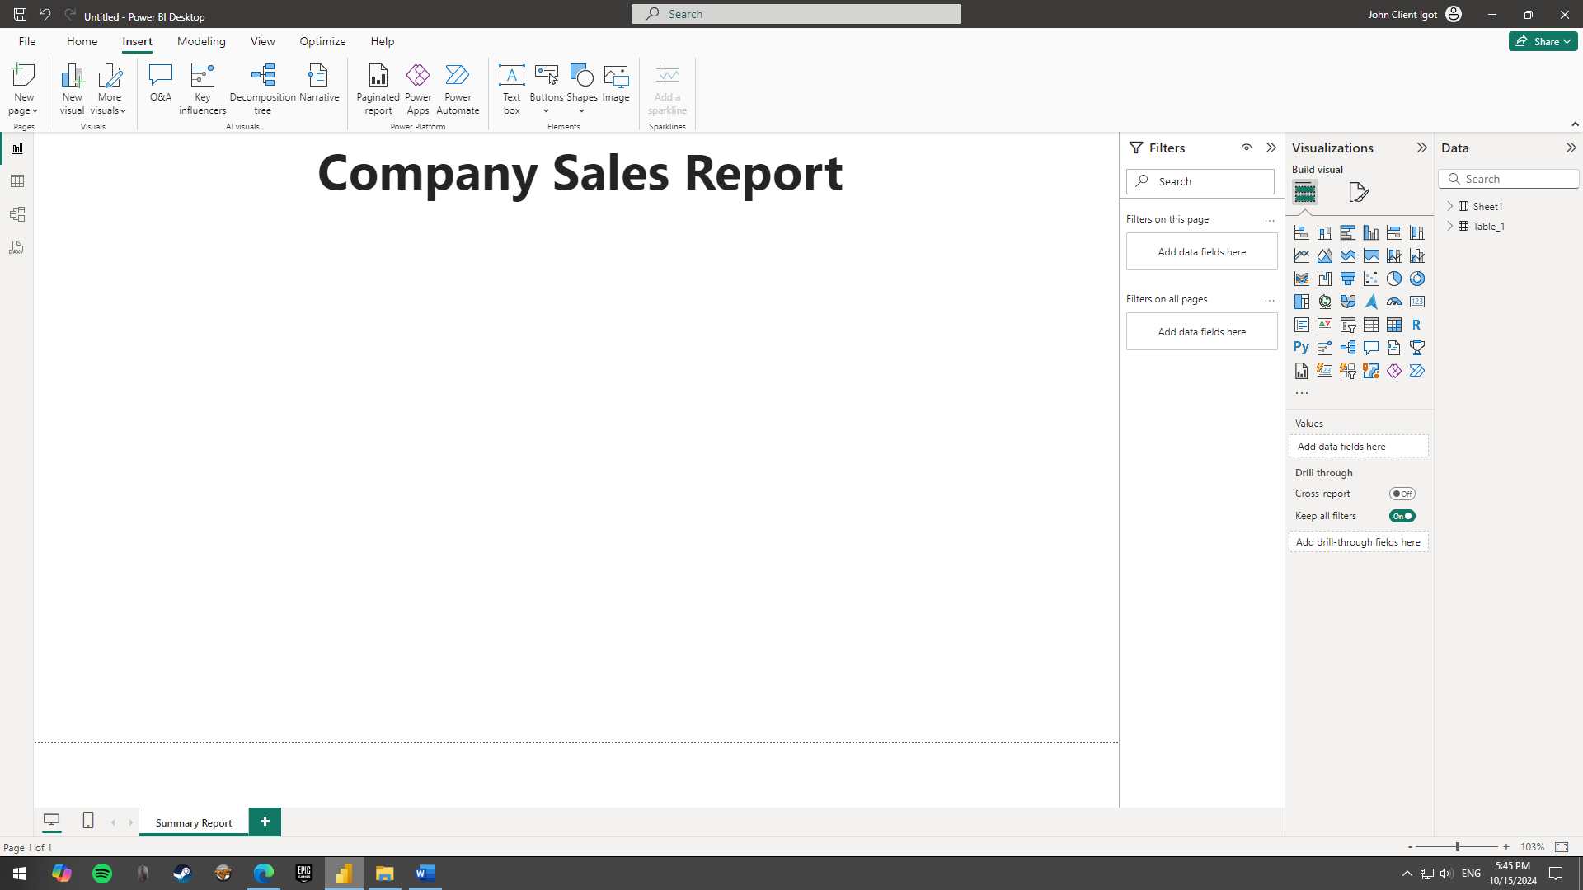

1. Illustrate results by building intuitive charts.

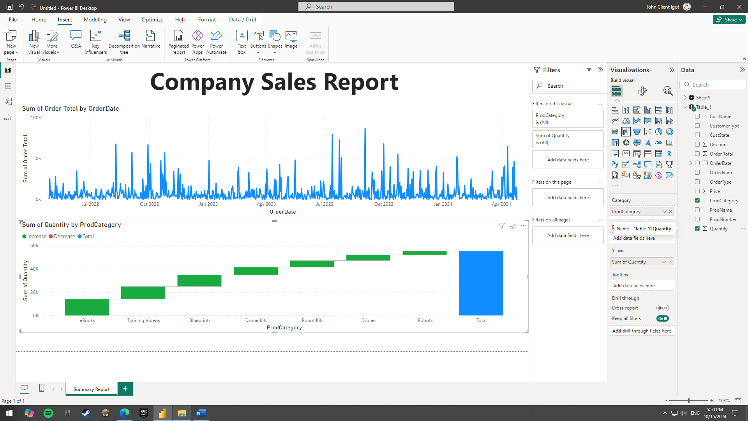

1. Do even more by configuring charts

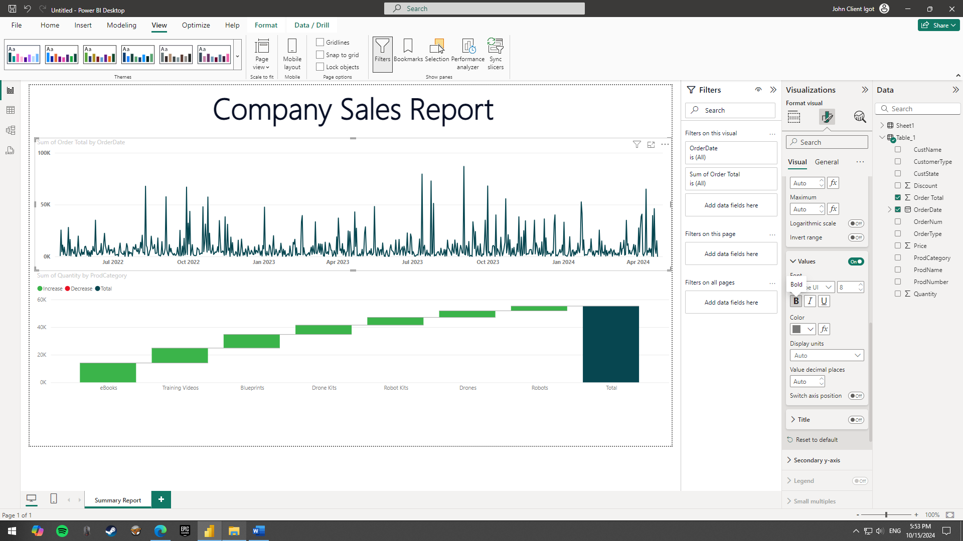

1. Drill down on results using slicers

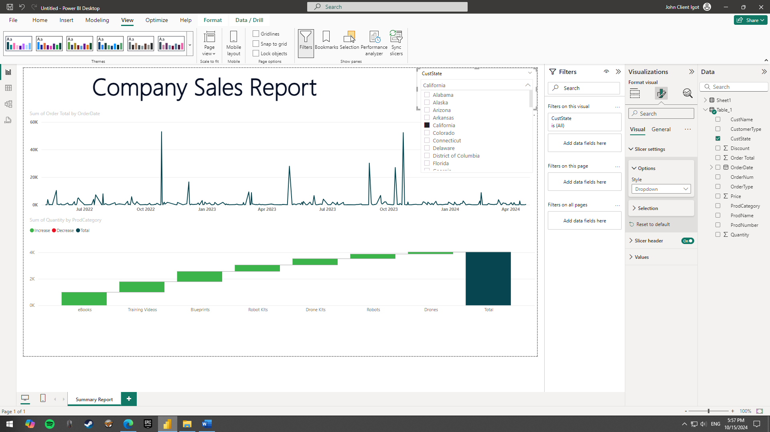

1. Collaborate by creating a shareable dashboard

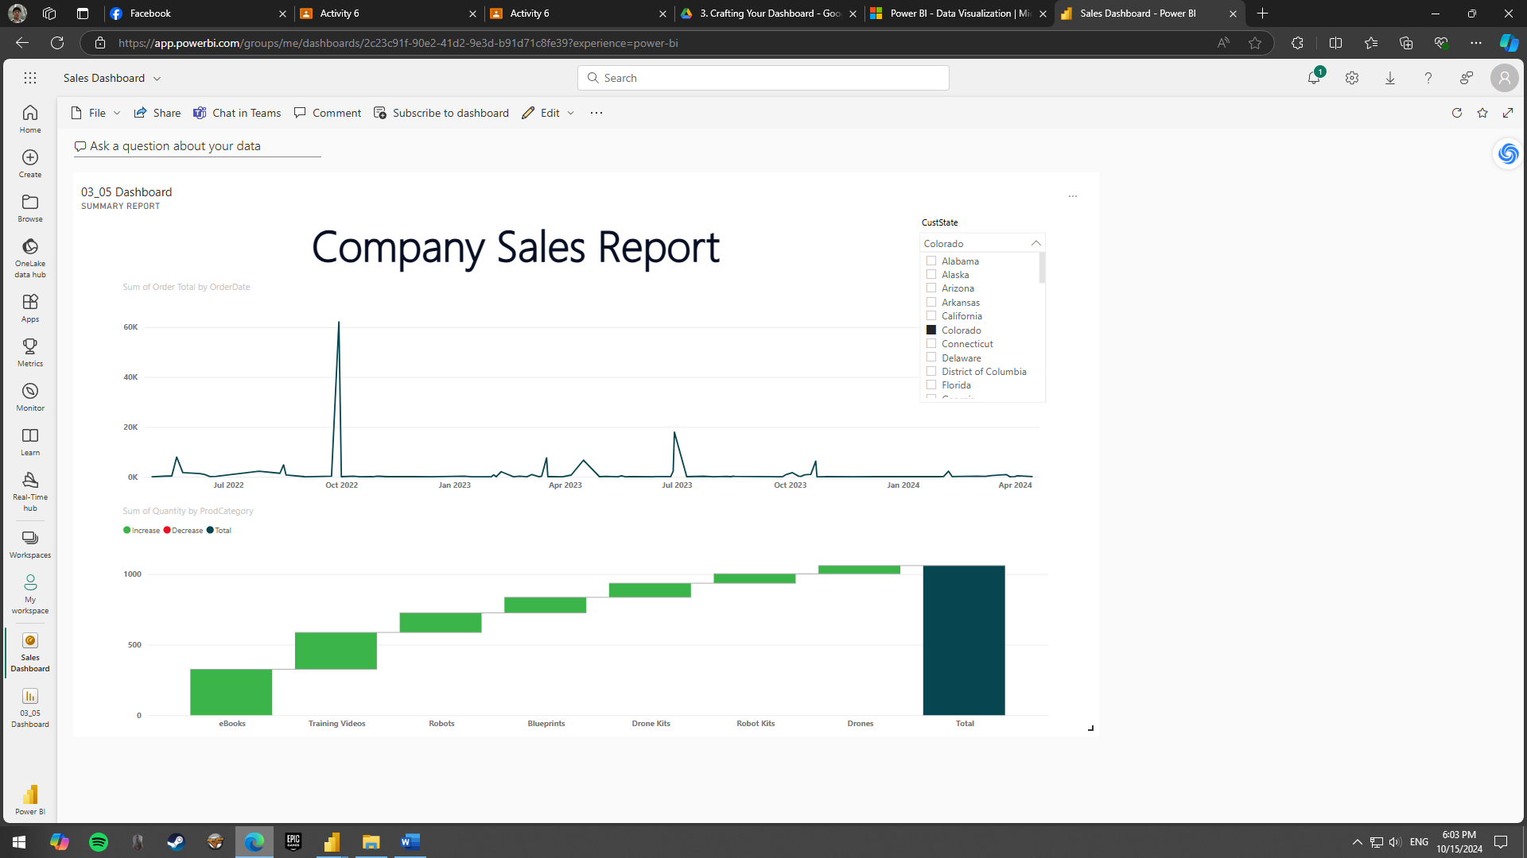

1. Wow stakeholders by enhancing your dashboard

