<https://www.unimrcp.org>

<https://www.unimrcp.org/gdf>

<https://www.unimrcp.org/gdf>

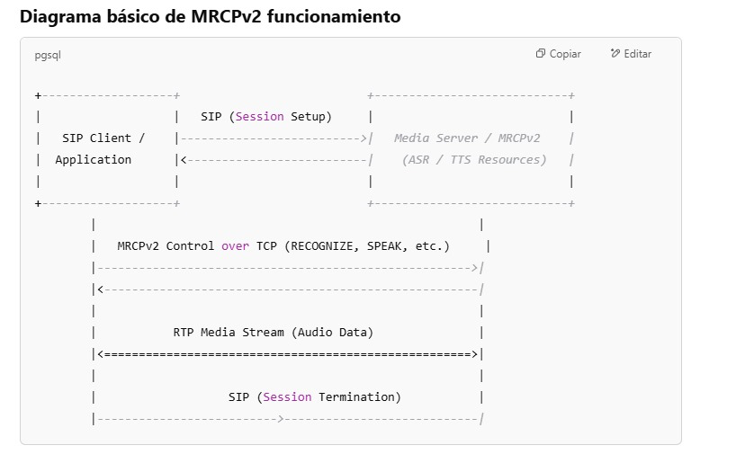

RFC 6787

<https://datatracker.ietf.org/doc/rfc6787/>

<https://github.com/unispeech/unimrcp>

