# Chapter Two Stream-breeding salamander occupancy across the Mid-Atlantic region of the United States

## FIGURES

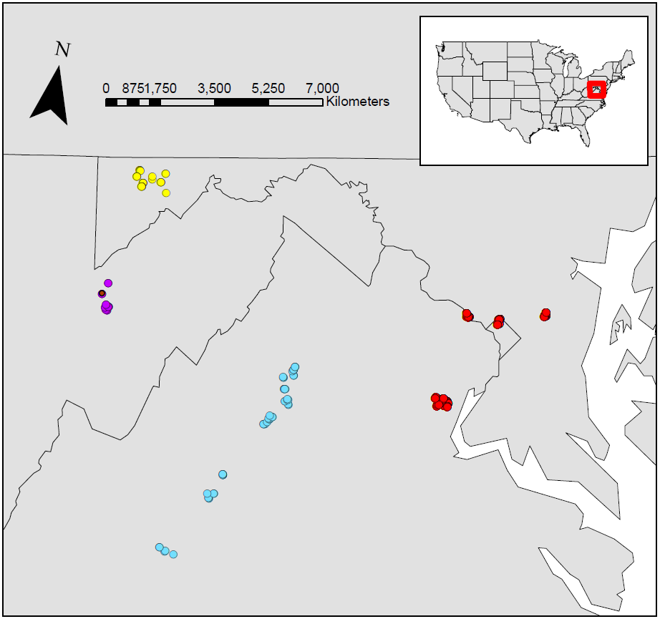

Figure 12. A map of the transects sampled in the Mid-Atlantic region of the United States. Data was gathered from four regions: western Maryland (yellow), Canaan Valley National Wildlife Refuge (purple), Shenandoah National Park (blue), and the National Capital Region (red).

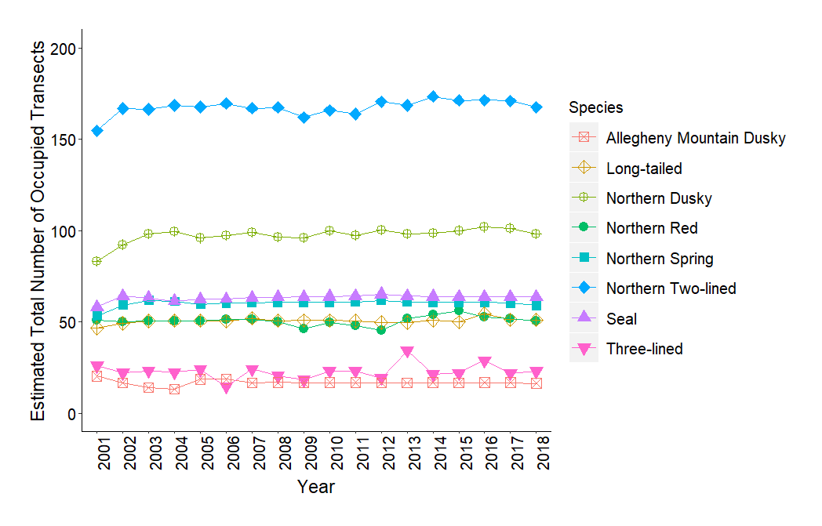

Figure 13. The estimated total number of occupied transects for each species across all of the sampling years.

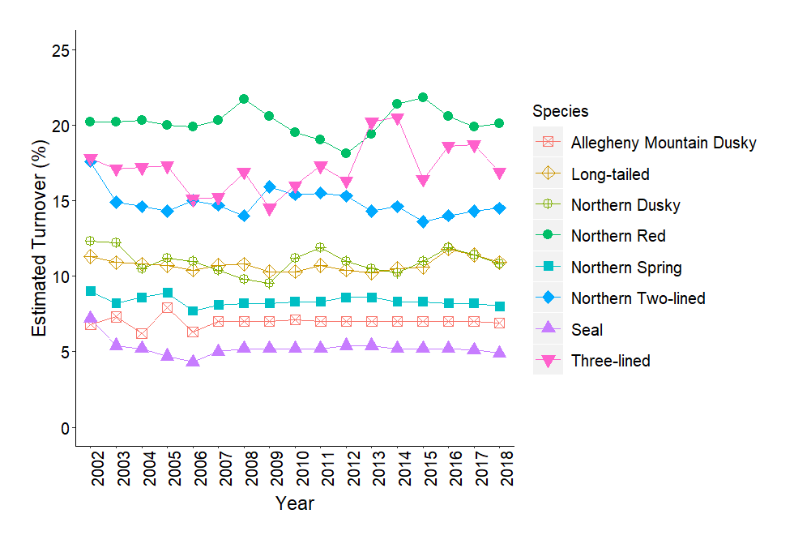

Figure 14. The estimated percent turnover (a site's occupancy state changing from occupied to unoccupied or vice versa) for each species across all of the sampling years following the first year.

(A)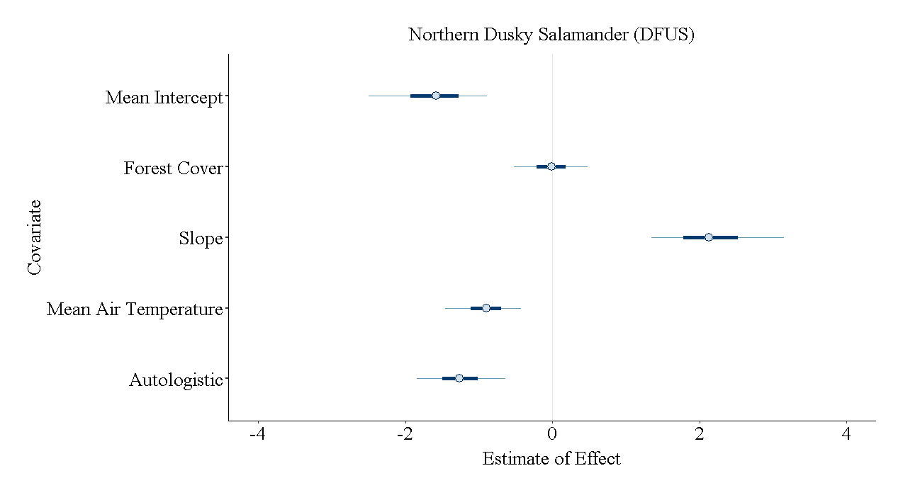(B)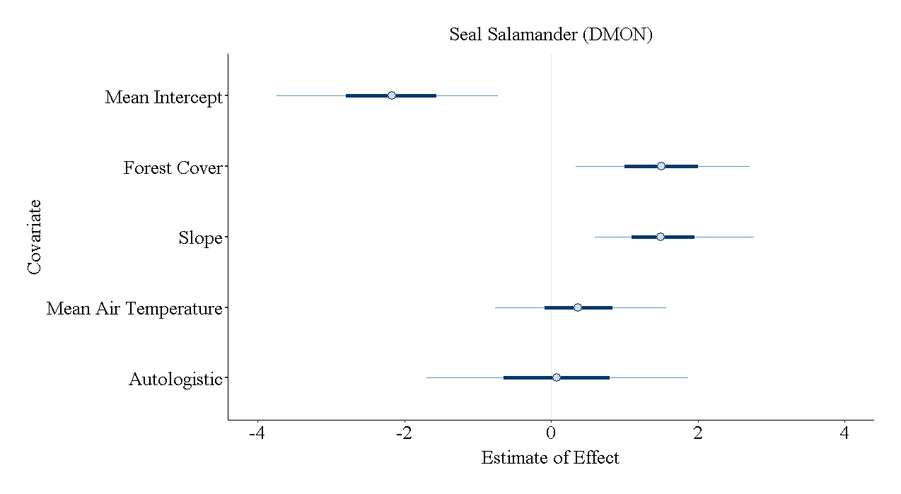

(C)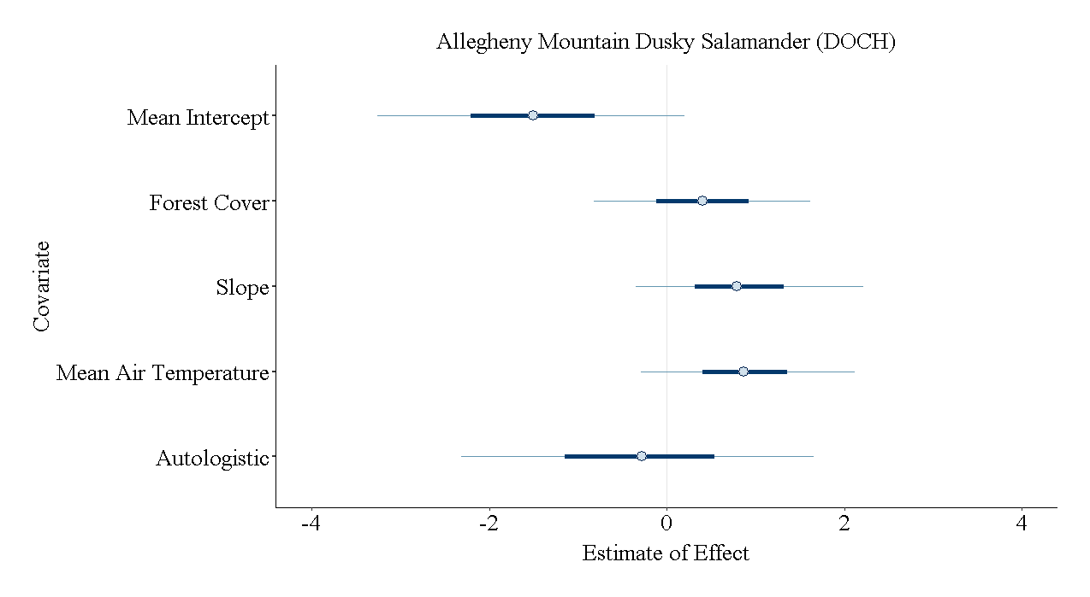(D)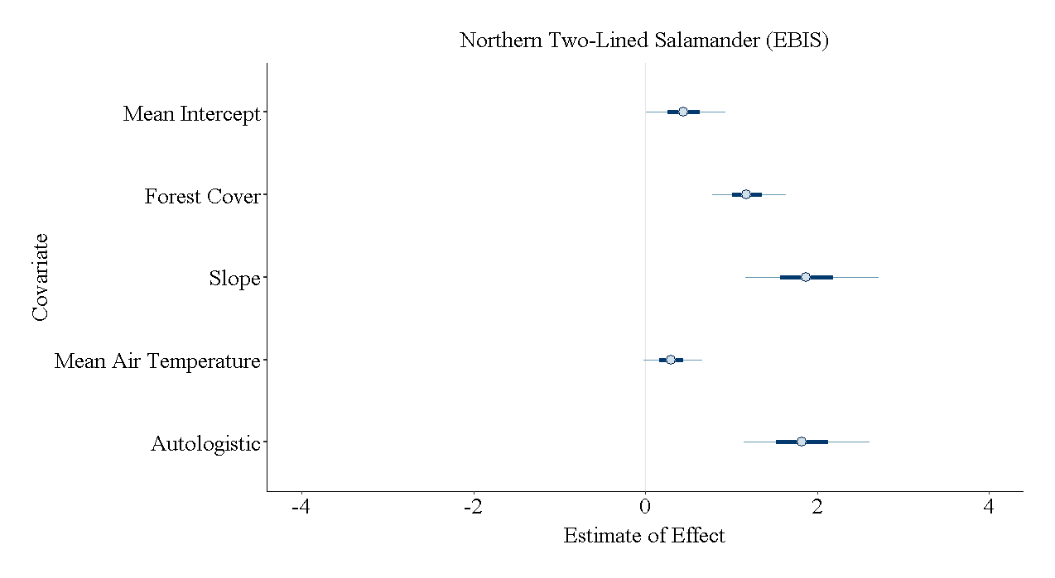

(E)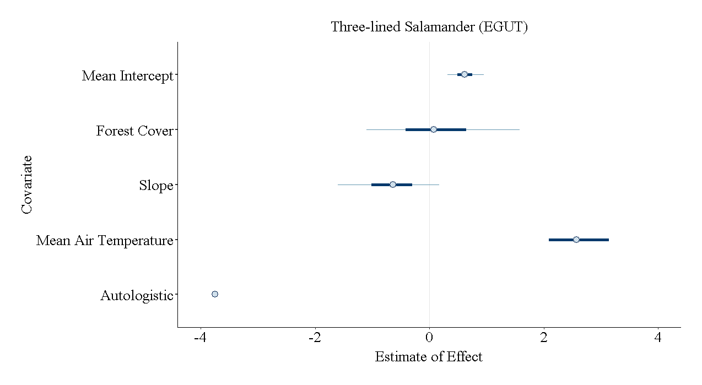(F)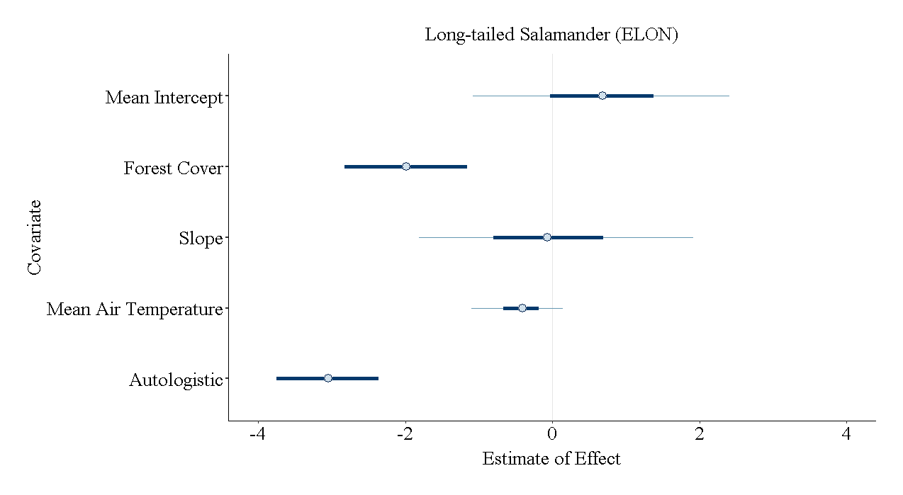

(G)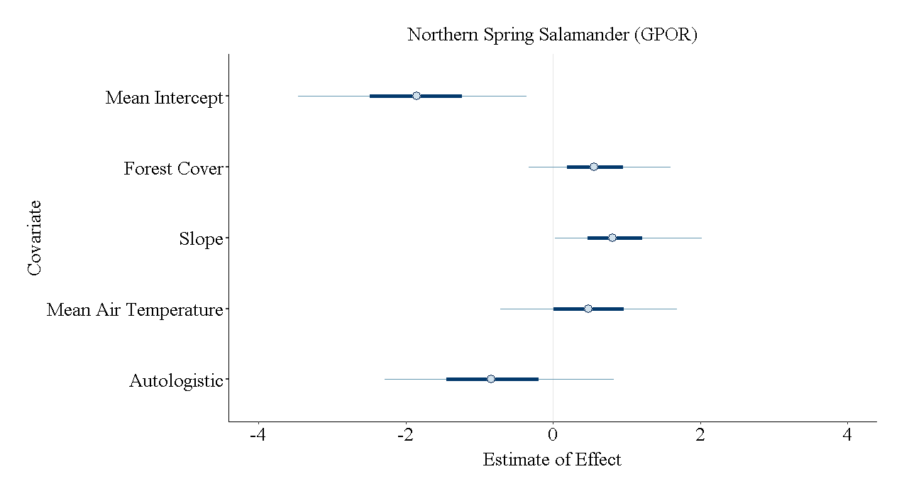(H)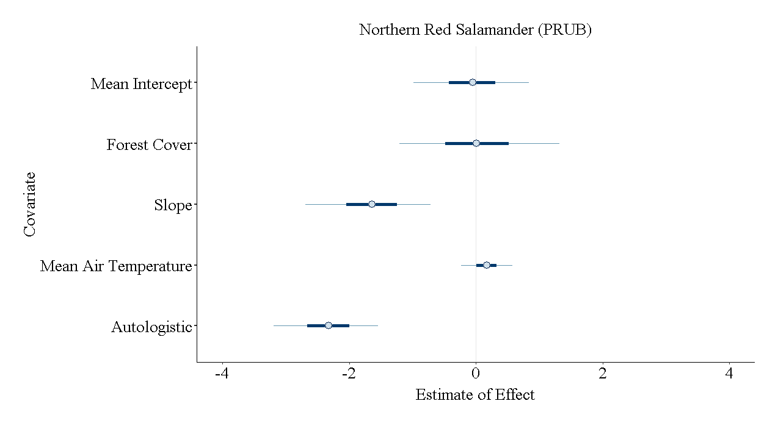

Figure 15. The estimated effects of the model covariates on the occupancy of each species with credible intervals.Refer to Appendix A to see the posterior probability density functions for these covariates. (A) northern dusky salamander, *Desmognathus fuscus; (B)* Allegheny Mountain dusky salamander, *Desmognathus ochrophaeus*; (C) seal salamander, *Desmognathus monticola; (D)* northern two-lined salamander, *Eurycea bislineata*; (E) three-lined salamander, *Eurycea guttoline*ata; (F) long-tailed salamander, *Eurycea longicauda; (G)*  northern spring salamander, *Gyrinphilus porphyriticus; and (H)* northern red salamander, *Pseudotriton ruber ruber*

(A)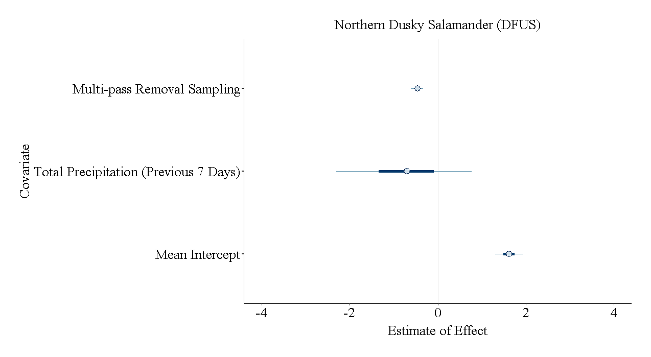(B)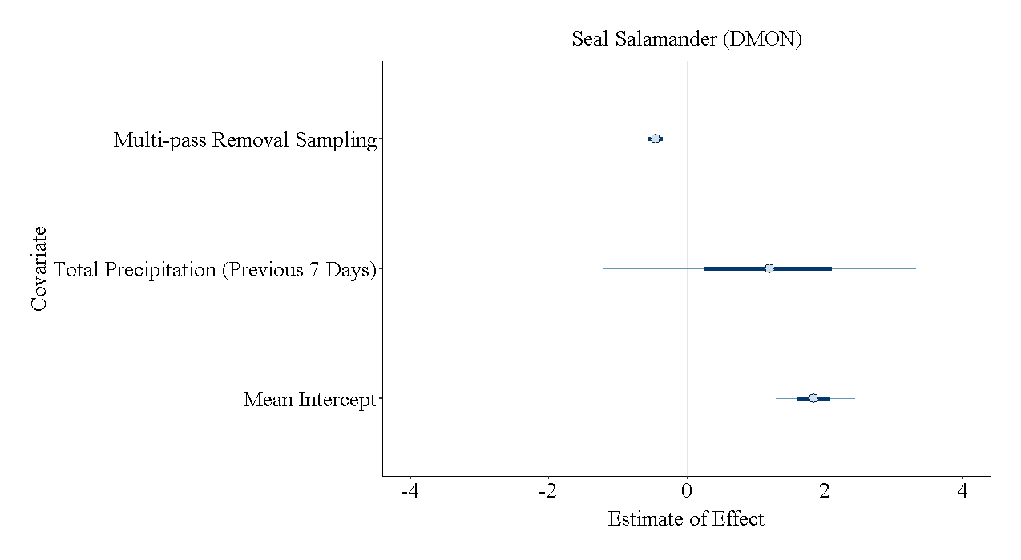

(C)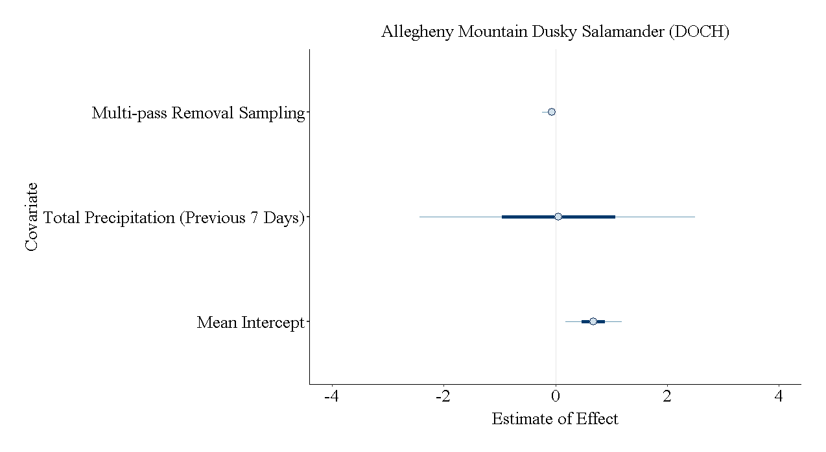(D)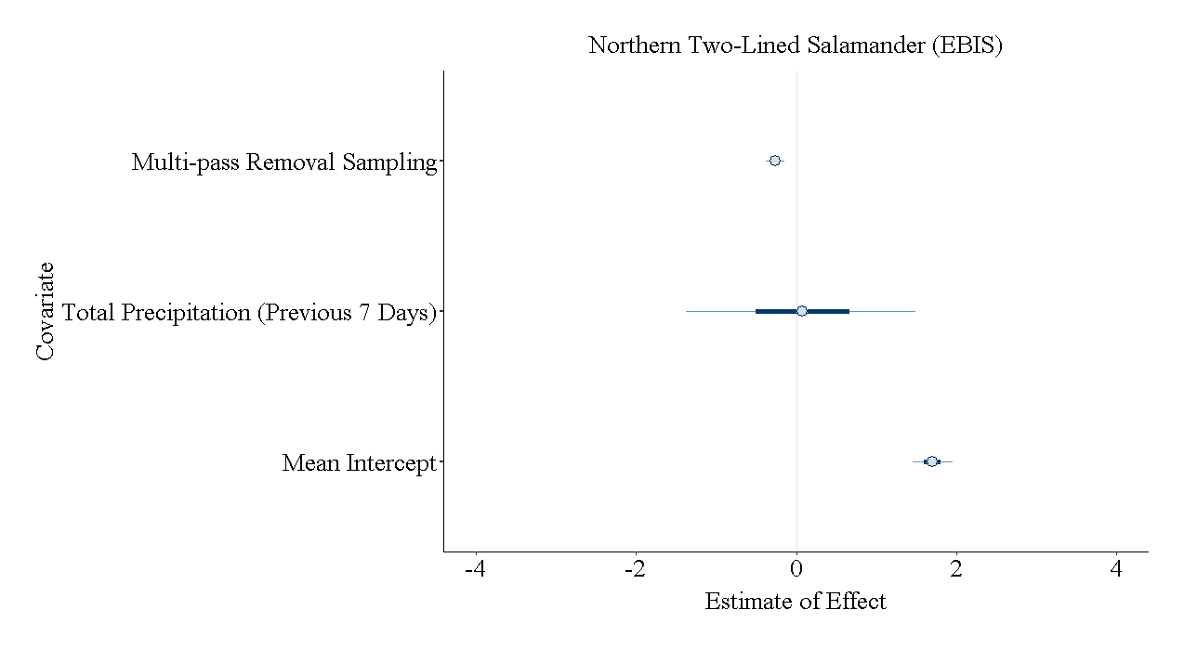

(E)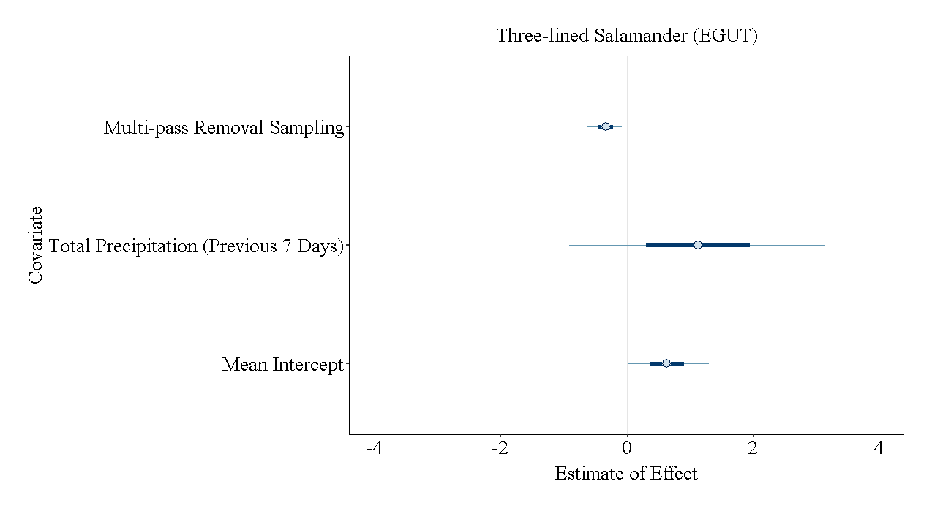(F)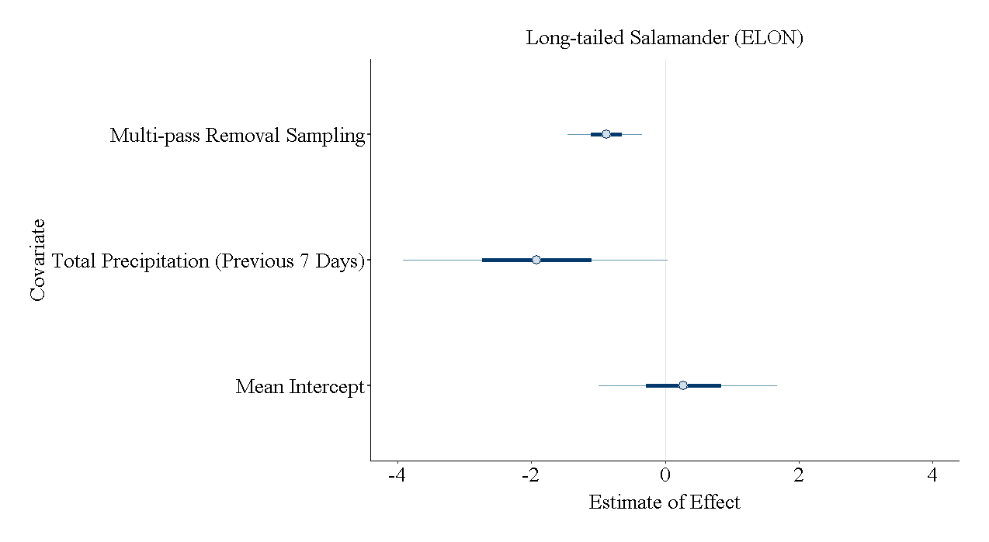

(G)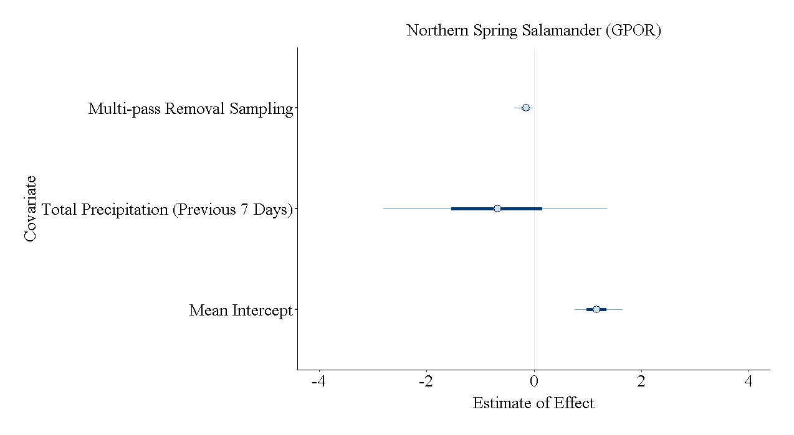(H)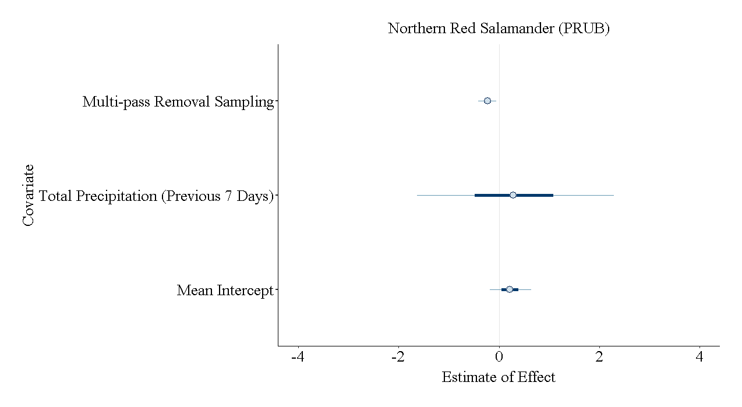

Figure 16. The estimated effects of the model covariates on detection of each species with credible intervals. Refer to Appendix A to see the posterior probability density functions for these covariates. (A) northern dusky salamander, *Desmognathus fuscus; (B)* Allegheny Mountain dusky salamander, *Desmognathus ochrophaeus*; (C) seal salamander, *Desmognathus monticola; (D)* northern two-lined salamander, *Eurycea bislineata*; (E) three-lined salamander, *Eurycea guttoline*ata; (F) long-tailed salamander, *Eurycea longicauda; (G)*  northern spring salamander, *Gyrinphilus porphyriticus; and (H)* northern red salamander, *Pseudotriton ruber ruber*

## TABLES

Table 9. A summary of the number of sampling years, transect, and salamanders observed for each region (not accounting for imperfect detection).

|  |  |  |  |  |  |
| --- | --- | --- | --- | --- | --- |
| Region | Sampling Years | Total Number of Transects | Total Number of Salamanders Observed | Mean Number of Salamanders Observed per Transect-Visit | Standard Deviation of Salamanders Observed per Transect-Visit |
| Western Maryland | 2018 | 35 | 86 | 2.46 | 3.02 |
| Shenandoah National Park | 2012 | 54 | 540 | 10.00 | 3.06 |
| National Capitals Region | 2005-2017 | 120 | 1905 | 2.72 | 1.69 |
| Canaan Valley National Wildlife Refuge | 2001-2006 | 9 | 173 | 3.60 | 1.70 |
|  | Overall Total | | 2704 | 3.23 | 2.59 |

Table 10. Estimates of probability of occupancy and detection probability (A) and the effects of the environmental covariates (B) for each of the species. (values shown in bold if the credible interval did not overlap zero; refer to Figure 2 in Appendix A to see credible intervals)

(A)

|  |  |  |  |  |  |
| --- | --- | --- | --- | --- | --- |
|  | Occupancy probability ( $ψ)$ | | | Detection probability (*p*) | |
| Species | Mean | St. Dev. | Mean | | St. Dev. |
| northern dusky | 4.4683 | 0.0151 | 0.7717 | | 0.0225 |
| seal | 0.5340 | 0.0373 | 0.8069 | | 0.0373 |
| Allegheny Mountain dusky | 0.4682 | 0.1413 | 0.6434 | | 0.0657 |
| northern two-lined | 0.7675 | 0.0150 | 0.8127 | | 0.0154 |
| three-lined | 0.1050 | 0.0230 | 0.5840 | | 0.0650 |
| long-tailed | 0.2320 | 0.1060 | 0.4030 | | 0.1350 |
| northern red | 0.2320 | 0.0410 | 0.5060 | | 0.0440 |
| northern spring | 0.4486 | 0.0956 | 0.7377 | | 0.0408 |

(B)

|  |  |  |  |  |  |  |
| --- | --- | --- | --- | --- | --- | --- |
|  | Forest cover | | Slope | | Mean air temperature | |
| Species | Mean | St. Dev. | Mean | St. Dev. | Mean | St. Dev. |
| northern dusky | -0.913 | 0.318 | **2.175** | **0.552** | **-0.014** | **0.303** |
| seal | **0.379** | **0.712** | **1.562** | **0.661** | 1.507 | 0.723 |
| Allegheny Mountain dusky | 0.886 | 0.736 | 0.842 | 0.779 | 0.403 | 0.753 |
| northern two-lined | **0.307** | **0.210** | **1.893** | **0.474** | 1.190 | 0.262 |
| three-lined | 2.651 | 0.749 | -0.667 | 0.543 | **0.138** | **0.815** |
| long-tailed | **-0.436** | **0.382** | -0.027 | 1.142 | -1.998 | 1.238 |
| northern red | 0.171 | 0.245 | **-1.660** | **0.605** | 0.027 | 0.770 |
| northern spring | 0.485 | 0.734 | **0.885** | **0.616** | 0.589 | 0.601 |

Table 11. The results of the dynamic occupancy model for the northern dusky salamander (*Desmognathus fuscus*) where mean $ψ$ is the mean occupancy state, mean *p* is the mean detection probability, $α_{0}$ is the estimated intercept of detection, is the effect of the total precipitation of the previous seven days on detection, is the effect of multi-pass removal sampling on detection, mean is the mean estimated intercept of occupancy, sd is the standard deviation of the estimated intercept of occupancy, – are the environmental covariates ( = forest cover, = slope, = mean air temperature), is the autologistic effect , *Z* sum[1-18] is the estimated total number of transects occupied in [year], turnover[2-18] is the estimated turnover of sites from occupied to unoccupied or vice versa in [year], and deviance is the total amount of deviance in the model.

|  | Mean | St. Dev. | 2.5% | 50% | 97.5% | Rhat | n.eff |
| --- | --- | --- | --- | --- | --- | --- | --- |
| mean ψ | 0.447 | 0.015 | 0.417 | 0.447 | 0.476 | 1 | 6652 |
| mean *p* | 0.772 | 0.022 | 0.726 | 0.772 | 0.814 | 1 | 9797 |
| $$α_{0}$$ | 1.616 | 0.193 | 1.243 | 1.614 | 1.998 | 1 | 9489 |
| $$α_{1}$$ | -0.728 | 0.937 | -2.627 | -0.706 | 1.044 | 1 | 18832 |
| $$α_{2}$$ | -0.465 | 0.085 | -0.634 | -0.465 | -0.299 | 1 | 10028 |
| mean $β_{0}$ | -1.253 | 0.365 | -1.947 | -1.261 | -0.503 | 1 | 3948 |
| sd $β_{0}$ | 0.163 | 0.072 | 0.069 | 0.149 | 0.335 | 1 | 1380 |
| $$β_{1}$$ | -0.913 | 0.318 | -1.582 | -0.895 | -0.345 | 1 | 2303 |
| $$β_{2}$$ | 2.175 | 0.552 | 1.208 | 2.131 | 3.378 | 1 | 1526 |
| $$β_{3}$$ | -0.014 | 0.303 | -0.625 | -0.011 | 0.581 | 1 | 3930 |
| $$β_{4}$$ | -1.62 | 0.494 | -2.689 | -1.58 | -0.763 | 1 | 3256 |
| *Z* sum[1] | 83.202 | 8.065 | 66 | 84 | 98 | 1 | 2223 |
| *Z* sum[2] | 92.248 | 5.711 | 80 | 92 | 103 | 1 | 4547 |
| *Z* sum[3] | 98.175 | 5.059 | 88 | 98 | 108 | 1 | 7641 |
| *Z* sum[4] | 99.412 | 4.979 | 90 | 99 | 109 | 1 | 9090 |
| *Z* sum[5] | 95.783 | 4.666 | 87 | 96 | 105 | 1 | 10785 |
| *Z* sum[6] | 97.206 | 4.122 | 89 | 97 | 105 | 1 | 9843 |
| *Z* sum[7] | 98.911 | 4.642 | 90 | 99 | 108 | 1 | 11308 |
| *Z* sum[8] | 96.374 | 4.616 | 87 | 96 | 105 | 1 | 10285 |
| *Z* sum[9] | 96.032 | 4.651 | 87 | 96 | 105 | 1 | 10603 |
| *Z* sum[10] | 99.806 | 4.866 | 90 | 100 | 109 | 1 | 11104 |
| *Z* sum[11] | 97.446 | 4.848 | 88 | 97 | 107 | 1 | 11214 |
| *Z* sum[12] | 100.296 | 4.103 | 93 | 100 | 108.075 | 1 | 11458 |
| *Z* sum[13] | 98.107 | 4.474 | 89 | 98 | 107 | 1 | 11335 |
| *Z* sum[14] | 98.623 | 4.505 | 90 | 99 | 107 | 1 | 11376 |
| *Z* sum[15] | 99.997 | 4.778 | 91 | 100 | 109 | 1 | 11866 |
| *Z* sum[16] | 101.763 | 4.597 | 93 | 102 | 111 | 1 | 10800 |
| *Z* sum[17] | 101.303 | 4.778 | 92 | 101 | 111 | 1 | 12389 |
| *Z* sum[18] | 98.095 | 4.556 | 89 | 98 | 107 | 1 | 13362 |
| turnover[2] | 0.123 | 0.026 | 0.073 | 0.124 | 0.174 | 1 | 7884 |
| turnover[3] | 0.122 | 0.025 | 0.073 | 0.119 | 0.174 | 1 | 8540 |
| turnover[4] | 0.105 | 0.026 | 0.06 | 0.106 | 0.161 | 1 | 7733 |
| turnover[5] | 0.112 | 0.026 | 0.064 | 0.11 | 0.165 | 1 | 8114 |
| turnover[6] | 0.11 | 0.024 | 0.064 | 0.11 | 0.161 | 1 | 7762 |
| turnover[7] | 0.104 | 0.024 | 0.06 | 0.101 | 0.156 | 1 | 8402 |
| turnover[8] | 0.098 | 0.024 | 0.055 | 0.096 | 0.147 | 1 | 8312 |
| turnover[9] | 0.095 | 0.024 | 0.05 | 0.092 | 0.142 | 1 | 8447 |
| turnover[10] | 0.112 | 0.025 | 0.064 | 0.11 | 0.165 | 1 | 8057 |
| turnover[11] | 0.119 | 0.026 | 0.069 | 0.119 | 0.174 | 1 | 7556 |
| turnover[12] | 0.11 | 0.025 | 0.064 | 0.11 | 0.161 | 1 | 8129 |
| turnover[13] | 0.105 | 0.024 | 0.06 | 0.106 | 0.156 | 1 | 8266 |
| turnover[14] | 0.102 | 0.023 | 0.06 | 0.101 | 0.151 | 1 | 8150 |
| turnover[15] | 0.11 | 0.024 | 0.069 | 0.11 | 0.161 | 1 | 8022 |
| turnover[16] | 0.119 | 0.024 | 0.073 | 0.119 | 0.17 | 1 | 7999 |
| turnover[17] | 0.114 | 0.025 | 0.069 | 0.115 | 0.165 | 1 | 8092 |
| turnover[18] | 0.108 | 0.026 | 0.06 | 0.106 | 0.165 | 1 | 8093 |
| deviance | 1203.275 | 30.417 | 1147.507 | 1201.908 | 1266.41 | 1 | 11026 |

Table 12. The results of the dynamic occupancy model for the seal salamander (*Desmognathus monticola*) where mean $ψ$ is the mean occupancy state, mean *p* is the mean detection probability, $α_{0}$ is the estimated intercept of detection, is the effect of the total precipitation of the previous seven days on detection, is the effect of multi-pass removal sampling on detection, mean is the mean estimated intercept of occupancy, sd is the standard deviation of the estimated intercept of occupancy, – are the environmental covariates ( = forest cover, = slope, = mean air temperature), is the autologistic effect , *Z* sum[1-18] is the estimated total number of transects occupied in [year], turnover[2-18] is the estimated turnover of sites from occupied to unoccupied or vice versa in [year], and deviance is the total amount of deviance in the model.

|  | Mean | St. Dev. | 2.5% | 50% | 97.5% | Rhat | n.eff |
| --- | --- | --- | --- | --- | --- | --- | --- |
| mean ψ | 0.534 | 0.107 | 0.329 | 0.539 | 0.733 | 1 | 469 |
| mean *p* | 0.807 | 0.037 | 0.728 | 0.809 | 0.875 | 1 | 7122 |
| $$α_{0}$$ | 1.85 | 0.347 | 1.192 | 1.843 | 2.562 | 1 | 11401 |
| $$α_{1}$$ | 1.15 | 1.37 | -1.652 | 1.201 | 3.697 | 1 | 16607 |
| $$α_{2}$$ | -0.446 | 0.148 | -0.74 | -0.444 | -0.163 | 1 | 13959 |
| mean $β_{0}$ | 0.081 | 1.079 | -2.018 | 0.08 | 2.254 | 1 | 443 |
| sd $β_{0}$ | 2.037 | 3.118 | 0.148 | 1.005 | 12.575 | 1.05 | 303 |
| $$β_{1}$$ | 0.379 | 0.712 | -0.988 | 0.362 | 1.82 | 1 | 5006 |
| $$β_{2}$$ | 1.562 | 0.661 | 0.456 | 1.497 | 3.056 | 1.01 | 2402 |
| $$β_{3}$$ | 1.507 | 0.723 | 0.116 | 1.502 | 2.948 | 1 | 588 |
| $$β_{4}$$ | -2.186 | 0.927 | -4.058 | -2.17 | -0.423 | 1 | 3146 |
| *Z* sum[1] | 58.14 | 5.177 | 46 | 59 | 67 | 1 | 1214 |
| *Z* sum[2] | 64.147 | 3.773 | 56 | 64 | 71 | 1 | 1549 |
| *Z* sum[3] | 63.029 | 3.632 | 55 | 63 | 70 | 1 | 1983 |
| *Z* sum[4] | 61.373 | 3.654 | 54 | 62 | 68 | 1 | 2079 |
| *Z* sum[5] | 62.296 | 3.613 | 55 | 63 | 69 | 1 | 2091 |
| *Z* sum[6] | 62.377 | 3.593 | 55 | 63 | 69 | 1 | 2040 |
| *Z* sum[7] | 63.231 | 3.835 | 55 | 63 | 70 | 1 | 2422 |
| *Z* sum[8] | 63.477 | 3.882 | 55 | 64 | 71 | 1 | 2901 |
| *Z* sum[9] | 63.599 | 3.934 | 55 | 64 | 71 | 1 | 2623 |
| *Z* sum[10] | 63.725 | 3.954 | 55 | 64 | 71 | 1 | 2909 |
| *Z* sum[11] | 64.011 | 3.915 | 56 | 64 | 71 | 1 | 2839 |
| *Z* sum[12] | 65.015 | 3.241 | 59 | 65 | 71 | 1 | 2579 |
| *Z* sum[13] | 64.021 | 3.894 | 56 | 64 | 71 | 1 | 3189 |
| *Z* sum[14] | 63.753 | 3.951 | 56 | 64 | 71 | 1 | 3180 |
| *Z* sum[15] | 63.672 | 3.928 | 55 | 64 | 71 | 1 | 2589 |
| *Z* sum[16] | 63.663 | 3.872 | 56 | 64 | 71 | 1 | 2402 |
| *Z* sum[17] | 63.6 | 3.807 | 55 | 64 | 71 | 1 | 2522 |
| *Z* sum[18] | 63.575 | 3.194 | 57 | 64 | 69 | 1 | 2000 |
| turnover[2] | 0.072 | 0.021 | 0.037 | 0.069 | 0.119 | 1 | 3404 |
| turnover[3] | 0.054 | 0.021 | 0.023 | 0.05 | 0.101 | 1 | 3763 |
| turnover[4] | 0.052 | 0.021 | 0.018 | 0.05 | 0.096 | 1 | 3378 |
| turnover[5] | 0.047 | 0.021 | 0.014 | 0.046 | 0.096 | 1 | 3883 |
| turnover[6] | 0.043 | 0.021 | 0.009 | 0.041 | 0.087 | 1 | 4014 |
| turnover[7] | 0.05 | 0.022 | 0.014 | 0.046 | 0.101 | 1 | 4282 |
| turnover[8] | 0.052 | 0.023 | 0.014 | 0.05 | 0.101 | 1 | 4236 |
| turnover[9] | 0.052 | 0.023 | 0.014 | 0.05 | 0.101 | 1 | 4112 |
| turnover[10] | 0.052 | 0.023 | 0.014 | 0.05 | 0.101 | 1 | 4150 |
| turnover[11] | 0.052 | 0.023 | 0.014 | 0.05 | 0.101 | 1 | 4176 |
| turnover[12] | 0.054 | 0.023 | 0.014 | 0.05 | 0.106 | 1 | 3606 |
| turnover[13] | 0.054 | 0.023 | 0.014 | 0.05 | 0.106 | 1 | 3723 |
| turnover[14] | 0.052 | 0.023 | 0.014 | 0.05 | 0.101 | 1 | 4031 |
| turnover[15] | 0.052 | 0.023 | 0.014 | 0.05 | 0.101 | 1 | 4292 |
| turnover[16] | 0.052 | 0.022 | 0.014 | 0.05 | 0.101 | 1 | 3901 |
| turnover[17] | 0.051 | 0.023 | 0.014 | 0.05 | 0.101 | 1 | 4624 |
| turnover[18] | 0.049 | 0.021 | 0.014 | 0.046 | 0.096 | 1 | 4031 |
| deviance | 250.11 | 13.542 | 225.095 | 250.52 | 275.459 | 1 | 1475 |

Table 13. The results of the dynamic occupancy model for the Allegheny Mountain dusky salamander (*Desmognathus ochrophaeus*) where mean $ψ$ is the mean occupancy state, mean *p* is the mean detection probability, $α_{0}$ is the estimated intercept of detection, is the effect of the total precipitation of the previous seven days on detection, is the effect of multi-pass removal sampling on detection, mean is the mean estimated intercept of occupancy, sd is the standard deviation of the estimated intercept of occupancy, – are the environmental covariates ( = forest cover, = slope, = mean air temperature), is the autologistic effect , *Z* sum[1-18] is the estimated total number of transects occupied in [year], turnover[2-18] is the estimated turnover of sites from occupied to unoccupied or vice versa in [year], and deviance is the total amount of deviance in the model.

|  | Mean | St. Dev. | 2.5% | 50% | 97.5% | Rhat | n.eff |
| --- | --- | --- | --- | --- | --- | --- | --- |
| mean ψ | 0.468 | 0.141 | 0.212 | 0.465 | 0.739 | 1.01 | 380 |
| mean *p* | 0.643 | 0.066 | 0.507 | 0.646 | 0.763 | 1 | 11723 |
| $$α_{0}$$ | 0.678 | 0.308 | 0.083 | 0.673 | 1.292 | 1 | 11490 |
| $$α_{1}$$ | 0.045 | 1.501 | -2.959 | 0.056 | 2.949 | 1 | 19924 |
| $$α_{2}$$ | -0.086 | 0.078 | -0.292 | -0.064 | -0.002 | 1 | 19102 |
| mean $β_{0}$ | -0.306 | 1.22 | -2.718 | -0.282 | 2.021 | 1 | 362 |
| sd $β_{0}$ | 3.594 | 6.372 | 0.253 | 1.587 | 22.533 | 1.15 | 317 |
| $$β_{1}$$ | 0.885 | 0.734 | -0.515 | 0.866 | 2.383 | 1 | 5085 |
| $$β_{2}$$ | 0.842 | 0.779 | -0.563 | 0.793 | 2.526 | 1 | 2938 |
| $$β_{3}$$ | 0.403 | 0.753 | -1.069 | 0.406 | 1.86 | 1 | 447 |
| $$β_{4}$$ | -1.515 | 1.049 | -3.604 | -1.506 | 0.514 | 1 | 3120 |
| *Z* sum[1] | 20.212 | 3.743 | 14 | 20 | 28 | 1 | 4249 |
| *Z* sum[2] | 16.605 | 3.421 | 11 | 16 | 24 | 1 | 6511 |
| *Z* sum[3] | 14.046 | 3.788 | 7 | 14 | 22 | 1 | 5401 |
| *Z* sum[4] | 13.114 | 3.602 | 7 | 13 | 21 | 1 | 5976 |
| *Z* sum[5] | 18.505 | 3.358 | 12 | 18 | 26 | 1 | 5680 |
| *Z* sum[6] | 18.521 | 3.364 | 13 | 18 | 26 | 1 | 6293 |
| *Z* sum[7] | 16.595 | 3.808 | 10 | 16 | 25 | 1 | 7051 |
| *Z* sum[8] | 16.76 | 3.784 | 10 | 17 | 25 | 1 | 6747 |
| *Z* sum[9] | 16.685 | 3.773 | 10 | 17 | 24 | 1 | 6831 |
| *Z* sum[10] | 16.694 | 3.777 | 10 | 17 | 25 | 1 | 6565 |
| *Z* sum[11] | 16.688 | 3.783 | 10 | 17 | 25 | 1 | 6615 |
| *Z* sum[12] | 16.678 | 3.773 | 10 | 17 | 24 | 1 | 6789 |
| *Z* sum[13] | 16.681 | 3.769 | 10 | 17 | 24 | 1 | 6389 |
| *Z* sum[14] | 16.717 | 3.768 | 10 | 17 | 24 | 1 | 6965 |
| *Z* sum[15] | 16.658 | 3.753 | 10 | 16 | 24 | 1 | 6952 |
| *Z* sum[16] | 16.707 | 3.786 | 10 | 17 | 24 | 1 | 6997 |
| *Z* sum[17] | 16.688 | 3.84 | 10 | 17 | 25 | 1 | 6371 |
| *Z* sum[18] | 16.269 | 2.496 | 12 | 16 | 22 | 1 | 8972 |
| turnover[2] | 0.068 | 0.019 | 0.032 | 0.069 | 0.11 | 1 | 5461 |
| turnover[3] | 0.073 | 0.02 | 0.037 | 0.073 | 0.115 | 1 | 5020 |
| turnover[4] | 0.062 | 0.02 | 0.028 | 0.06 | 0.106 | 1 | 5357 |
| turnover[5] | 0.079 | 0.019 | 0.046 | 0.078 | 0.119 | 1 | 5659 |
| turnover[6] | 0.063 | 0.019 | 0.028 | 0.06 | 0.101 | 1 | 5297 |
| turnover[7] | 0.07 | 0.021 | 0.032 | 0.069 | 0.115 | 1 | 5369 |
| turnover[8] | 0.07 | 0.021 | 0.032 | 0.069 | 0.115 | 1 | 5241 |
| turnover[9] | 0.07 | 0.021 | 0.032 | 0.069 | 0.115 | 1 | 5256 |
| turnover[10] | 0.071 | 0.021 | 0.032 | 0.069 | 0.115 | 1 | 5643 |
| turnover[11] | 0.07 | 0.021 | 0.032 | 0.069 | 0.115 | 1 | 5288 |
| turnover[12] | 0.07 | 0.021 | 0.032 | 0.069 | 0.115 | 1 | 5480 |
| turnover[13] | 0.07 | 0.021 | 0.032 | 0.069 | 0.115 | 1 | 5564 |
| turnover[14] | 0.07 | 0.021 | 0.032 | 0.069 | 0.115 | 1 | 5539 |
| turnover[15] | 0.07 | 0.021 | 0.032 | 0.069 | 0.115 | 1 | 5435 |
| turnover[16] | 0.07 | 0.021 | 0.032 | 0.069 | 0.115 | 1 | 5433 |
| turnover[17] | 0.07 | 0.021 | 0.032 | 0.069 | 0.115 | 1 | 5508 |
| turnover[18] | 0.069 | 0.02 | 0.032 | 0.069 | 0.11 | 1 | 5284 |
| deviance | 123.704 | 13.857 | 101.88 | 122.03 | 155.414 | 1 | 7625 |

Table 14. The results of the dynamic occupancy model for the northern two-lined salamander (*Eurycea bislineata*) where mean $ψ$ is the mean occupancy state, mean *p* is the mean detection probability, $α_{0}$ is the estimated intercept of detection, is the effect of the total precipitation of the previous seven days on detection, is the effect of multi-pass removal sampling on detection, mean is the mean estimated intercept of occupancy, sd is the standard deviation of the estimated intercept of occupancy, – are the environmental covariates ( = forest cover, = slope, = mean air temperature), is the autologistic effect , *Z* sum[1-18] is the estimated total number of transects occupied in [year], turnover[2-18] is the estimated turnover of sites from occupied to unoccupied or vice versa in [year], and deviance is the total amount of deviance in the model.

|  | Mean | St. Dev. | 2.5% | 50% | 97.5% | Rhat | n.eff |
| --- | --- | --- | --- | --- | --- | --- | --- |
| mean ψ | 0.768 | 0.015 | 0.738 | 0.767 | 0.797 | 1 | 7424 |
| mean *p* | 0.813 | 0.015 | 0.782 | 0.813 | 0.842 | 1 | 11322 |
| $$α_{0}$$ | 1.7 | 0.154 | 1.404 | 1.699 | 2.005 | 1 | 10335 |
| $$α_{1}$$ | 0.072 | 0.873 | -1.671 | 0.078 | 1.745 | 1 | 19487 |
| $$α_{2}$$ | -0.266 | 0.071 | -0.404 | -0.266 | -0.129 | 1 | 10709 |
| mean $β_{0}$ | 1.841 | 0.451 | 1.03 | 1.818 | 2.791 | 1 | 1354 |
| sd $β_{0}$ | 0.373 | 0.147 | 0.17 | 0.346 | 0.734 | 1 | 1818 |
| $$β_{1}$$ | 0.307 | 0.21 | -0.088 | 0.298 | 0.741 | 1 | 4400 |
| $$β_{2}$$ | 1.893 | 0.474 | 1.047 | 1.865 | 2.903 | 1 | 2189 |
| $$β_{3}$$ | 1.19 | 0.262 | 0.714 | 1.179 | 1.742 | 1 | 2431 |
| $$β_{4}$$ | 0.453 | 0.283 | -0.075 | 0.442 | 1.045 | 1 | 6052 |
| *Z* sum[1] | 154.655 | 8.088 | 138 | 155 | 169 | 1 | 2767 |
| *Z* sum[2] | 166.747 | 5.587 | 155 | 167 | 177 | 1 | 8038 |
| *Z* sum[3] | 166.389 | 5.322 | 156 | 167 | 176 | 1 | 11849 |
| *Z* sum[4] | 168.556 | 5.252 | 158 | 169 | 179 | 1 | 13861 |
| *Z* sum[5] | 167.612 | 4.81 | 158 | 168 | 177 | 1 | 13177 |
| *Z* sum[6] | 169.487 | 4.095 | 161 | 170 | 177 | 1 | 11402 |
| *Z* sum[7] | 166.945 | 4.949 | 157 | 167 | 176 | 1 | 13161 |
| *Z* sum[8] | 167.372 | 4.686 | 158 | 167 | 177 | 1 | 12063 |
| *Z* sum[9] | 161.927 | 4.875 | 152 | 162 | 171 | 1 | 13224 |
| *Z* sum[10] | 165.809 | 5.166 | 156 | 166 | 176 | 1 | 13253 |
| *Z* sum[11] | 163.761 | 5.019 | 154 | 164 | 173 | 1 | 13733 |
| *Z* sum[12] | 170.453 | 4.533 | 162 | 170 | 179 | 1 | 12756 |
| *Z* sum[13] | 168.539 | 4.726 | 159 | 169 | 178 | 1 | 12509 |
| *Z* sum[14] | 173.315 | 4.583 | 164 | 173 | 182 | 1 | 12115 |
| *Z* sum[15] | 171.183 | 5.024 | 161 | 171 | 181 | 1 | 13295 |
| *Z* sum[16] | 171.296 | 4.849 | 162 | 171 | 181 | 1 | 11546 |
| *Z* sum[17] | 170.911 | 5.036 | 161 | 171 | 181 | 1 | 14214 |
| *Z* sum[18] | 167.482 | 4.655 | 158 | 168 | 176 | 1 | 17126 |
| turnover[2] | 0.176 | 0.029 | 0.124 | 0.174 | 0.234 | 1 | 5841 |
| turnover[3] | 0.149 | 0.027 | 0.101 | 0.147 | 0.206 | 1 | 12067 |
| turnover[4] | 0.146 | 0.028 | 0.096 | 0.147 | 0.202 | 1 | 11492 |
| turnover[5] | 0.143 | 0.027 | 0.092 | 0.142 | 0.197 | 1 | 11704 |
| turnover[6] | 0.15 | 0.025 | 0.106 | 0.147 | 0.202 | 1 | 11925 |
| turnover[7] | 0.147 | 0.026 | 0.101 | 0.147 | 0.197 | 1 | 10879 |
| turnover[8] | 0.14 | 0.025 | 0.092 | 0.138 | 0.193 | 1 | 11613 |
| turnover[9] | 0.159 | 0.025 | 0.11 | 0.161 | 0.211 | 1 | 11171 |
| turnover[10] | 0.154 | 0.027 | 0.106 | 0.151 | 0.211 | 1 | 10621 |
| turnover[11] | 0.155 | 0.027 | 0.106 | 0.156 | 0.206 | 1 | 11660 |
| turnover[12] | 0.153 | 0.025 | 0.106 | 0.151 | 0.206 | 1 | 12120 |
| turnover[13] | 0.143 | 0.024 | 0.096 | 0.142 | 0.193 | 1 | 12425 |
| turnover[14] | 0.146 | 0.024 | 0.101 | 0.147 | 0.193 | 1 | 11171 |
| turnover[15] | 0.136 | 0.025 | 0.092 | 0.133 | 0.188 | 1 | 11871 |
| turnover[16] | 0.14 | 0.025 | 0.096 | 0.138 | 0.193 | 1 | 12083 |
| turnover[17] | 0.143 | 0.026 | 0.096 | 0.142 | 0.197 | 1 | 12295 |
| turnover[18] | 0.145 | 0.028 | 0.092 | 0.142 | 0.202 | 1 | 12171 |
| deviance | 1822.89 | 30.875 | 1766.178 | 1821.517 | 1886.888 | 1 | 13519 |

Table 15. The results of the dynamic occupancy model for the three-lined salamander (*Eurycea guttolineata*) where mean $ψ$ is the mean occupancy state, mean *p* is the mean detection probability, $α_{0}$ is the estimated intercept of detection, is the effect of the total precipitation of the previous seven days on detection, is the effect of multi-pass removal sampling on detection, mean is the mean estimated intercept of occupancy, sd is the standard deviation of the estimated intercept of occupancy, – are the environmental covariates ( = forest cover, = slope, = mean air temperature), is the autologistic effect , *Z* sum[1-18] is the estimated total number of transects occupied in [year], turnover[2-18] is the estimated turnover of sites from occupied to unoccupied or vice versa in [year], and deviance is the total amount of deviance in the model.

|  | Mean | St. Dev. | 2.5% | 50% | 97.5% | Rhat | n.eff |
| --- | --- | --- | --- | --- | --- | --- | --- |
| mean ψ | 0.105 | 0.023 | 0.072 | 0.101 | 0.161 | 1 | 1073 |
| mean *p* | 0.584 | 0.065 | 0.455 | 0.584 | 0.708 | 1 | 9597 |
| $$α_{0}$$ | 0.644 | 0.392 | -0.073 | 0.626 | 1.451 | 1 | 9539 |
| $$α_{1}$$ | 1.128 | 1.228 | -1.285 | 1.126 | 3.532 | 1 | 19405 |
| $$α_{2}$$ | -0.342 | 0.167 | -0.692 | -0.335 | -0.047 | 1 | 11290 |
| mean $β_{0}$ | -3.798 | 0.639 | -5.194 | -3.754 | -2.662 | 1.04 | 301 |
| sd $β_{0}$ | 4.102 | 5.776 | 0.622 | 2.296 | 20.323 | 1.01 | 255 |
| $$β_{1}$$ | 2.651 | 0.749 | 1.417 | 2.572 | 4.267 | 1.02 | 138 |
| $$β_{2}$$ | -0.667 | 0.543 | -1.79 | -0.639 | 0.328 | 1.01 | 765 |
| $$β_{3}$$ | 0.138 | 0.815 | -1.306 | 0.081 | 1.914 | 1.01 | 809 |
| $$β_{4}$$ | 0.626 | 0.194 | 0.269 | 0.618 | 1.031 | 1 | 3711 |
| *Z* sum[1] | 25.958 | 7.444 | 14 | 25 | 43 | 1 | 1692 |
| *Z* sum[2] | 21.996 | 6.114 | 12 | 21 | 36 | 1 | 1907 |
| *Z* sum[3] | 23.026 | 6.471 | 12 | 22 | 38 | 1 | 1735 |
| *Z* sum[4] | 22.412 | 6.258 | 12 | 22 | 37 | 1 | 1713 |
| *Z* sum[5] | 23.747 | 6.539 | 13 | 23 | 38 | 1 | 1625 |
| *Z* sum[6] | 14.589 | 5.301 | 7 | 14 | 28 | 1 | 1267 |
| *Z* sum[7] | 24.061 | 6.62 | 13 | 23 | 39 | 1 | 1821 |
| *Z* sum[8] | 20.353 | 5.898 | 11 | 20 | 34 | 1 | 1531 |
| *Z* sum[9] | 18.221 | 5.662 | 10 | 17 | 32 | 1 | 1507 |
| *Z* sum[10] | 23.145 | 6.386 | 13 | 22 | 38 | 1 | 1620 |
| *Z* sum[11] | 23.049 | 6.437 | 13 | 22 | 38 | 1 | 1704 |
| *Z* sum[12] | 19.207 | 5.145 | 11 | 19 | 31 | 1 | 1955 |
| *Z* sum[13] | 34.31 | 5.577 | 26 | 33 | 48 | 1 | 1334 |
| *Z* sum[14] | 21.168 | 5.446 | 13 | 20 | 34 | 1 | 1375 |
| *Z* sum[15] | 21.937 | 6.351 | 12 | 21 | 36 | 1 | 1668 |
| *Z* sum[16] | 28.862 | 5.78 | 20 | 28 | 42 | 1 | 1526 |
| *Z* sum[17] | 21.757 | 6.249 | 11 | 21 | 36 | 1 | 1813 |
| *Z* sum[18] | 22.928 | 6.368 | 13 | 22 | 38 | 1 | 1574 |
| turnover[2] | 0.178 | 0.042 | 0.106 | 0.174 | 0.271 | 1 | 1345 |
| turnover[3] | 0.171 | 0.04 | 0.106 | 0.17 | 0.261 | 1 | 1212 |
| turnover[4] | 0.172 | 0.04 | 0.106 | 0.17 | 0.261 | 1 | 1294 |
| turnover[5] | 0.173 | 0.04 | 0.106 | 0.17 | 0.261 | 1 | 1283 |
| turnover[6] | 0.151 | 0.039 | 0.087 | 0.147 | 0.239 | 1 | 1202 |
| turnover[7] | 0.152 | 0.039 | 0.087 | 0.147 | 0.243 | 1 | 1254 |
| turnover[8] | 0.169 | 0.041 | 0.101 | 0.165 | 0.261 | 1 | 1258 |
| turnover[9] | 0.145 | 0.037 | 0.087 | 0.142 | 0.229 | 1 | 1097 |
| turnover[10] | 0.16 | 0.039 | 0.096 | 0.156 | 0.248 | 1 | 1282 |
| turnover[11] | 0.173 | 0.041 | 0.106 | 0.17 | 0.261 | 1 | 1257 |
| turnover[12] | 0.163 | 0.037 | 0.101 | 0.161 | 0.248 | 1 | 1433 |
| turnover[13] | 0.202 | 0.034 | 0.147 | 0.197 | 0.28 | 1 | 1251 |
| turnover[14] | 0.205 | 0.035 | 0.147 | 0.202 | 0.284 | 1 | 1025 |
| turnover[15] | 0.164 | 0.038 | 0.101 | 0.161 | 0.248 | 1 | 1166 |
| turnover[16] | 0.186 | 0.039 | 0.119 | 0.183 | 0.271 | 1 | 1257 |
| turnover[17] | 0.187 | 0.039 | 0.119 | 0.183 | 0.275 | 1 | 1289 |
| turnover[18] | 0.169 | 0.04 | 0.101 | 0.165 | 0.257 | 1 | 1322 |
| deviance | 277.606 | 20.447 | 242.235 | 275.968 | 322.016 | 1 | 7910 |

Table 16. The results of the dynamic occupancy model for the long-tailed salamander (*Eurycea longicauda*) where mean $ψ$ is the mean occupancy state, mean *p* is the mean detection probability, $α_{0}$ is the estimated intercept of detection, is the effect of the total precipitation of the previous seven days on detection, is the effect of multi-pass removal sampling on detection, mean is the mean estimated intercept of occupancy, sd is the standard deviation of the estimated intercept of occupancy, – are the environmental covariates ( = forest cover, = slope, = mean air temperature), is the autologistic effect , *Z* sum[1-18] is the estimated total number of transects occupied in [year], turnover[2-18] is the estimated turnover of sites from occupied to unoccupied or vice versa in [year], and deviance is the total amount of deviance in the model.

|  | Mean | St. Dev. | 2.5% | 50% | 97.5% | Rhat | n.eff |
| --- | --- | --- | --- | --- | --- | --- | --- |
| mean ψ | 0.232 | 0.106 | 0.044 | 0.234 | 0.431 | 1 | 2591 |
| mean *p* | 0.403 | 0.135 | 0.171 | 0.394 | 0.68 | 1 | 2103 |
| $$α_{0}$$ | 0.291 | 0.813 | -1.217 | 0.268 | 1.941 | 1 | 2589 |
| $$α_{1}$$ | -1.923 | 1.214 | -4.321 | -1.918 | 0.402 | 1 | 8494 |
| $$α_{2}$$ | -0.886 | 0.338 | -1.56 | -0.877 | -0.255 | 1 | 8892 |
| mean $β_{0}$ | -3.056 | 1.027 | -5.071 | -3.05 | -1.076 | 1 | 1815 |
| sd $β_{0}$ | 0.511 | 0.601 | 0.09 | 0.358 | 1.907 | 1.04 | 603 |
| $$β_{1}$$ | -0.436 | 0.382 | -1.257 | -0.407 | 0.248 | 1 | 1303 |
| $$β_{2}$$ | -0.027 | 1.142 | -2.175 | -0.071 | 2.354 | 1 | 2000 |
| $$β_{3}$$ | -1.998 | 1.238 | -4.453 | -1.985 | 0.373 | 1 | 3177 |
| $$β_{4}$$ | 0.674 | 1.073 | -1.457 | 0.684 | 2.771 | 1.01 | 2192 |
| *Z* sum[1] | 46.668 | 22.659 | 7 | 46 | 90 | 1 | 2476 |
| *Z* sum[2] | 49.214 | 23.126 | 9 | 49 | 93 | 1 | 2660 |
| *Z* sum[3] | 50.502 | 23.313 | 9 | 51 | 94 | 1 | 2719 |
| *Z* sum[4] | 50.621 | 23.357 | 9 | 51 | 94 | 1 | 2665 |
| *Z* sum[5] | 50.545 | 23.402 | 9 | 51 | 94 | 1 | 2648 |
| *Z* sum[6] | 50.264 | 23.466 | 9 | 51 | 94 | 1 | 2666 |
| *Z* sum[7] | 51.85 | 23.474 | 10 | 52 | 96 | 1 | 2720 |
| *Z* sum[8] | 50.626 | 23.446 | 9 | 51 | 95 | 1 | 2737 |
| *Z* sum[9] | 50.688 | 23.458 | 9 | 51 | 94 | 1 | 2642 |
| *Z* sum[10] | 50.697 | 23.457 | 9 | 51 | 94 | 1 | 2654 |
| *Z* sum[11] | 50.405 | 23.472 | 9 | 51 | 95 | 1 | 2624 |
| *Z* sum[12] | 49.672 | 23.51 | 8 | 50 | 94 | 1 | 2750 |
| *Z* sum[13] | 49.554 | 23.533 | 8 | 50 | 94 | 1 | 2665 |
| *Z* sum[14] | 50.767 | 23.443 | 9 | 51 | 95 | 1 | 2652 |
| *Z* sum[15] | 49.872 | 23.59 | 8 | 50 | 94 | 1 | 2668 |
| *Z* sum[16] | 54.385 | 23.452 | 13 | 55 | 98 | 1 | 2658 |
| *Z* sum[17] | 51.15 | 23.588 | 9 | 52 | 95.025 | 1 | 2695 |
| *Z* sum[18] | 51.014 | 23.518 | 9 | 51 | 95 | 1 | 2723 |
| turnover[2] | 0.113 | 0.042 | 0.041 | 0.11 | 0.206 | 1 | 3894 |
| turnover[3] | 0.109 | 0.044 | 0.037 | 0.106 | 0.206 | 1 | 4054 |
| turnover[4] | 0.108 | 0.044 | 0.037 | 0.106 | 0.206 | 1 | 3872 |
| turnover[5] | 0.107 | 0.044 | 0.037 | 0.101 | 0.206 | 1 | 4164 |
| turnover[6] | 0.104 | 0.044 | 0.032 | 0.101 | 0.202 | 1 | 3634 |
| turnover[7] | 0.107 | 0.044 | 0.037 | 0.101 | 0.206 | 1 | 4016 |
| turnover[8] | 0.108 | 0.044 | 0.037 | 0.101 | 0.206 | 1 | 4108 |
| turnover[9] | 0.103 | 0.043 | 0.032 | 0.096 | 0.202 | 1 | 3999 |
| turnover[10] | 0.103 | 0.044 | 0.032 | 0.101 | 0.202 | 1 | 3765 |
| turnover[11] | 0.107 | 0.044 | 0.037 | 0.101 | 0.206 | 1 | 4066 |
| turnover[12] | 0.104 | 0.044 | 0.032 | 0.101 | 0.202 | 1 | 3903 |
| turnover[13] | 0.102 | 0.044 | 0.032 | 0.096 | 0.202 | 1 | 3958 |
| turnover[14] | 0.105 | 0.044 | 0.032 | 0.101 | 0.202 | 1 | 4043 |
| turnover[15] | 0.106 | 0.044 | 0.037 | 0.101 | 0.202 | 1 | 3954 |
| turnover[16] | 0.118 | 0.044 | 0.046 | 0.115 | 0.216 | 1 | 4029 |
| turnover[17] | 0.114 | 0.044 | 0.041 | 0.11 | 0.211 | 1 | 3985 |
| turnover[18] | 0.109 | 0.044 | 0.037 | 0.106 | 0.206 | 1 | 3974 |
| deviance | 100.732 | 19.097 | 67.834 | 99.256 | 141.246 | 1 | 1561 |

Table 17. The results of the dynamic occupancy model for the northern spring salamander (*Gyrinophilus porphyriticus*) where mean $ψ$ is the mean occupancy state, mean *p* is the mean detection probability, $α_{0}$ is the estimated intercept of detection, is the effect of the total precipitation of the previous seven days on detection, is the effect of multi-pass removal sampling on detection, mean is the mean estimated intercept of occupancy, sd is the standard deviation of the estimated intercept of occupancy, – are the environmental covariates ( = forest cover, = slope, = mean air temperature), is the autologistic effect , *Z* sum[1-18] is the estimated total number of transects occupied in [year], turnover[2-18] is the estimated turnover of sites from occupied to unoccupied or vice versa in [year], and deviance is the total amount of deviance in the model.

|  | Mean | St. Dev. | 2.5% | 50% | 97.5% | Rhat | n.eff |
| --- | --- | --- | --- | --- | --- | --- | --- |
| mean ψ | 0.449 | 0.096 | 0.297 | 0.438 | 0.657 | 1.01 | 616 |
| mean *p* | 0.738 | 0.041 | 0.653 | 0.739 | 0.813 | 1 | 7613 |
| $$α_{0}$$ | 1.178 | 0.273 | 0.685 | 1.164 | 1.756 | 1 | 9893 |
| $$α_{1}$$ | -0.697 | 1.265 | -3.217 | -0.679 | 1.717 | 1 | 20515 |
| $$α_{2}$$ | -0.159 | 0.106 | -0.398 | -0.144 | -0.009 | 1 | 16469 |
| mean $β_{0}$ | -0.791 | 0.976 | -2.581 | -0.841 | 1.243 | 1.02 | 556 |
| sd $β_{0}$ | 1.117 | 1.936 | 0.08 | 0.575 | 5.588 | 1.06 | 355 |
| $$β_{1}$$ | 0.485 | 0.734 | -0.979 | 0.477 | 1.934 | 1 | 3735 |
| $$β_{2}$$ | 0.885 | 0.616 | -0.111 | 0.806 | 2.355 | 1.01 | 1228 |
| $$β_{3}$$ | 0.589 | 0.601 | -0.505 | 0.561 | 1.879 | 1.01 | 696 |
| $$β_{4}$$ | -1.872 | 0.951 | -3.808 | -1.853 | -0.06 | 1 | 2064 |
| *Z* sum[1] | 53.239 | 7.161 | 38 | 54 | 66 | 1 | 1692 |
| *Z* sum[2] | 59.117 | 5.11 | 49 | 59 | 69 | 1 | 3011 |
| *Z* sum[3] | 61.822 | 4.796 | 52 | 62 | 71 | 1 | 3838 |
| *Z* sum[4] | 61.188 | 4.773 | 52 | 61 | 70 | 1 | 4383 |
| *Z* sum[5] | 59.453 | 4.801 | 50 | 59 | 69 | 1 | 4371 |
| *Z* sum[6] | 60.225 | 4.721 | 51 | 60 | 69 | 1 | 4291 |
| *Z* sum[7] | 60.518 | 4.982 | 51 | 61 | 70 | 1 | 5148 |
| *Z* sum[8] | 60.576 | 4.996 | 51 | 61 | 70 | 1 | 4504 |
| *Z* sum[9] | 60.64 | 4.986 | 51 | 61 | 70 | 1 | 4837 |
| *Z* sum[10] | 60.688 | 4.961 | 51 | 61 | 70 | 1 | 5334 |
| *Z* sum[11] | 60.902 | 4.914 | 51 | 61 | 70 | 1 | 5126 |
| *Z* sum[12] | 61.805 | 3.768 | 55 | 62 | 70 | 1 | 4711 |
| *Z* sum[13] | 60.867 | 4.899 | 51 | 61 | 70 | 1 | 4769 |
| *Z* sum[14] | 60.708 | 4.961 | 51 | 61 | 70 | 1 | 5363 |
| *Z* sum[15] | 60.635 | 4.938 | 51 | 61 | 70 | 1 | 4988 |
| *Z* sum[16] | 60.551 | 4.934 | 51 | 61 | 70 | 1 | 5272 |
| *Z* sum[17] | 60.285 | 4.838 | 51 | 60 | 70 | 1 | 5142 |
| *Z* sum[18] | 58.878 | 4.247 | 50 | 59 | 67 | 1 | 4099 |
| turnover[2] | 0.09 | 0.027 | 0.041 | 0.091 | 0.145 | 1 | 2096 |
| turnover[3] | 0.082 | 0.028 | 0.032 | 0.082 | 0.141 | 1 | 2660 |
| turnover[4] | 0.086 | 0.028 | 0.036 | 0.086 | 0.145 | 1 | 2753 |
| turnover[5] | 0.089 | 0.028 | 0.036 | 0.086 | 0.15 | 1 | 2538 |
| turnover[6] | 0.077 | 0.028 | 0.027 | 0.077 | 0.136 | 1 | 2597 |
| turnover[7] | 0.081 | 0.03 | 0.027 | 0.077 | 0.145 | 1 | 2488 |
| turnover[8] | 0.082 | 0.03 | 0.027 | 0.082 | 0.145 | 1 | 2612 |
| turnover[9] | 0.082 | 0.03 | 0.032 | 0.082 | 0.145 | 1 | 2479 |
| turnover[10] | 0.083 | 0.03 | 0.032 | 0.082 | 0.145 | 1 | 2303 |
| turnover[11] | 0.083 | 0.03 | 0.032 | 0.082 | 0.145 | 1 | 2458 |
| turnover[12] | 0.086 | 0.03 | 0.032 | 0.086 | 0.15 | 1 | 2250 |
| turnover[13] | 0.086 | 0.03 | 0.032 | 0.086 | 0.15 | 1 | 2302 |
| turnover[14] | 0.083 | 0.03 | 0.027 | 0.082 | 0.145 | 1 | 2585 |
| turnover[15] | 0.083 | 0.03 | 0.027 | 0.082 | 0.145 | 1 | 2444 |
| turnover[16] | 0.082 | 0.03 | 0.027 | 0.082 | 0.145 | 1 | 2689 |
| turnover[17] | 0.082 | 0.03 | 0.027 | 0.082 | 0.145 | 1 | 2368 |
| turnover[18] | 0.08 | 0.029 | 0.027 | 0.077 | 0.141 | 1 | 2616 |
| deviance | 280.085 | 18.051 | 254.056 | 276.967 | 327.205 | 1.01 | 3101 |

Table 18. The results of the dynamic occupancy model for the northern red salamander (*Pseudotriton ruber ruber*) where mean $ψ$ is the mean occupancy state, mean *p* is the mean detection probability, $α_{0}$ is the estimated intercept of detection, is the effect of the total precipitation of the previous seven days on detection, is the effect of multi-pass removal sampling on detection, mean is the mean estimated intercept of occupancy, sd is the standard deviation of the estimated intercept of occupancy, – are the environmental covariates ( = forest cover, = slope, = mean air temperature), is the autologistic effect , *Z* sum[1-18] is the estimated total number of transects occupied in [year], turnover[2-18] is the estimated turnover of sites from occupied to unoccupied or vice versa in [year], and deviance is the total amount of deviance in the model.

|  | Mean | St. Dev. | 2.5% | 50% | 97.5% | Rhat | n.eff |
| --- | --- | --- | --- | --- | --- | --- | --- |
| mean ψ | 0.232 | 0.041 | 0.168 | 0.227 | 0.324 | 1 | 1917 |
| mean *p* | 0.506 | 0.044 | 0.422 | 0.505 | 0.593 | 1 | 6940 |
| $$α_{0}$$ | 0.219 | 0.251 | -0.247 | 0.211 | 0.724 | 1 | 7432 |
| $$α_{1}$$ | 0.302 | 1.179 | -1.988 | 0.283 | 2.647 | 1 | 12000 |
| $$α_{2}$$ | -0.23 | 0.108 | -0.451 | -0.225 | -0.034 | 1 | 9300 |
| mean $β_{0}$ | -2.338 | 0.503 | -3.387 | -2.323 | -1.39 | 1.01 | 1205 |
| sd $β_{0}$ | 0.268 | 0.115 | 0.11 | 0.244 | 0.556 | 1 | 966 |
| $$β_{1}$$ | 0.171 | 0.245 | -0.317 | 0.169 | 0.666 | 1 | 6567 |
| $$β_{2}$$ | -1.66 | 0.605 | -2.932 | -1.64 | -0.536 | 1.01 | 822 |
| $$β_{3}$$ | 0.027 | 0.77 | -1.462 | 0.011 | 1.576 | 1 | 1715 |
| $$β_{4}$$ | -0.064 | 0.553 | -1.184 | -0.052 | 1.003 | 1 | 2407 |
| *Z* sum[1] | 50.875 | 11.068 | 32 | 50 | 75 | 1 | 2351 |
| *Z* sum[2] | 50.175 | 10.157 | 33 | 49 | 72 | 1 | 2342 |
| *Z* sum[3] | 50.634 | 10.104 | 34 | 50 | 73 | 1 | 2384 |
| *Z* sum[4] | 50.589 | 10.077 | 34 | 50 | 72 | 1 | 2360 |
| *Z* sum[5] | 50.403 | 10.046 | 34 | 49 | 72 | 1 | 2313 |
| *Z* sum[6] | 51.363 | 9.499 | 36 | 50 | 73 | 1 | 2071 |
| *Z* sum[7] | 51.283 | 10.028 | 35 | 50 | 73 | 1 | 2267 |
| *Z* sum[8] | 49.932 | 9.804 | 34 | 49 | 71 | 1 | 2202 |
| *Z* sum[9] | 45.97 | 9.777 | 30 | 45 | 67 | 1 | 2203 |
| *Z* sum[10] | 49.588 | 10.107 | 33 | 49 | 72 | 1 | 2266 |
| *Z* sum[11] | 47.704 | 9.983 | 31 | 47 | 69 | 1 | 2370 |
| *Z* sum[12] | 45.171 | 9.263 | 30 | 44 | 65 | 1 | 2361 |
| *Z* sum[13] | 51.539 | 9.662 | 36 | 50 | 73 | 1 | 2127 |
| *Z* sum[14] | 53.799 | 9.554 | 39 | 53 | 75 | 1 | 2121 |
| *Z* sum[15] | 55.856 | 9.914 | 39.975 | 55 | 78 | 1 | 2337 |
| *Z* sum[16] | 52.462 | 9.741 | 37 | 51 | 74 | 1 | 2327 |
| *Z* sum[17] | 51.925 | 9.992 | 35 | 51 | 73.025 | 1 | 2239 |
| *Z* sum[18] | 50.555 | 10.171 | 34 | 50 | 72 | 1 | 2293 |
| turnover[2] | 0.202 | 0.04 | 0.128 | 0.202 | 0.284 | 1 | 2859 |
| turnover[3] | 0.202 | 0.04 | 0.128 | 0.202 | 0.284 | 1 | 3180 |
| turnover[4] | 0.203 | 0.04 | 0.128 | 0.202 | 0.284 | 1 | 3251 |
| turnover[5] | 0.2 | 0.039 | 0.128 | 0.197 | 0.28 | 1 | 3102 |
| turnover[6] | 0.199 | 0.038 | 0.128 | 0.197 | 0.28 | 1 | 2977 |
| turnover[7] | 0.203 | 0.038 | 0.133 | 0.202 | 0.28 | 1 | 2880 |
| turnover[8] | 0.217 | 0.039 | 0.142 | 0.216 | 0.294 | 1 | 3186 |
| turnover[9] | 0.206 | 0.037 | 0.138 | 0.206 | 0.28 | 1 | 3049 |
| turnover[10] | 0.195 | 0.038 | 0.124 | 0.193 | 0.271 | 1 | 2931 |
| turnover[11] | 0.19 | 0.039 | 0.119 | 0.188 | 0.271 | 1 | 3210 |
| turnover[12] | 0.181 | 0.037 | 0.11 | 0.179 | 0.257 | 1 | 3156 |
| turnover[13] | 0.194 | 0.036 | 0.128 | 0.193 | 0.271 | 1 | 2946 |
| turnover[14] | 0.214 | 0.035 | 0.151 | 0.216 | 0.284 | 1 | 2852 |
| turnover[15] | 0.218 | 0.037 | 0.147 | 0.216 | 0.294 | 1 | 3078 |
| turnover[16] | 0.206 | 0.038 | 0.138 | 0.206 | 0.284 | 1 | 3101 |
| turnover[17] | 0.199 | 0.038 | 0.128 | 0.197 | 0.275 | 1 | 2797 |
| turnover[18] | 0.201 | 0.04 | 0.128 | 0.202 | 0.284 | 1 | 2950 |
| deviance | 692.628 | 30.887 | 636.017 | 691.274 | 756.771 | 1 | 6164 |

# APPENDIX A

(A)

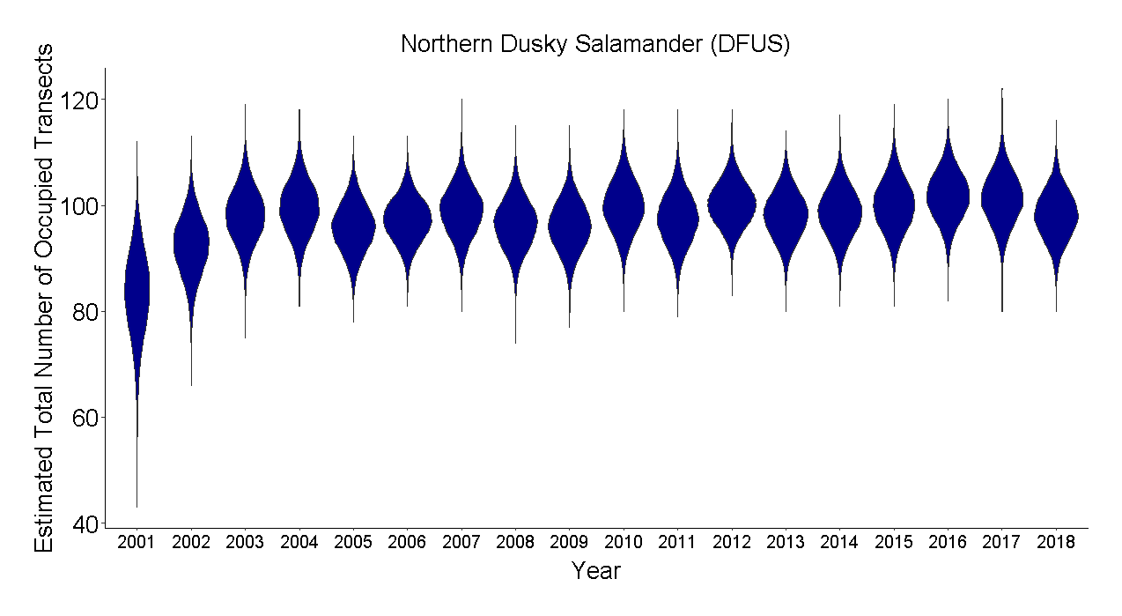

(B)

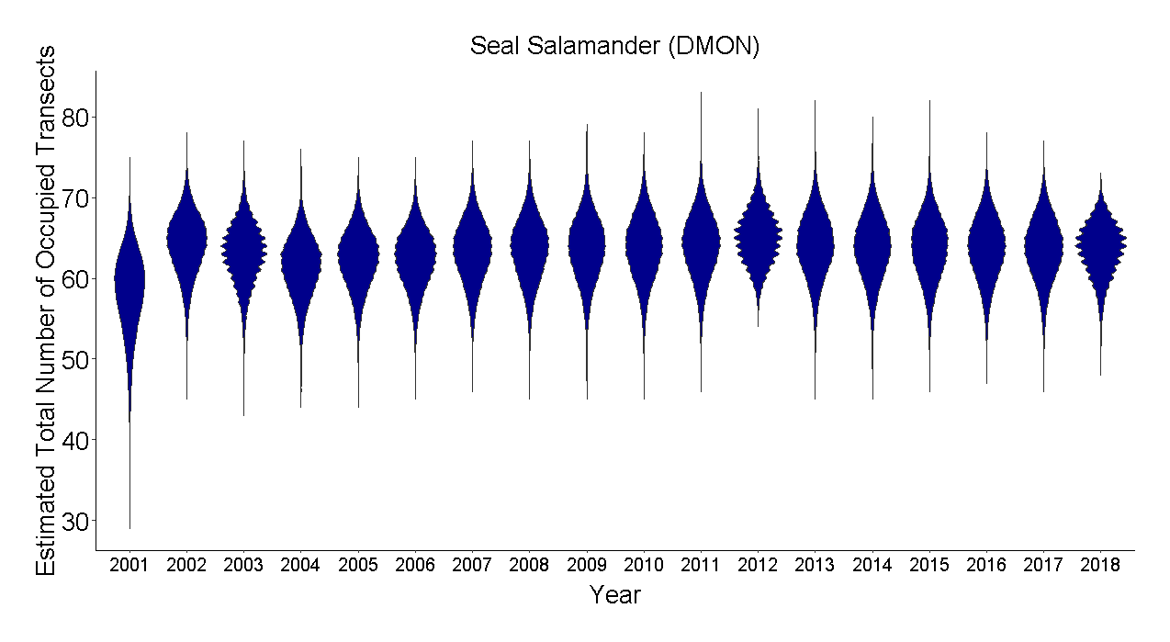

(C)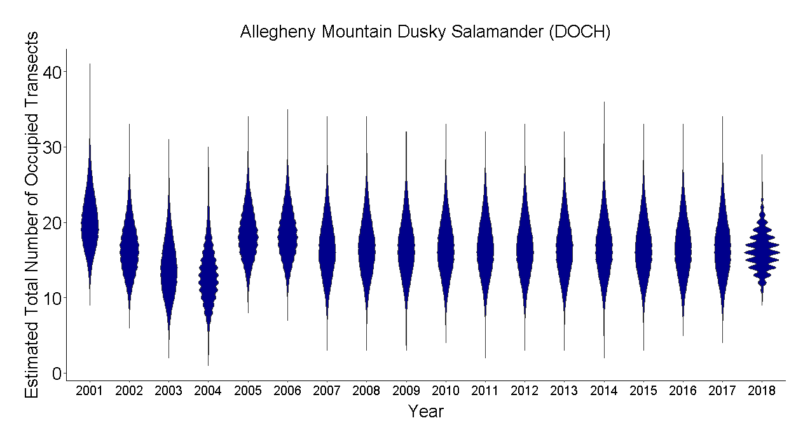(D)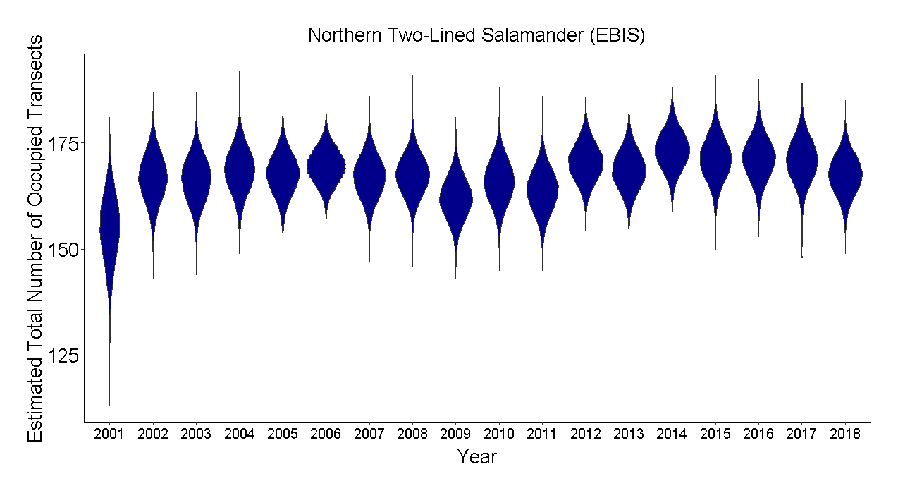

(E)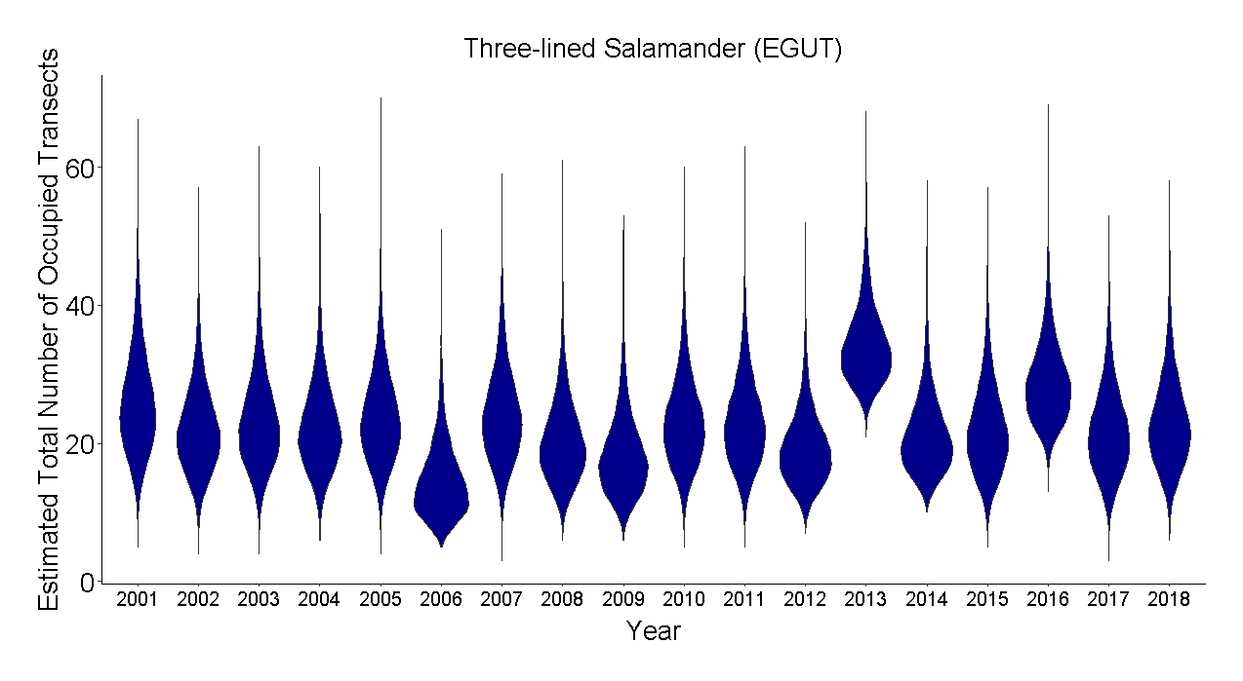(F)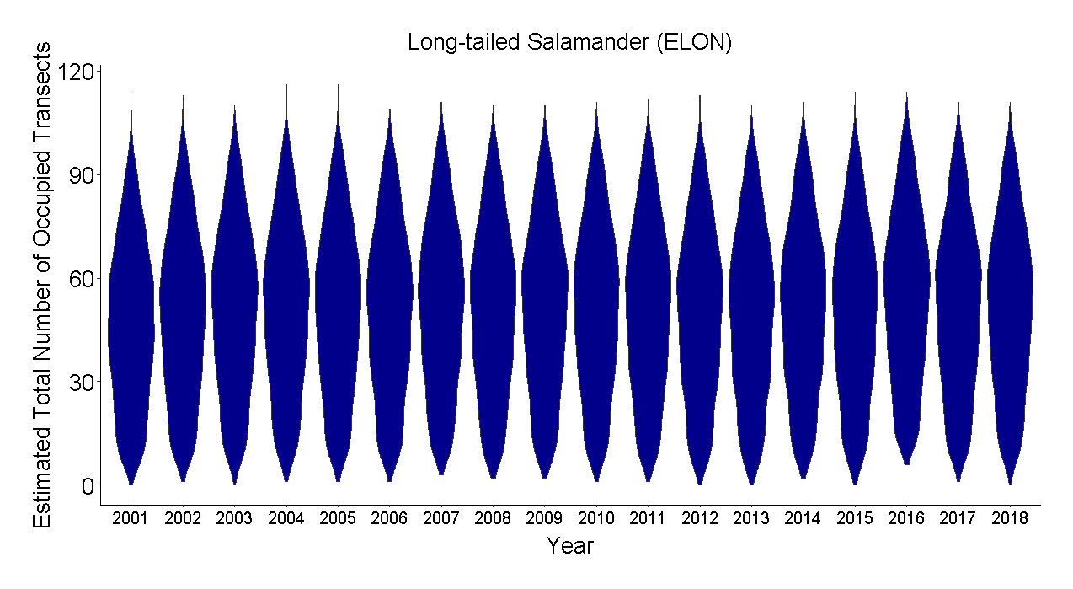

(G)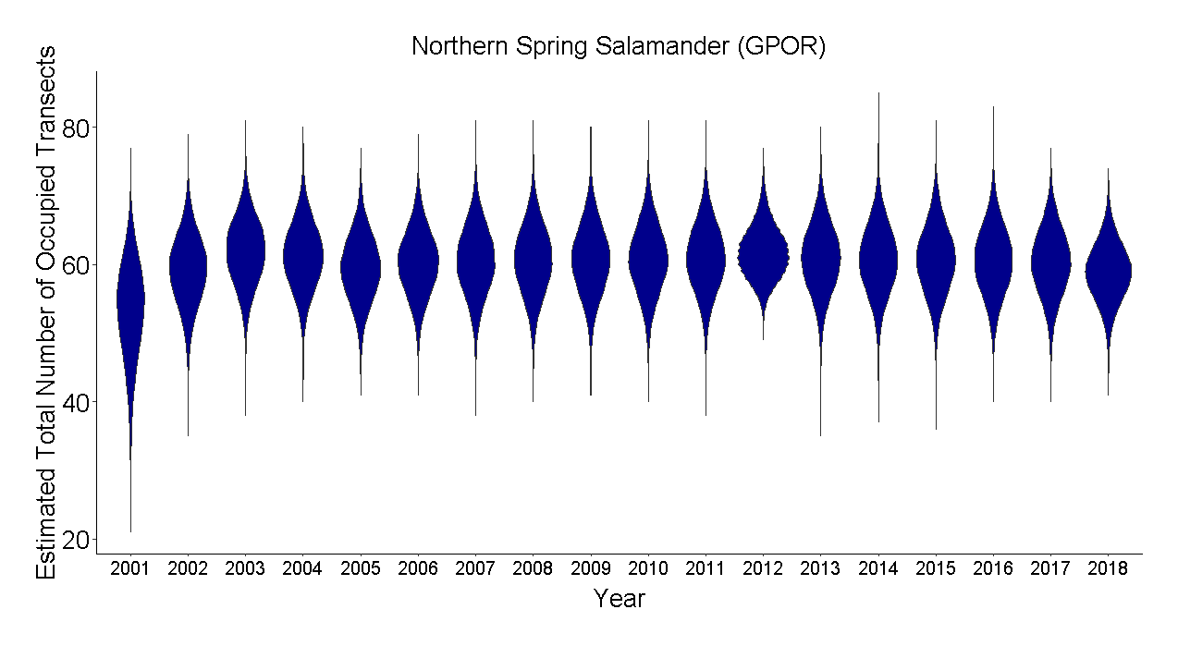(H)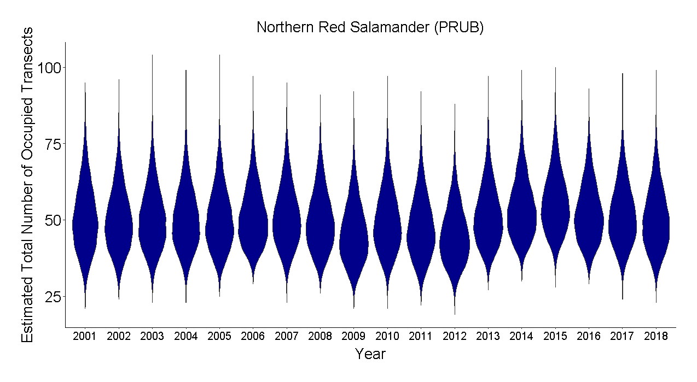

Figure 17. The estimated total number of occupied transects for each year and species. (A) northern dusky salamander, *Desmognathus fuscus; (B)* Allegheny Mountain dusky salamander, *Desmognathus ochrophaeus*; (C) seal salamander, *Desmognathus monticola; (D)* northern two-lined salamander, *Eurycea bislineata*; (E) three-lined salamander, *Eurycea guttoline*ata; (F) long-tailed salamander, *Eurycea longicauda; (G)*  northern spring salamander, *Gyrinophilus porphyriticus; and (H)* northern red salamander, *Pseudotriton ruber ruber*

(A)

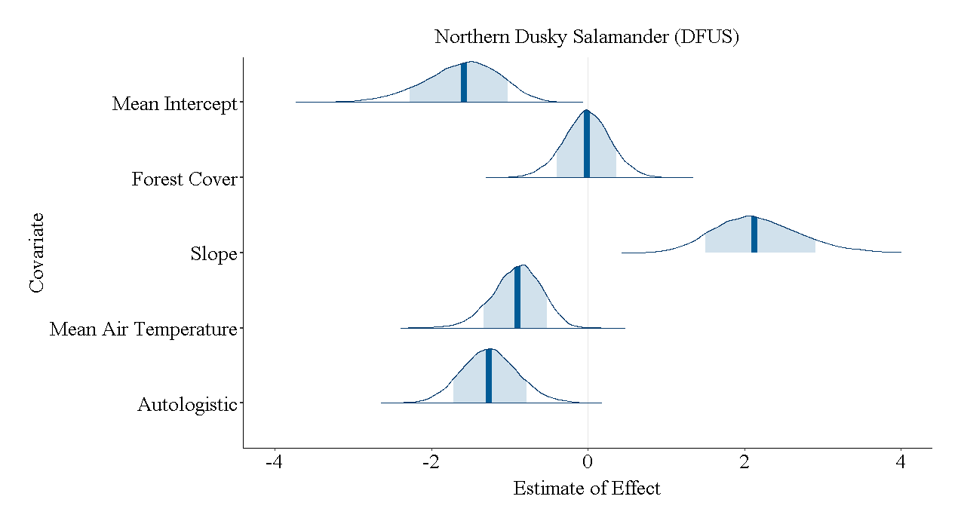(B)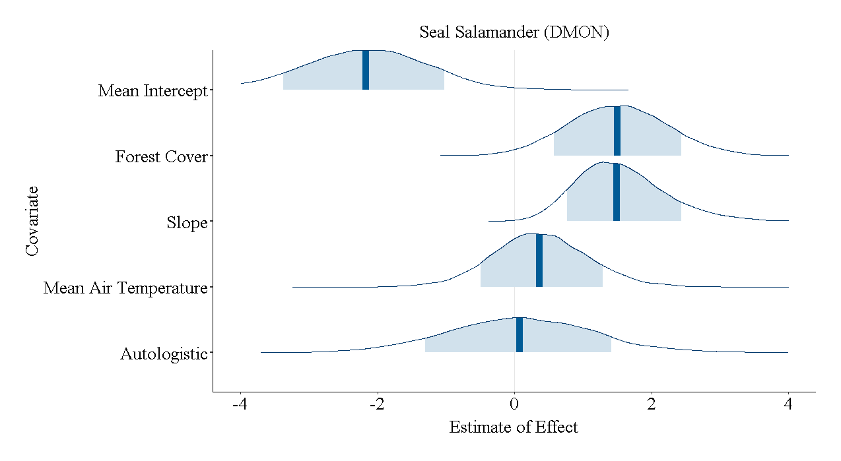

(C)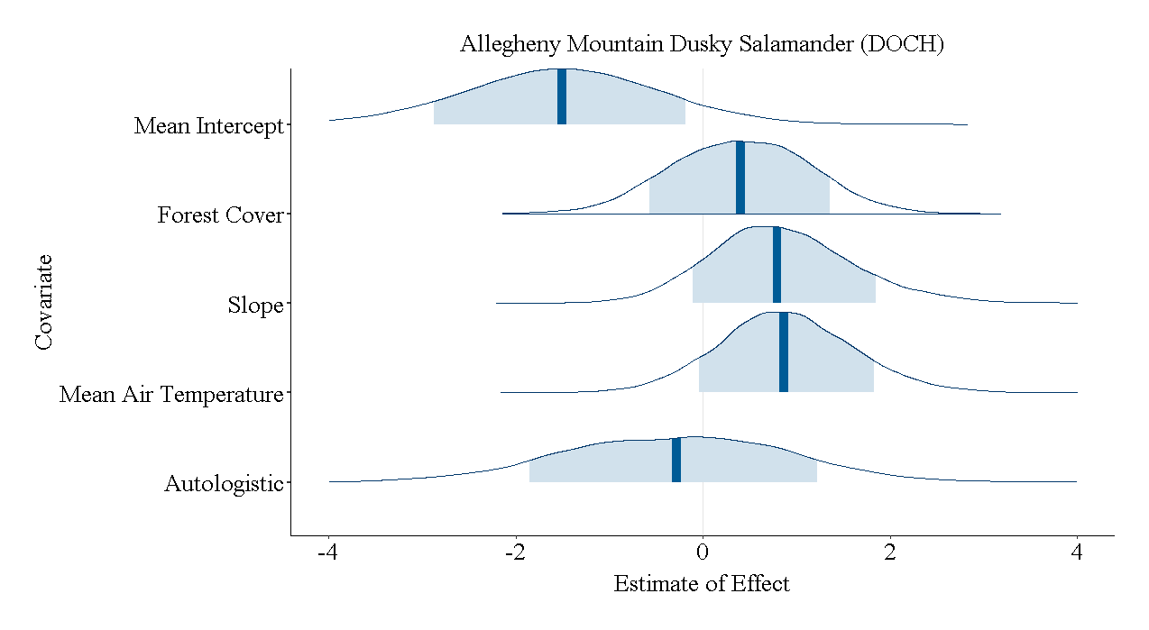(D)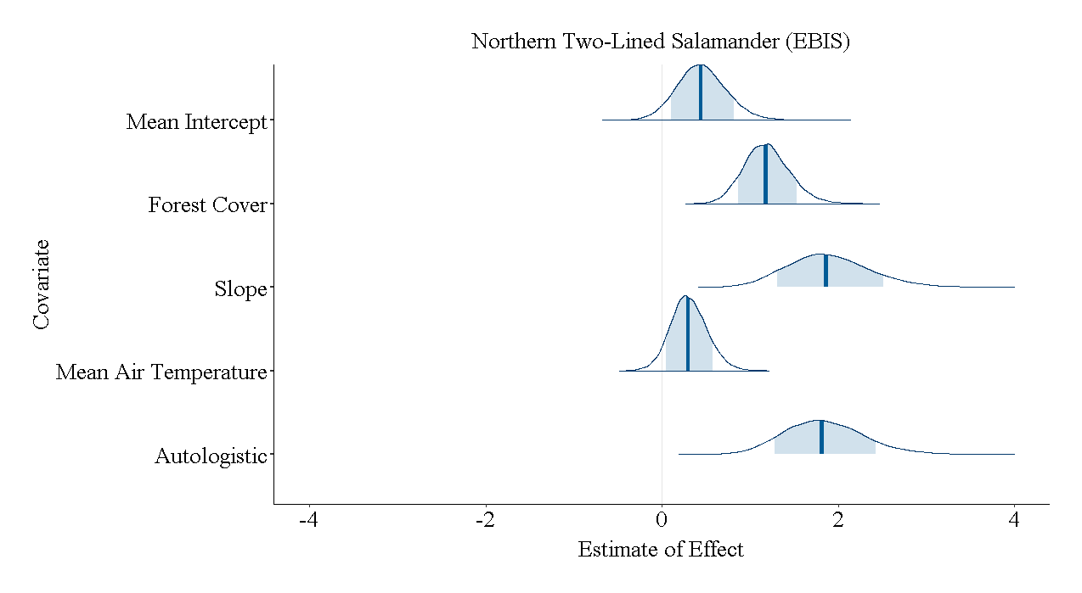

(E)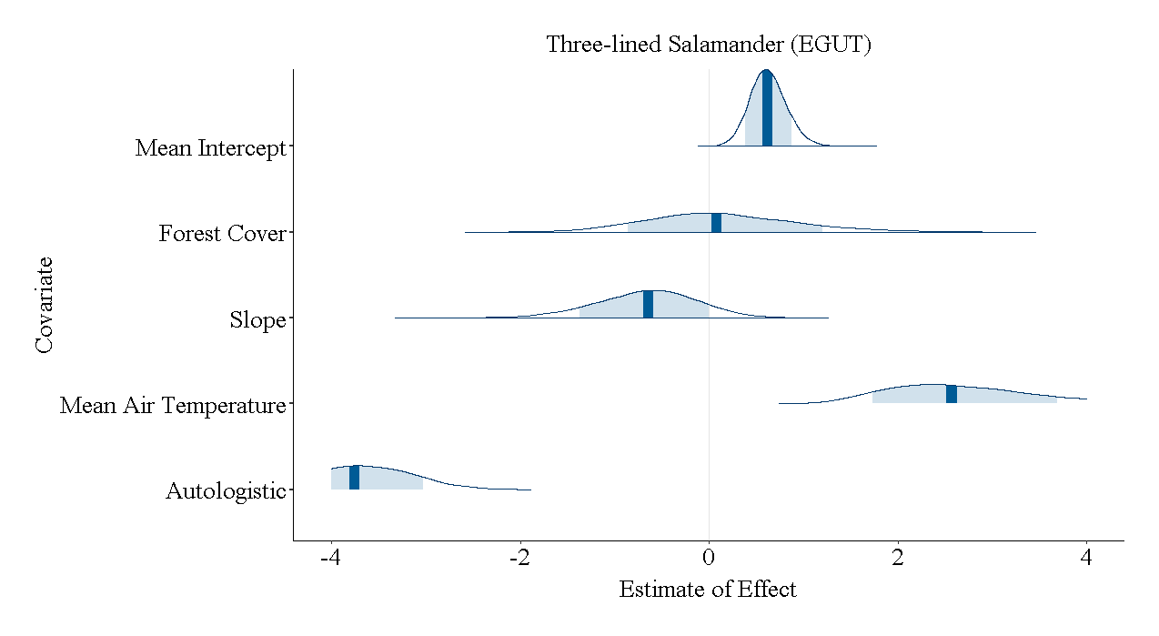(F)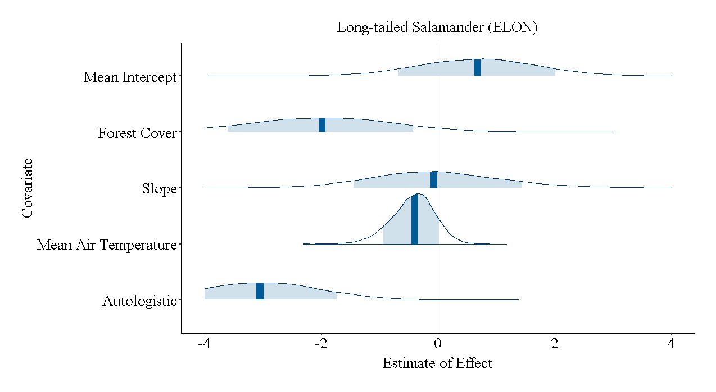

(G)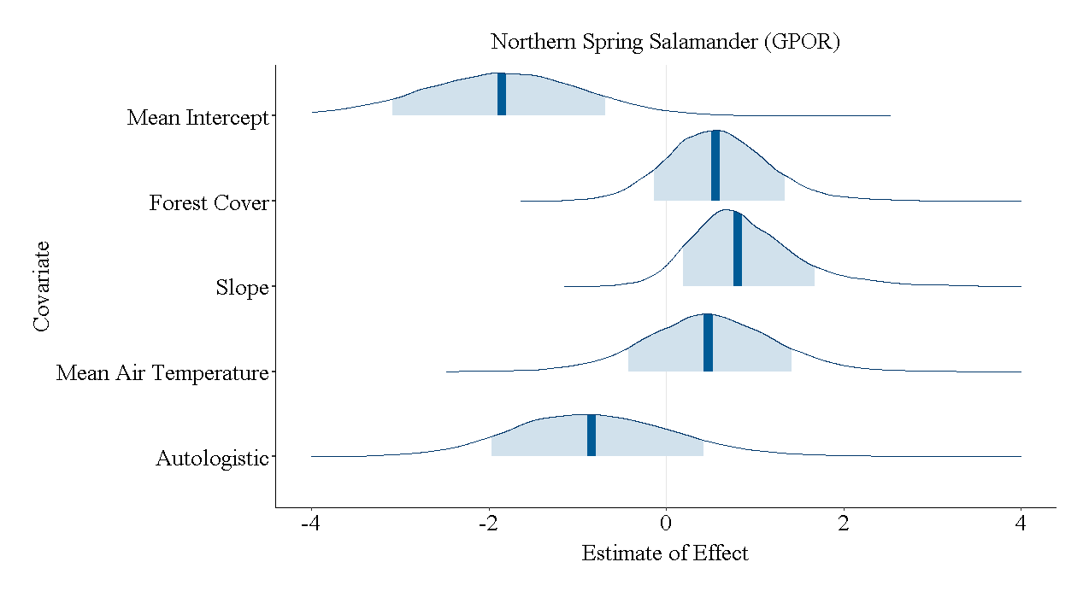(H)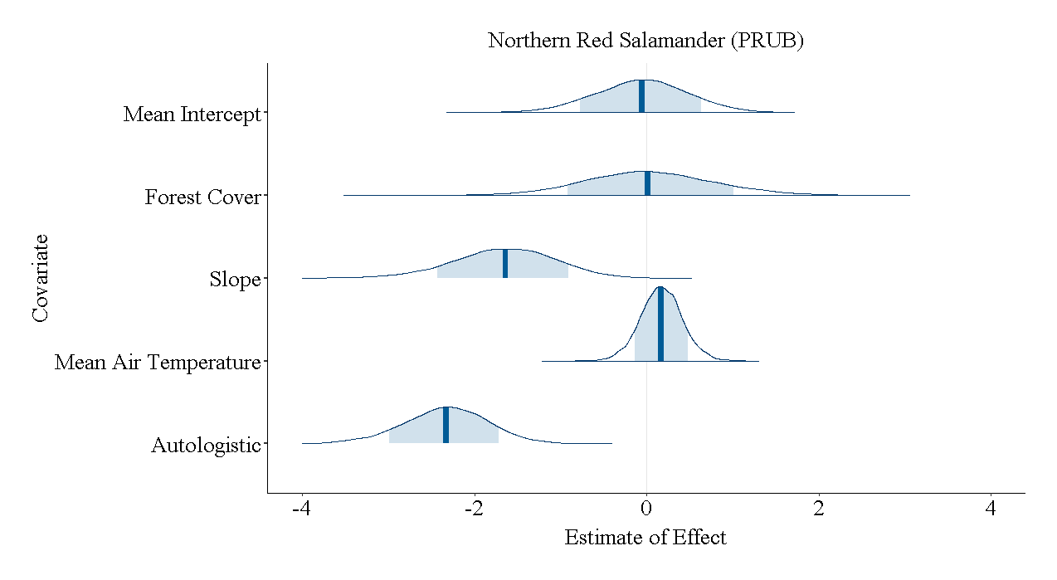

Figure 18.The posterior probability density functions of the model covariates on the occupancy of each species. (A) northern dusky salamander, *Desmognathus fuscus*; (B) Allegheny Mountain dusky salamander, *Desmognathus ochrophaeus*; (C) seal salamander, *Desmognathus monticola*; (D) northern two-lined salamander, Eury*cea bislineata*; (E) three-lined salamander, *Eurycea guttolineata*; (F) long-tailed salamander, *Eurycea longicauda*; (G) northern spring salamander, *Gyrinophilus porphyriticus*; and (H) northern red salamander, *Pseudotriton ruber ruber*

(A)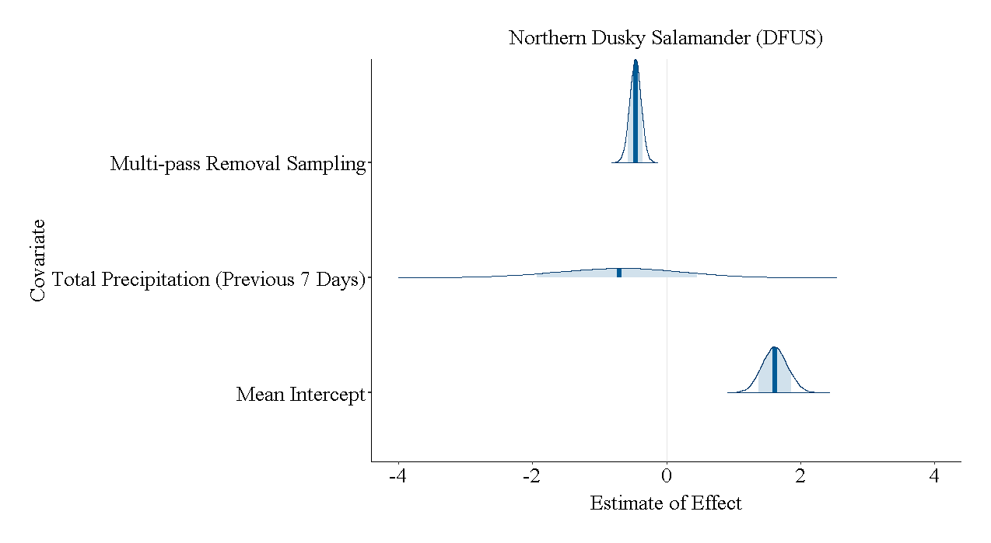(B)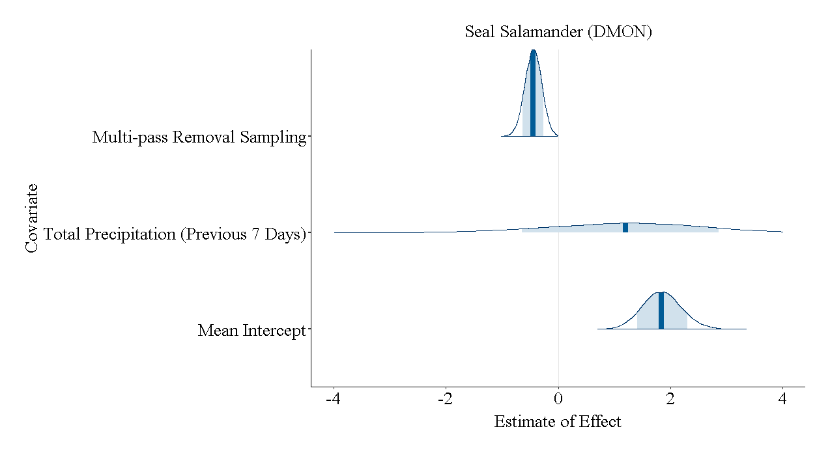

(C)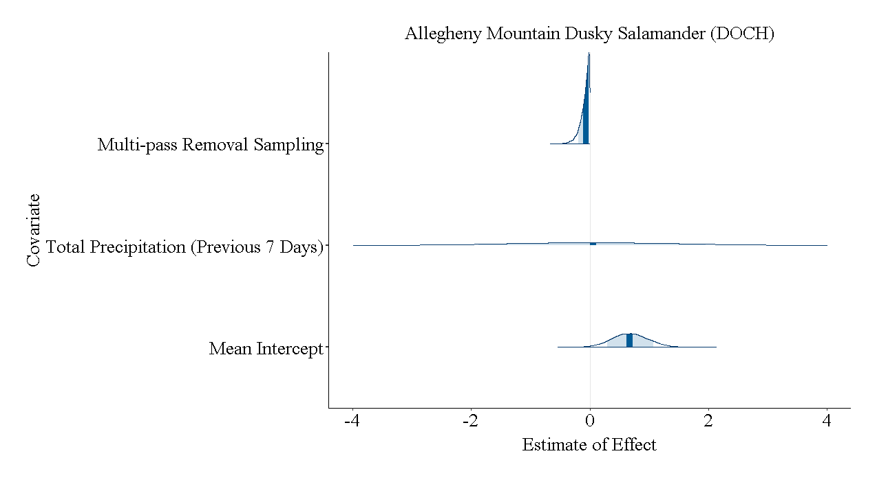(D)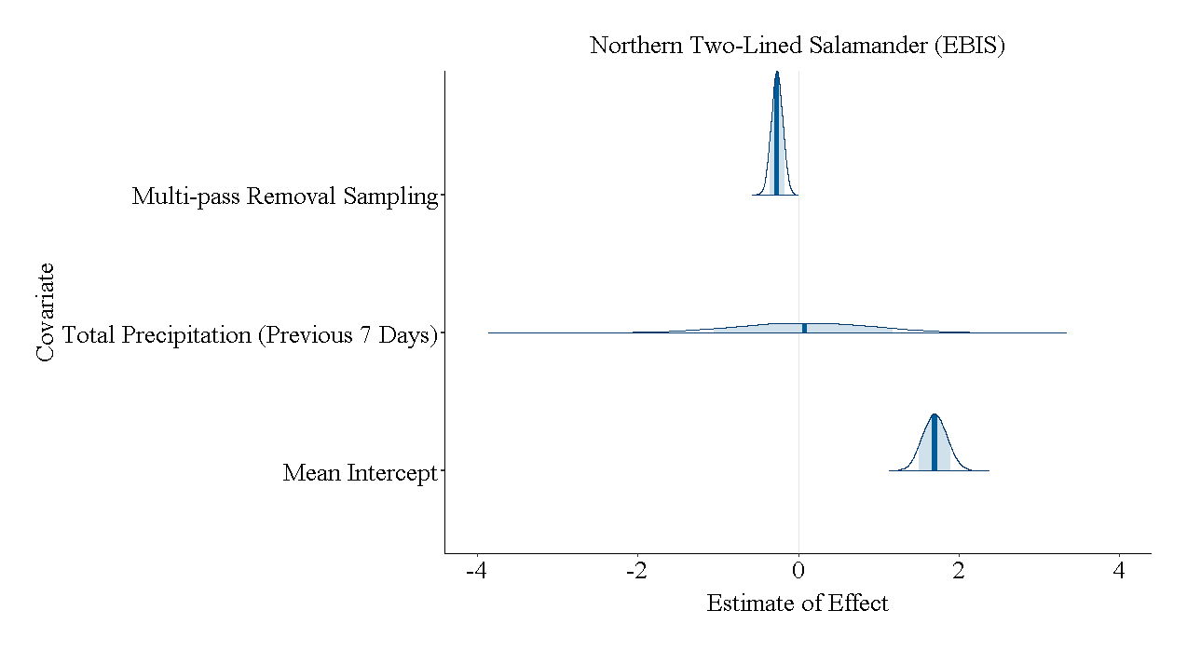

(E)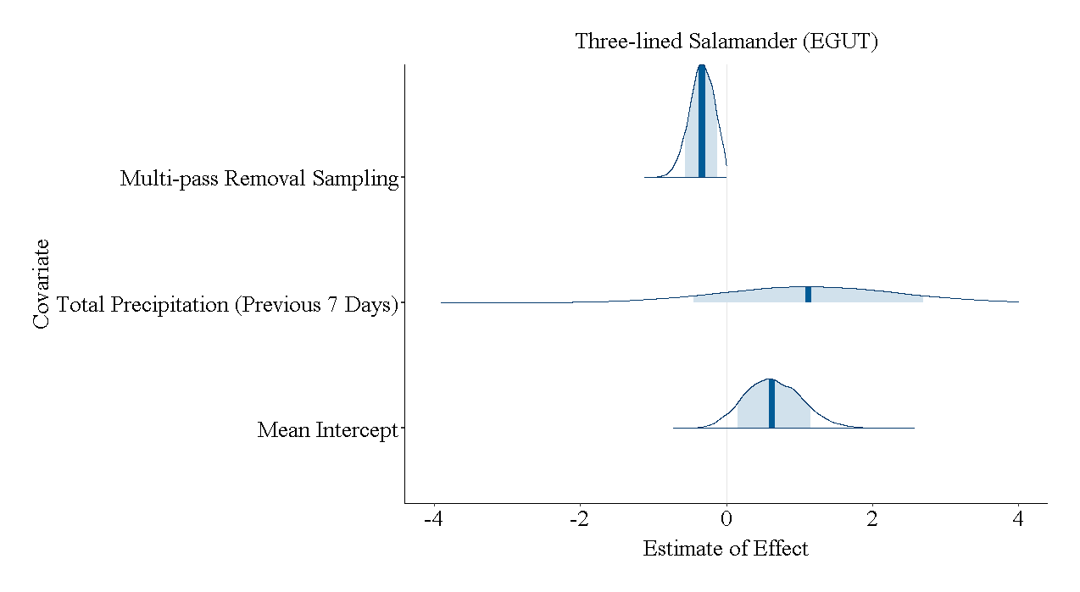(F)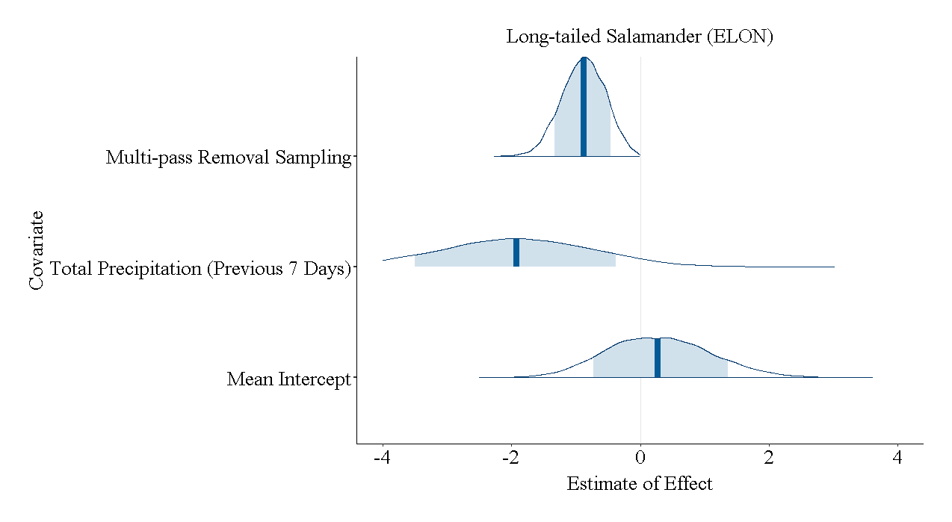

(G)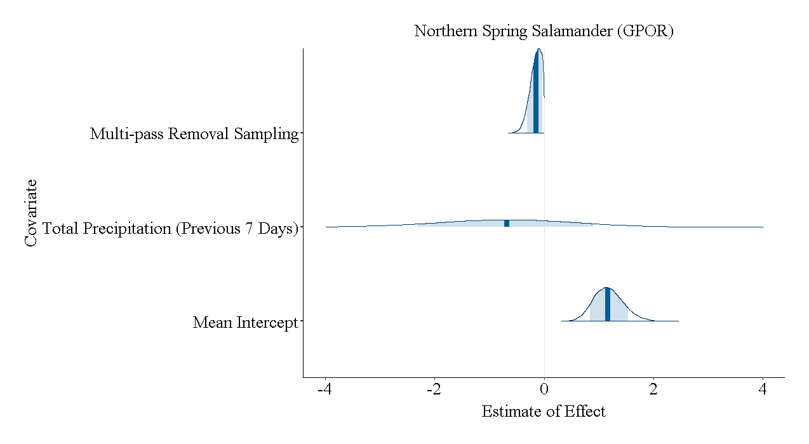(H)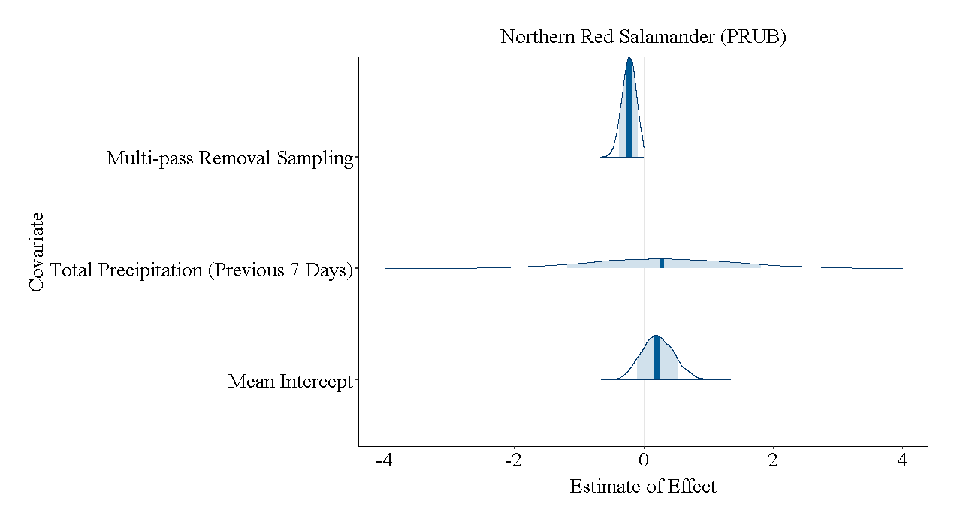

Figure 19. The posterior probability density functions of the model covariates on the detection of each species. (A) northern dusky salamander, *Desmognathus fuscus*; (B) Allegheny Mountain dusky salamander, *Desmognathus ochrophaeus*; (C) seal salamander, *Desmognathus monticola*; (D) northern two-lined salamander, Eury*cea bislineata*; (E) three-lined salamander, *Eurycea guttolineata*; (F) long-tailed salamander, *Eurycea longicauda*; (G) northern spring salamander, *Gyrinophilus porphyriticus*; and (H) northern red salamander, *Pseudotriton ruber ruber*