15 II V I licks- Altered Dominants
Jens Larsen 11/2/2017

Thanks for the interest in my videos and lessons and for signing up for my newsletter!

The II V I cadence is the most common device in Jazz Harmony. Learning to play freely and develop vocabulary over this is essential for anybody wanting to improvise in a jazz style. The altered dominant is the next level choice for this cadence, and equally important to master.

This short E-book can work as a sort of index to my video lessons on YouTube

I have many lessons on different devices and ideas related to these lines. For each lick I will make a short description of what is going on and if possible link to a YouTube lesson that explores the device further.
As always you can get more out of these licks if you take the idea and try to make your own lines with them. This is a huge part of how I work with new material!
I hope you find some new ideas and can implement it into your own playing!

Remember that you can help me by subscribing to my YouTube channel:
https://www.youtube.com/JensLarsen

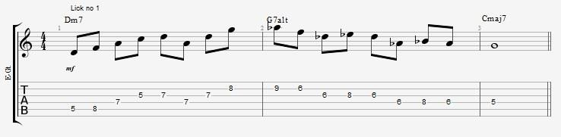
Lick no 1

In this lick I am using a basic Dm7 and a stack of 4ths on the Dm7. The G7 line is built from the Bb minor pentatonic scale.
If you want to check out more about using the pentatonic scale on a II Valt I then you can do so here: https://www.youtube.com/watch?v=5mIZGywe8tA

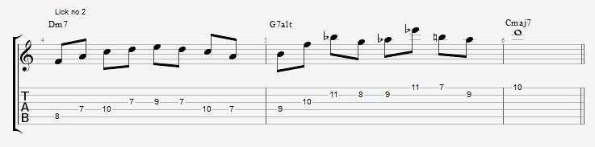
Lick no 2 is making use of quartal harmony and upper structure triads on the dominant. Starting with a stack of 4ths from B. Note that the first interval is an augmented 4th. It later continues with an Abm triad. The Dm7 line is built around an Fmaj7 arpeggio with a few added scale notes. What Ted Greene might refer to as a condensed Fmaj7(13) arpeggio.

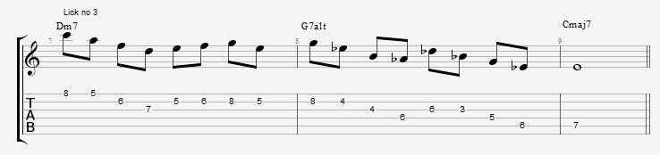
Lick no 3

The Dm7 line in this lick is built around a descending Dm7 arpeggio and a small scale fragment. The G7alt line is using is using two diatonic arpeggios from G altered or Ab melodic minor: AbmMaj7 and Eb7. It’s very useful to check out how you can use the other diatonic arpeggios so that you can build a bigger vocabulary with more melodic material than just the basic arpeggio.
For more ideas on chaining together several arpeggios you can look at this lesson: https://www.youtube.com/watch?v=76yoV6hWOxI

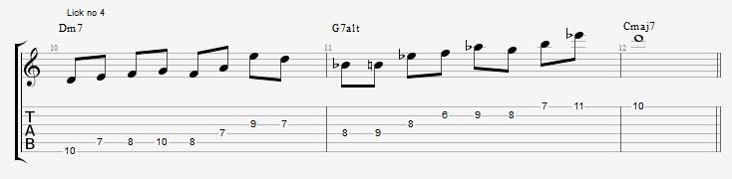
This lick is using a scale run and an Fmaj7 Shell voicing for the Dm7 part. The G7 altered part is built from a non diatonic arpeggio: Bmaj7(b5) followed by a B augmented triad.
More “secret” arpeggios in the altered scale can be found here: https://www.youtube.com/watch?v=e1jgscnhLt8

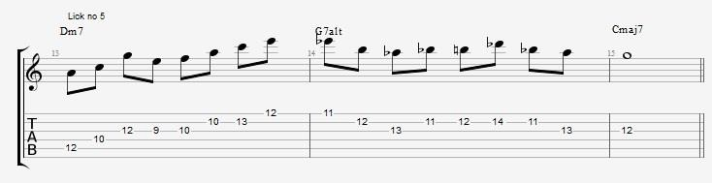
Lick no 5

Shell voicings are a great melodic device! (just ask Pat Metheny…) In no 5 I start with an Am7 shell voicing as arpeggio and follow that with an Fmaj7 arpeggio. On the G7 alt the line is a more conventional construction from an Ab minor triad and a scale run.
If you want more ideas for shell voicings I talk about this here: https://www.youtube.com/watch?v=KD3M-fjFqJ8

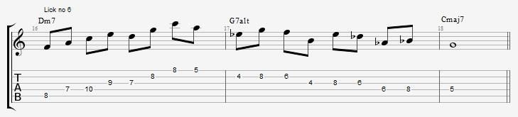
Lick no 6

Using the arpeggio form the 3rd of the chord is an essential technique to add extensions to the line. In this lick I use Fmaj7 to get an Dm7(9) sound in there. On the 2nd half of the Dm7 line I am using a

stack of 4ths from D to create a Dm11 sound. The G7alt line is a scale sequence in the altered scale that sits nicely on the fretboard.
If you want to explore more of the ideas available over a Dm7 arpeggio you can check out this video with 10 arpeggios over a m7 chord: https://www.youtube.com/watch?v=UfXBtYkDHWo

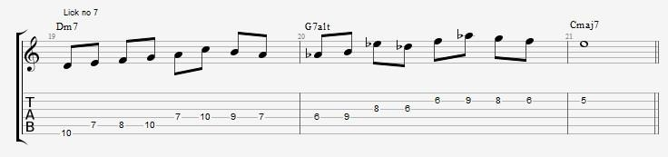
Lick no 7

In lick no 7 I use a more scalar approach on the Dm7, but you should notice how it still outlines a Dm7 by having the triad notes on the strong beats. The Altered dominant line here is drawing from the tri-tone material. It is using two triads: Ab minor and Db major. You could hear it as spelling out an Abm7 Db7 sound.
For more ideas on drawing altered sounds from the tri-tone dominant you can check out this lesson: https://www.youtube.com/watch?v=51MCFyXYyas

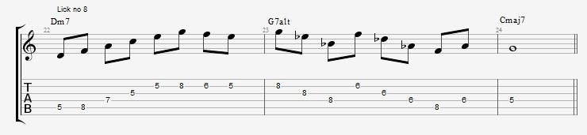
Lick no 8

Extended arpeggios like the Dm11 arpeggio I use in Lick no 8 has been a standard part of the jazz vocabulary since Wes Montgomery. They work extremely well for sweep picking. The altered dominant line is in this case a triad pair of the triads Db and Eb. These are both diatonic to Ab melodic minor (or G altered)
If you want to check out more on Triad pairs in the altered scale you can here: https://www.youtube.com/watch?v=9wtvmPkMJN8

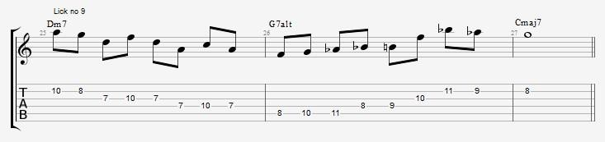
The pentatonic scale is always going to be a great resource for melodic ideas. In this example I am using one of the exercises that I cover in my lesson on unconventional pentatonic exercises. The Altered line is first a scale run and then a stack of 4ths from B.
If you want to check out the video on pentatonic exercises you can do so here: https://www.youtube.com/watch?v=B6kLHoInO6A

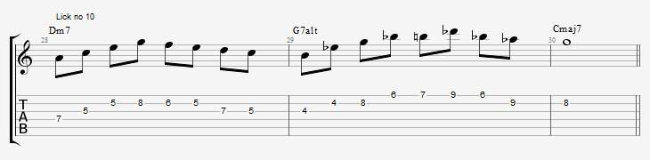
Lick no 10

Using the arpeggio from the 5th to encircle the 3rd is a great, tried and true trick for the II minor chord. The line continues after this with a descending scale run. On the G7alt I am using the Bmaj7(#5) arpeggio and following this with a small scale-pattern before resolving to Cmaj7.
For another thorough look at Altered dominant ideas you can also check out this lesson: https://www.youtube.com/watch?v=m_OTV0GlJfg

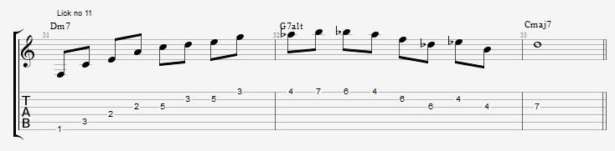
Drop2 voicings are such a great tool for structures with large intervals and range. In this line I am using an Fmaj7 drop2 voicing as an arpeggio over the Dm7. Notice how the Dm7 line has a range of more than 2 octaves! On the G altered chord I am using a mix of a scale run and some diatonic 3rd. The line sounds better if one part has a lot of huge intervals and the other is a bit more in a natural smaller range.
If you want to check out more about using Drop2 voicings as arpeggios you can do so here: https://www.youtube.com/watch?v=xnNEwNgFZiw

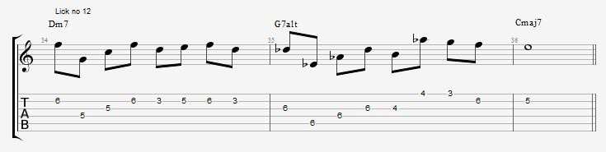
Lick no 12

Quartal harmony has been a big part of the modern jazz sound since Kind Of Blue and Coltrane in the late 50’s and beginning 60’s! The entire line here is using quartal 3 part arpeggios. First a stack of 4ths from the G on the Dm7. This gives us a Dm7(11) sound. On the G7alt it’s an arpeggio from the Eb that gives us the alterations: b13,b9 and b5.
If you want to check out some more quartal harmony you can do so with in this video: https://www.youtube.com/watch?v=aL8gSJxRE6E

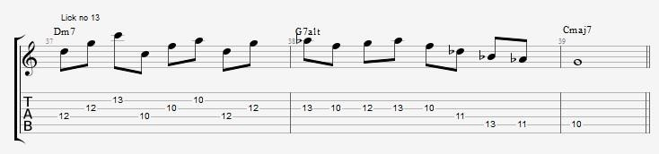
Some of the “normal” exercises yield some unusual melodies if you apply them to the pentatonic scale. This example starts off with the Dm pentatonic played in “diatonic triads” The G7 part of the lick is focused more on the Bbm connection but not strictly pentatonic.
If you want to explore more ideas from the pentatonic scale you can do so here: https://www.youtube.com/watch?v=x-K_oG-GQFE

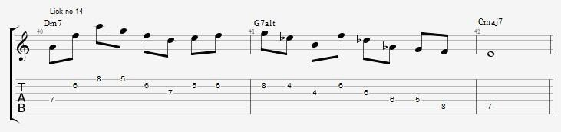
Lick no 14

Open triads are another great way to use triads in your lines. The wide intervals make for a beautiful open sound! In this lick I am using an open F major triad. The altered dominant line is using a triad pair consisting of a B augmented and Db major triad.
If you want to check out more about triad pairs you can also do so in this first part of 3 videos: https://www.youtube.com/watch?v=RVjqS7R5HEQ

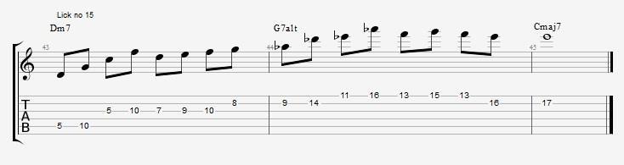
This lick opens with a very useful way of playing quartal arpeggios. I cover this in my 3 lessons in the pentatonic scale video that I also linked to above. The altered line is using an Absus4 triad as an upper-structure triad. Something you can also explore further in this video:
https://www.youtube.com/watch?v=ZWEPQaBMMi8

I hope you can use the lines and have some new ideas to start working with!

