D-Lev Tour Kit Build
Eric Wallin, 2023-06-14
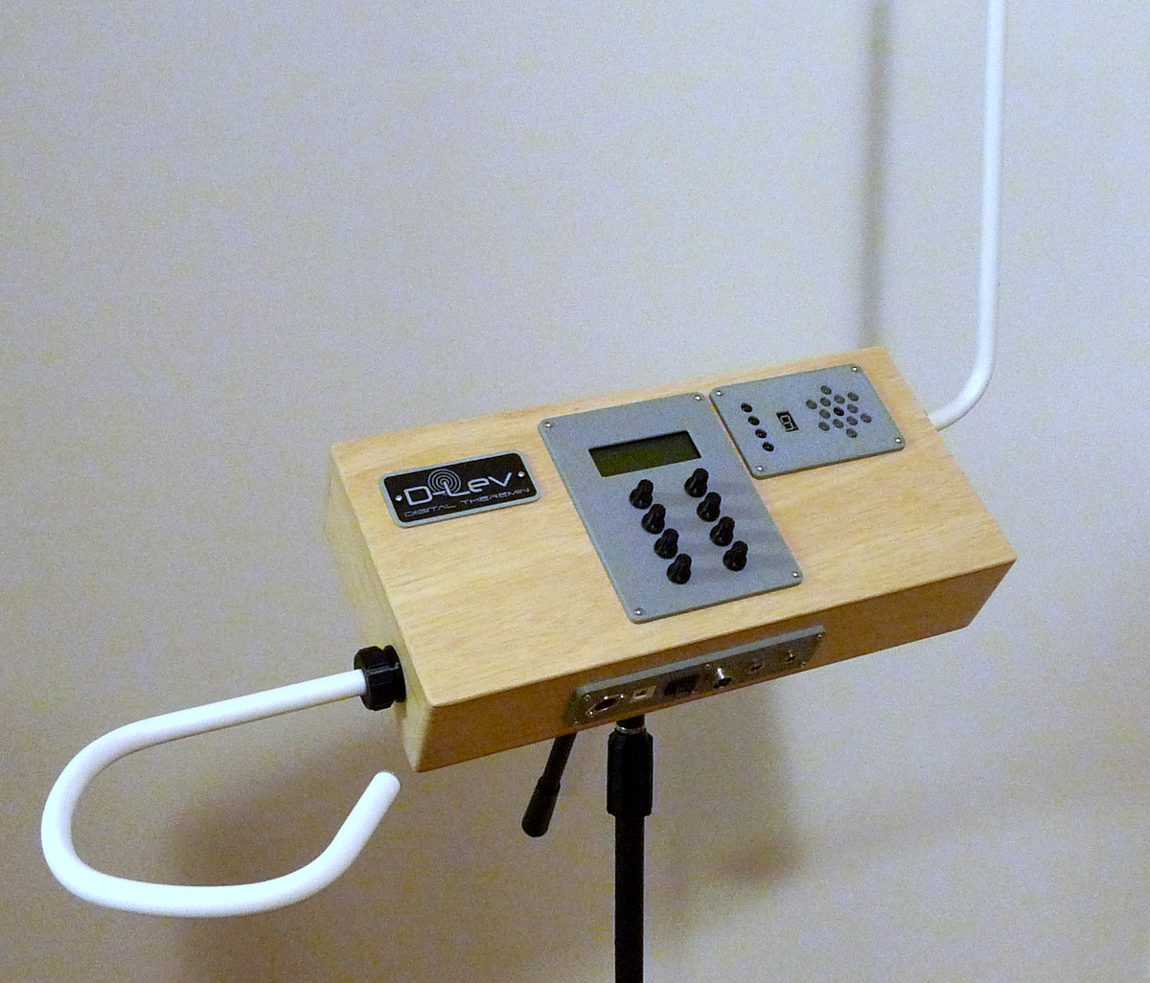
This is a description of how I built a small enclosure for the D-Lev kit components. Goals were decent looks, minimum size & weight for maximum portability, and rod antennas due to analog expectations and familiarity. The moniker is an endearing ripoff of the tVox tour. We all need portable instruments!

The Case
For light weight, ½” x 4” x 4’ Poplar for the sides and 5mm Luan plywood for the top and bottom were chosen, both purchased from the local Home Depot. The Poplar dimensions were actually ½” x 3 ½” x a tad over 48”. Using a radial arm saw, the Poplar width was ripped down to 75mm, and two pieces cut to 175mm length for the left and right sides. The remaining Poplar was cut in half to give two boards a bit over 425mm long for the front and back. The sides were glued with some overhang inside the front and back boards, with intended final exterior dimensions of 425mm width by 200mm length. Corner block reinforcements were fashioned by cutting the Poplar rip scrap at a 30 degree angle (this angle is easiest to cut before the rip). The glue joints were clamped via fender washers and drywall screws, which were later removed, the holes filled with DAP natural plastic wood after the glue dried. Then the holes for the antenna mount hardware were drilled using a 1” circle cutter and hand drill.
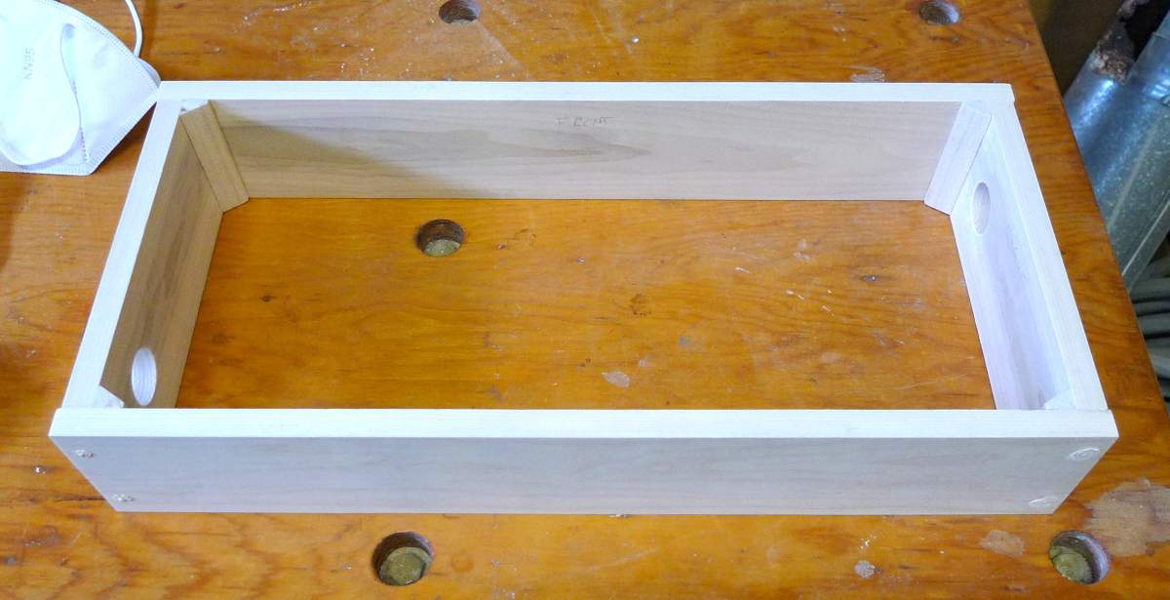
The sides glued and reinforced, screw holes filled, and antenna mount holes drilled.
The top and bottom surfaces of the sides were leveled with a sanding stick (a guitar trick). Then the plywood top and bottom pieces were cut a bit oversize and glued on.
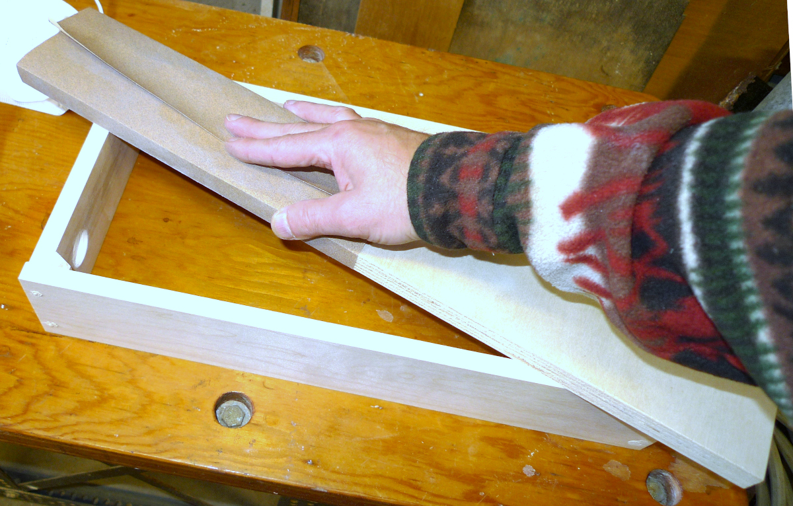
A sanding stick was used to level the top and bottom mating surfaces.
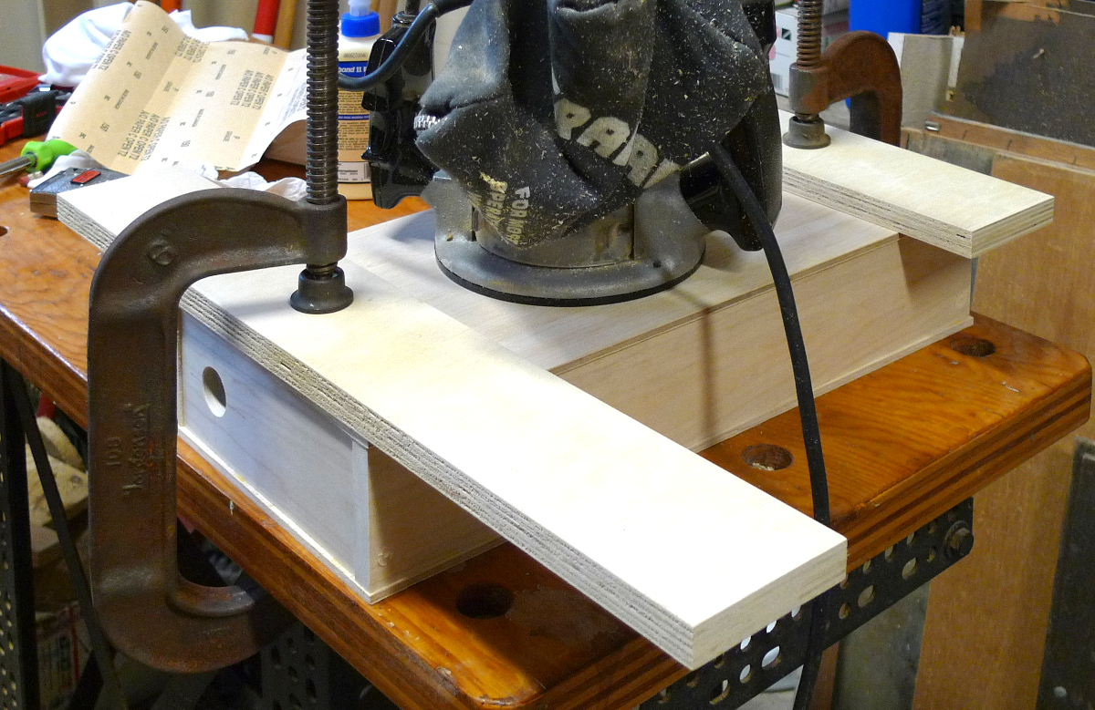
Gluing the oversize top and bottom gently with C-clamps and the weight of a router.
All of the overhang was removed with a router and a laminate flush trimming bit, then the entire exterior was sanded with a palm sander. The side corners were rounded using a ¼” rounding over router bit, the top and bottom corners were rounded off manually with a sanding stick, with a final palm sand. Then the controls, display, and I/O panel holes were cut freehand with a ¼” router bit. Finally, the antenna mount locator key slots were filed using a round hand file.
The centerline of control panel was located 200mm from the left side of the case, the centerline of the tuner panel 330mmm from the left side (giving a ~5mm gap between them), and the centerline of the I/O panel 185mm from the left side. The control panel was offset 5mm toward the front of the case, and the front edge of the tuner aligned with it. The I/O panel was centered vertically on the case side.
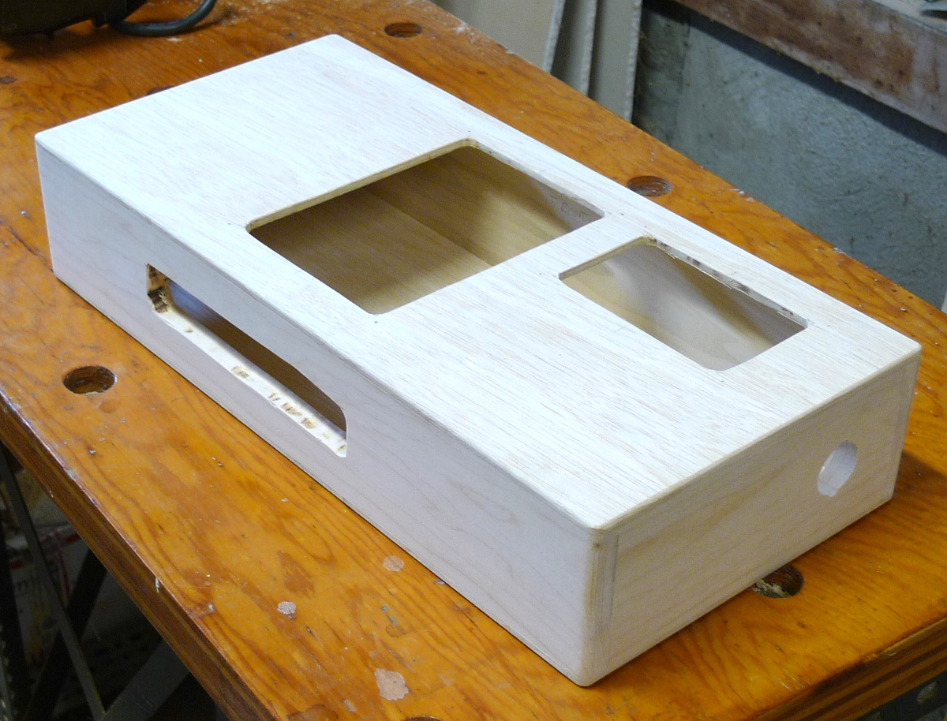
Trimmed, sanded, and routed case.
The case was vacuumed and dusted, and the exterior given 3 coats of water-based satin varnish (Varathane) with the recommended 2 hours drying time between the first and second coats, 8 hours drying time between the second and third coats, and a light sanding with 220 grit paper before the final coat to knock off the fuzz and bumps and smooth things out.
A scrap piece of 5mm Luan plywood was cut to 100mm by 175mm and glued to the inside back, centered from left and right, to reinforce the mike stand flange (On-Stage u-mount, UM5006). The flange itself was located 1/3 of the way down from the front (66mm) to give an automatic upright orientation gravitational assist when mounted on an angled boom mike stand. The hole for the flange was cut with a 7/8” circle cutter and hand drill. A 3D printed black PETG trim ring spiffed up the appearance, and 4mm stainless socket head cap screws affixed the flange and trim ring. The rubber backing glued onto the flange back at manufacture was retained to prevent anything inserted too far inside the mounting thread hole from damaging the control unit.
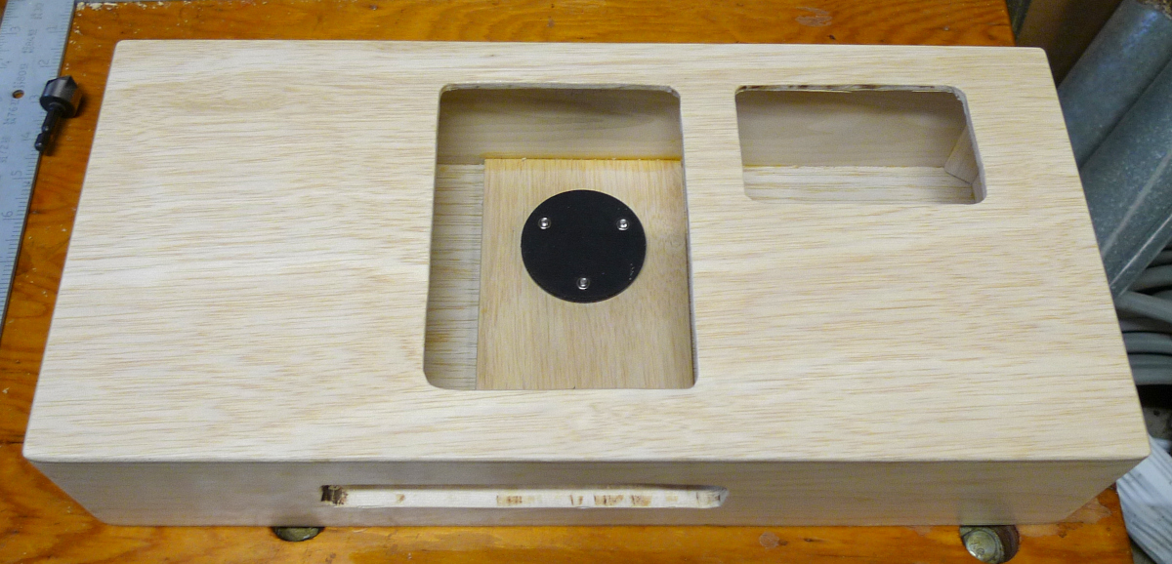
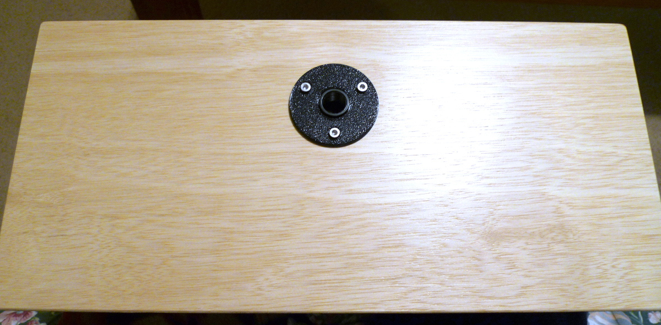
Inside (top) and outside (bottom) views of the mike stand flange and trim ring.
Two scrap pieces of 5mm Luan plywood were cut to 75mm square and glued to the inside between front and back to create supports for the pitch and volume AFE / coil boxes. The AFE boxes themselves (with a few thin card stock spacers providing clearance) were used to locate the supports during gluing. To keep the boxes in their final positions in the case, two spacers were formed from 4mm corrugated plastic sheeting, cut in a “Z”, and taped together with packing tape. The tape was extended out some to provide a grab handle for easy removal.
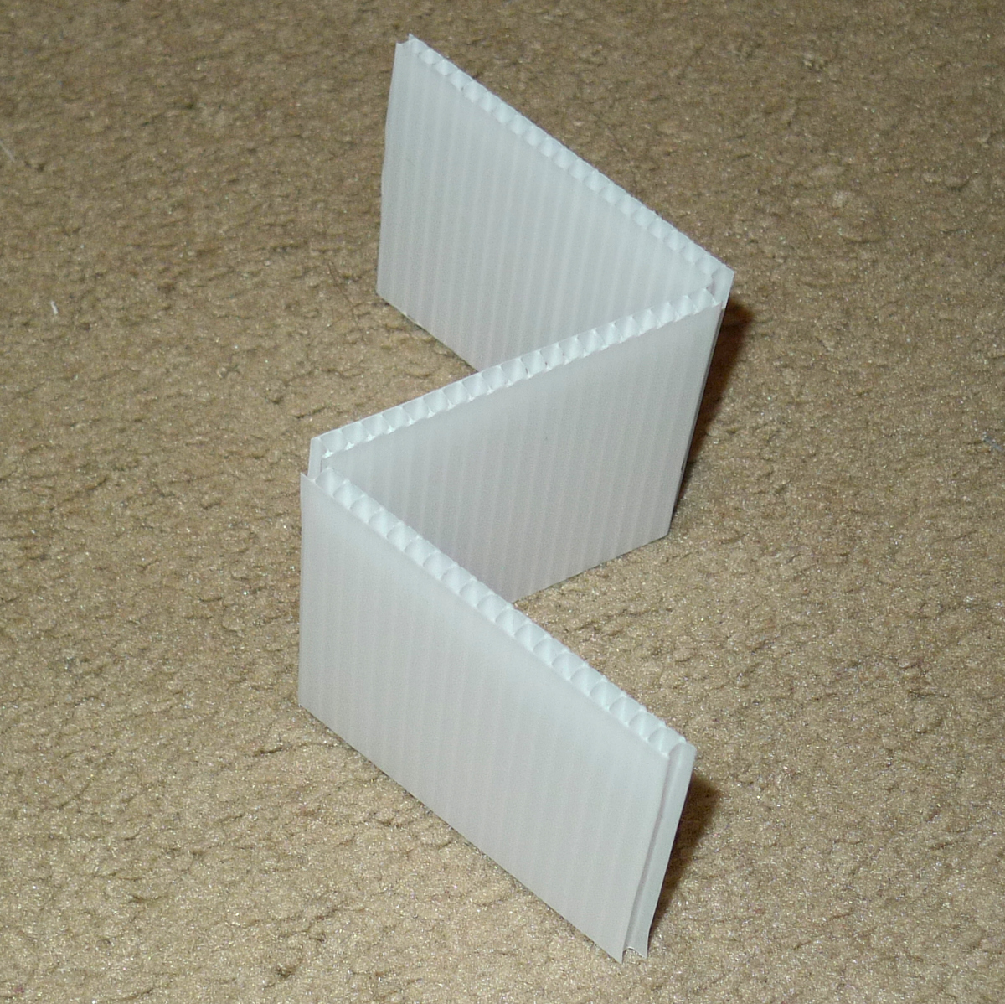
Spacer constructed of a “Z” of corrugated plastic sheeting.
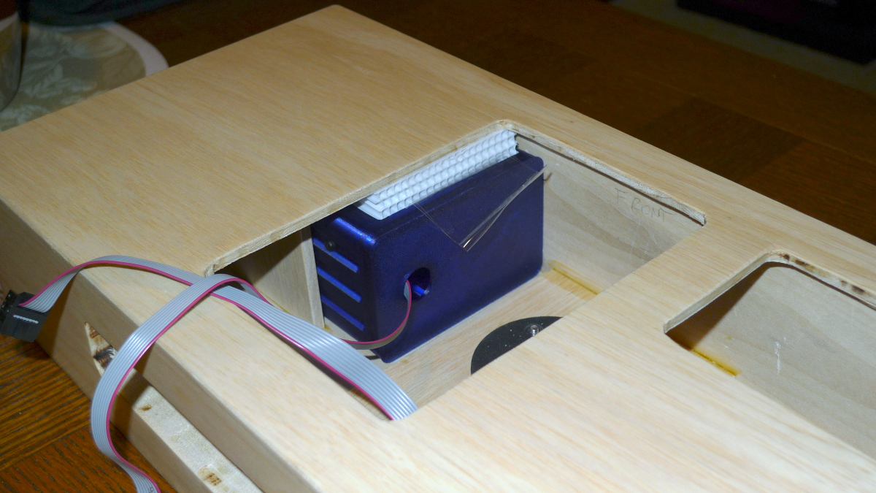
Spacer on top of the volume AFE / coil box, pulled forward here a bit for viewing.
The plywood side support is also visible here.
The antenna support hardware was 3D printed and installed in the case. The mounting nuts were tightened snug by hand (my hand was a little cramped tightening the volume side support).
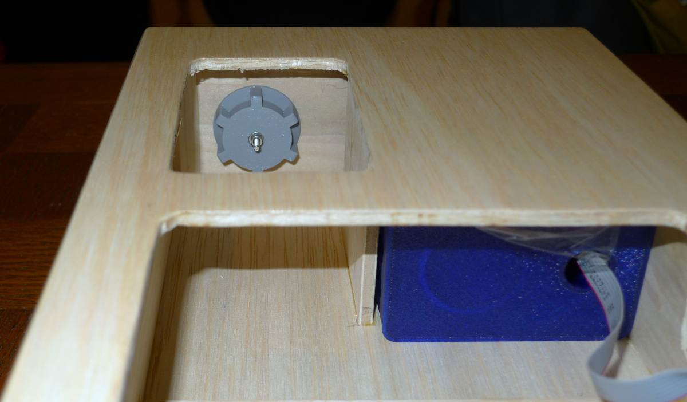
Pitch antenna mounting hardware installed. Note stainless M3 socket head cap screw protruding from the mounting nut center – the D-Lev kit AFE antenna wires were simply alligator clipped to these antenna mounting hardware contact screws. Also note that, due to an abundance of caution, the final install of the pitch AFE box was flipped over in order to position the coil farther away from the LED tuner panel (not sure if it makes any difference).

Antennas
The antennas were constructed of white ½” PEX plumbing tubing, which has 15.875mm OD and somewhere around 12mm ID. The pipes were bent by applying heat from a heat gun for approximately 2 minutes to the bend area, a screen door coil spring was inserted to keep the pipe from collapsing, and the pipe was bent around a 75mm diameter drinking glass. After some cooling the spring was removed and the pipe further cooled under a running tap. The volume antenna required many touch-ups to the bends, which didn’t seem to discolor the tubing any. The tubing ends were trimmed to length via radial arm saw, and the ends capped with 3D printed gray PETG plugs, affixed via friction and a bit of wood glue.
For conductivity, kitchen aluminum foil was wrapped around a length of 8mm diameter foam gasket material. 26 AWG bus wire was twisted to one end of this, loosely coiled around the remaining length, then twisted to the other end. The wire was used to pull the wrapped gasket through the antenna tube, and then soldered to a small coil spring scavenged from a retractable ball point pen. The small spring forms an electrical connection between the internal antenna foil and a protruding stainless M3 cap head screw internal to the mounting hardware nut. The spring was supported in the plug via a 90 degree left hand screw thread matching the diameter and pitch of the spring coil, with sufficient diameter clearance in the 10mm mating area to allow for compression without friction nor the possibility of buckling.
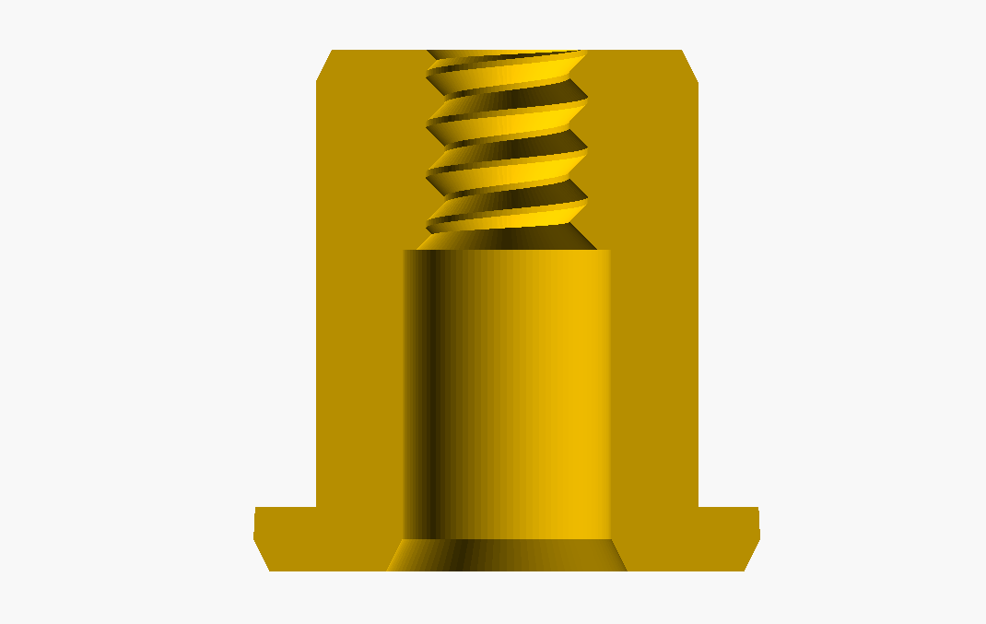
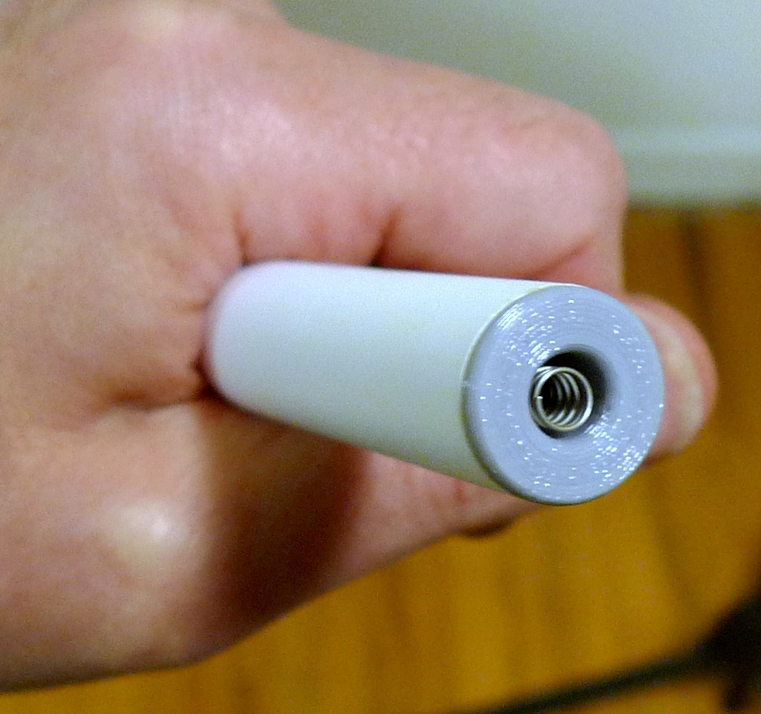
Top: Spring support antenna end plug, cutaway view.
Bottom: Spring flush with the end of the plug.
It took many test prints to get a thread that held the spring snugly, but not too snugly. It might be better to instead use a slightly smaller pitch to provide some friction, but this wasn’t tested.

Antenna Mounting Hardware
I modeled the antenna mounting hardware very loosely after the volume antenna support on Roger Hess’ P3 D-Lev, which employs a split brass compression ferrule to form a friction fit with the antenna OD by turning the outer knob / nut. However, I wanted to make it entirely of 3D printed parts, including the split ring ferrule. PEX is an extremely slippery plastic which makes it difficult to form a friction fit, and I found through experimentation that a 15 degree wall taper was necessary in order to exert enough pressure on the tubing without having to super torque the tightening knob. So the mounting hardware consists of a body, a split ring, an exposed tightening knob, and an internal nut to hold it all tight to the body of the Theremin.
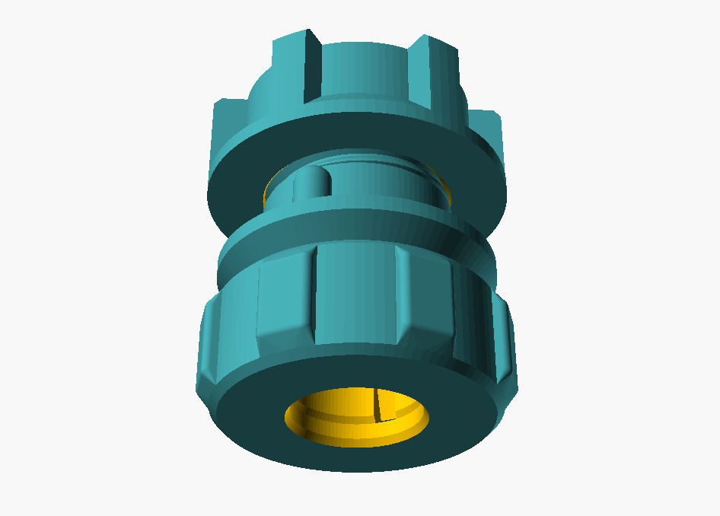
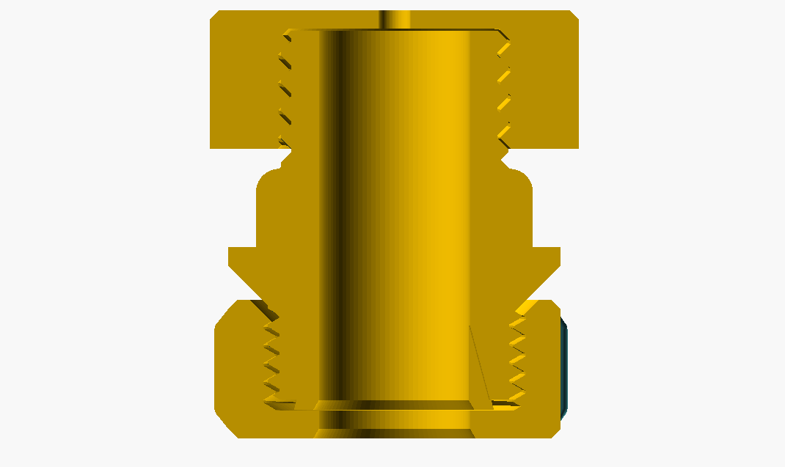
Top: Antenna mount tightening knob, body, and nut. The split ring is visible inside.
Bottom: Cutaway view of the assembly.
For smoothness of operation and mechanical advantage, a 60 degree M28 x 2 thread was used for the tightening knob. For more friction and hopefully stronger printed walls, a 90 degree M25 x 3 thread was used for the fixing nut. Two 5mm diameter locators on the body OD keep it from rotating when torquing the external knob. The nut has a 3mm hole to accommodate the electrical contact screw. The split ring diameters were printed 1mm oversize in order to make it spring out and open when not tight, facilitating easier insertion of the antenna rod.
The knob and body were printed in black PETG, the split ring in “space gray” PETG, and the nut in light gray PETG.
A stainless M3 socket head cap screw was used to make electrical contact with the antenna spring. On the contact side two lock washers and an M3 nut were added to give it some height, with a regular washer at the bottom. On the backside a regular washer, a lock washer, and an M3 nut were used.
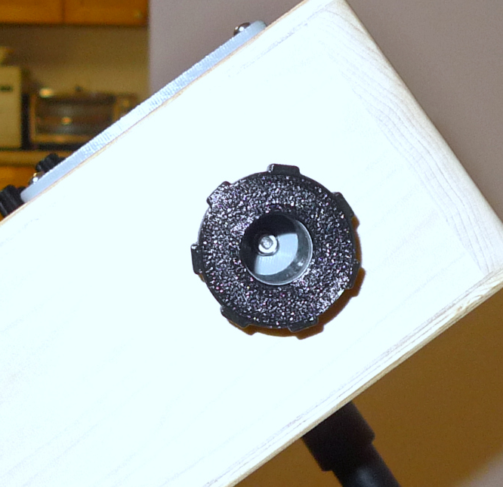
The M3 contact screw can be seen at the bottom of the antenna mount.

I/O Panel
An I/O panel was designed and 3D printed with light gray PETG. The connectors from left to right: MIDI TX (5-pin DIN); serial port & power (female USB B); power (SPDT center-off rocker switch); multi-connector (5-pin aviation connector); monitor stereo headphone-level output (¼” TRS); monitor stereo line-level output (¼” TRS).
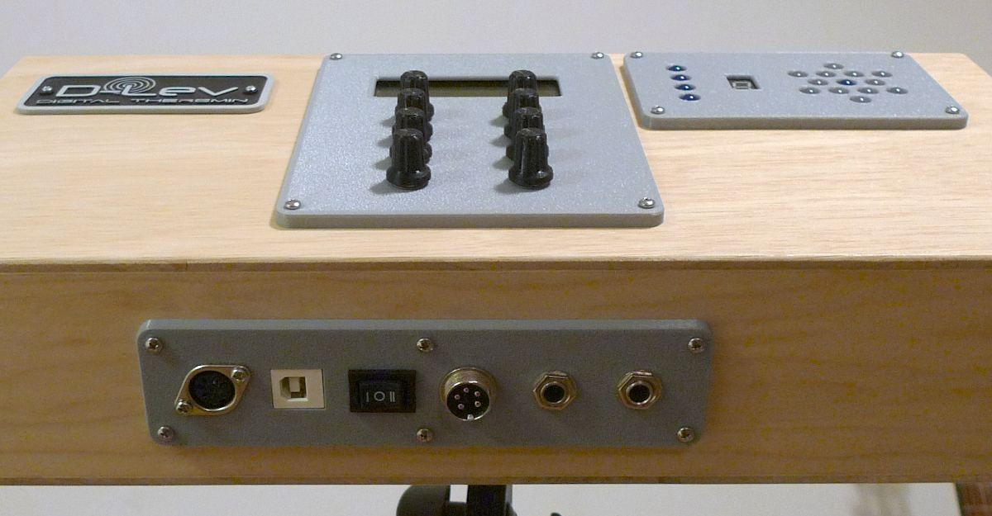
The I/O panel.

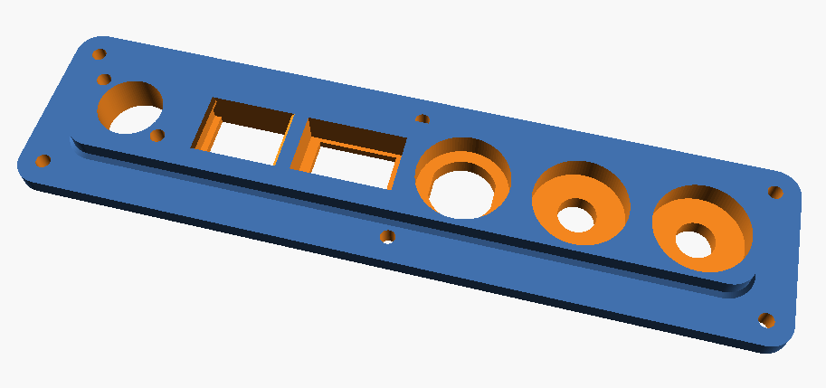
I/O panel rear view.
The left position of the power rocker selects USB powering; the right position selects multi-connector powering; the center position turns the D-Lev off. The multi-connector has pins for +5V power & ground, as well as for ACAL & mute footswitch control (clockwise starting at lower left: mute, ground, +5V, ground, ACAL). The two stereo outputs connect to a single internal Prozor DAC box, which is screwed to the mike stand flange plywood reinforcement.
The USB B connector is a keystone mount with a USB A type internal connector. Plugged into this is a USB TTL serial port PCB obtained from Amazon.
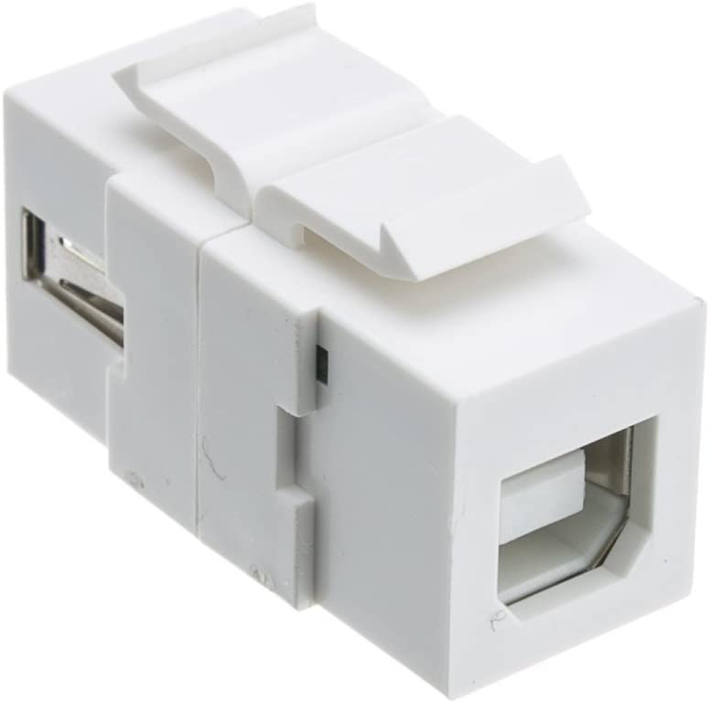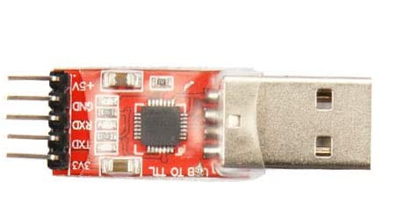
USB keystone connector (left); USB TTL serial PCB (right).
Except for the DAC box, all I/O panel electrical connections were via the D-Lev control board expansion port, which is a 2x8 IDC ribbon cable connector.

Final Thoughts
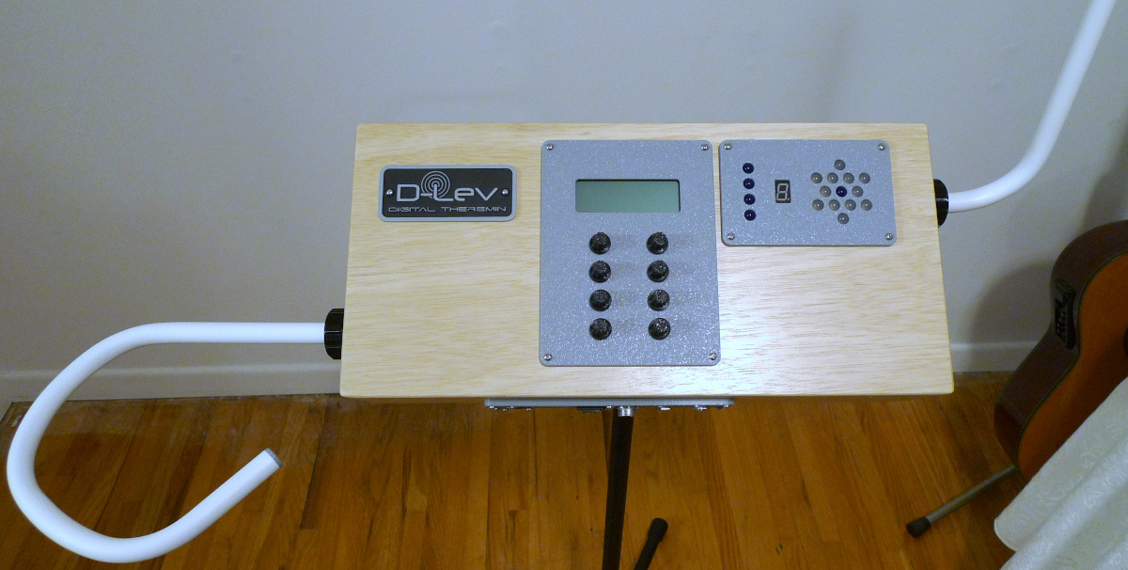
Player’s view of the D-Lev Tour.
- PEX tubing is fairly tricky to bend without getting it too hot and sagging. Use a timer and go slow. Buy a bunch of tubing and practice. Heating it with the spring inside seems to increase the chances of overheating. 90 degree bends are more prone to collapsing, and make it harder to snake whatever conductive material through. I’ve watched YouTube videos where they pour heated sand into the tube and turn the whole thing into a noodle – I haven’t tried this though, and would worry about maintaining a good circular profile at the mounting end.
- I wrote an openSCAD file to assist volume loop design, but found the length wasn’t constant through the centerline: the internal bend compresses more than the eternal bend expands. In the end I just eyeballed things and did a bunch of reheating touch-up. One shape turned out really nice and retro modern looking, but the bends unfortunately were overheated and saggy looking.
- If you bend with the volume antenna upside down (like if you were looking at it while lying on the floor) the bends tend to look better from the player’s perspective.
- PEX manufacturing lettering is easily removed with a bit of acetone, but only before heating, not after.
- Since the conductive diameters are the same, I attempted to keep the overall conductive lengths of the volume and pitch antennas roughly the same too.
- Cutting the I/O panel slot was nearly disastrous. I tried to use a router guide, but idiotically used it for the near side rather than the far side. Then the guide loosened and the cut wandered. The bit was rather dull so the wood shavings piling up in the slot smoldered and almost caught fire. The bit heated up and slowly worked its way out of the collet. I got lucky.
- I wish I’d taken more pictures, particularly of the I/O panel wiring.
- One secret to easy really crisp joinery is to cut things 2mm or so oversize and trim off the overhang with a flush cutting router bit. The corners should first be relieved with a file to keep them from splintering out when routing flush.
- If going for this component layout, I wouldn’t make the internal cabinet dimensions (400mm x 175mm x 75mm) any smaller, as that would make some of the installation / assembly impossible due to AFE box interference / too small for your hand to tighten the antenna mount nuts / etc.
- Were I to build it again, I’d probably locate the centerline of control panel 195mm from the left side of the case, rather than 200mm. This would give a ~10mm gap between the control and tuner panels and might be a bit nicer looking. The blueprint on the last page of this document is drawn with the 195mm location.
- I've been seriously punting on the whole cabinetry thing. Earlier on this was driven by my desire to gently push plates while avoiding woodwork. And my building of a rod-based model could be easily misinterpreted a tacit endorsement of rods, a reference standard as it were. These days I'm more sanguine (and resigned) about it all, particularly after an antenna capacitance experiment I performed a while back, but it’s my feeling is that the D-Lev linearization process works a little better with plates.
