IS216 Sample Large Lab Test (Set B) [40 marks]

General Instructions:
- This is a time-bound (2 hours), open-book, open-Internet, and individual test.
- You must test your web pages using Google Chrome Web Browser Version 129.0.x or later. Your graders will be using only Google Chrome Web Browser (Version 129.0.x or later) to test your web pages.

- No questions will be entertained by the IS216 teaching team (faculty/instructor/invigilators) during the test period. If necessary, make your own assumptions and proceed to complete test questions.

- You must use only standard HTML5, CSS, Bootstrap (Version 5.3), JavaScript, Axios, and Vue.js (Version 3) in your solutions unless the question specifies otherwise. Do not use any other third-party libraries (e.g. Angular, React, or others).

- Use meaningful names for HTML class/id and JavaScript variables and functions/methods. You must indent your code (HTML/CSS/JavaScript) properly. Failure to do so will attract a penalty of up to 20% of your score for the corresponding question.

- You MUST include your name as author in the comments of all your submitted source files. Failure to do so will attract a penalty of up to 20% of your score for the corresponding question.
For example, if your registered name is "KIM Jong Un" and email ID is kim.jongun.2022, include the following comment at the beginning of each source file you write.
HTML files | CSS, JavaScript files
<!--  Name: KIM Jong Un  Email: kim.jongun.2022  --> | /*  Name: KIM Jong Un  Email: kim.jongun.2022  */

- You may wish to comment out the parts in your code which cause errors. Commented code will not be marked.

Academic Integrity
- All student submissions will be thoroughly checked by an SMU-approved source code plagiarism checker software program AND an additional external software program. The source code checking will be conducted across all submissions (from 10 sections of IS216).
- Suspected plagiarism cases will be reported immediately to the IS216 faculty in charge and SCIS Dean’s Office for further investigation.
- Students in the suspected cases will be informed accordingly by their section faculty, and the incident will be escalated to the SMU University Council of Student Conduct.
- More information about the SMU Student Code of Conduct can be found at this link: https://academy.smu.edu.sg/code-conduct

Submission Instructions

- Due Date
  - XX November 2024 (xxx) XX:XX PM Singapore Time
  - Late submission policy is as follows:

Submit within 5 minutes of set deadline | 10% penalty of your entire test’s score
Beyond 5 minutes | 0 mark

- Zip up all files in Q1/Q2/Q3/Q4 folders into <YOUR_SMU_ID>.zip
  - For example, kim.jongun.2022.zip
- Verify by unzipping this zip file – check the content inside
- Incorrect submission file name WILL attract a penalty of up to 20% of your score for the entire test.

- Only zip format is accepted.
  - .7z, rar or other compression formats are NOT accepted.
  - Until the correct zip format is submitted again by the student, it will be assumed that the student has NOT made the submission and late submission policy will apply.

- Submit the zip file to the following location:
  - IS216-MERGED eLearn page: https://elearn.smu.edu.sg/d2l/home/398535
  - Go to Assignments Large Lab Test Submit your ZIP file
  - It is your (student’s) individual responsibility to ensure that the zip file submission was successful.
  - Your section faculty and Teaching Assistants will NOT verify the submission for you.

Legend
 Do NOT edit this given resource file.
 Your answer/code goes here into this given resource file.

IMPORTANT
Inside resources folder, you will find Bootstrap files. Please do NOT edit these files.
- Bootstrap\
  - bootstrap.bundle.min.js
  - bootstrap.min.css

Q1. [CSS, Bootstrap, JavaScript] Grocery [10 marks]
Given resources:
- Q1\
  - grocery.html
  - grocery.js

You are to edit grocery.html and grocery.js only. Do not create additional files.

IMPORTANT
You are free to define HTML elements and CSS style required to match the screenshots to the best of your interpretation where the requirement is not stated explicitly. This includes margin, padding, font style, font size, font weight, etc.

- grocery.html must only contain HTML and CSS code. You must write ALL JavaScript code inside grocery.js.
- JavaScript code written inside grocery.html will NOT be considered for grading.

Part A: Complete grocery.html

Complete the implementation of grocery.html such that when rendered in a web browser, grocery.html displays the following:
grocery.html
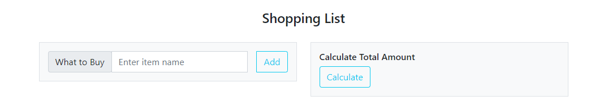

Please take note of the following user interface layout guidelines:

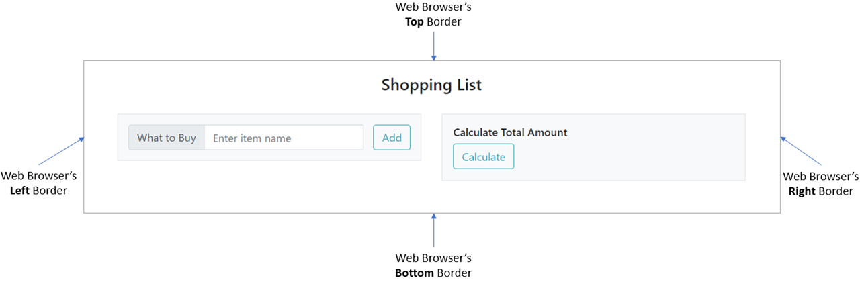

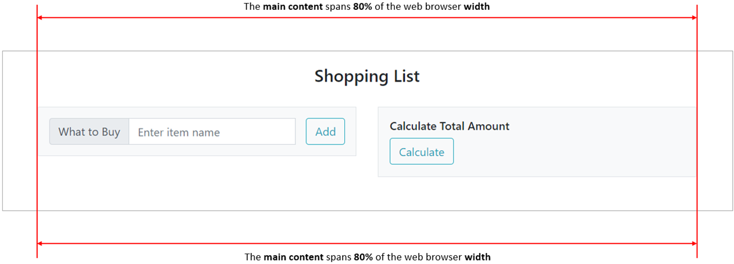

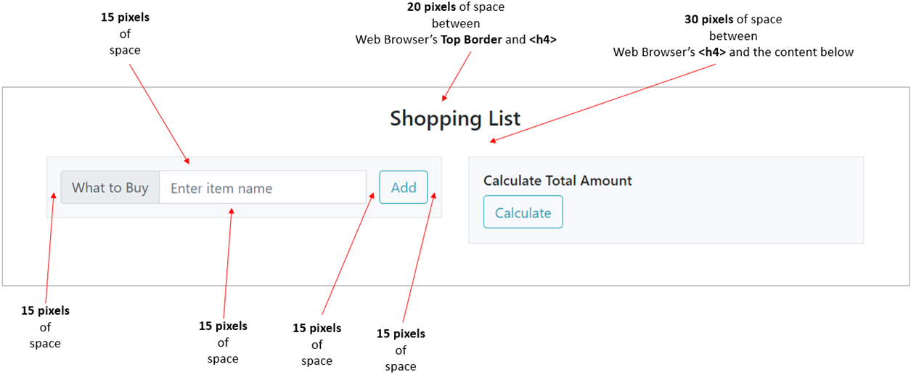

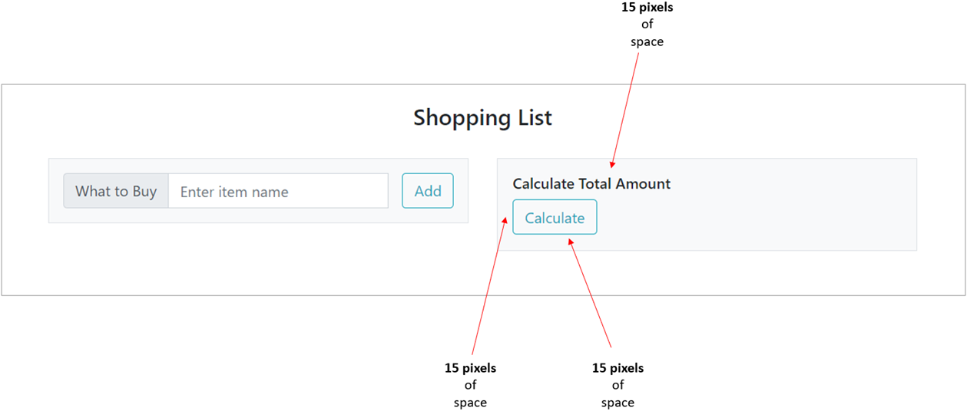

Part B: Complete grocery.js

Implement addItem() and processItems() such that the following user scenario is fulfilled.

grocery.html (before clicking Add button)
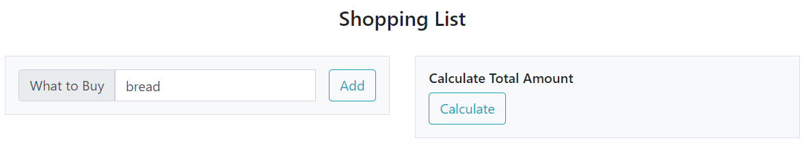

- The user keys in string/text bread in the input text field.
- The user clicks the Add button.

Grocery.html (after clicking Add button)
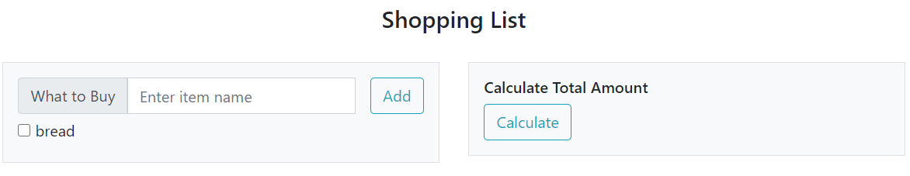

Item bread has been added with a checkbox.
Next, the user will add one more item.

grocery.html (before clicking Add button)
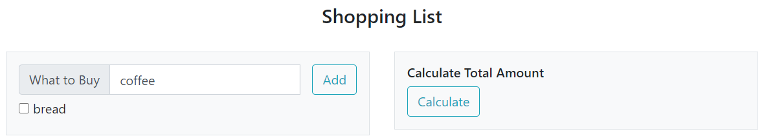

- The user keys in string/text coffee in the input text field.
- The user clicks the Add button.

grocery.html (after clicking Add button)
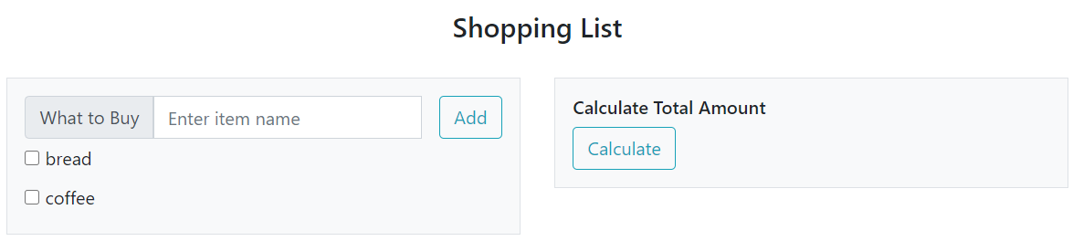

Item coffee has been added with a checkbox.
grocery.html (before clicking Calculate button)
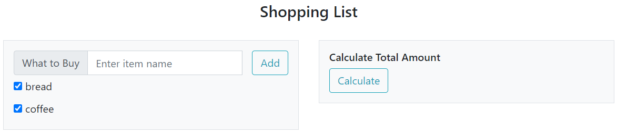

- The user selects both bread checkbox and coffee checkbox.
- The user clicks the Calculate button.

grocery.html (after clicking Calculate button)
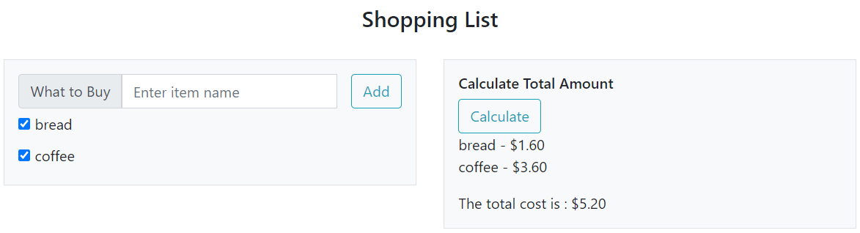

Below the Calculate button, each item’s name and its price are listed.
- Each item’s price information can be found in the shopList array in grocery.js.

Furthermore, the total cost is calculated and displayed below the item list.

Part C: Complete grocery.js

Modify addItem() and processItems() such that the following user scenario is fulfilled.

grocery.html (before clicking Add button)
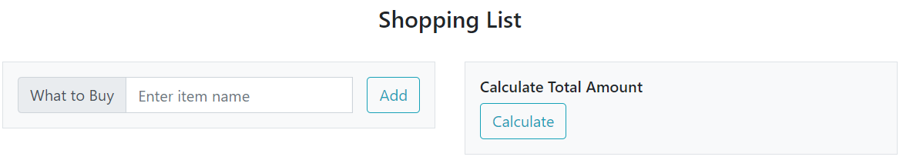

- The user does NOT key in anything in the input text field (leaving it empty).
- The user clicks the Add button.

grocery.html (after clicking on Add button)
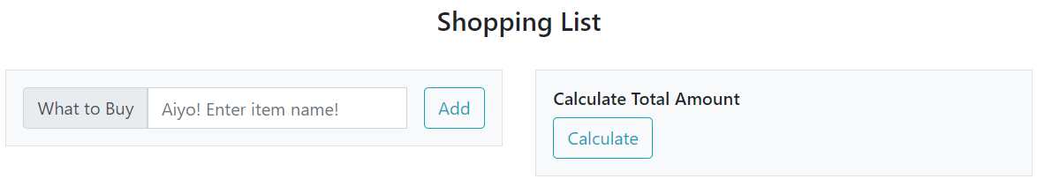

The input text field’s placeholder value has been updated to Aiyo! Enter item name!
Next, the user will add one item.

grocery.html (before clicking Add button)
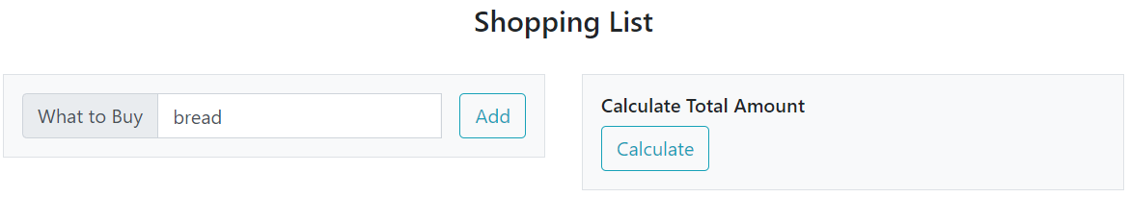

- The user keys in string/text bread in the input text field.
- The user clicks the Add button.

grocery.html (after clicking Add button)
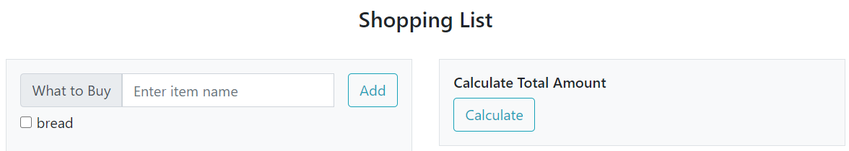

Item bread has been added with a checkbox button.
Next, the user will add one more item.

grocery.html (before clicking Add button)
- The user keys in string/text coffee in the input text field.
- The user clicks the Add button.

grocery.html (after clicking Add button)
Item coffee has been added with a checkbox button.

grocery.html (before clicking Add button)
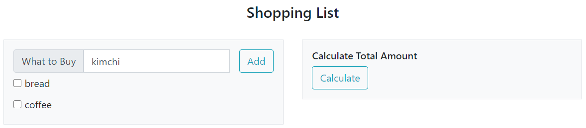

- The user keys in string/text kimchi in the input text field.
- The user clicks the Add button.

grocery.html (after clicking Add button)
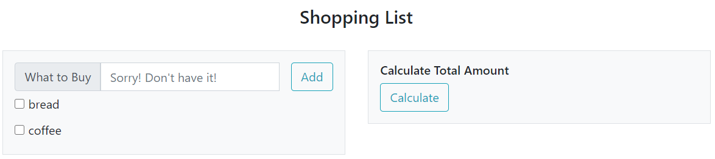

Item kimchi is NOT available in this shop (refer to the variable shopList in grocery.js file).
The input text field’s placeholder value has been updated to Sorry! Don’t have it!

- The user does NOT select any item checkboxes.
- The user clicks the Calculate button.

grocery.html (after clicking Calculate button)
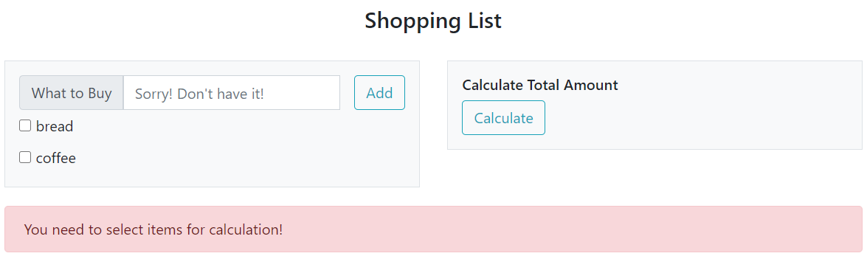

At the bottom of the webpage, an alert message is displayed with text You need to select items for calculation!

- Again, the user does NOT select any item checkboxes.
- The user clicks the Calculate button.

grocery.html (after clicking Calculate button for the 2nd time)
At the bottom of the webpage, an alert message is displayed with text You need to select items for calculation!
- If the user repeatedly clicks on the Calculate button without any items selected, grocery.html must display only ONE (1) alert notification at all times.

grocery.html (before clicking Calculate button)
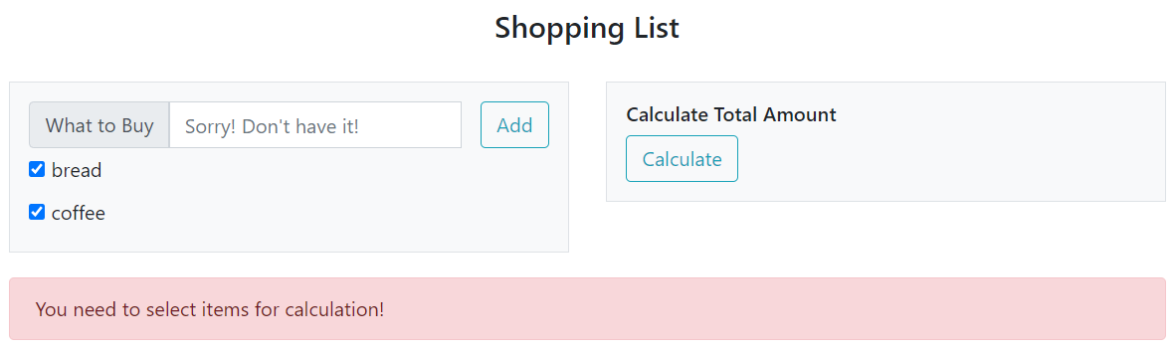

- Finally, the user selects both bread checkbox and coffee checkbox.
- The user clicks the Calculate button.

grocery.html (after clicking Calculate button)
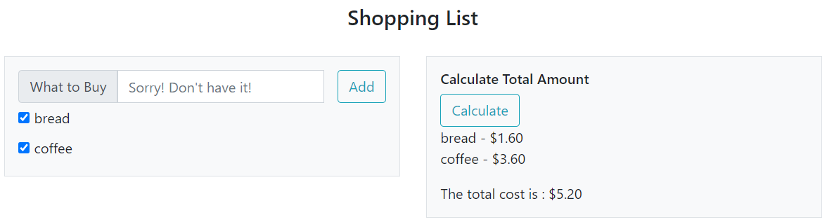

Below the Calculate button, each item and its price are listed. Furthermore,
- The total cost is calculated and displayed, and;
The alert notification is removed from the web page.

Q2. [Bootstrap, JavaScript, Axios] Oscars [10 marks]
Given resources:
- Q2\
  - krazyoscars/* (more folders & files)
  - axios.js
  - oscars.html
  - oscars.js

You are to edit oscars.html and oscars.js only. Do not create additional files.

IMPORTANT

Q2 krazyoscars contains API files.

- You do NOT need to see and understand the API source codes.

- You can view the API documentation at:
http://localhost/.../Q2/krazyoscars/index.html

- Go to Q2 krazyoscars config database.php
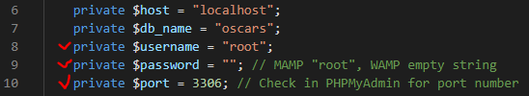
Please edit Lines 8, 9, 10 as per your local computer’s setup

- Go to Q2 krazyoscars db load.sql
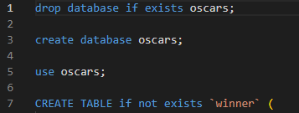
Use PHPMyAdmin (http://localhost/phpmyadmin/) or any MySQL client (e.g. MySQL WorkBench) to run all lines of SQL statements inside load.sql.

- Now, KrazyOscars API should be ready and you will be able to connect to and interact with it from your JavaScript code (oscars.js).

You are free to define HTML elements and CSS style required to match the screenshots to the best of your interpretation where the requirement is not stated explicitly. This includes margin, padding, font style, font size, font weight, etc.

- oscars.html must only contain HTML and CSS code. You must write ALL JavaScript code inside oscars.js.
- JavaScript code written inside oscars.html will NOT be considered for grading.
Part A: Complete the top heading in oscars.html

Edit oscars.html such that when rendered in a web browser, oscars.html displays the following at the top of the page:

oscars.html


Please take note of the following user interface guidelines:

- The height of the heading box (in aqua color) is 100 pixels.
- The heading box spans 100% of the web browser’s width
- There is no margin between the heading box and the top border of the web browser

Part B: Complete the dropdown menu in oscars.html

Complete implementation of oscars.html such that it displays the following when the user clicks on the “List of Decades” dropdown menu:

oscars.html
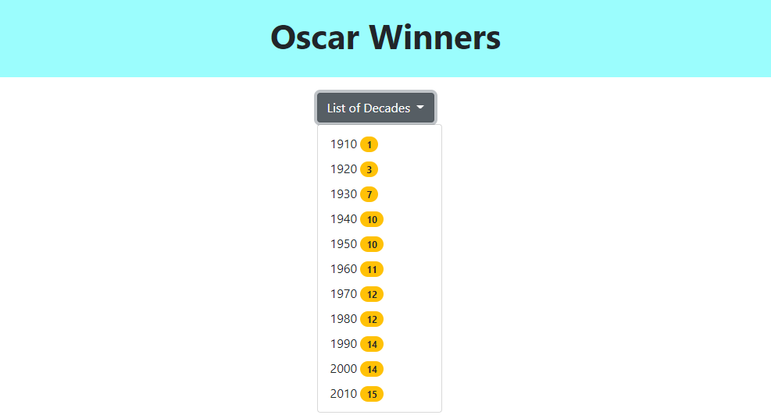

Please take note of the following user interface layout guidelines:
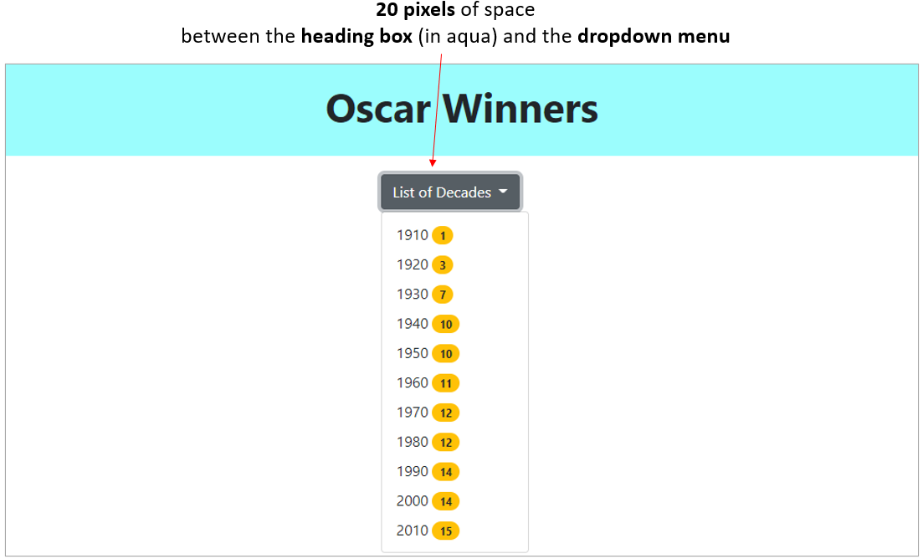

- The dropdown menu lists different decades (1910, 1920… and so on) during which Oscar awards were given.
  - For example, the decade of “1920” encompasses years 1920, 1921… all the way to 1929.
- The yellow circle on the right-hand side of each decade denotes the total number of Oscar winners in that decade.

Make appropriate changes in one or more source file(s) so that oscars.html displays the dropdown menu as shown above.

IMPORTANT
- Do NOT hardcode the decades (e.g. 1910, 1920, etc.) in the dropdown menu.
  - You must retrieve it dynamically by calling KrazyOscars API.

- Do NOT hardcode the total number of Oscar winners in the dropdown menu.
  - Your code must dynamically retrieve the values by calling KrazyOscars API.

- Your code MUST use relative URLs for API endpoints and images.
  - For example, an example of a relative URL (relative to the current file, e.g. oscars.html) is:
    - <img src="krazyoscars/images/cher.jpg"> ---> Use this!!!
    - <img src="http://localhost/krazyoscars/images/cher.jpg"> ---> DO NOT USE THIS!!!
  - Failure to do so will attract a penalty of up to 20% of your score for the entire Question 4.

Part C: Complete the main body in oscars.html

Complete implementation of oscars.html such that when rendered in a web browser, oscars.html displays the following:

oscars.html
(Web Browser Width 768 pixels)
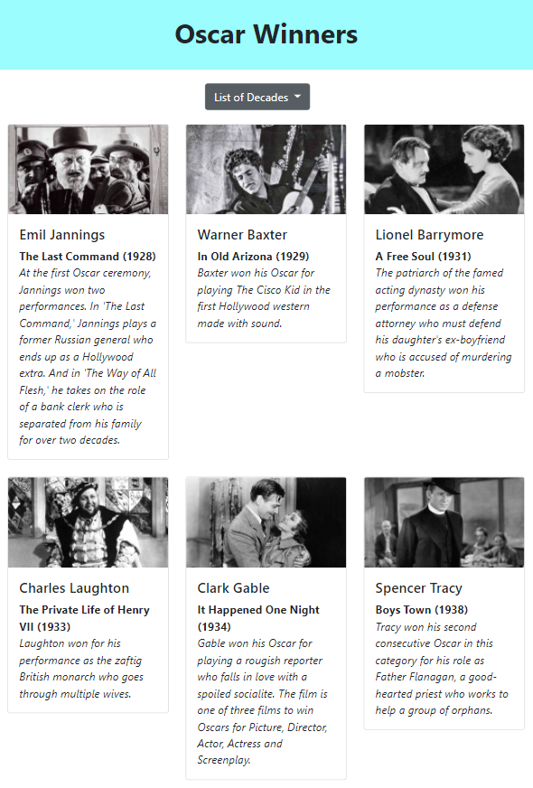
… there’s more content below…
oscars.html
(Web Browser Width 576 pixels)
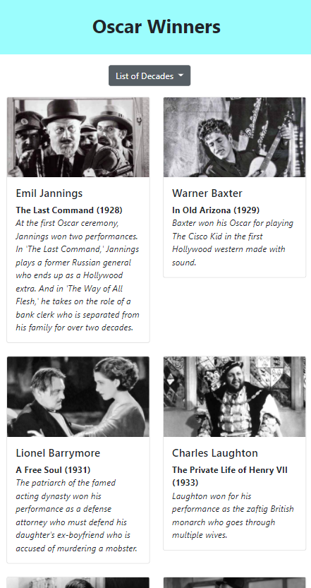
… there’s more content below…
oscars.html
(Web Browser Width 575 pixels)
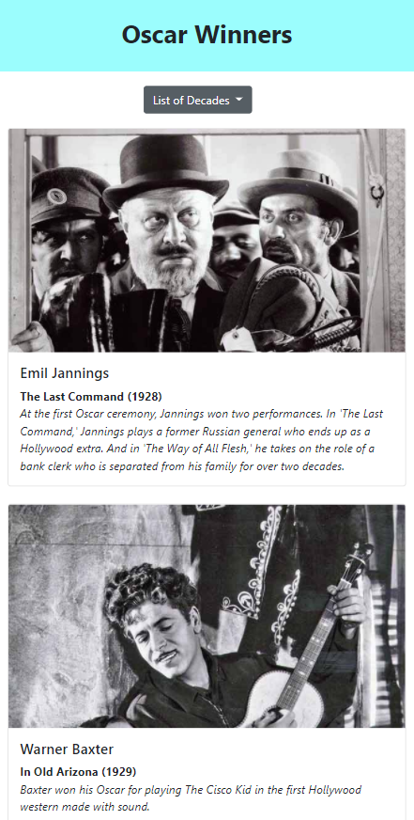
… there’s more content below…

- When the web page is loaded for the first time, it must display ALL available/retrievable Oscar winners and display each winner in a Bootstrap card. There are 109 Oscar winners in the API’s database.

- Note that each Oscar winner is to be rendered inside a Bootstrap card.

- Each card shows the details of an Oscar winner. Inside each card, style the content (e.g. Oscar winner’s name, movie title, year, and description) appropriately. Here is an example:

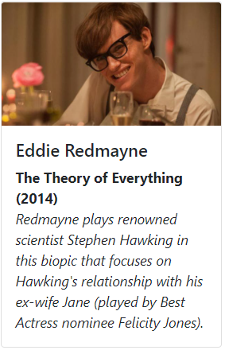

- Make appropriate changes in one or more source file(s) so that oscars.html displays as described above.

IMPORTANT: Your code MUST use relative URLs for API endpoints and images.
  - Failure to do so will attract a penalty of up to 20% of your score for the entire Question 4.

Part D: Complete the main body in oscars.html

When the user clicks on a decade in the dropdown menu, oscars.html must display only those Oscar winners who received the award in that decade. For example, below, the user clicks on 1920 (there are 3 Oscar winners in that decade). The red circle is an annotation used for illustration - it is NOT part of the web page.
oscars.html
(Web Browser Width 768 pixels)
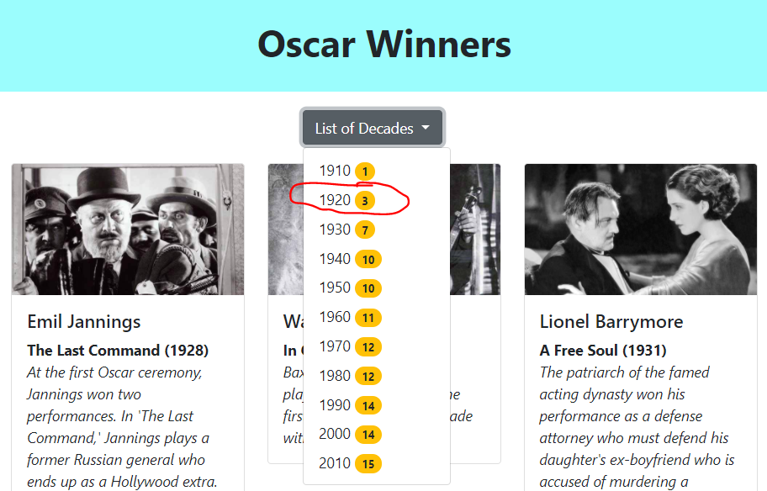

oscars.html must display as shown below. Only those Oscar winners who received the award in the 1920s (decade) are displayed.

oscars.html
(Web Browser Width 768 pixels)
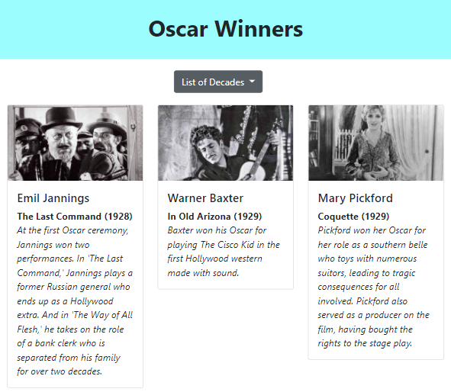

Make appropriate changes in one or more source file(s) so that oscars.html displays as described above.

IMPORTANT: Your code MUST use relative URLs for API endpoints and images.
- Failure to do so will attract a penalty of up to 20% of your score for the entire Question 4.

Q3. [Vue.js] Sentiment [10 marks]
Given resources:
- Q3\
  - vue.global.js
  - Sentiment.vue

You are to edit Sentiment.vue only. Do not edit the other files. Do not create additional files.

IMPORTANT
You are free to define HTML elements and CSS style required to match the screenshots to the best of your interpretation where the requirement is not stated explicitly. This includes margin, padding, font style, font size, font weight, etc.

First, please carefully inspect Sentiment.vue.

- It is a Vue component and it is used in App.vue .

- The Vue component already has data properties declared.
  - Please NOTE that you (as a developer) should NOT manually edit data() section inside Sentiment.vue except test cases (which you can simply comment/uncomment).
  - Your HTML and JavaScript code CAN access these data properties (e.g. read, edit).

Part A: Complete computed property greeting

Complete computed property greeting() in Sentiment.vue such that when rendered in a web browser, http://localhost:5173 displays the following:
http://localhost:5173

Header <h1> text
  - Please do NOT hardcode the header text.
  - The day text (e.g. Monday, Tuesday,…) must be derived from the current date/time.
    - HINT: JavaScript DATE()
    - You can also use data property numeric_to_day at the top of Sentiment.vue.
  - HINT: Which Vue directive can you use to retrieve the information from an existing Vue component data property?

Part B: Complete the <template> section in Sentiment.vue

Edit sentiment.vue such that when rendered in a web browser, the web page displays the following:

http://localhost:5173
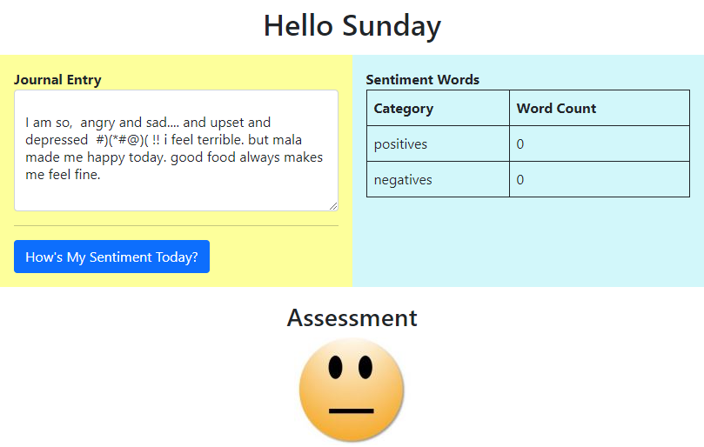

- Journal Entry
  - Please do NOT hardcode the journal entry text shown above.
  - HINT: Which Vue directive can you use to retrieve the information from an existing Vue component data property?
  - Later on, when the user keys in new journal entry text, your web application should be able to take this new data and update the corresponding Vue component data property.
- Table of sentiment words
  - Please do NOT hardcode the table data inside <tbody>…</tbody>.
  - HINT: Which Vue directives can you use to retrieve the information from an existing Vue component data property “sentiment_word_counts”?
- Assessment
  - Please do NOT hardcode the <img> tag’s src.
  - HINT: Which Vue directive can you use to retrieve the information from an existing Vue component data property?

Part C: Complete process_entry()

Complete Sentiment.vue such that when the user clicks on How’s My Sentiment Today? button, your web application will update the Table (on the right-hand side).

For example, see the above screenshot where the user wrote the following in the textarea:
I am so, angry and sad.... and upset and depressed #)(*#@)( !! i feel terrible. but mala made me happy today. good food always makes me feel fine.

Next, user clicked on How’s My Sentiment Today? button.

http://localhost:5173
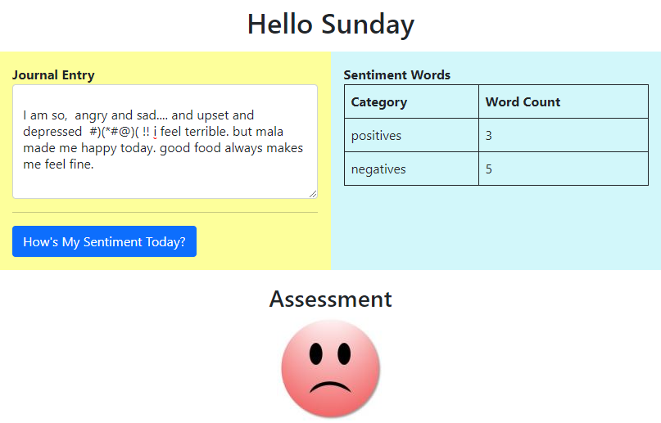

- Sentiment.vue shows the total number of positive words and the total number of negative words found in the journal entry in the Table (on the right-hand side).
  - You can use the following data properties declared in the Sentiment.vue:
    - sentiment_dictionary
    - regex
- Based on the positive/negative word counts, under Assessment, an image is displayed to reflect the overall sentiment.
  - You can use the following data properties declared in the Sentiment.vue:
    - image_sources

Another Test Case

Suppose the user keyed in the following journal entry:
i feel so FINE and happy. today is a terrific fabulous day !!!!

Next, user clicked on How’s My Sentiment Today? button. Sentiment.vue shows the analysis results in the Table. This time, Assessment shows a green smiley image.

http://localhost:5173
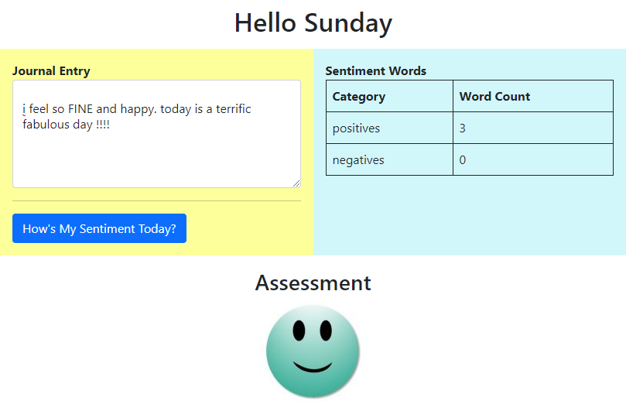

Q4. [Vue Components] FormatObject [10 marks]
Given resources:
- Q4\
  - App.vue
  - FormatObject.vue
  - vue.global.js

You are to edit FormatObject.vue only. Do not edit the other files.

Look through the codes in the given file App.vue.

Edit the given file FormatObject.vue to implement the Vue component FormatObject according to the following rules:

- If data is a simple type (e.g. String, numbers, Boolean, etc.), display data as an HTML text.
- If data is an object, display its properties as an HTML unordered list. Display each property in the following format where <name> and <value> are property name and property value respectively.
<name> : <value>
- If data is an array, display its elements as an HTML unordered list. Display each array element in the format where <index> and <value> are the index and value of the array element respectively.
[<index>] <value>
- Note that property values and array elements (<value> in points 2 and 3) can be another object, array or simple type. Apply the rules 1 to 3 recursively to display <value>.
Refer to the expected output of App.vue in browser for examples of the above rules:
Expected output | Corresponding data
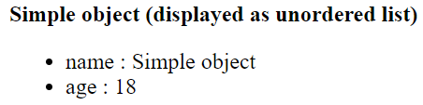 | {  name: 'Simple object',  age: 18  }
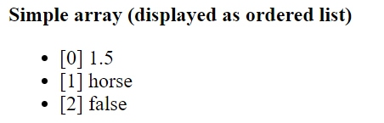 | [1.5, "horse", false]
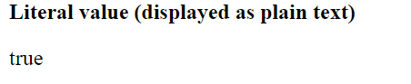 | true
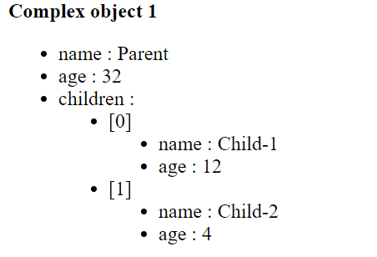 | {  name: 'Parent',  age: 32,  children: [  { name: 'Child-1', age: 12},  { name: 'Child-2', age: 4},  ]  }
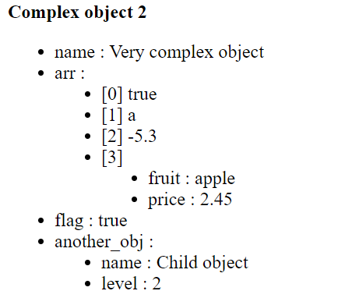 | {  name: 'Very complex object',  arr: [  true,  "a",  -5.3,  {  fruit: 'apple',  price: 2.45  }  ],  flag: true,  another_obj: {  name: 'Child object',  level: 2  }  }
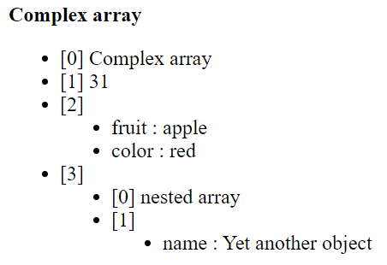 | [  "Complex array",  31,  {  fruit: 'apple',  color: "red"  },  [  'nested array',  {name: 'Yet another object'}  ]  ]
 | {}
 | []

Do NOT hardcode. The values in App.vue will be changed during grading.

