Legend


Do NOT edit this given resource file.
Your answer/code goes here into this given resource file.

Before you start coding, you need to run npm install in the terminal to install the required packages.

Q1. [Vue.js] Big Bang [7 marks]

Given resources:
src/components/Bigbang.vue
All other resources

Part A

Edit src/components/Bigbang.vue to have a web app that does the following:

- Contains radio buttons for the selection of Celebrity (there are a total of THREE (3) celebrities).
  - You cannot hard-code their info. You must retrieve it from the Vue component data.
- Contains checkboxes for the selection of Activities.
  - You cannot hard-code their info. You must retrieve it from the Vue component data.
  - All prices must be displayed in 2 decimal places.
- The “Bill Section” (below <hr>) should only be shown if the total_bill computed property (in the Vue instance) is a non-null value.
  - Do not modify total_bill computed property implementation in this Part A.
  - Use the given implementation as is. HINT: Observe what the computed property returns and think about how you can leverage it in the component template.

Your web app must display as below:

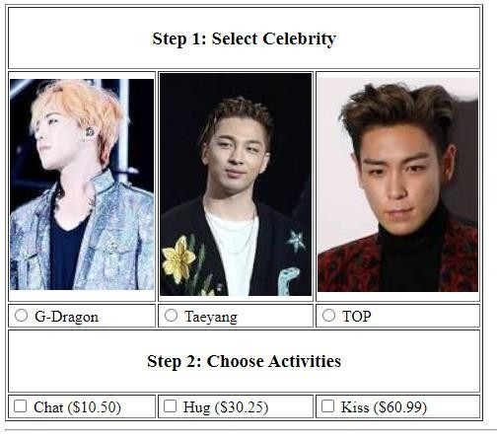

Part B

Edit src/components/Bigbang.vue so that the Bill Table appears in an HTML table that looks like below.

The “Bill Table” comes from total_bill computed property.
- By default, it returns null.
- Modify the implementation of total_bill computed property such that it returns an HTML table.
- Modify the component template such that the HTML table is correctly displayed.
- NOTE:
  - The “Bill Table” is displayed only if a celebrity is selected AND at least 1 activity is selected.
  - All prices and the total bill amount must be displayed in 2 decimal places.

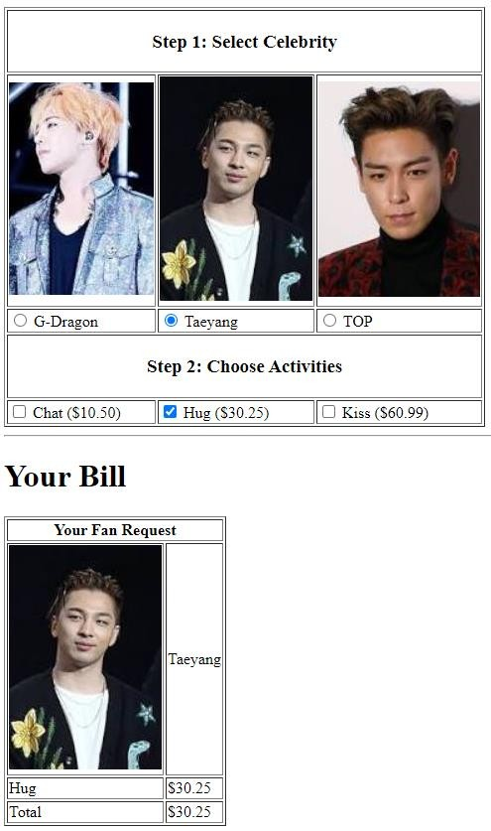

Sample Output (Q1)
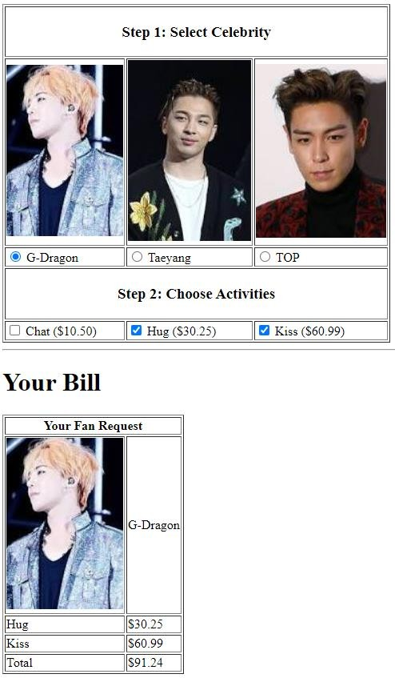

Q2. Hiking [8 marks]

Given resources:
src/components/q2.vue
src/components/q2-D.vue
All other resources

Ariana keeps track of her hikes by recording down how many steps she takes and whether each step was up (U) or down (D). A hike starts at sea level and ends at sea level. Each step up or down represents ONE (1) unit change in altitude. We define the following terms:
- A mountain is a sequence of consecutive steps above sea level, starting with a step up from sea level and ending with a step down to sea level.
- A valley is a sequence of consecutive steps below sea level, starting with a step down from sea level and ending with a step up to sea level.
For instance, given a hike path 'DDUUUUDD':
- She first enters a valley TWO (2) units deep (down).
- After that, she climbs out TWO (2) units high and then continues onto a mountain TWO (2) units high (up). She returns to sea level and ends her hike.

Part A

Complete the implementation of the method get_level(). It takes the hiker’s hike path (e.g. DDUUUUDD) as a String from the textarea (in <template>), and it returns the level at which the hiker is situated (at the end of the hike).
- If the level at which the hiker is situated is ZERO (0), it means the path is a VALID path (since we define a valid path to be the one where the hiker ends the hike at sea level).
- If the level at which the hiker is situated is a NEGATIVE NUMBER, it means the path is an INVALID path. It means that the hiker is still in a valley. The hike did NOT end yet and we declare this an INVALID path.
- If the level at which the hiker is situated is a POSITIVE NUMBER, it means the path is an INVALID path. It means that the hiker is still on a mountain. The hike did NOT end yet and we declare this an INVALID path.

Given a path DDUUUUDD, the method must return ZERO (0).
Given a path DDDDUUU, the method must return NEGATIVE ONE (-1). Given a path UUUUDD, the method must return POSITIVE TWO (2).

Part B

Complete the implementation of the method count_valleys(). It takes the hiker’s hike path (e.g. DDUUUUDD) as a String from the textarea (in <template>), and it returns the total number of valleys she walked through.

Given a path DDUUU, the method must return ONE (1).
Given a path DDDDUUU, the method must return ZERO (0).
Given a path DDDUUUDDUU, the method must return TWO (2).

Part C

Complete the implementation of the method count_mountains(). It takes the hiker’s hike path (e.g. DDUUUUDD) as a String from the textarea (in <template>), and it returns the total number of mountains she walked through.

Given a path UUUDDD, the method must return ONE (1).
Given a path UUUUDDD, the method must return ZERO (0).
Given a path UUUDDDUUDD, the method must return TWO (2).

Part D

When page q2-D.vue loads for the first time, it looks like the following:

q2-D.vue
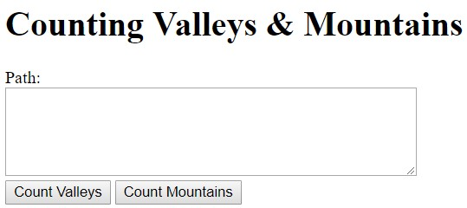

The page has:
- A textarea (empty)
- A button which displays “Count Valleys”
- A button which displays “Count Mountains”

Edit q2-D.vue so that it performs the following:

Sample Output
q2-D.vue  (before button click) | q2-D.vue  (after button click)
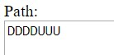  Click on either of the two SUBMIT buttons | 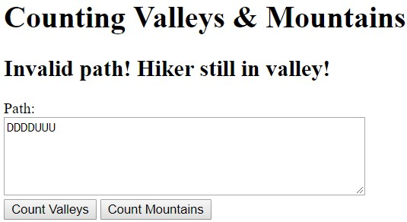
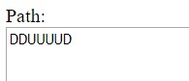  Click on either of the two SUBMIT buttons | 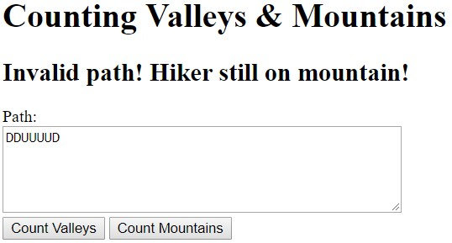
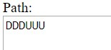  Click on “Count Valleys” SUBMIT button | 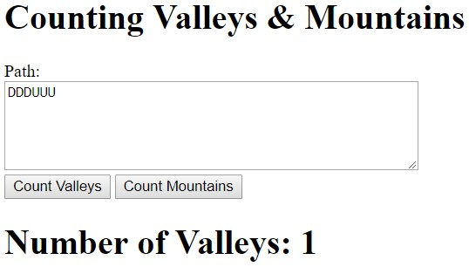
Click on “Count Mountains” SUBMIT button | 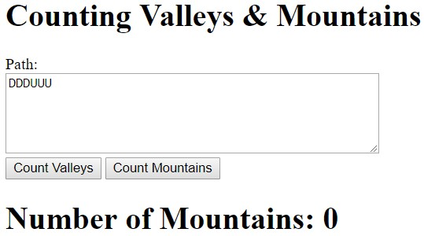
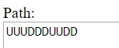  Click on “Count Mountains” SUBMIT button | 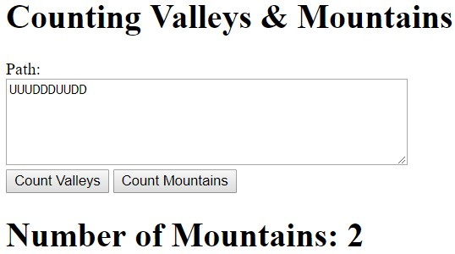
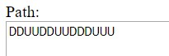  Click on “Count Valleys” SUBMIT button | 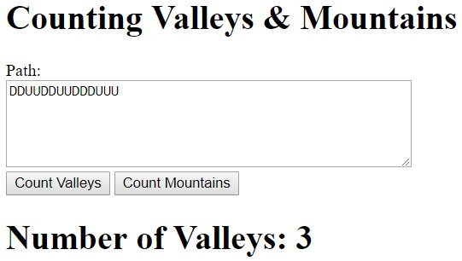

Part E

This time, a hiker’s path looks like the following (for example):

SDDUU

- The first character ‘S’ indicates the start of a hike, which occurs at sea level.
- Next, she enters a valley TWO (2) units deep (down).
- After that, she climbs out TWO (2) units high and reaches sea level.
- And, she is done with the hike.

Edit q2-D.vue such that the method print_path() outputs the hike path. The hike path can be retrieved from the textarea (in <template>).

Upon clicking “Show Hiking Path” button, q2-D.vue must correctly display the hike path’s altitude change as the hike progresses (Left to Right).

IMPORTANT: You MAY ASSUME that the user input path will always be a VALID HIKE. Please test your code against the below listed test cases ONLY.

q2-D.vue  (before button click) | q2-D.vue  (after button click)
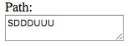 | 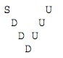
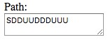 | 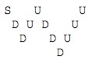
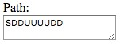 | 