IS216 Final Exam Practice Paper (Lab Test 2)
Table of Contents
Q1. Café Latte Vue (CSS, Vue.js) [10 marks] 2
Introduction 2
Part 1 — Look and Feel [5 marks] 2
Part 2 — Functionality [5 marks] 3
Q2. Registry of Adventurers (CSS, Vue.js) [10 marks] 4
Introduction 4
Part 1 — Look and Feel [4 marks] 4
Part 2 — Display the adventurer groups [6 marks] 5
Q3. Recipe Dashboard (Bootstrap, Vue.js) [10 marks] 7
Scenario: Recipe Card Dashboard 7
Part 1: Responsive Layout [4 marks] 7
Part 2: Vue.js Components [6 marks] 7
Q4. Contact Bridge (Javascript logic) [5 marks] 11

Disclaimer:
- In this paper, each question tests a mix of concepts (e.g. CSS and Vue.js). In contrast, each question typically focuses on a single topic in an actual paper.
- The marks allocation is arbitrary.

Q1. Café Latte Vue (CSS, Vue.js) [10 marks]
Given resources in folder q1
Barista.vue

Introduction
You’ve just been hired as the front-end developer for Café Latte Vue, a quirky coffee shop that wants to digitize their barista order board. Your job is to finish building a small Vue.js app (Barista.vue) that will allow baristas to:
- Enter drink orders
- Display them on a styled list
- Mark them as completed
Your project manager left behind partial HTML, Vue code, and instructions, but the app is unfinished. Your task is to complete the code using proper vanilla CSS and Vue.js directives.

Part 1 — Look and Feel [5 marks]
The manager wants the order board to look clean and organized. Write CSS rules that satisfy the following:
- All <h1> elements should have a dark brown color (#4b2e1e)
- All menu order items (class="order-item") must have:
  - light beige background (#f5f0e6)
  - 12px padding
  - 6px border-radius
- The drink input field drinkInput should have a 2px solid brown (#8b4513) border
- Inside list (class="order-list"), apply 10px bottom margin to direct child <li> elements only.
- Style both <button> and <li> with bold font.

Expected output and behaviour:
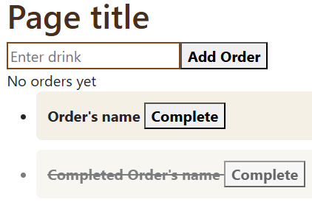

Part 2 — Functionality [5 marks]
Finish the Vue.js app so that baristas can interact with it properly.
- Display the shop name stored in shopName in the page title
- Bind the drink name input drinkInput to newDrink.
- When the “Add Order” button is clicked, call the method addOrder(), which pushes a new object into the orders array. Sample object:
{ name: "Value of the input text field", completed: false }
- Show "No orders yet" when orders array is empty. Show the list of orders otherwise.
- When the button “Complete” is clicked,
  - Set the corresponding order (drink)’s completed to true.
  - Apply the "completed" CSS class to drinks <li>.

Expected behaviour:

- Initial loading
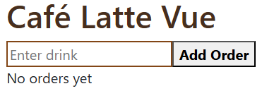
- Type “Milk” in the input text field
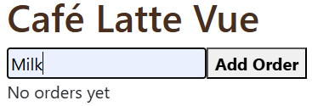
- Click “Add Order”
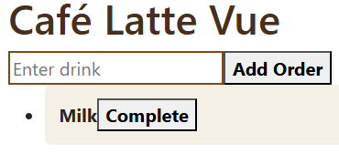
- Add “Tea”
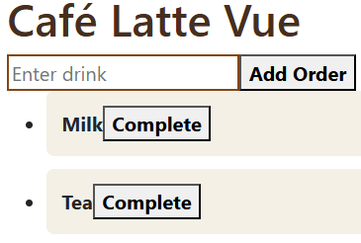
- Click “Complete” for Milk
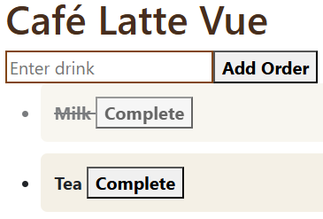

Q2. Registry of Adventurers (CSS, Vue.js) [10 marks]
Given resources in folder q2
Adventurers.vue
 data.js

Introduction
You’ve reincarnated in the fantasy country Camelot, and work as a clerk at the Guild of Adventurers. Their registry of adventurers’ notice board has been damaged in a recent attack by the demons. Your job is to rectify Vue.js app (Adventurers.vue) to:
- Display adventurer groups and its members
- Restore the original look and feel
Your task is to complete the code using proper vanilla CSS and Vue.js directives.

Part 1 — Look and Feel [4 marks]
The guild master wants the registry of adventurers’ board restore to its original look. Make use of existing CSS classes, write additional CSS rules that satisfy the following:
- The group of badges (class="badge-group") is at the top right corner of its corresponding <h3>.
- The link (class="toplink")
  - Has height and width of 50px
  - Is permanently at bottom right corner of the browser viewport regardless of scrolling and window size.

Expected look and feel:
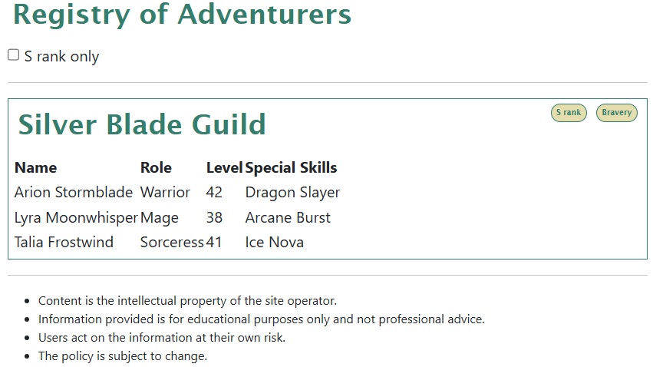
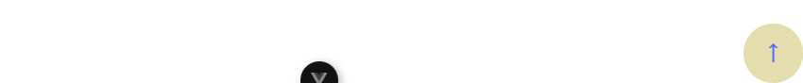

Part 2 — Display the adventurer groups [6 marks]
Finish the Vue.js app as described below. Do NOT edit the <script> section.
- Display adventurer groups, badges and its members’ details. The information is stored in groups.
- Bind the checkbox “S rank only” to srank_only.
- When the checkbox is ticked, display the groups with “S rank” badge only.

Expected output & behaviour:
- Initial loading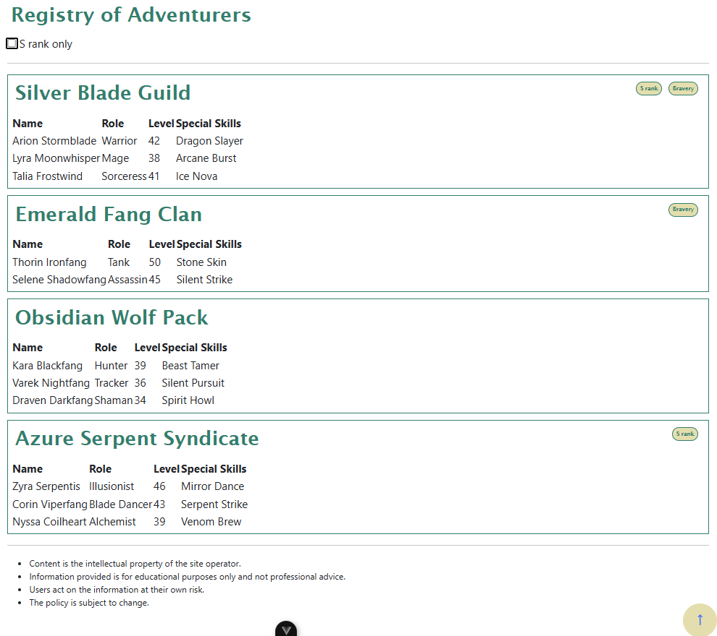
- Tick the checkbox “S rank only” 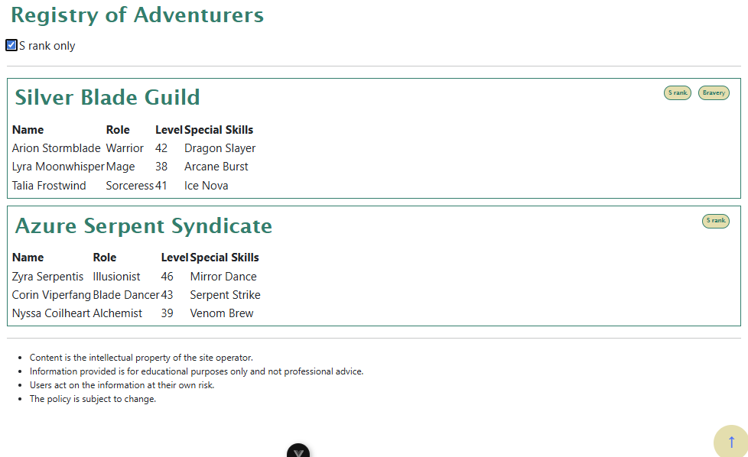

Q3. Recipe Dashboard (Bootstrap, Vue.js) [10 marks]
Given resources in folder q2
Dashboard.vue
RecipeCard.vue
data.js
/public/q3/*.jpg

Scenario: Recipe Card Dashboard
You are building a recipe dashboard for a cooking website. The dashboard should display recipe cards in a responsive layout and allow users to interact with recipes through favoriting.

Part 1: Responsive Layout [4 marks]
Create a responsive layout that displays recipe cards with the following behavior:
- < 768px: 1 card per row
- >=768px: 2 cards per row
- >=992px: 3 cards per row
Additionally,
- < 992px: The sidebar filter panel should appear below the recipe cards
- >=992px: The sidebar should appear on the left and has the same width as the cards
You should test at 575px, 576px, 768px, 992px.

Part 2: Vue.js Components [6 marks]
Implement the following Vue.js functionality:
- Display recipes
  - Dashboard displays all recipes using the child component RecipeCard.
  - RecipeCard displays the recipe’s details at the position indicated in the given resource file.
Sample recipe object
{
id: 1,
title: 'Spaghetti Carbonara',
description: 'Classic Italian pasta with eggs, cheese, and pancetta',
image: '/q3/Spaghetti Carbonara.jpg',
cookTime: '30 min',
difficulty: 'Medium'
}

  - Sets the background colour of the badge <span> (class="badge badge-difficulty") to according to the recipe’s difficulty by applying a corresponding Bootstrap class:
    - Easy: bg-success
    - Medium: bg-warning
    - Hard: bg-danger
- Add a recipe to favorites
  - RecipeCard emits a custom event favorite when the "Favorite" button is clicked, sending the recipe ID to the parent. You may add supporting methods.
  - Dashboard’s method handleFavorite is setup to handle the favorite event. Complete the method to find the recipe by id and adds its title to favoritedRecipes array.
- Customizable footer content.
  - Lastly, RecipeCard has a named slot to allow customizable footer content. Refer to Dashboard for more information on how the slot is used.

Expected output & behavior
575px | 576px
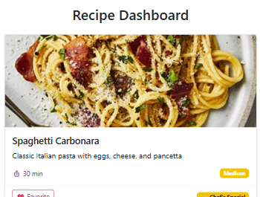  … Parts truncated for brevity’s sake…  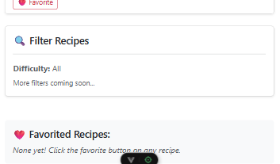 | 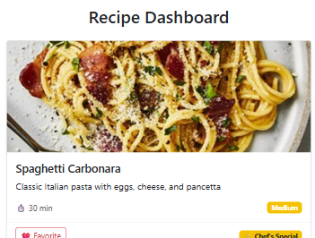  … Parts truncated for brevity’s sake…  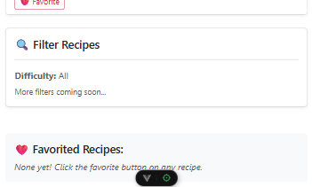

768px
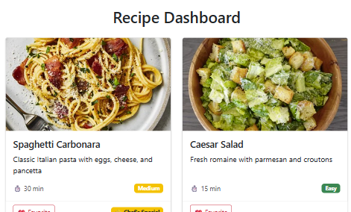
… Parts truncated for brevity’s sake…

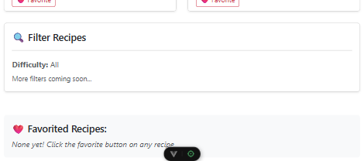

992px
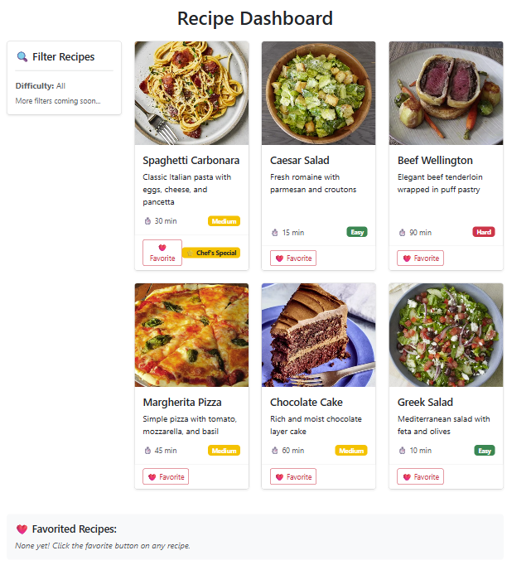

- Click Spaghetti Carbonara “Favorite” button
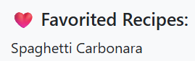
- Click Chocolate Cake “Favorite” button
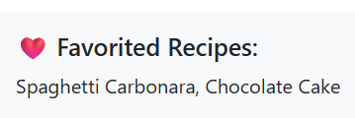

Q4. Contact Bridge (Javascript logic) [5 marks]
Given resources in folder q1
ContactBridge.vue
tests.js

In contract bridge,
- The suit rank order from highest to lowest is Spades, Hearts, Diamonds, and Clubs.
- Cards of equal suit are ranked by their card values from highest to lowest: (A, K, Q, J, 10, 9, 8, 7, 6, 5, 4, 3, 2).

Your task is to complete the method sort(cards) in the component ContactBridge to sort the given deck of cards from highest to lowest according to contract bridge rules.
- The parameter cards is an array of Strings representing the deck of cards.
  - E.g. ["C10", "SA", "H2", "D5"] for 10 of Club, Ace of Spade, 2 of Hearts, 5 of Diamond
- Each string element represents a card
  - The first character is the suit - "S", "H", "D", "C" for Spades, Hearts, Diamonds, and Clubs.
  - The rest is the card's value - A, K, Q, J, 10, 9, 8, 7, 6, 5, 4, 3, 2.
Example
let deck = ["C10", "H2", "SA", "H6", "D5"]
this.sort(deck)
After sorting, deck is ["SA", "H6", "H2", "D5", "C10"]

When completed, click the “Run Tests” button to check your code.
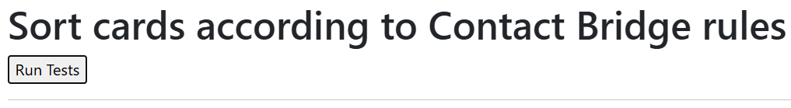
Running tests... Wed Nov 19 2025 10:02:15 GMT+0800 (Singapore Standard Time)
Test 1: Same suit
Data: ["C7","C5","C2","C8"]
Expected: ["C8","C7","C5","C2"]
Actual: ["C8","C7","C5","C2"]
PASS
Test 2: One of each suit
Data: ["C4","H3","D2","S2"]
Expected: ["S2","H3","D2","C4"]
Actual: ["S2","H3","D2","C4"]
PASS
Test 3: Duplicates
Data: ["H3","C4","D2","C4","H3","D2","S2","S2","C4"]
Expected: ["S2","S2","H3","H3","D2","D2","C4","C4","C4"]
Actual: ["S2","S2","H3","H3","D2","D2","C4","C4","C4"]
PASS
Test 4: Higher values
Data: ["S9","S10","SJ","SQ","SK","SA"]
Expected: ["SA","SK","SQ","SJ","S10","S9"]
Actual: ["SA","SK","SQ","SJ","S10","S9"]
PASS
Test 5: A mixture
Data: ["C7","D8","H9","S10","H5","SJ","H9","HQ","D8","DK","CA"]
Expected: ["SJ","S10","HQ","H9","H9","H5","DK","D8","D8","CA","C7"]
Actual: ["SJ","S10","HQ","H9","H9","H5","DK","D8","D8","CA","C7"]
PASS
TOTAL: 5 out of 5

