

United States Department of the Interior

U.S. GEOLOGICAL SURVEY
Wisconsin Water Science Center
8505 Research Way
Middleton, WI 53562-3586
Phone: (608) 828-9901
Fax: (608) 821-3817
http://wi.water.usgs.gov

June 2, 2012

MEMORANDUM
To: Steve Westenbroek, USGS-WiWSC, Middleton, WI
From: Mike Fienen, USGS-WiWSC, Middleton, WI
Subject: Response to Colleague review of manuscript: Response to Steve Westenbroek Colleague Review of Approaches in Highly Parameterized Inversion – bgaPEST: A Bayesian Geostatistical Approach Implementation with Pest – Documentation and Instructions
Dear Steve:
Thanks very much for your review of our manuscript Approaches in Highly Parameterized Inversion – bgaPEST: A Bayesian Geostatistical Approach Implementation with Pest – Documentation and Instructions. You provided valuable insights that will certainly improve the use and readability of the documentation. In the remainder of this document I have repeated your comments either in plain type or as a pasted graphic and responded in italics indicating my response and action taken. In the first section, I repeat and discuss the general comments made in your email message. In the second, I discuss your annotations in the PDF. In most cases, I adopted the change (as indicated by checking the box next to the comment in the PDF). Where I saw highlighting I checked the box but no changes were requested. In cases where the response was not straightforward or discussion is required, I clipped the annotation from the PDF and inserted it below.

General Comments
I have reviewed your bgaPEST documentation and have made numerous comments and suggestions in the attached annotated PDF document. Feel free to use the suggestions and comments as you see fit.
As I discussed with you some time back, I have not reviewed the mathematics contained in the document. Also, I have not yet had the opportunity to fire up the executable, although I hope to change that in the near future.
I think the document is well-written for a specialized professional (academic?) target audience. The document assumes knowledge and mastery of many high-level mathematical concepts, and will only make sense to a person already making use of PEST or UCODE(?!) software in model optimization exercises.
Unfortunately, try as I might, I still do not have a solid conceptual (intuitive) understanding of what goes on inside the software. As I indicated in my attached comments, the flow chart within the current document presents a view of the process that is perhaps too streamlined. I think that it is important to attempt to communicate (conceptually) the steps involved in the outer and inner loops so that the control variables within bgaPEST may be modified intelligently.
Please talk to me if any of my comments or suggestions is unclear.
Cheers,
- Steve
The other colleague reviewer made a similar comment regarding the target audience level of the Introduction. I have tried to clarify and adjust the discussion to a level requiring a bit less background knowledge. I have also revisited the flow chart to help expand on the conceptual understanding of the method and software.
Sincerely,

Specific Comments from the PDF Markup
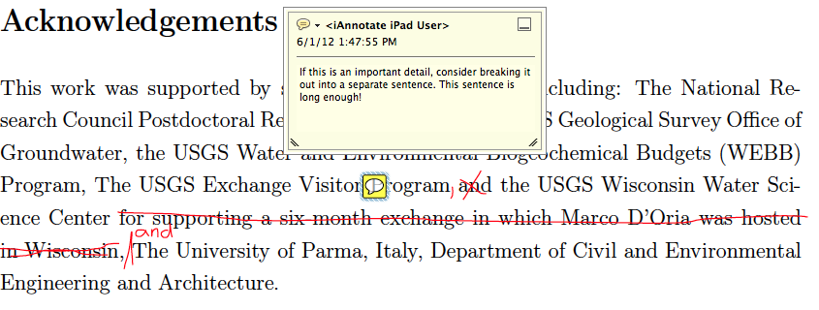
Unless there is a policy objection, I prefer to include mention of the 6-month exchange. I did split up the sentences, however.
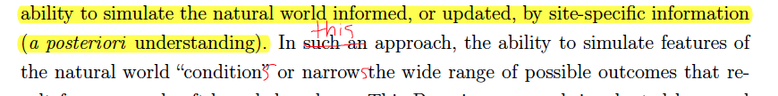
On this page, “such as” was changed to “this” and both “condition” and “narrow” were made plural.
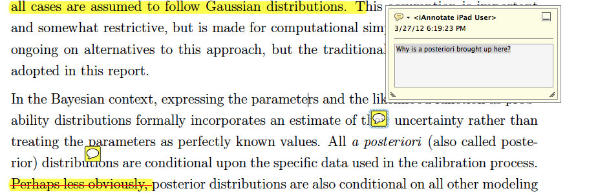
A posteriori is brought up in this paragraph to highlight the concept that all estimated parameter pdfs are posterior in the sense that they incorporate BOTH prior information and information from the experiment. This was described in a new sentence added just before equation #1.
Is "sufficient limitation" a term used in the geostatistical/optimization literature? I do not appreciate (fully understand) the meaning as used here...
“Sufficient” in this context has no special meaning, but the term is superfluous and was removed for clarity.
Beta association == subgroup or subset?
The paragraph where this comment appears was already dedicated to explaining beta associations. Furthermore, a box is provided later to help explain. It is complicated, but I’m not sure adding language at this spot would clarify things.
mu or x-bar in statistics... I've never seen beta used in this manner. Is there a particular branch of mathematics that tends to use this notation more than others?
Indeed, there are other cases where mu and x-bar and other terms are used. That’s why we said in the text beta is used in *the* mathematics – we are indicating that it is used in the specific mathematics supporting this work.
This section contains a lot of background information. It is hard to ferret out what exactly *this* report covers and does not cover. Suggest creating a background section to hold the more contextual / conceptual elements. In the purpose and scope please tell me what I can expect to find in the report, and what is beyond the scope and should be found elsewhere (e.g. Jupiter protocol, much PEST-specific background information, etc.)
I looked over this section (which is quite short) and I strongly feel the background in place is necessary context for outlining both the purpose and the scope. The background comes in more detail in the sections immediately following this one. As a result, I plan to retain the structure as it is.
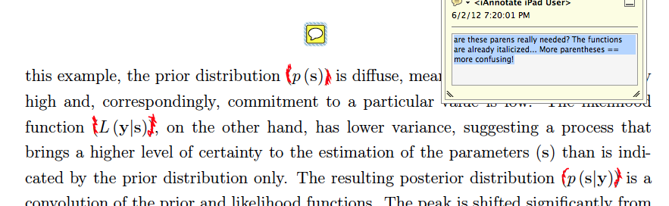
Indeed, these parentheses are not necessary and were removed.
Is there a sane reason why one would choose to use bgaPEST without optimizing structural parameters? This would seem to defeat the purpose...
Indeed, it is usually the case that structural parameters should be optimized for. However, many previous studies and PEST do not facilitate this estimation of structural parameters, so in bgaPEST it is possible to run the estimation holding them constant.
This is the first occurrence of "linesearch". I have only a vague sense of what you are talking about here.
I added text “(discussed below)” to the sentence where linesearch is first mentioned. I’ve struggled with the interweaving of theory and user instructions so in this case I realize it’s out of the blue a bit, but I think readers will be able to find the description where necessary.
I'd like to see a less abbreviated, more conceptual view of what actually takes place during the course of a bgaPEST run.
In other words, drop the programming paradigm and walk me through the steps that bgaPEST runs through during an outer iteration. What steps take place in an inner iteration? Don't worry at this point about if struct_par_opt == 1, because you haven't introduced that control variable yet anyway.
The main intended point of this chart was to show the difference between inner and outer iterations. I added explanatory text in blue to help fill in the gap and I hope that this further description
Is this independent of the # of gridcells?
Yes
These two items represent the two allowable forms of a block, no? Is there a way to indicate this visually by means of indentation?
Will try to do so in the final layout.
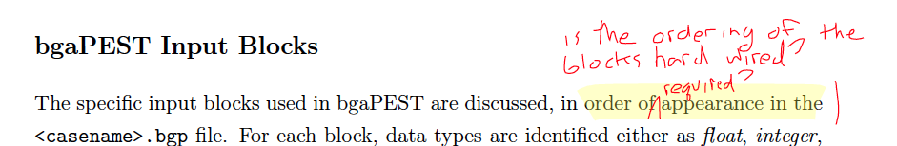
Yes – the order is required. Good observation. I added a sentence at this location making that point clear. Thanks for catching that!
I love this design strategy... Can you use different typography to make it obvious which values are absolutely required (i.e. have no default value)?
Rather than changing the typography for these, based on the other reviewer’s comments, I moved the default value to be adjacent to the variable name.
It looks as though all values in the algorithmic_cv block have default values. I assume this means that the entire block may be omitted?
Indeed, the entire block can be omitted as described in Appendix B on default values.
General note on this section:
I think that much of this information could be presented more effectively in a table format. I'd like to see a table that lists ALL of the possible block types, perhaps indicating at a glance which blocks are always required and which are optional.
The same can be said for the variable definitions within the individual blocks: it would be nice to be able to see which are always required in a block, and which have default values. Placing the default values in a separate column would mean that the reader would not have to scan for the last line of text to find the default value.
A summary table was created with all blocks and variables indicated along with default values. This table has been added as an appendix.
Is there a rule of thumb for estimating initial epistemic error?
This is discussed in the section on Level of Fit under Guidelines.
Um, I need a more complete definition here... Which parameters are you referring to?
Added the word “estimated” before parameters to be sure it is clear I am talking about the parameters being estimated.
You're talking about a bgaPEST parameter that is used to determine the behavior of the optimization algorithm upon the model parameters? It appears that you're referring to both types of "parameters" in this paragraph, Should perhaps refer to the SenMethod variable as opposed to parameter?
No. In this section we are only discussing parameters being estimated for the model. bgaPEST parameters are Structural Parameters. This is discussed clearly in the box Structural Parameters.
Ah. I see. I assumed that the x, y, and z were to be ignored as well.
I assume that for a time series at a point, x would in fact be the observation time?
Yes.
It would be nice to have a complete "bare-bones" file listed here as a figure.
Added one of the example input files from the example problems.
As we have discussed, three examples, differing primarily in dimensionality, don't offer me (at least) a lot of additional insight into the application of bgaPEST. An example pulled from another field, for example Marco's synthetic streamflow application, would offer a contrasting example regarding application of bgaPEST.
Indeed. We have added Marco’s surface water example. Thanks for the suggestion!

Mike Fienen
Research Hydrologist Phone (608) 821-3894
U.S. Geological Survey Fax (608) 821-3817
8505 Research Way email mnfienen@usgs.gov
Middleton, WI 53562

