Differential Effects of Exercise Modality on Cognition and Brain in Older Adults (COMET)

Eric Vidoni, PT, Ph.D. and Amanda N Szabo-Reed, Ph.D.

Table of Contents

# Report Summary

This section will be written by the PIs. This is a placeholder.

# Protocol Synopsis

## Project Organizational Chart, Personnel

## Brief Statement of Purpose of Trial

## Projected Timetable and Schedule

# Narrative / Trial Summary

## Study Status

## Summary of Past DSMB Meetings

### Action Items

### Resolution of Action Items

## Summary of Protocol Changes

# Recruitment and Participant Status: Figures and Tables

## Figure 1: Overall Study Status

Date as of: Jan 03, 2022

Date of report: Jan 13, 2022

Recruitment start date: Sept 09, 2021

Can’t export an html source. Get from scientist email.

## Figure 2: Enrollment: Actual vs. Expected

Date as of: Jan 03, 2022

Date of report: Jan 13, 2022

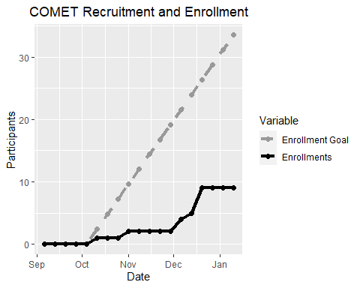

## Table 1: Participant Enrollment Status

Date as of: Jan 03, 2022

Date of report: Jan 13, 2022

| Participant Enrollment Status | | |
| --- | --- | --- |
| rowname | N | Percent |
| Enrolled | 9 | 100 |
| Active | 9 | 100 |
| Completed | 0 | 0 |
| Discontinued Treatment/Follow-up Continued | 0 | 0 |
| Discontinued from Study | 0 | 0 |

## Table 2: Reasons for Screen Failures

Date as of: Jan 03, 2022

Date of report: Jan 13, 2022

| Reasons for Screen Failures | | |
| --- | --- | --- |
| Screen Fail Reason | n | Percent |
| Considered Active | 5 | 7 |
| Discomfort with Procedures | 1 | 1 |
| Distance to Study Activities | 1 | 1 |
| Neurological or Psychiatric Condition | 5 | 7 |
| New Reason - Need to update | 2 | 3 |
| Other - see below | 1 | 1 |
| Travel more than 4 weeks | 8 | 11 |
| Missing Reason | 0 | 0 |
| Total Screen Fail | 23 | 32 |
| Total Screened | 72 | 100 |

| Other |
| --- |
| Husband died after initial screen |

## Table 3: Protocol Deviations

Date as of: Jan 03, 2022

Date of report: Jan 13, 2022

| Protocol Deviation | n | Since Last DSMC Report |
| --- | --- | --- |
| Did not meet inclusion/exclusion criteria | 1.00 | 1.00 |
| Total # of Deviations | 1.00 | 1.00 |
| Participants Enrolled | 9.00 | 9.00 |
| Deviations per Participant | 0.11 | 0.11 |

## Table 4: Demographic and Key Baseline Characteristics

Date as of: Jan 03, 2022

Date of report: Jan 13, 2022

| Characteristic | N = 91 |
| --- | --- |
| Race |  |
| White | 9 (100%) |
| Ethnicity |  |
| Not Hispanic or Latino | 9 (100%) |
| Gender |  |
| Man | 2 (22%) |
| Woman | 7 (78%) |
| Age | 72.2, 71.0 (4.4,67.0,80.0) |
| 1n (%); Mean, Median (SD,Minimum,Maximum) | |

## Table 5: Treatment Duration for All Participants

Date as of: Jan 03, 2022

Date of report: Jan 13, 2022

| Treatment Duration for All Participants | | |
| --- | --- | --- |
| Total N = 9 | | |
| Time in Study | n | Percent |
| Baseline | 9 | 100 |
| Week 26 | 0 | 0 |
| Week 52 | 0 | 0 |

# Safety Assessments for All Participants: Tables and Listing

## Table 6: Treatment Duration for All Participants

Date as of: Jan 03, 2022

Date of report: Jan 13, 2022

| Total Events | |
| --- | --- |
| Adverse Events | Not Related, N = 11 |
| Body System and Preferred Term |  |
| Respiratory, thoracic and mediastinal disorders - Dyspnea | 1 (100%) |
| 1n (%) | |
| N equals the total number events | |

Text to fill space

| Total Participants | |
| --- | --- |
| Total Consented = 14 | |
| Adverse Events | Not Related, N = 11 |
| Body System and Preferred Term |  |
| Respiratory, thoracic and mediastinal disorders - Dyspnea | 1 (100%) |
| 1n (%) | |
| N equals the total number of participants with an AE (each participant is counted once). | |
| The denominator to find percent of participants with AEs is total consented | |

## Add another column calculating the percent of elibible participants who have an AE. Couldn't figure out in gtsummary.

## Table 7: Severity of Adverse Events by Preferred Term

Date as of: Jan 03, 2022

Date of report: Jan 13, 2022

| Adverse Events | Grade 2; Moderate, N = 11 |
| --- | --- |
| Preferred Term |  |
| Dyspnea | 1 (100%) |
| 1n (%) | |

## Listing 1: Serious Adverse Events

Date as of: Jan 03, 2022

Date of report: Jan 13, 2022

## There have been no serious adverse events

## Listing 2: Deaths

Date as of: Jan 03, 2022

Date of report: Jan 13, 2022

## There have been no deaths.

## Listing 3: Adverse Events

Date as of: Jan 03, 2022

Date of report: Jan 13, 2022

| Study ID | Weeks on Intervention | Preferred Term | Related | Severity | Serious | Initiated as Event of Interest |
| --- | --- | --- | --- | --- | --- | --- |
| 8 |  | Dyspnea | Not Related | Grade 2; Moderate | No | No |