Title

Authors

Table of Contents

# Protocol Synopsis

Edit here for protocol synopsis

## Project Organizational Chart, Personnel

the org chart file can be found here P:/IRB_STUDY0011132_Cohort/RIS_code/BOLD_dsmc/data/dsmc_report/org_chart.xlsx. Please edit and save the file to update.

| **Personnel** | **Role** | **Team** |
| --- | --- | --- |

## Brief Statement of Purpose of Trial

Edit the purpose below to fit the needs of the BOLD project.

The purpose of this study is to test the combined and independent effects of aerobic and resistance training on:

1. cognitive performance
2. regional brain volume
3. cardiorespiratory fitness and strength
4. fluid biomarkers

The study is registered as NCT04848038, <https://clinicaltrials.gov/ct2/show/NCT04848038>

## Projected Timetable and Schedule

To import a project timeline, save a .png file over this file: P:/IRB_STUDY0011132_Cohort/RIS_code/BOLD_dsmc/data/dsmc_report/project_timeline.png 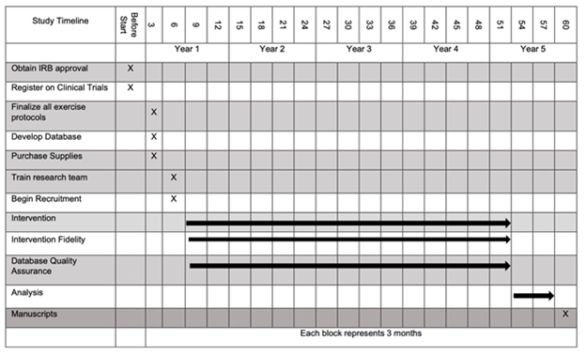

# Recruitment and Participant Status: Figures and Tables

## Figure 1a: Screening Consort Diagram

Date as of: Nov. 11, 2023

Date of report: Nov 12, 2023

Recruitment start date: Sept 09, 2021

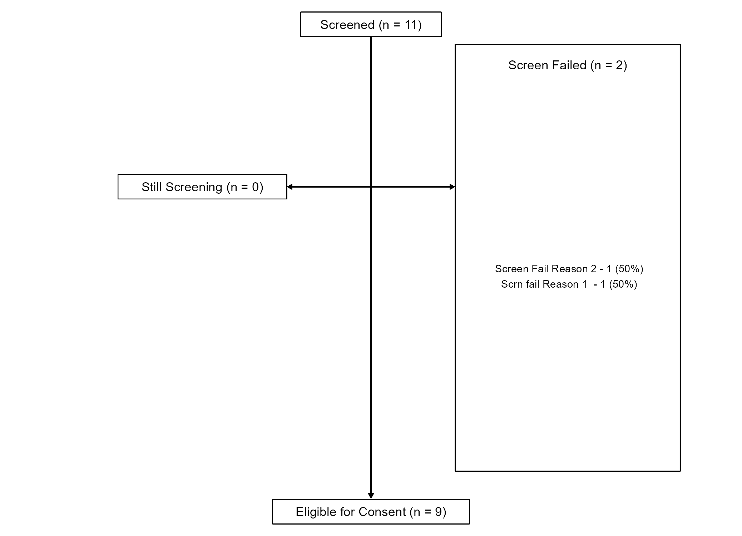

## Figure 1b: Enrollment Consort Diagram

Date as of: Nov. 11, 2023

Date of report: Nov 12, 2023

Recruitment start date: Sept 09, 2021

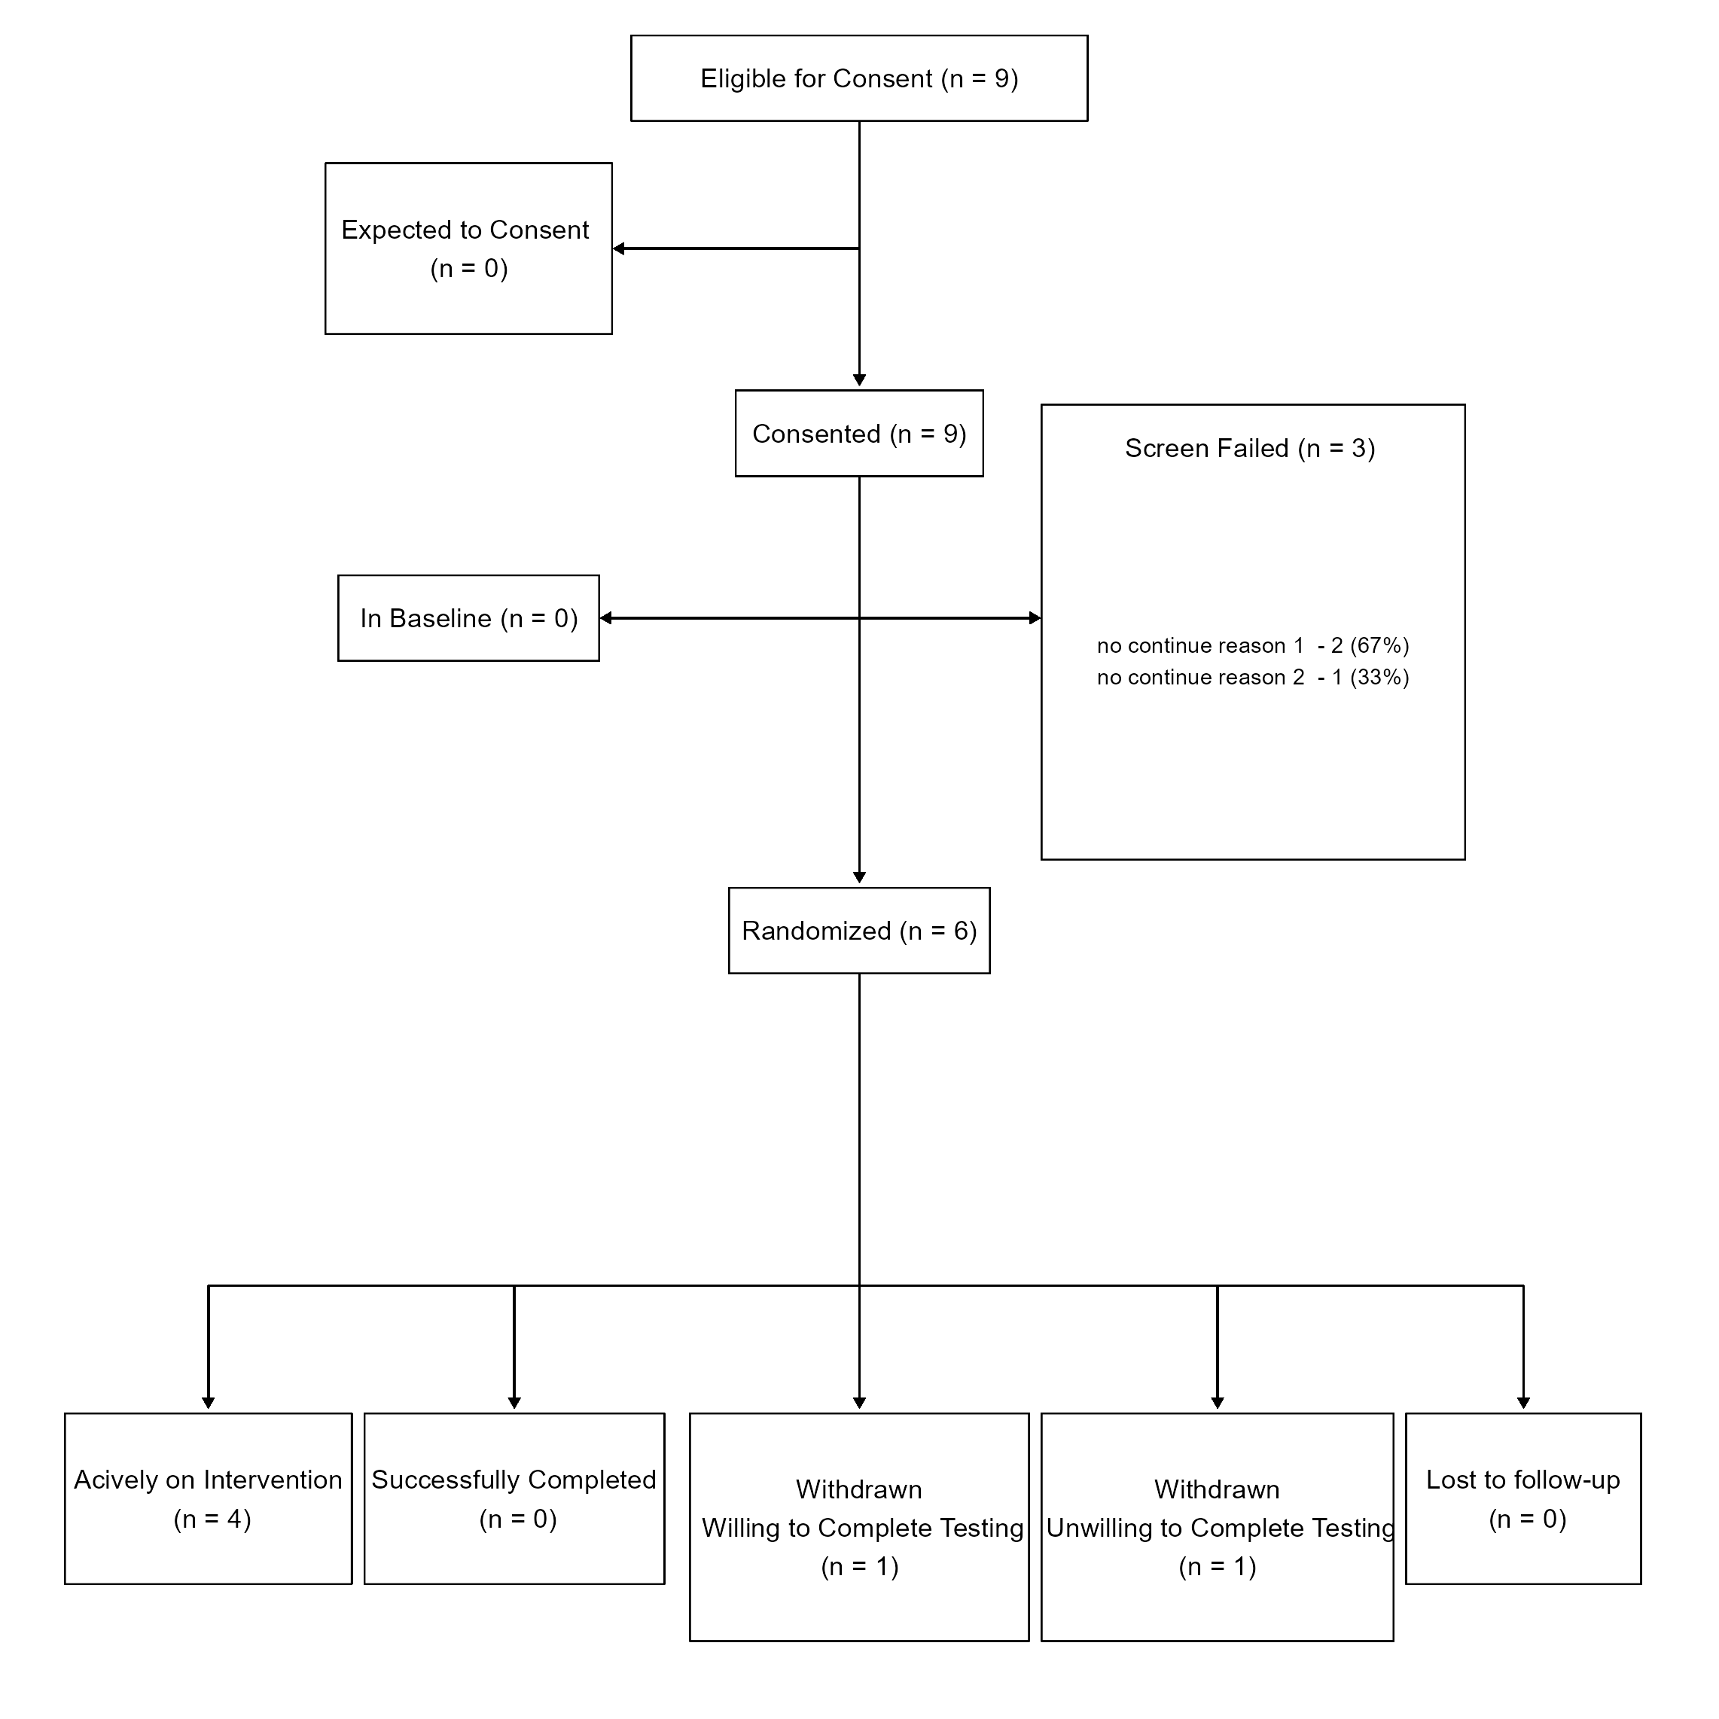

## Figure 2: Enrollment: Actual vs. Expected

Date as of: Nov. 11, 2023

Date of report: Nov 12, 2023

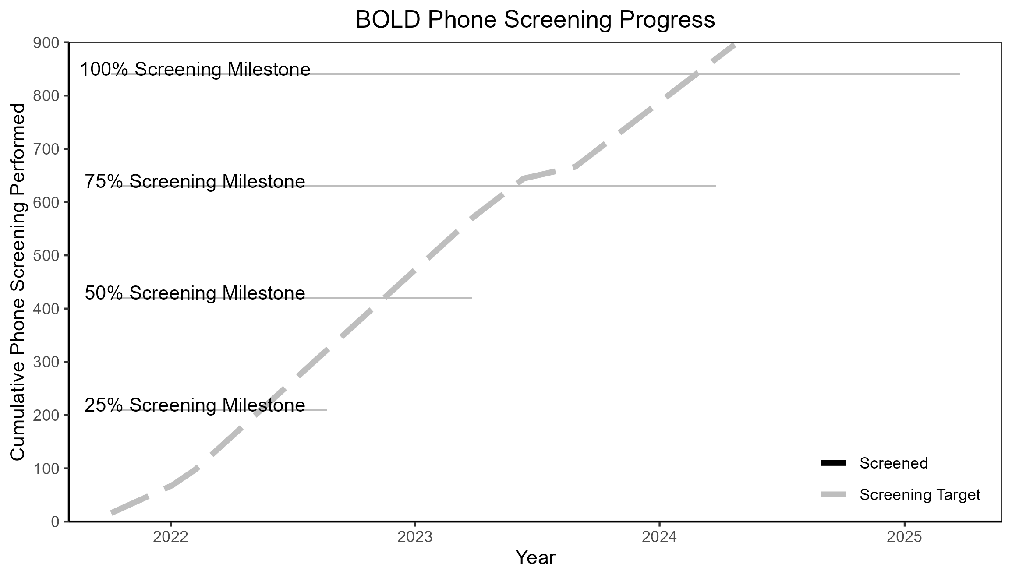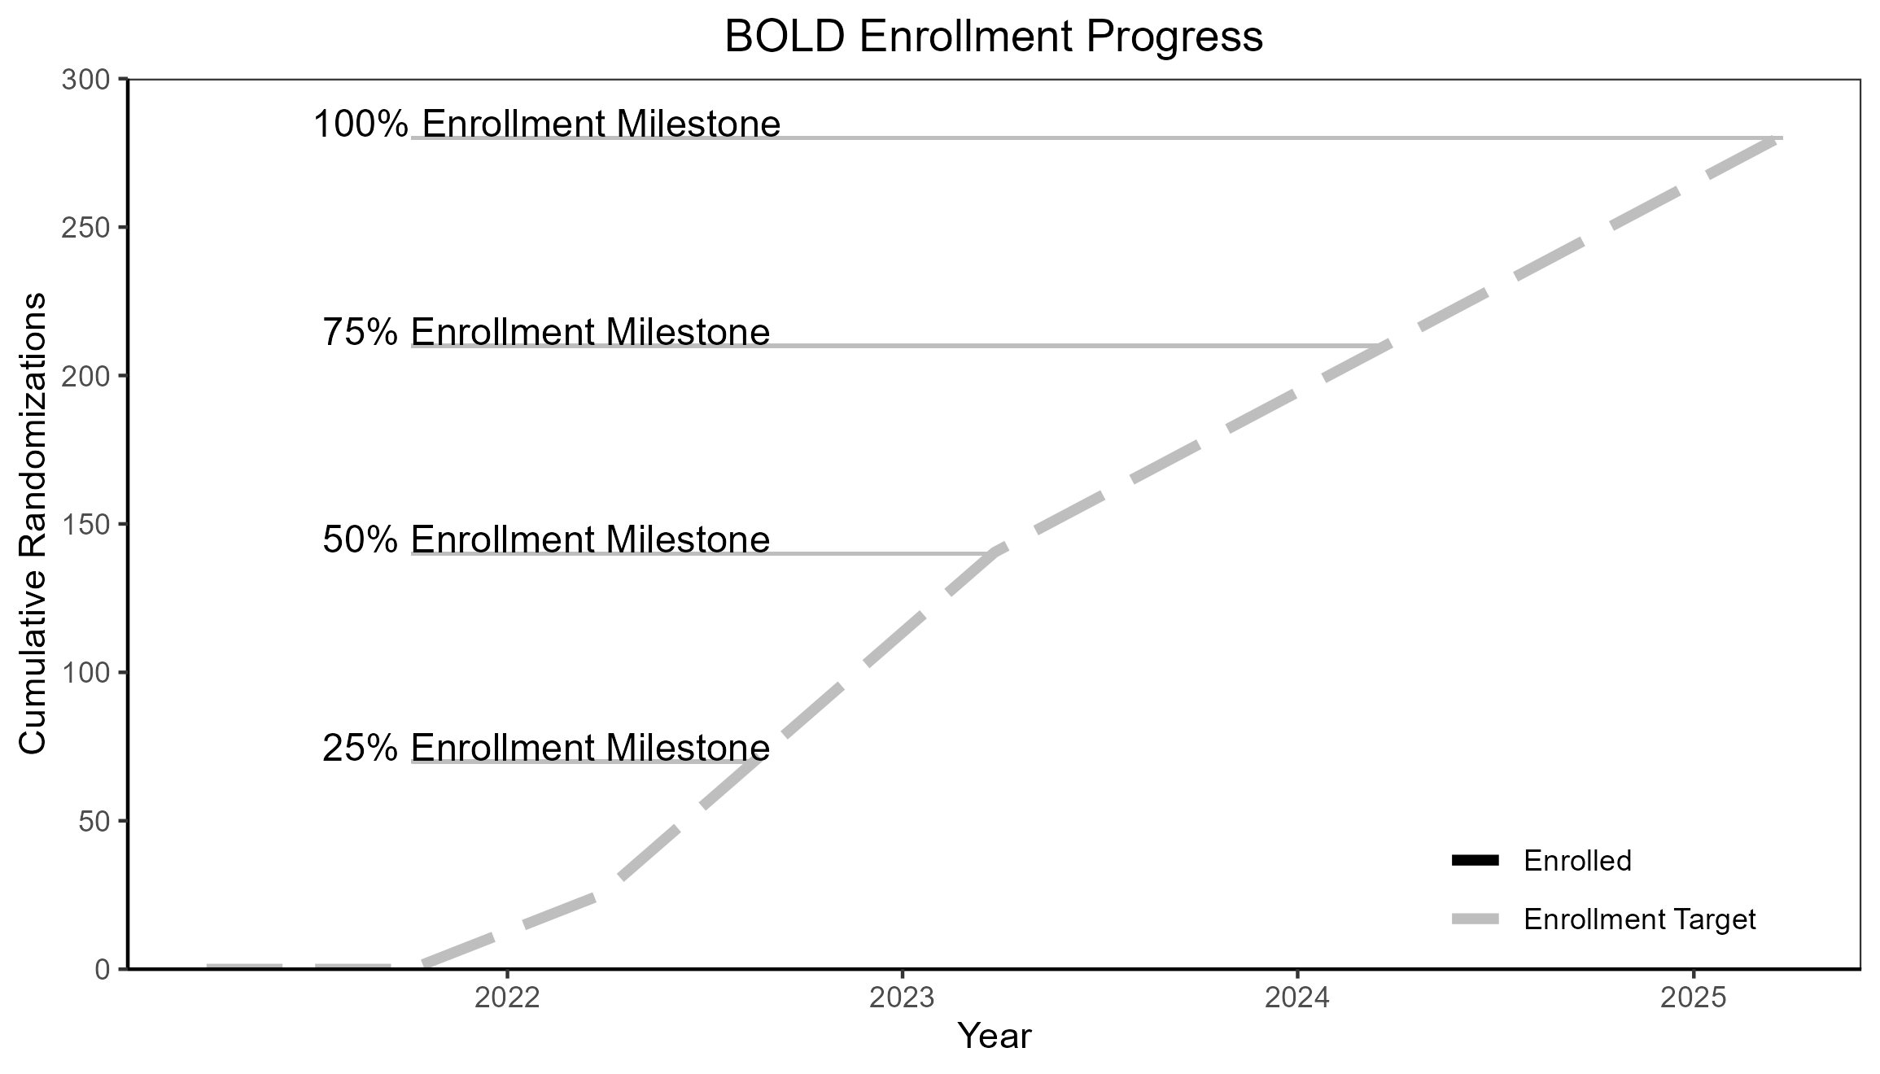

## Table 1: Participant Enrollment Status

Date as of: Nov. 11, 2023

Date of report: Nov 12, 2023

| Participant Enrollment Status (N = 6) | | |
| --- | --- | --- |
| Status | N | Percent |
| Pre-Intervention | 0 | 0% |
| Active | 4 | 67% |
| Completed | 0 | 0% |
| Discontinued Treatment/Follow-up Continued | 1 | 17% |
| Discontinued from Study | 1 | 17% |
| Lost to Follow-up | 0 | 0% |

### Reasons for Intervention Discontinuation

|  | **N = 2**1 |
| --- | --- |
| Reason |  |
| Dissatisfaction | 1 (50%) |
| Injury | 1 (50%) |
| 1n (%) | |

## Table 2: Reasons for Screen Failures

Date as of: Nov. 11, 2023

Date of report: Nov 12, 2023

### Phone-screen Screen Fails: By Race

| Phone-screen Screen Fails | | |
| --- | --- | --- |
|  | **Overall**, N = 11 | **Asian**, N = 11 |
| Reason |  |  |
| Screen Fail Reason 2 | 1 (100%) | 1 (100%) |
| 1n (%) | | |
| n - Number of listed screen-fail reason.   (%) - Percent is calculated by dividing the number of a given reason (n) by the number of a racial or ethnic category (N).   This table is primarily used to examine racial differences for screen failing so that barriers to entry can be addressed. | | |

### Phone-screen Screen Fails: Percentage of Total Screened

| Phone-screen Screen Fails (Total Screened = 11) | | |
| --- | --- | --- |
|  | **Overall**, N = 11 | **Asian**, N = 11 |
| Reason |  |  |
| Screen Fail Reason 2 | 1 (9%) | 1 (9%) |
| 1n (%) | | |
| n - Number of listed screen-fail reason.   (%) - Percent is calculated by dividing the number of a given reason (n) by the total number of phone screens (N).This percentage includes all eligible and still screening participants. | | |

### Post-consent Screen Fails: By Race and Ethnicity

| Post-consent Screen Fails | | | | |
| --- | --- | --- | --- | --- |
|  | **Overall**, N = 31 | **Mixed Race**, N = 11 | **None of these fully describe me**, N = 11 | **Prefer not to answer**, N = 11 |
| Reason |  |  |  |  |
| no continue reason 1 | 2 (67%) | 1 (100%) | 1 (100%) | 0 (0%) |
| no continue reason 2 | 1 (33%) | 0 (0%) | 0 (0%) | 1 (100%) |
| 1n (%) | | | | |
| n - Number of listed screen-fail reason.   (%) - Percent is calculated by dividing the number of a given reason (n) by the number of a racial or ethnic category (N).   This table is primarily used to examine racial or ethnic differences for screen failing so that barriers to entry can be addressed. | | | | |

### Post-consent Screen Fails: Percentage of Total Screened

| Post-consent Screen Fails (Total Consented = 9) | | | | |
| --- | --- | --- | --- | --- |
|  | **Overall**, N = 31 | **Mixed Race**, N = 11 | **None of these fully describe me**, N = 11 | **Prefer not to answer**, N = 11 |
| Reason |  |  |  |  |
| no continue reason 1 | 2 (22%) | 1 (11%) | 1 (11%) | 0 (0%) |
| no continue reason 2 | 1 (11%) | 0 (0%) | 0 (0%) | 1 (11%) |
| 1n (%) | | | | |
| n - Number of listed screen-fail reason.   (%) - Percent is calculated by dividing the number of a given reason (n) by the total number of consents. This percentage includes all eligible and still screening participants. | | | | |

## Table 3a: Demographic and Key Baseline Characteristics

Date as of: Nov. 11, 2023

Date of report: Nov 12, 2023

| Enrollment Demographics Since Last Report | | |
| --- | --- | --- |
|  | **Overall**, N = 61 | **Since Last Report**, N = 61 |
| Race |  |  |
| Asian | 1 (17%) | 1 (17%) |
| Black, African American, or African | 1 (17%) | 1 (17%) |
| Middle Eastern or North African | 1 (17%) | 1 (17%) |
| Mixed Race | 1 (17%) | 1 (17%) |
| White | 2 (33%) | 2 (33%) |
| Ethnicity |  |  |
| Hispanic or Latino | 1 (17%) | 1 (17%) |
| Not Hispanic or Latino | 5 (83%) | 5 (83%) |
| Sex |  |  |
| Man | 3 (50%) | 3 (50%) |
| Woman | 3 (50%) | 3 (50%) |
| Rural |  |  |
| Not Rural | 6 (100%) | 6 (100%) |
| Age | NA, (NA) | NA, (NA) |
| Unknown | 6 | 6 |
| 1n (%); Mean, (SD) | | |

| Enrollment Demographics - Group by Reporting Period | |
| --- | --- |
|  | **2024-02-28**, N = 61 |
| Race |  |
| Asian | 1 (17%) |
| Black, African American, or African | 1 (17%) |
| Middle Eastern or North African | 1 (17%) |
| Mixed Race | 1 (17%) |
| White | 2 (33%) |
| Ethnicity |  |
| Hispanic or Latino | 1 (17%) |
| Not Hispanic or Latino | 5 (83%) |
| Sex |  |
| Man | 3 (50%) |
| Woman | 3 (50%) |
| Rural |  |
| Not Rural | 6 (100%) |
| Age | NA, (NA) |
| Unknown | 6 |
| 1n (%); Mean, (SD) | |

## Table 3b: Demographic and Key Baseline Characteristics

Date as of: Nov. 11, 2023

Date of report: Nov 12, 2023

| Screened Demographics Since Last Report | | |
| --- | --- | --- |
|  | **Overall**, N = 111 | **Since Last Report**, N = 111 |
| Race |  |  |
| Asian | 2 (20%) | 2 (20%) |
| Black, African American, or African | 1 (10%) | 1 (10%) |
| Middle Eastern or North African | 1 (10%) | 1 (10%) |
| Mixed Race | 2 (20%) | 2 (20%) |
| None of these fully describe me | 1 (10%) | 1 (10%) |
| Prefer not to answer | 1 (10%) | 1 (10%) |
| White | 2 (20%) | 2 (20%) |
| Unknown | 1 | 1 |
| Ethnicity |  |  |
| Hispanic or Latino | 1 (10%) | 1 (10%) |
| Not Hispanic or Latino | 9 (90%) | 9 (90%) |
| Unknown | 1 | 1 |
| Sex |  |  |
| Man | 4 (40%) | 4 (40%) |
| Woman | 6 (60%) | 6 (60%) |
| Unknown | 1 | 1 |
| Rural |  |  |
| Not Rural | 11 (100%) | 11 (100%) |
| Age | NA, (NA) | NA, (NA) |
| Unknown | 11 | 11 |
| 1n (%); Mean, (SD) | | |

| Screened Demographics - Group by Reporting Period | |
| --- | --- |
|  | **2024-02-28**, N = 111 |
| Race |  |
| Asian | 2 (20%) |
| Black, African American, or African | 1 (10%) |
| Middle Eastern or North African | 1 (10%) |
| Mixed Race | 2 (20%) |
| None of these fully describe me | 1 (10%) |
| Prefer not to answer | 1 (10%) |
| White | 2 (20%) |
| Unknown | 1 |
| Ethnicity |  |
| Hispanic or Latino | 1 (10%) |
| Not Hispanic or Latino | 9 (90%) |
| Unknown | 1 |
| Sex |  |
| Man | 4 (40%) |
| Woman | 6 (60%) |
| Unknown | 1 |
| Rural |  |
| Not Rural | 11 (100%) |
| Age | NA, (NA) |
| Unknown | 11 |
| 1n (%); Mean, (SD) | |

# Protocol Fidelity

**Protocol Deviation**

A protocol deviation occurs when, without significant consequences, the activities on a study diverge from the Institutional Review Board-approved protocol.

* Study visit occurred outside of protocol time frame due to participant’s schedule
* Study activities performed close to, but not precisely at specified time points

**Protocol Violation**

A divergence from the protocol that materially (a) reduces the quality or completeness of the data, (b) makes the Informed Consent Form inaccurate, or (c) impacts a subject’s safety, rights, or welfare.

* Failure to obtain informed consent or re-consent when required by the IRB.
* Modifying the protocol without IRB approval, except to avoid immediate hazard to subjects.
* Inadequate or delinquent informed consent
* Inclusion/exclusion criteria not met
* Unreported serious adverse events
* Improper breaking of the blind
* Use of prohibited medication
* Mishandled samples
* Materially inadequate record keeping
* Intentional deviation from protocol, Good Clinical Practice, or regulations by study personnel

**Reference**

See Bhatt (2012) for more information.

Bhatt A. Protocol deviation and violation. Perspect Clin Res. 2012 Jul;3(3):117. doi: 10.4103/2229-3485.100663. PMID: 23125964; PMCID: PMC3487227.

## Table 4: Protocol Violations

Date as of: Nov. 11, 2023

Date of report: Nov 12, 2023

| Protocol Violation | n | Since Last DSMC Report |
| --- | --- | --- |
| Total # of Violations | 0 | 0 |
| Participants Consented | 9 | 9 |
| Violations per Participant | 0 | 0 |

## Table 5: Protocol Deviations

Date as of: Nov. 11, 2023

Date of report: Nov 12, 2023

| Protocol Deviation | n | Since Last DSMC Report |
| --- | --- | --- |
| Did not meet inclusion/exclusion criteria | 1.00 | 1.00 |
| Total # of Deviations | 1.00 | 1.00 |
| Participants Consented | 9.00 | 9.00 |
| Deviations per Participant | 0.11 | 0.11 |

## Listing 1: New Protocol Violations

Date as of: Nov. 11, 2023

Date of report: Nov 12, 2023

## There have been no new violations.

## Listing 2: All Protocol Violations

Date as of: Nov. 11, 2023

Date of report: Nov 12, 2023

## There have been no violations.

## Table 6: Data Counts

This section will not work. Would need to be rewritten specifically for BOLD project.

Date as of: Nov. 11, 2023

Date of report: Nov 12, 2023

# Safety Assessments for All Participants: Tables and Listing

## CTCAE 5.0 Criteria

**Grades**

Grade refers to the severity of the AE. The CTCAE displays Grades 1 through 5 with unique clinical descriptions of severity for each AE based on this general guideline:

* **Grade 1** Mild; asymptomatic or mild symptoms; clinical or diagnostic observations only; intervention not indicated.
* **Grade 2** Moderate; minimal, local or noninvasive intervention indicated; limiting age-appropriate instrumental ADL*.
* **Grade 3** Severe or medically significant but not immediately life-threatening; hospitalization or prolongation of hospitalization indicated; disabling; limiting self care ADL**.
* **Grade 4** Life-threatening consequences; urgent intervention indicated.
* **Grade 5** Death related to AE.

**Relatedness**

Relatedness refers to the relationship of the AE to the intervention. COMET rates relatedness from not related to definitely related.

* **Not Related** The AE is clearly NOT related to the intervention
* **Possibly Related** The AE may be related to the intervention
* **Definitely Related** The AE is clearly related to the intervention

**Definitions**

* **Adverse Event** Any untoward or unfavorable medical occurrence in a human subject participant, including any abnormal sign, symptom, or disease, temporally associated with the participants’ involvement in the research, whether or not considered related to participation in the research.
* **Event of Interest** Incidental findings or events uncovered during baseline testing not directly attributable to the study. It is often unclear if the event is new onset. Most are pre-existing and asymptomatic i.e., asymptomatic ST segment depression on a maximal exercise test.
* **System Organ Class (SOC)** The highest level of the MedDRA1 hierarchy, also referred to as System Organ Classe (SOC), is identified by anatomical or physiological system, etiology, or purpose (e.g., SOC Investigations for laboratory test results). CTCAE terms are grouped by MedDRA Primary SOCs. Within each SOC, AEs are listed and accompanied by descriptions of severity (Grade).
* **Preferred Term** A term that is a unique representation of a specific event used for medical documentation and scientific analyses. Each CTCAE v4.0 term is a MedDRA LLT (Lowest Level Term).

## Table 7a: Non-related Adverse Events

Date as of: Nov. 11, 2023

Date of report: Nov 12, 2023

## [1] "There have been no non-related adverse events."

## Table 7b: Related Adverse Events

Date as of: Nov. 11, 2023

Date of report: Nov 12, 2023

| Related Adverse Events Since Last Report | | |
| --- | --- | --- |
| Adverse Events | **Overall**, N = 41 | **Since Last Report**, N = 41 |
| Preferred Term |  |  |
|  | 1 (25%) | 1 (25%) |
| Atrioventricular block complete | 1 (25%) | 1 (25%) |
| Portal hypertension | 1 (25%) | 1 (25%) |
| Test | 1 (25%) | 1 (25%) |
| 1n (%) | | |
| *Table includes both possibly- and definitely-related adverse events. | | |

| Related Adverse Events - Group by Reporting Period | |
| --- | --- |
| Adverse Events | **2023-08-31**, N = 41 |
| Preferred Term |  |
|  | 1 (25%) |
| Atrioventricular block complete | 1 (25%) |
| Portal hypertension | 1 (25%) |
| Test | 1 (25%) |
| 1n (%) | |
| If a reporting period is not included, no related adverse events happened during that period. | |

| Related Adverse Events Since Last Report | | | |
| --- | --- | --- | --- |
| Date of Onset | Outcome | Preferred Term | Summary |
| 2023-07-12 | Recovered/Resolved |  | Testing |
| 2023-08-21 | Unknown | Atrioventricular block complete | Test |
| 2023-08-17 | Recovered/Resolved | Portal hypertension | Test |
| 2023-07-19 | Recovered/Resolved | Test | Test |

## Table 7c: Non-related Serious Adverse Events

Date as of: Nov. 11, 2023

Date of report: Nov 12, 2023

## [1] "There have been no non-related serious adverse events"

## Table 7d: Related Serious Adverse Events

Date as of: Nov. 11, 2023

Date of report: Nov 12, 2023

| Related Serious Adverse Events Since Last Report | | |
| --- | --- | --- |
| Adverse Events | **Overall**, N = 41 | **Since Last Report**, N = 41 |
| Preferred Term |  |  |
|  | 1 (25%) | 1 (25%) |
| Atrioventricular block complete | 1 (25%) | 1 (25%) |
| Portal hypertension | 1 (25%) | 1 (25%) |
| Test | 1 (25%) | 1 (25%) |
| 1n (%) | | |
| *Table includes both possibly- and definitely-related adverse events. | | |

| Related Serious Adverse Events - Group by Reporting Period | |
| --- | --- |
| Adverse Events | **2023-08-31**, N = 41 |
| Preferred Term |  |
|  | 1 (25%) |
| Atrioventricular block complete | 1 (25%) |
| Portal hypertension | 1 (25%) |
| Test | 1 (25%) |
| 1n (%) | |
| If a reporting period is not included, no related adverse events happened during that period. | |

| Related Serious Adverse Events Since Last Report | | | |
| --- | --- | --- | --- |
| Date of Onset | Outcome | Preferred Term | Summary |
| 2023-07-12 | Recovered/Resolved |  | Testing |
| 2023-08-21 | Unknown | Atrioventricular block complete | Test |
| 2023-08-17 | Recovered/Resolved | Portal hypertension | Test |
| 2023-07-19 | Recovered/Resolved | Test | Test |

## Listing 3: Serious Adverse Events

Date as of: Nov. 11, 2023

Date of report: Nov 12, 2023

| Date of Onset | Date Ceased | Related | Outcome | SOC and Preferred Term | Summary |
| --- | --- | --- | --- | --- | --- |
| 2023-07-12 | 2023-07-12 | Definitely Related | Recovered/Resolved | Blood and lymphatic system disorders - | Testing |
| 2023-07-19 | 2023-07-19 | Definitely Related | Recovered/Resolved | Blood and lymphatic system disorders - Test | Test |
| 2023-08-17 | 2023-08-17 | Possibly Related | Recovered/Resolved | Injury, poisoning and procedural complications - Portal hypertension | Test |
| 2023-08-21 | 2023-08-21 | Definitely Related | Unknown | Eye disorders - Atrioventricular block complete | Test |

## Listing 4: Deaths

Date as of: Nov. 11, 2023

Date of report: Nov 12, 2023

| Date of Death | Cause of Death | Related |
| --- | --- | --- |
| 2023-08-21 | test | Definitely Related |

## Listing 5a: New Adverse Events Related to the Intervention

Date as of: Nov. 11, 2023

Date of report: Nov 12, 2023

| Adverse Events Related to the Intervention Since Date of Last Report (2023-02-08) | | | | | |
| --- | --- | --- | --- | --- | --- |
| Date | Related | Outcome | Severity | SOC and Preferred Term | Summary |
| 2023-08-17 | Possibly Related | Recovered/Resolved | Grade 2; Moderate | Injury, poisoning and procedural complications - Portal hypertension | Test |
| 2023-07-12 | Definitely Related | Recovered/Resolved | Grade 1; Mild | Blood and lymphatic system disorders - | Testing |
| 2023-07-19 | Definitely Related | Recovered/Resolved | Grade 3; Severe | Blood and lymphatic system disorders - Test | Test |
| 2023-08-21 | Definitely Related | Unknown | Grade 1; Mild | Eye disorders - Atrioventricular block complete | Test |

## Listing 5b: New Adverse Events Not Related to Intervention

Date as of: Nov. 11, 2023

Date of report: Nov 12, 2023

| Adverse Events Not Related to the Intervention Since Date of Last Report (2023-02-08) | | | | | |
| --- | --- | --- | --- | --- | --- |
| Date | Related | Outcome | Severity | SOC and Preferred Term | Summary |

## Listing 6a: All Adverse Events

Date as of: Nov. 11, 2023

Date of report: Nov 12, 2023

| All Adverse Events | | | | | |
| --- | --- | --- | --- | --- | --- |
| Date | SOC and Preferred Term | Related | Severity | Serious | Outcome |
| 2023-07-12 | Blood and lymphatic system disorders - | Definitely Related | Grade 1; Mild | Yes | Recovered/Resolved |
| 2023-07-19 | Blood and lymphatic system disorders - Test | Definitely Related | Grade 3; Severe | Yes | Recovered/Resolved |
| 2023-08-17 | Injury, poisoning and procedural complications - Portal hypertension | Possibly Related | Grade 2; Moderate | Yes | Recovered/Resolved |
| 2023-08-21 | Eye disorders - Atrioventricular block complete | Definitely Related | Grade 1; Mild | Yes | Unknown |