Title

Authors

Table of Contents

# Closed Session Report Summary

Please write a closed report summary

# Recruitment and Participant Status: Figure and Tables

## Figure 1a: Screening Consort Diagram

Date as of: Nov. 11, 2023

Date of report: Nov 12, 2023

Recruitment start date: Sept 09, 2021

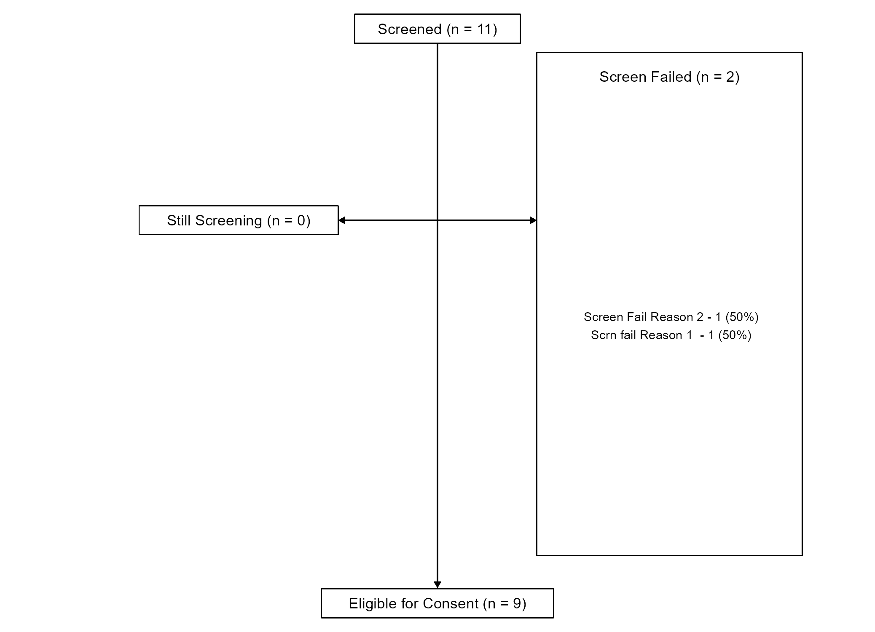

## Figure 1b: Enrollment Consort Diagram

Date as of: Nov. 11, 2023

Date of report: Nov 12, 2023

Recruitment start date: Sept 09, 2021

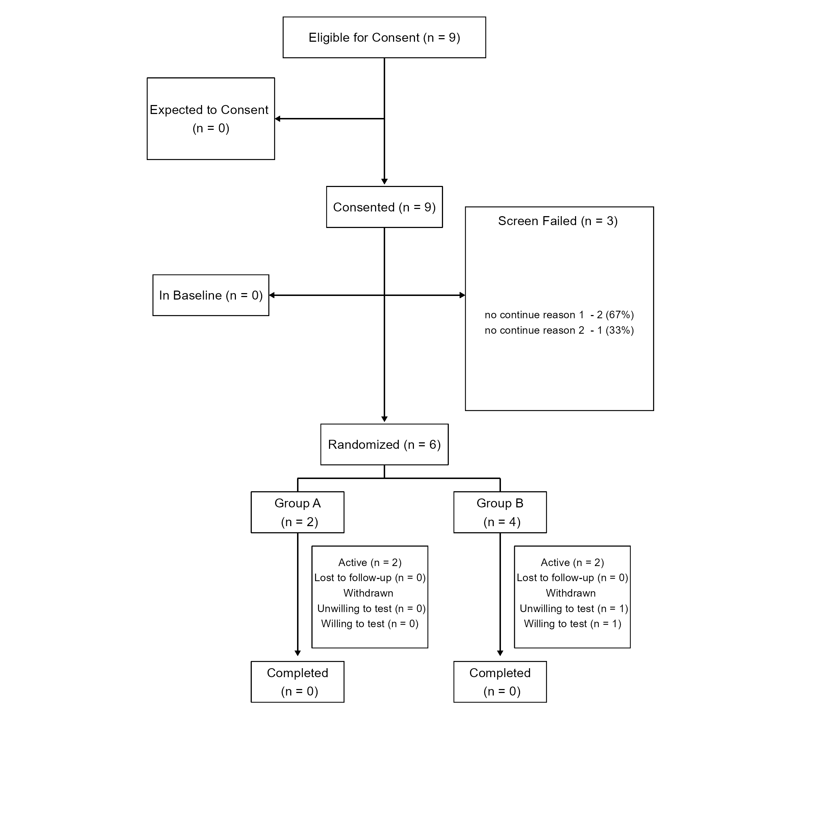

## Table 3: Demographic and Key Baseline Characteristics

Date as of: Nov. 11, 2023

Date of report: Nov 12, 2023

| **Characteristic** | **A**, N = 21 | **B**, N = 41 | **p-value**2 |
| --- | --- | --- | --- |
| Race |  |  | >0.9 |
| Asian | 1 (50%) | 0 (0%) |  |
| Black, African American, or African | 0 (0%) | 1 (25%) |  |
| Middle Eastern or North African | 0 (0%) | 1 (25%) |  |
| Mixed Race | 0 (0%) | 1 (25%) |  |
| White | 1 (50%) | 1 (25%) |  |
| Ethnicity |  |  | >0.9 |
| Hispanic or Latino | 0 (0%) | 1 (25%) |  |
| Not Hispanic or Latino | 2 (100%) | 3 (75%) |  |
| sex |  |  | >0.9 |
| Man | 1 (50%) | 2 (50%) |  |
| Woman | 1 (50%) | 2 (50%) |  |
| Rural |  |  |  |
| Not Rural | 2 (100%) | 4 (100%) |  |
| Age | NA, (NA) | NA, (NA) |  |
| Unknown | 2 | 4 |  |
| 1n (%); Mean, (SD) | | | |
| 2Fisher's exact test | | | |
| p-values were calculated using Fisher’s exact test for categorical variables (Race, Ethnicity, sex and Rural) and a one-way ANOVA for continuous variables. | | | |

# Safety Assessments for All Participants: Tables and Listing

## CTCAE 5.0 Criteria

**Grades**

Grade refers to the severity of the AE. The CTCAE displays Grades 1 through 5 with unique clinical descriptions of severity for each AE based on this general guideline:

* **Grade 1** Mild; asymptomatic or mild symptoms; clinical or diagnostic observations only; intervention not indicated.
* **Grade 2** Moderate; minimal, local or noninvasive intervention indicated; limiting age-appropriate instrumental ADL*.
* **Grade 3** Severe or medically significant but not immediately life-threatening; hospitalization or prolongation of hospitalization indicated; disabling; limiting self care ADL**.
* **Grade 4** Life-threatening consequences; urgent intervention indicated.
* **Grade 5** Death related to AE.

**Relatedness**

Relatedness refers to the relationship of the AE to the intervention. COMET rates relatedness from not related to definitely related.

* **Not Related** The AE is clearly NOT related to the intervention
* **Possibly Related** The AE may be related to the intervention
* **Definitely Related** The AE is clearly related to the intervention

**Definitions**

* **Adverse Event** Any untoward or unfavorable medical occurrence in a human subject participant, including any abnormal sign, symptom, or disease, temporally associated with the participants’ involvement in the research, whether or not considered related to participation in the research.
* **Event of Interest** Incidental findings or events uncovered during baseline testing not directly attributable to the study. It is often unclear if the event is new onset. Most are pre-existing and asymptomatic i.e., asymptomatic ST segment depression on a maximal exercise test.
* **System Organ Class (SOC)** The highest level of the MedDRA1 hierarchy, also referred to as System Organ Classe (SOC), is identified by anatomical or physiological system, etiology, or purpose (e.g., SOC Investigations for laboratory test results). CTCAE terms are grouped by MedDRA Primary SOCs. Within each SOC, AEs are listed and accompanied by descriptions of severity (Grade).
* **Preferred Term** A term that is a unique representation of a specific event used for medical documentation and scientific analyses. Each CTCAE v4.0 term is a MedDRA LLT (Lowest Level Term).

## Table 7a: Non-related Adverse Events

Date as of: Nov. 11, 2023

Date of report: Nov 12, 2023

## [1] "There have been no non-related adverse events."

## Table 7b: Related Adverse Events

Date as of: Nov. 11, 2023

Date of report: Nov 12, 2023

| Related Adverse Events | | |
| --- | --- | --- |
| Adverse Events | **A**, N = 11 | **B**, N = 31 |
| Preferred Term |  |  |
|  | 0 (0%) | 1 (33%) |
| Atrioventricular block complete | 0 (0%) | 1 (33%) |
| Portal hypertension | 0 (0%) | 1 (33%) |
| Test | 1 (100%) | 0 (0%) |
| Updates |  |  |
| Since Last Report | 1 (100%) | 3 (100%) |
| 1n (%) | | |
| *Table includes both possibly- and definitely-related adverse events. | | |

## Table 7c: Non-related Serious Adverse Events

Date as of: Nov. 11, 2023

Date of report: Nov 12, 2023

## [1] "There have been no non-related serious adverse events."

## Table 7d: Related Serious Adverse Events

Date as of: Nov. 11, 2023

Date of report: Nov 12, 2023

| Related Serious Adverse Events | | | |
| --- | --- | --- | --- |
| Adverse Events | **Overall**, N = 41 | **A**, N = 11 | **B**, N = 31 |
| Preferred Term |  |  |  |
|  | 1 (25%) | 0 (0%) | 1 (33%) |
| Atrioventricular block complete | 1 (25%) | 0 (0%) | 1 (33%) |
| Portal hypertension | 1 (25%) | 0 (0%) | 1 (33%) |
| Test | 1 (25%) | 1 (100%) | 0 (0%) |
| Updates |  |  |  |
| Since Last Report | 4 (100%) | 1 (100%) | 3 (100%) |
| 1n (%) | | | |
| *Table includes both possibly- and definitely-related adverse events. | | | |

## Table 8a: Severity of Adverse Events by Group

Date as of: Nov. 11, 2023

Date of report: Nov 12, 2023

|  | **Grade 1; Mild**, N = 21 | **Grade 2; Moderate**, N = 11 | **Grade 3; Severe**, N = 11 |
| --- | --- | --- | --- |
| Group |  |  |  |
| A | 0 (0%) | 0 (0%) | 1 (100%) |
| B | 2 (100%) | 1 (100%) | 0 (0%) |
| 1n (%) | | | |
| Adverse events that occurred in participants without an assigned group have been removed from tables sorting by group. | | | |

## Table 9a: Relatedness of Adverse Events by Group

Date as of: Nov. 11, 2023

Date of report: Nov 12, 2023

|  | **Definitely Related**, N = 31 | **Possibly Related**, N = 11 |
| --- | --- | --- |
| Group |  |  |
| A | 1 (33%) | 0 (0%) |
| B | 2 (67%) | 1 (100%) |
| 1n (%) | | |
| Adverse events that occurred in participants without an assigned group have been removed from tables sorting by group. | | |

## Listing 3a: Serious Adverse Events

Date as of: Nov. 11, 2023

Date of report: Nov 12, 2023

| Group | Date of Onset | Date Ceased | Related | SOC and Preferred Term | Summary |
| --- | --- | --- | --- | --- | --- |
| B | 2023-07-12 | 2023-07-12 | Definitely Related | Blood and lymphatic system disorders - | Testing |
| A | 2023-07-19 | 2023-07-19 | Definitely Related | Blood and lymphatic system disorders - Test | Test |
| B | 2023-08-17 | 2023-08-17 | Possibly Related | Injury, poisoning and procedural complications - Portal hypertension | Test |
| B | 2023-08-21 | 2023-08-21 | Definitely Related | Eye disorders - Atrioventricular block complete | Test |

## Listing 4: Deaths

Date as of: Nov. 11, 2023

Date of report: Nov 12, 2023

| Group | Date of Death | Cause of Death | Related |
| --- | --- | --- | --- |
| B | 2023-08-21 | test | Definitely Related |

## Listing 5a: New Adverse Events Related to the Intervention

Date as of: Nov. 11, 2023

Date of report: Nov 12, 2023

| Adverse Events Related to the Intervention Since Date of Last Report (2023-02-08) | | | | | |
| --- | --- | --- | --- | --- | --- |
| Group | Date | Related | Severity | SOC and Preferred Term | Summary |
| B | 2023-08-17 | Possibly Related | Grade 2; Moderate | Injury, poisoning and procedural complications - Portal hypertension | Test |
| B | 2023-07-12 | Definitely Related | Grade 1; Mild | Blood and lymphatic system disorders - | Testing |
| A | 2023-07-19 | Definitely Related | Grade 3; Severe | Blood and lymphatic system disorders - Test | Test |
| B | 2023-08-21 | Definitely Related | Grade 1; Mild | Eye disorders - Atrioventricular block complete | Test |

## Listing 5b: New Adverse Events Not Related to Intervention

Date as of: Nov. 11, 2023

Date of report: Nov 12, 2023

| Adverse Events Not Related to the Intervention Since Date of Last Report (2023-02-08) | | | | | |
| --- | --- | --- | --- | --- | --- |
| Group | Date | Related | Severity | SOC and Preferred Term | Summary |

## Listing 6a: All Adverse Events

Date as of: Nov. 11, 2023

Date of report: Nov 12, 2023

| All Adverse Events | | | | | | |
| --- | --- | --- | --- | --- | --- | --- |
| Group | Date | SOC and Preferred Term | Related | Severity | Serious | Outcome |
| A | 2023-07-19 | Blood and lymphatic system disorders - Test | Definitely Related | Grade 3; Severe | Yes | Recovered/Resolved |
| B | 2023-07-12 | Blood and lymphatic system disorders - | Definitely Related | Grade 1; Mild | Yes | Recovered/Resolved |
| B | 2023-08-17 | Injury, poisoning and procedural complications - Portal hypertension | Possibly Related | Grade 2; Moderate | Yes | Recovered/Resolved |
| B | 2023-08-21 | Eye disorders - Atrioventricular block complete | Definitely Related | Grade 1; Mild | Yes | Unknown |