**Paint Meister Story Board**

Screen 1 Splash Screen

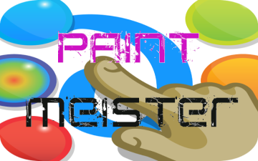

Screen 2 Paint Screen

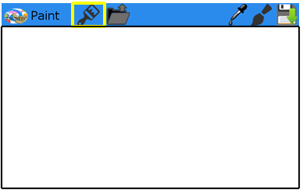

Screen 3 Load Saves Screen 4 Select Color Screen 5 Select Brush

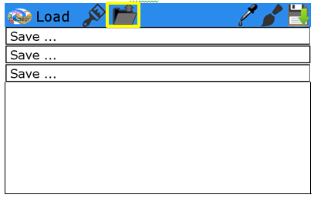 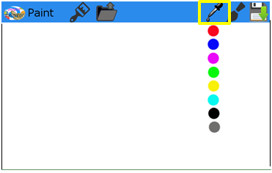 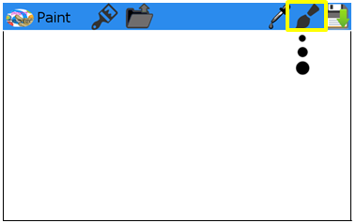

Screen 1 Splash Screen

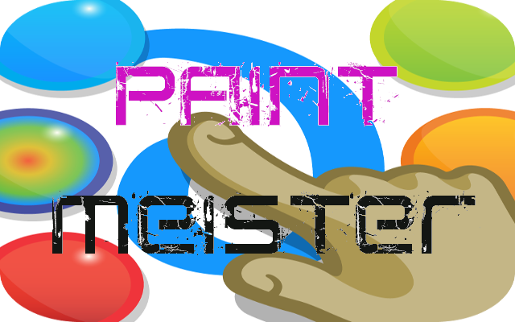

**Description:**

Show when user starts device.

Saves current drawing

Screen 2 Paint Screen

Accessed through brush tab

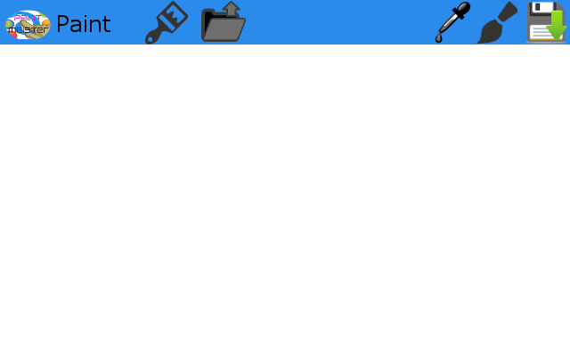

**Description:**

Screen where user can draw on device.

Screen 3 Load Saves Screen

Accessed through Load tab

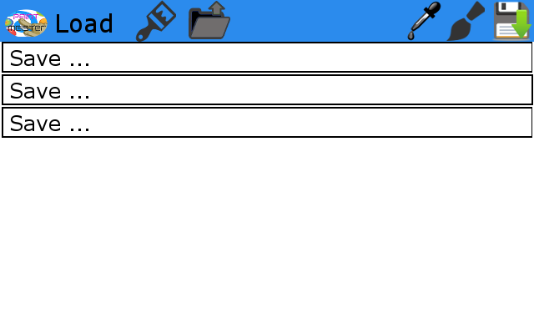

**Description:**

Screen where user can load old saved drawings.

Screen 4 Select Color

Accessed through Select Icon

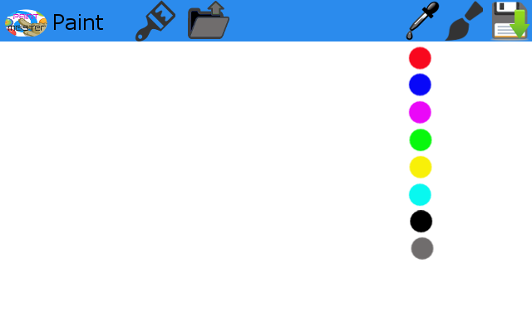

**Description:**

Icon to select color.

Screen 5 Select Brush

Accessed through brush Icon

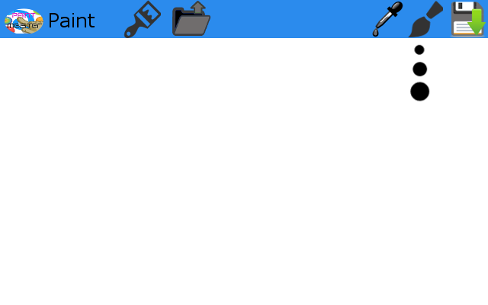

**Description:**

Icon to select brush size.