Static Loader Design Notes

Static Load File Format
The Static Load File is a custom CFE load file format that is created by extracting the code, data, and bss sections from a static link elf file that is produced by the gnu compiler. The Static Load File format is shown below.
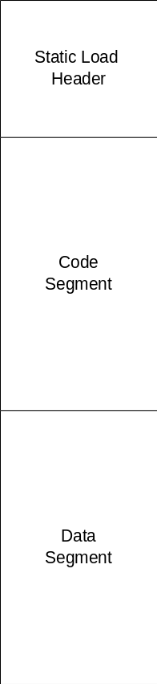

Static Load Header
The Static Load Header contains all of the information the Static Loader needs to locate the code, data, and bss into memory.

typedef struct
{
uint32 file_marker; /* Unique file type or marker */
uint32 entry_point; /* Entry point for Task/Application */
uint32 flags; /* Flags - Currently just to indicate compression */
uint32 code_target; /* Address in RAM where code is copied */
uint32 code_size; /* Size of Code Segment */
uint32 code_offset; /* Offset in this file where code segment starts */
uint32 data_target; /* Address in RAM where data is copied */
uint32 data_size; /* Size of Data Segment */
uint32 data_offset; /* Offset in this file where data segment starts */
uint32 bss_target; /* Address in RAM where BSS is located */
uint32 bss_size; /* Size of BSS Segment */
char object_name[OBJ_NAME_SIZE]; /* Name of Object -- CI_APP */
char entry_point_name[OBJ_NAME_SIZE]; /* Name of Entry point -- CI_AppMain */

} static_load_file_header_t;

Byte Ordering
Note that the endianess of the target is determined from the original elf file and the byte order of the static load file header is adjusted if necessary. The Code and Data segments are already in the correct byte order for the target so no adjustments are necessary.

Compression
The static loader supports LZMA compression of the code and data segments. Compression is implemented using an open source LZMA compression software development kit available from http://www.7-zip.org/sdk.html.

Compressed Static Load Files are nearly identical to uncompressed Static Load Files, the only difference being that the Code and Data Segments are compressed into a Compressed Archives.

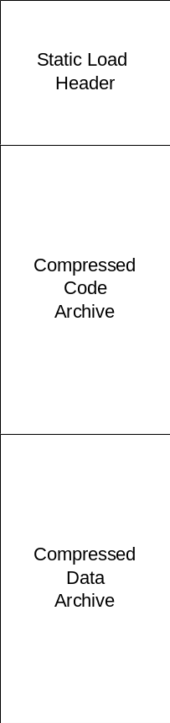

Compressed Archive Format
The Compressed Archive format is shown below. The LZMA Compressed Archive consists of a LZMA Header followed by Compressed Data.



LZMA Header
When data is compressed with the LZMA software development kit, it produces an output format that does not contain all of the information necessary to decompress the archive. So a LZMA Header was added to the Compressed Data output from the LZMA software development kit that contains the additional information necessary to decompress the archive.

typedef struct {
uint8 Properties[LZMA_PROPS_SIZE];
uint8 UncompressedDataSize[LZMA_UNCOMPRESSEDDATASIZE_SIZE];
} Lzma_Header_t;

Note that the fields in the LZMA Header are stored in a byte encoded in little endian format which makes them endian independent.

Building a Static Load File
Static Load Files are created using the elf2staticload tool. This command line tool reads a static link elf file as input, extracts the code and data segments, optionally compresses the code and data segments, and then outputs a Static Load File.

Available Options:

Usage: elf2staticload [OPTION]... INPUT_FILE OUTPUT_FILE
Converts a static link ELF file into a CFE load file:

Options:
-o, --object_name override the default object name
-e, --entry_point_name override the default entry point name
-c, --compression compress the text and data sections
-I, --print_input_file print the contents of the ELF file to
the console
-H, --print_output_file_header print the CFE static link file header
to the console
-D, --print_output_file_data print the CFE static link file data to
the console
-V, --version output version information and exit
-h, --help output usage information and exit

By default the object and entry point names are extracted from
the ELF file.

