Reference vs. Pointers

- There are two ways to let other code reach our variable.
- Int score = 100;
- Int *ptr = &score;
- A pointer is a sticky note, which contains the address of score.
- A reference is a second nameplate
  - Instead of a note, you attached a second name to the variable.
  - It’s the same variable, just with another name and there’s no address
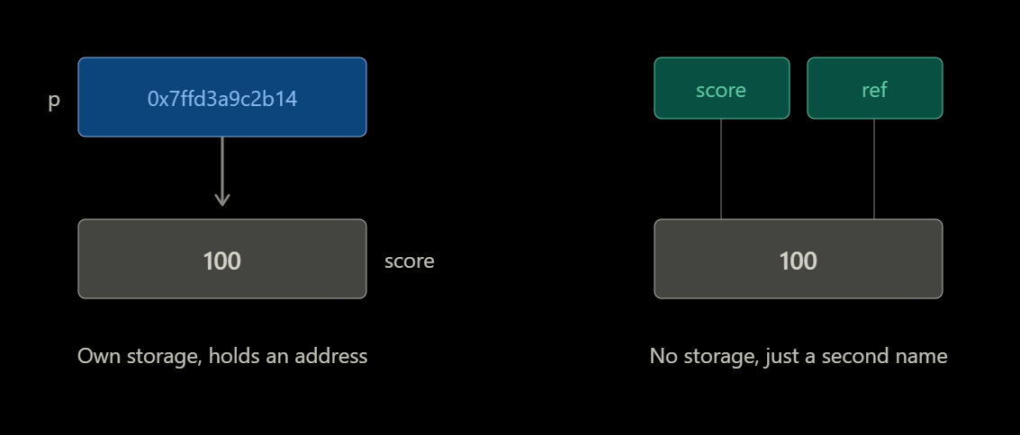
Two rules that make references safer
- A reference must be initialized and can never be null.
- A reference can never be moved to a different variable/object.
Two jobs:
- Let a function modify the caller’s variable, gets the real thing, not a copy.
- Read a big object without copying it.
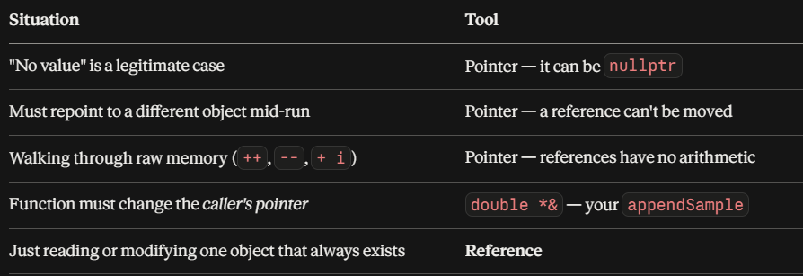

NOTES

