Relationship Between Arrays and Pointers

NOTES

- The value of an array name is the address of the first element inside the array.
- The value of a pointer variable that points to an array will be the address of the first element of that array
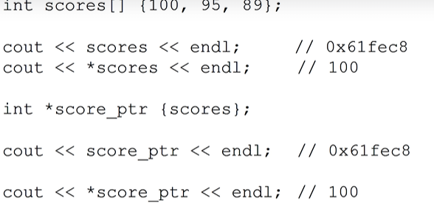
You can use a pointer as an array when you want to iterate through an array.
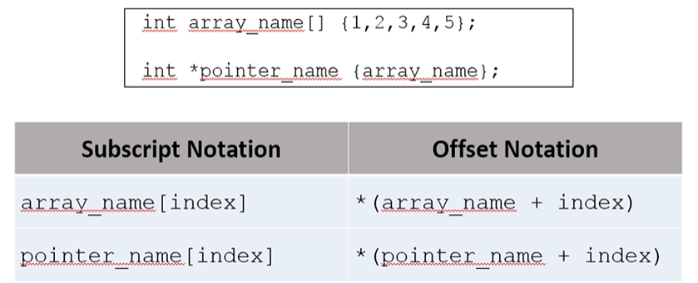
KEY POINTS

- This is important because when we allocate arrays dynamically on the heap, we have to be able to walk through to them.

