Constructors

- Constructor:
  - It makes it possible to have an object ready to use.
  - They’re commonly used for initialization
  - If you have code that creates objects with or without initialization information, the default constructor is no longer generated by C++.
  - Best practice: To initialize all class attributes so there is no garbage.
- Overloaded Constructors
  - They give flexibility when initializing objects.
  - There can be several overload constructors. Overloading constructors just means there are more than one legitimate way to create or initialize an object.
    - className() -> Expects No Arguments
    - className(std::string name, int age) -> Expects “n” Arguments.
  - 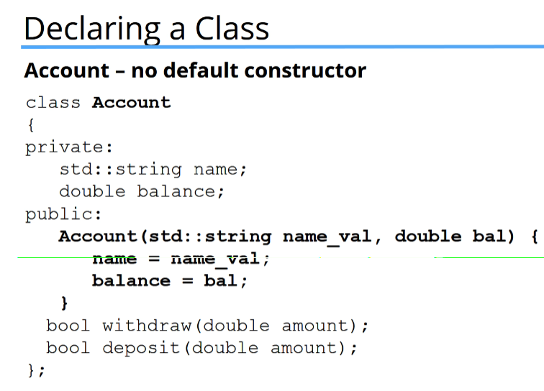
- Default Constructor:
  - If you write no constructor at all for a class (they go inside the class structure), C++ will generate a Default Constructor, also known as no-args Constructor, that does nothing.
  - That constructor is called behind the code when you instantiate a new object with no arguments:
    - className object;
  - 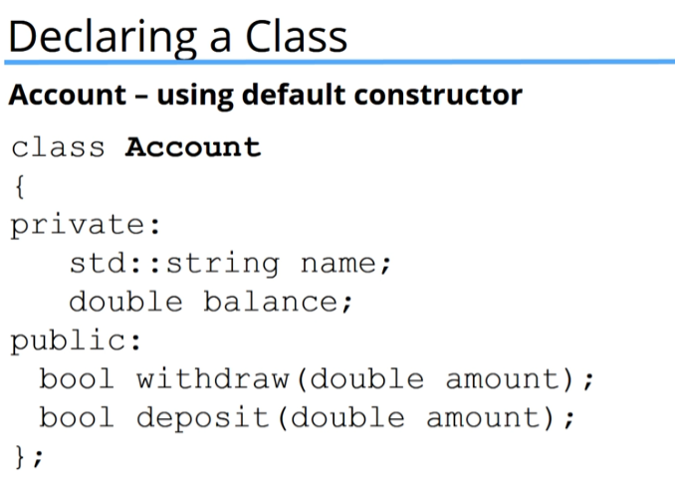
NOTES

