**🔶 1. Key Features of the ROSCA App**

* **User Registration & Login**
* **Group Creation & Joining**
* **Member Contribution Tracking**
* **Pot Distribution Management**
* **Payment Reminders / Status Notifications**
* **Admin Role for Group Oversight**
* **Transaction History**
* (Optional) **Mobile Responsiveness / App Version**

**🔶 2. Basic Tech Stack (Suggested)**

| **Layer** | **Suggested Tech** |
| --- | --- |
| Frontend | React / Next.js / Vue |
| Backend | Node.js (Express) or Django / Flask (Python) |
| Database | PostgreSQL / MySQL / MongoDB |
| Authentication | JWT or OAuth |
| Hosting | DigitalOcean, AWS, or Vercel (Frontend), Render (Backend) |
| Payments (Optional) | Stripe, PayPal, or local APIs |

**🔶 3. Database Schema Example**

Here’s a simple SQL-style schema to manage ROSCA logic:

**Tables:**

**users**

* id (PK)
* name
* email
* hashed_password
* created_at

**rosca_groups**

* id (PK)
* group_name
* admin_user_id (FK → users.id)
* contribution_amount
* contribution_interval (weekly, monthly)
* start_date
* created_at

**group_members**

* id (PK)
* user_id (FK → users.id)
* rosca_group_id (FK → rosca_groups.id)
* order_in_rotation
* has_received_pot (boolean)

**contributions**

* id (PK)
* group_member_id (FK → group_members.id)
* amount_paid
* paid_on (timestamp)

**pot_distributions**

* id (PK)
* rosca_group_id (FK → rosca_groups.id)
* recipient_member_id (FK → group_members.id)
* amount_distributed
* distributed_on (timestamp)

**🔶 4. Project Development Roadmap**

**Phase 1: Backend API**

* User registration/login
* Create and manage ROSCA groups
* Add members to groups
* Track contributions & pot distributions
* RESTful or GraphQL API

**Phase 2: Frontend Website**

* Dashboard with active groups
* Group details page (show rotation, members, contribution schedule)
* Payment input / tracking UI
* Admin control interface (to distribute pots manually or automatically)
* Notifications for pending contributions

**Phase 3: Extra Features**

* Email/SMS reminders
* Payment API integration
* Mobile app version (React Native / Flutter)

**🔶 5. Example Starter Stack**

* **Backend**: Node.js (Express) + PostgreSQL using Sequelize ORM
* **Frontend**: React + Tailwind CSS for styling
* **Auth**: JWT-based authentication
* **Hosting**: Vercel (Frontend) + Render or Railway (Backend)

**🔶 Next Step:**

I can:

* Generate starter **code templates** (Node.js backend, React frontend).
* Build your **SQL database schema** as migration files.
* Provide **API endpoint designs**.
* Help with deploying your project.

**Step-by-step Flow**

1. **User Registration & Login**
   * POST /auth/register → Creates user, returns JWT.
   * POST /auth/login → Authenticates user, returns JWT.
2. **Group Creation & Token Generation**
   * POST /groups → Creates new group, generates unique inviteToken.
   * Token is sent to invitees (email, SMS, or verbally).
3. **Managing Groups**
   * GET /groups → Lists groups the user manages or is a member of.
   * GET /groups/:id → Retrieves full group details with members.
   * PATCH /groups/:id/invite-token → Rotates inviteToken (invalidates old one).
4. **Joining Groups**
   * POST /groups/join with inviteToken in body → Adds the authenticated user to the group if valid.
5. **Updating Roles**
   * PATCH /groups/:groupId/role → Changes a member’s role (admin → member or vice versa).A screenshot of a computer

     AI-generated content may be incorrect.

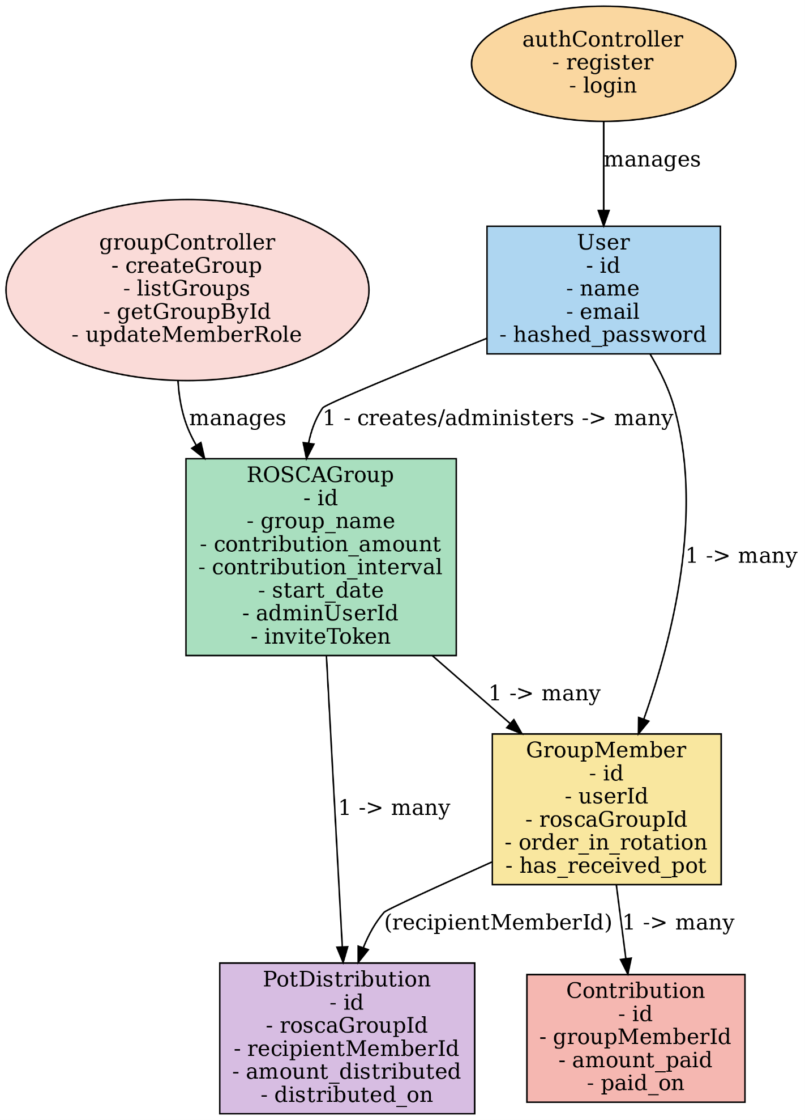

DB connection flow

**🔹 Summary Flow**

1. .env contains credentials (user, password, host, db name).
2. models/index.js reads .env, creates a Sequelize instance with those credentials.
3. Models (like User) are initialized with that Sequelize instance.
4. Controllers call User.create() (or findAll(), etc.).
5. Sequelize sends SQL queries through the connection to Postgres using the credentials from .env.
6. Postgres responds → Sequelize returns results to the controller → Express sends JSON to the client.

Hello! I can certainly help you refine that LinkedIn post.

-------------------------------------

Embarking on a new coding journey!

I "vibe-coded" a project, and I'm not looking back!

In less than a week, I managed to build more than an MVP for a project I'd spec'd out years ago.

**Tech Stack:**

* **Frontend:** React

* **Backend:** Node.js

* **Framework:** Express.js

* **Database:** PostgreSQL

* **ORM:** Sequelize

**Reflections on AI in Development:**

The software development landscape is undeniably being reshaped by AI. Rather than viewing it as a threat, I see it as a significant shift in expectations and roles. It's an exciting time to adapt and evolve!

**A Bilingual Development Experience:**

Interestingly, I recently switched my Microsoft profile language to French. This has led to many of my frequently used MS applications, including VS Code, adopting French. Even GitHub Copilot Chat now engages with me in French.