1.1

Ethernet Adapter and Ip address

Instance

After deletion

Updated trace

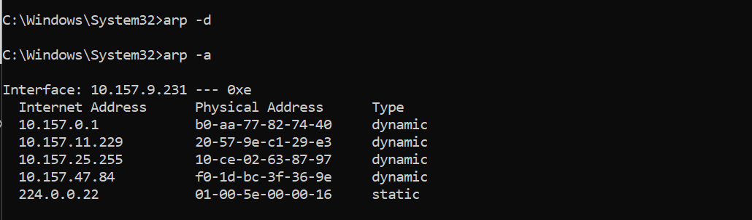

Request and reply

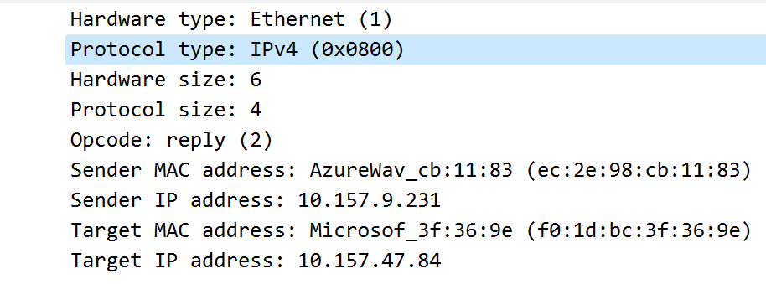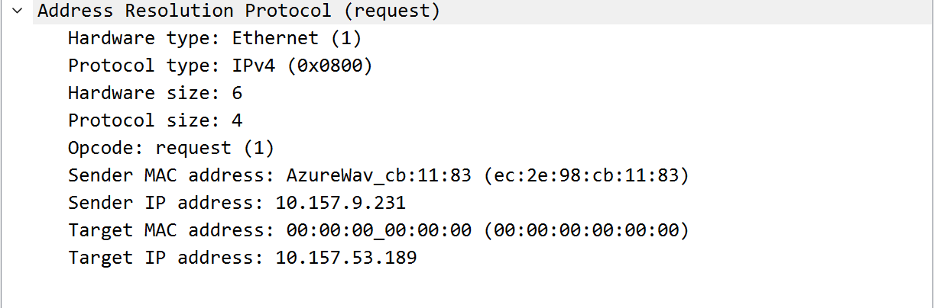

**Details of ARP over Ethernet**

1. What opcode is used to indicate a request? What about a reply?
   1. 1 for request, 2 for reply
2. How large is the ARP header for a request? What about for a reply? You will need to research this (hint: some sources define what belongs to the header differently, name which source you base your answer on)
   1. 28 bytes. (https://www.netometer.com/qa/arp.html#:~:text=The%20size%20of%20an%20ARP%20request%20or%20reply%20packet%20is%2028%20bytes.)source
3. What value is carried on a request for the unknown target MAC address?
   1. 00:00:00_00:00:00
4. What Ethernet Type value indicates that ARP is the higher layer protocol?
   1. 0x0806

**1.2. Understanding TCP network sockets**

Manually set a timer and went line by line counting

**1.3. Sniffing TCP/UDP traffic**

1. Explain both the commands you used in detail. What did they actually do?

Ncat -k -l 3333 establishes a port server for client to talk to

Ncat 127.0.0.1 3333 talks to the server from client on port 3333

1. How many frames were send back and forth to capture these 2 lines?

51 bytes for both

1. How many packets were sent back and forth to capture only those 2 lines?

3 packets

d) How many packets were needed to capture the whole "process" (starting the

communication, ending the communication)?

7 packets

1. How many bytes is the data (only the data) that was send?

7 bytes

1. How many total bytes went over the wire (back and forth) for the whole process?

14 bytes

g) How much overhead was there. Basically how many bytes was the whole process

compared to the actually data that we did send.

132 bytes

Udp sniffing

1. Explain both the commands you used in detail. What did they actually do?

Ncat -l -u 3333 established port 3333 with u flag specifying it is in udp server

Ncat -u 127.0.0.1 3333 u specifying sending to udp server.

1. How many frames were needed to capture those 2 lines?

40 bytes for the first and 39 for the second

1. How many packets were needed to capture those 2 lines?

2 packets

d) How many packets were needed to capture the whole "process" (starting the

communication, ending the communication)?

2 packets

e) How many total bytes went over the wire?

79 total bytes

f) How many bytes is the data (only the data) that was sent?

8 bytes for the first- and 7-bytes fir the second

g) Basically, how many bytes was the whole process compared to the actually data

that we did send.?

15 bytes

h) What is the difference in relative overhead between UDP and TCP and why?

Specifically, what kind of information was exchanged in TCP that was not

exchanged in UDP? Show the relative parts of the packet traces.

For the tcp requires more packets due to checks being made before and after sending data while udp only has 2 packets since its only sending and receive.

1.4. Internet Protocol (IP) Routing

(Home network)

(ASU network)

My home network is faster than asu network because the amount of request time out is few and time finished ms is less than asu.

1.5.1. Running things locally

Video: [**https://youtu.be/TxMo7_q_QLs**](https://youtu.be/TxMo7_q_QLs)

Number is shown as hex value 16 decimal->10 Hex

Changes made when running aws server and client was the ip address specified. Instead of -Phost=localhost it would have been the ip address ec2 had running. Also the port number that was set on aws security being port 8888. The source code was already set to port 8888 so no changes had to be made there.

**1.5.3. Client on AWS (2.5 points)**

Consider the case you want to run your server locally (so on your home computer) and your client on AWS (you do not have to do this but you can try). Does this work without issues? Can you do it in the same way as in 1.5.2? Why or why not? What is different?

This would still work although the port number would have to change to the ip address of your home computer and the port running would still be the same. It would be the same as 1.5.2.

**1.5.4. Client on AWS 2 (3 points)**

In this context also explain how the differences in local IP addresses, how your router

plays into all of this. Why can you easily reach your server on AWS with a client running

in your local network but not as easily go the other direction? And what can you do to

reach your server in your local network if you want to reach it from outside your network

(you do not have to do that)? What is the "issue" if you want to run your server locally

and reach it from the "outside world"?

Because the ip on your router is private rather than aws ip network is public. Your router can easily direct traffic to aws server but is a bit harder going the other way from aws client to local server due to your router being private. You will need to port forward your Ip to specifying which port and network to use or run. Issue here would be a security risk due to your information being open to the outside world.