<https://api.github.com/users/amehlhase316/repos>

https://api.github.com/repos/amehlhase316/memoranda/commits

Random repo listing commits

Commits from branch

Task2 Running web server

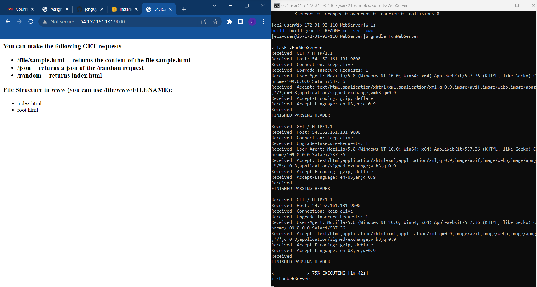

1. What filter did you use? Explain why you chose that filter.

Http filer because most get request from web services use http protocol

2. What happens when you are on /random and click the "Random" button compared

to the browser refresh (you can also use the command line output that the Web Server

generates to answer this)?

Generates a random pictures like streets or bread.

3. What kinds of response codes are you able to get through different requests to your

server?

200

4. Explain the response codes you get and why you get them.

Tells you response was successful when getting the api.

5. When you do a ipOfSecondMachine:9000 take a look what Wireshark generates as

a server response. Are you able to find the data that the server sends back to you?

Yes.

6. Based on the above question explain why HTTPs is now more common than HTTP.

7. What port does the server listen to for HTTP requests in our case, and is that the

most common port for HTTP?

Port 80

8. What local port is used when sending different requests to the Web Server?

Our local port.

Port 80

1. What is the URL that you can use now to reach the main page?

1. Check your traffic to your Webserver. What port is the traffic going to now? Is it the same as previously used or is it and should it be different?

3. Is it still HTTP or is it now HTTPs? Why?

4. Take a screen shot of your Web browser, your second machine and also showing the port on Wireshark, similar to the screen shot you took before (but also with Wireshark) and add it to your document for this task. If we do not see that you can now get to the webserver with the "different URL" we will not see that you actually setup the server correctly so make sure that shows up if you want points for this task.

* 1. **Some programming on your Web Server**

**2.5.3 Make your own requests**

**2.5.4 Protocol design**