User Guide: Getting Started with Updating the Family Tree
Users occasionally approach me concerned that they are unfamiliar with using a web-site to update information on the Inernet. Do not think of this site as being some special unfamiliar entity. It is simply an application, like a word processor, that runs on your computer, or tablet, or smart phone, and accesses and manipulates information held on a server, rather than on the disk of your computer. It is no different from accessing your e-mail or using Google Docs to edit office documents. Working with information which is stored on the Web instead of on your own computer hard-drive is simply a new metaphor for providing application services called “cloud computing” which simplifies your life by eliminating the need for you to purchase, install, and maintain software, like Microsoft® Office or Family Tree Maker©, on your computer. This new metaphor provides the ability to easily share the results of your research and cooperate with friends and family in collectively organizing your research.
The first step after you sign on before you can see the private details on your family or update the family tree is to identify a common ancestor of the family you wish to contribute to. On that page go to the bottom and click on the “contact author” link at the bottom of the page.
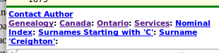Illustration 1: Contact Author Link at Bottom of Any Page
Clicking on this link opens a dialog that permits you to send a message to the site administrators and to each current owner of the individual. This implementation avoids revealing the e-mail addresses of contributors to casual visitors to the site.
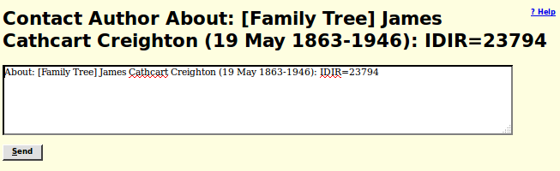Illustration 2: Contact Author Dialog
Explain in this note that you wish to be granted shared ownership of the individual on the page, that individual's ancestors, and that individual's descendants, and your reasons for requesting access, in particular your degree of relationship to the individual. Once you are granted shared ownership of the individual and the individual's family, you will receive an e-mail listing all of the individuals in the family tree that you now share ownership of, and can therefore update and see the private information for.
Now when you go to any of the identified individuals you will see a new button on the main page for the individual:
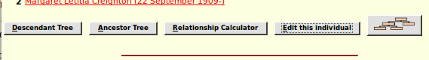Illustration 3: Edit this Individual Button
This functionality can also be requested by holding down the Alt shift, on either side of the space bar on most keyboards, and pressing the letter “E”.
When you click this button you are presented with the information recorded about the individual presented as an input form.
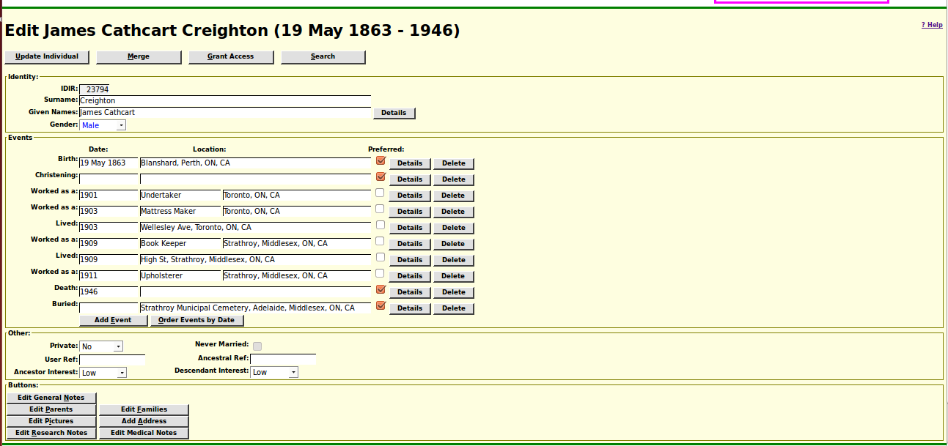Illustration 4: Edit Individual Dialog
You can change the contents of any of the input fields and then click on the “Update Individual” button, or use the keyboard short-cut Alt-U, to apply the changes.
At the top right of the form there is a link “? Help” which opens a page of documentation explaining in overall terms the use of this page. More usefully holding the mouse over any input field or button pops up a detailed description of the exact meaning and use of that field or button. Don't worry about entering bad values, since you can always just return to this page and correct the value. If you enter a value in a field that is inconsistent with the expectations, for example if you misspell the name of a month in a date field or enter an unusual character in an address, the color of the text changes to red as a reminder to you to reconsider the value. This is only a warning, you can store any value that you like into the database, but an invalid value may be misinterpreted.
Location input fields on the form, as elsewhere on the site, try to guide you in entering values that are as consistent with the standards of the site as possible. It is desirable that each actual location be identified as much as possible in the same way. For example a village name in Canada or the USA is normally entered in explicit form with the township, county name, postal abbreviation for the state or province, and the two-character international country code (as used in Internet domain names). So when you enter a location name that has never been used before anywhere on the site there is a popup dialog to warn you that you have entered a completely new place name.
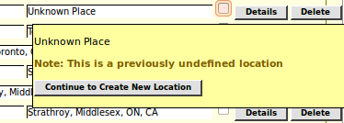Illustration 5: Prompt to Confirm Previously Undefined Location
You can then reconsider and change what you entered. Another feature is that you can just enter the beginning of a place name. If only one existing place name starts with that value, or if that value has been explicitly defined as a short-cut, then that one existing place name will replace what you have typed. If there are multiple existing place names starting with the same text then you are presented with a selection list from which you can choose. In addition your web-browser may suggest values that you have previously entered that partially match your text.
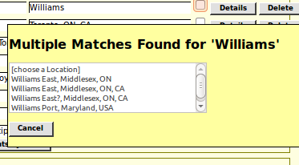Illustration 6: Multiple Matches on Beginning of Location Name
I have tried to make this page as intuitive as possible, but if you have any concerns even after viewing the popup help for a field do not be afraid to click on the “Contact Author” button in the bottom of the page. This queues a message to all of the administrators and all of the current owners of the individual as discussed above.
This edit dialog page is intended to be opened in a full-screen browser window, even though the elements as laid out only occupy a portion of that window. This is because most of the buttons on this form open supporting forms in the right hand half of the window. This is what is called “tiling” in the user interface business. Instead of the 1980s style “messy desk” method of screen space management, the application manages the available window space so as to automatically keep all of the work items that you are currently dealing with laid out as separate areas within the window. Less urgent items are temporarily hidden, and revealed as soon as you finish with the current activity.
In particular if you click on the “Edit Families” button, which appears as “Add Spouse or Child” if there are no families defined for this individual, the right hand side of the window presents an edit dialog for information about the preferred family.
You can modify any of the input fields in the “Edit Families” dialog and then apply the changes by clicking onthe “Update Family” button, or discard them by clicking on the “Close” button. If you click on a button to edit a family member, then a new edit individual dialog is displayed on top of the edit dialog for the primary individual:
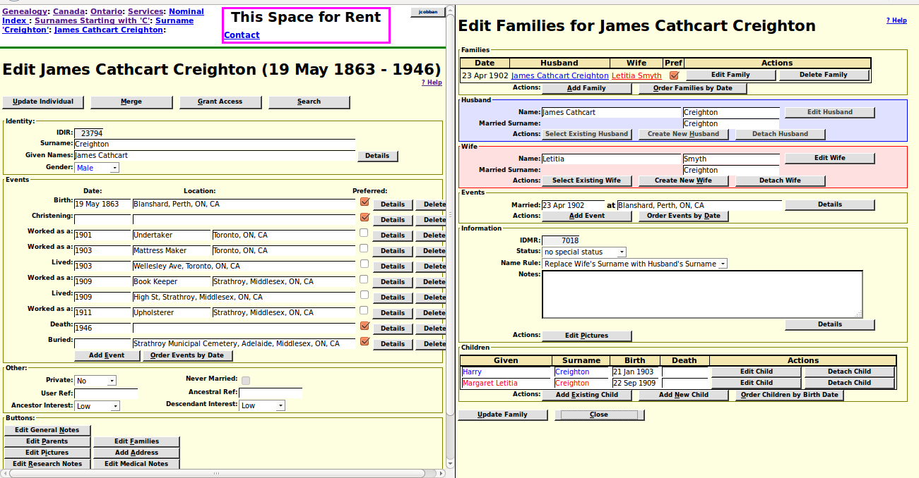Illustration 7: Edit Individual with Edit Family Dialog
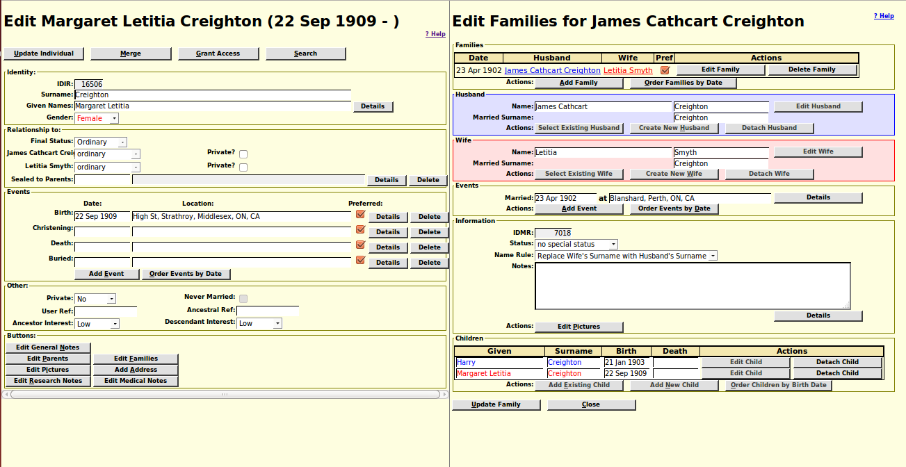Illustration 8: Edit a Child
When you do this notice that all of the “Edit” buttons for individuals in the Edit Families dialog are disabled. This is show by the text in the button changing from black to dark grey. To make this very clear if you click on the “Update Family” button while there is an unfinished edit of a family member displayed in the left hand side of the window, you will be warned to complete that edit before continuing.
You must update the family member by clicking on the “Update Individual” button or using the keyboard shortcut Alt-U. This applies any changes and closes the edit family member dialog, which reveals the edit dialog for the primary spouse.
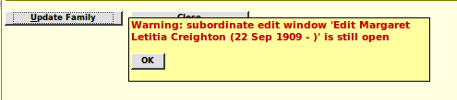Illustration 9: Warning of Attempt to Update a Family while Member Being Editted
All of this applies equally to the Edit or Add Parents dialog.
You can continue to make changes to the primary individual while editing the family. For example if you click on the “Details” button for any of the events in the left hand side of the window, an edit event dialog overlays the edit family dialog until you apply the changes to the event.

