User Guide: Understanding Locations

What is a Location?
A large part of the description of the life of an individual consists of events that happened in the life of the individual and facts that were observed about the individual.
Events are turning points in the life of the individual: birth, graduation, starting a new job, getting married, moving into a new home, dieing, being buried. Each event takes place at a specific date and time, at at a specific place. The imperfect nature of the historical record may mean that we do not know the specific date and time, or the specific place, where the event took place, but that does not change that the event, being a moment in time, happened at a specific place.
Facts are information about an individual that are observed at a specific place and time. Facts are the consequence of events. The fact that an individual was reported to be 3 years old on a specific date provides information about the birth event. The fact that an individual has a university degree on a specific date implies a graduation from university event. And so on. The fact itself was observed at a particular date and time and at a particular place.
Some mechanisms for recording family history, for example a Genealogical Data Communications (GEDCOM) file, record places only as text. There is no internal relationship between a place as recorded in the description of one fact or event and any other fact or event in the document. However locations have an existence in and of themselves. The location did not come into existence just at the moment of the event, and it does not cease to exist after the event. It is also desireable that each location be described using the same textual description in the discussion of every event that took place or fact that was observed at that location. Therefore on this site each location is an entity with attributes of its own beyond the references to the location that appear in fact and event descriptions.
When viewing the page for an individual if you hold the mouse over a location name the information which is recorded about that location is displayed:
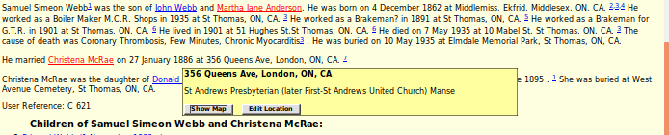Illustration 1: Location Popup
This site records more information about locations than most family history tools.
Each Location record contains the following information
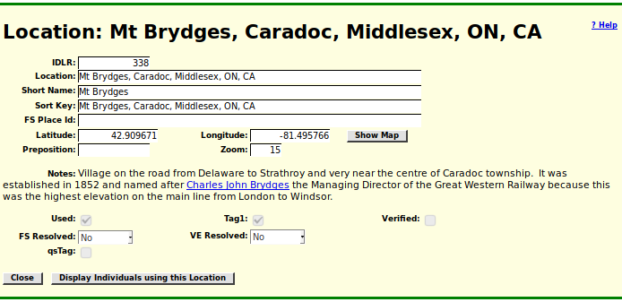Illustration 2: Detailed Display of Information about a Location as displayed to a casual visitor.
- Because, as will be described later, it is possible to have multiple Location records with the same location string, each Location record as a unique numeric key which is used internally to distinguish records.
- The location string is what is displayed as part of the description of a fact or event.
- The short name is used to distinguish this location from all other locations that start with the same text. Otherwise every time a user typed a location string that is the beginning of multiple location names the user would be prompted to choose between the choices.
- The sort key is used when displaying multiple locations. For example if a user asks to see all of the locations that are on a particular street in a city, or in a particular concession or range in a rural area, the sort key is initialized so that the locations are displayed in lot number order. For example it would be confusing if "147 King St, London, ON, CA" was displayed before "23 King St, London, ON, CA".
- The FS Place ID is a link to the way that the FamilySearch.org service manages the unique identification of locations.
- The latitude, longitude, and zoom values are used to control how the map of the location is displayed using Google® maps when the "Show Map" button is clicked. Note that if these are not filled in "Show Map" attempts to find the coordinates using the Google® maps service.
- The Preposition field is used when constructing the textual narrative for an individual. In English individual villages, towns, and even cities, use the preposition "at" for events while extended geographical areas, such as townships, counties, states, and countries use "in", and bodies of water use "on".
- The notes section can contain an extended rich-text document using many of the formatting capabilities of a word processor. Of particular effectiveness in this application the notes can contain links to any document on the web.
- The remaining options on this page are used internally by the site.

The Location String
The location string is used whenever a fact or event relating to an individual is displayed. Unlike a postal address as used in business applications this is a simple string, not a hierarchy of levels, and the only desirable properties are that it uniquely reference a single physical location, and that there is only a single string used to reference that physical location. The site does not itself assume any structure to the location string, however when Google® geo-location services are invoked, for example by clicking on the "Show Map" button in the above menu, the geo-location service does impose interpretative assumptions about the structure of the location name. For example one of the parameters which is passed to the geo-location service is the default country, which in this site is set to "Canada". As a consequence if Google® geo-location is asked to find "Toronto" it will interpret that as a request to find Toronto, Ontario, Canada, not Toronto, New South Wales, Australia.
The country name must always be present as the last part of any location name. Because most of the locations in this site are in Canada this is generally abbreviated to the ISO country code "CA", however it is spelled out in full in the location entries for each of the provinces and territories, so "Ontario, Canada".
The state or province name must always be present as the second last part of any location name. For Canada and the USA this can be abbreviated to the two-character official postal abbreviation, once again excepting the location name for the entire state or province, so "Ontario, Canada" is preferred to "ON, CA", but most locations within Ontario have the end of the address abbreviated to ", ON, CA".
The city or county name should be the third last part of any location name. Rural addresses always have the county name present, so "Strathroy, Middlesex, ON, CA" is preferred to "Strathroy, ON, CA". There is an exception, however, where a town within a county has the same name as a township in the same county, so "Goderich, ON, CA" is a reference to the town of Goderich and "Goderich, Huron, ON, CA" is a reference to the township of Goderich within which the town of Goderich is located. This convention is used because in many cases as the town became larger it was incorporated as a city, for example in the cases of London, Sarnia and Chatham. That is the site does not bother distinguishing between the town of Sarnia and its evolution into the city of Sarnia, where the only distinction is ultimately political.
During the implementation of the Durham Report in Ontario running up to 1852 the county administrations were established on a basis that continued up to the 1960s. One of the consequences of this that a number of townships came to be divided in two in order to simplify the boundaries between the new counties, or a township was just determined to be too large to be effectively administered as a single entity. As a result there came to be distinct townships identified by either a direction prefix or a suffix. For example "North Dorchester" and "South Dorchester", but "Nissouri West" and "Nissouri East". I observed that regardless of whether a prefix or a suffix was used the county administrations sorted the townships by the main portion of the name. So "East Williams" and "West Williams" come after "Westminster" where a strictly alphabetic order would have put "East Williams" before "Ekfrid" and "West Williams" just before "Westminster". So to avoid unnecessary duplication of locations it is preferred that these divided townships always be identified in location names with the direction as a suffix. So please use "Williams East, Middlesex, ON, CA", and "Dorchester North, Middlesex, ON, CA", and "Nissouri West, Middlesex, ON, CA".
It is preferred that for locations identified by property designations within a town, city, or township, that the lot number precede the street or concession identifier. This is that consistent way that properties are identified in cities, but various documents for rural properties can specify the lot number either before or after the concession number. To avoid creation of synonymous locations specify "lot 12 con 7, Lobo, Middlesex, ON, CA" rather than "con 7 lot 12, Lobo, Middlesex, ON, CA".
Places change names over time depending upon the political winds. For example in 1914 the city of Berlin, ON, CA was renamed to Kitchener, and the village of Bismark, Yarmouth, Elgin, ON, CA was renamed to West Lorne. In 1791 as part of dealing with the refugees from the American War of Independence, it was decided to split off the portion of the colony of Canada into a separate Upper Canada which would be more congenial to the refugees through the predominance of the English language, the English church, and English common law as opposed to the existing colony whose constitution specifically protected the rights of the French language, the French Catholic church, and French statute law. This division collapsed in coordinated violence in both halves of the colony in 1837 and as a consequence a new regime was established granting greater democratic rights to the resident subjects, and Upper Canada became Canada West. This system proved unworkable because it was seen as trying to swamp the rights of the French in a continental sea of English speakers, and the system was reformed again in 1867 with the creation of the Dominion of Canada and Canada West became Ontario. Prior to 1867 many official documents were sloppy about whether to use Canada West or Upper Canada. After 1867 most official documents when describing events that took place before confederation proleptically identified them as having taken place in Ontario. For example the 1871 census always identifies the birthplace of individuals born west of Montreal as Ontario regardless of what the region was called at the time of their actual birth.

Short Name
The short name field is used to facilitate data entry by avoiding a prompt to the user when the name as entered by the user does not uniquely identify a single Location record. For example there are multiple locations that start with "Mt Brydges", but the one identifying the village is used if that is all the user enters. Similarly there are multiple locations starting with "Toronto" but the location entry for the city itself has "Toronto" as its short name. There are altogether 39 entries starting with "Ontario", so the location "Ontario, Canada" has a short name of "Ontario".
The short name field can also be used to define an alternate abbreviation. For example there is an entry that maps the abbreviation "ON, CA" to "Ontario, Canada". Since the main entry for "Ontario, Canada" already has a short name of "Ontario" that means there are two Location records for "Ontario, Canada".

The Locations Menu
The Locations menu permits you to search for existing locations matching a pattern. This particular example shows how the sort field is used to ensure that the properties on this street are displayed in lot number order rather than simple collation order. You can select an individual location by clicking on the link in the first column:
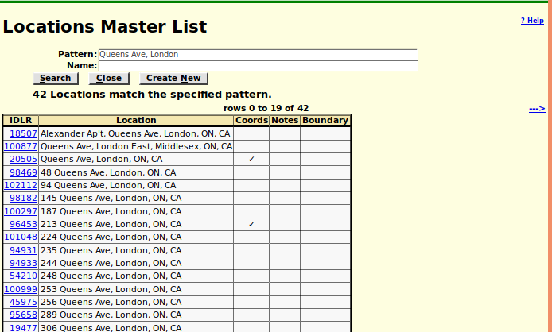Illustration 3: Locations Menu
Note the button "Display Individuals using this Location" at the bottom of the page. Clicking on this displays the following:
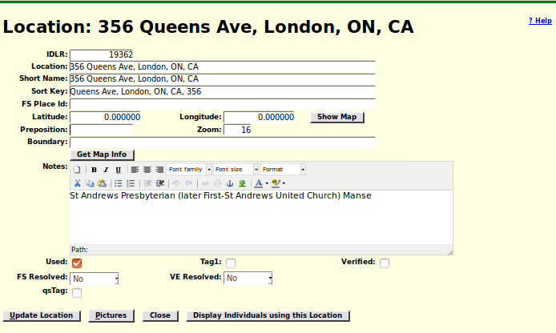Illustration 4: The Location Menu if the Current User is a Contributor
Since as described for the location this was a church manse it is not surprising that it was the place for a number of marriages. Note that in the 19th century it was only the Roman Catholic church that as a matter of policy held marriages in the church sanctuary because only the Roman Catholic church explicitly holds that marriage is one of the seven sacraments of the church and should be led by a priest as part of a mass. Protestant churches, following Luther who observed that there is not a single marriage in the entire Bible which mentions a priest as officiant, hold that the actual marriage ceremony is merely official recognition by the community that a marriage exists through the grace of God and the minister's responsibility is to ensure that the proper oaths are exchanged and forms are observed and that the marriage is registered with the hierarchy of the church and the civil authorities. Therefore Protestant churches in the 19th century, with the exception of High Anglican churches influenced by the Oxford Movement, eschewed the use of the church sanctuary for marriages. Protestant marriages were held in the parlor of the bride's home, the manse or rectory, or in a hotel. Even the Roman Catholic church in the case of a marriage involving a non-Catholic held the marriage in the residence of the priest because there was no mass involved.
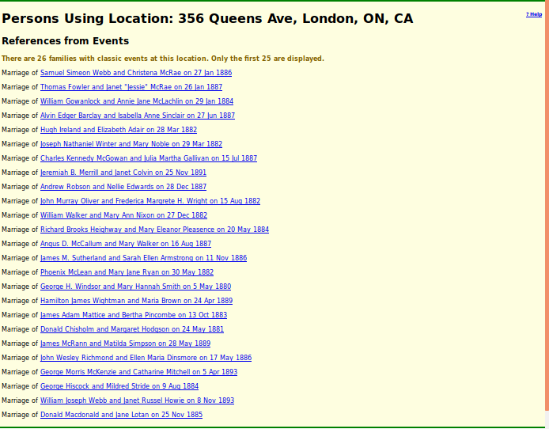Illustration 5: Display of Individuals and Families Referencing a Location
Note that this usage display page is the only place where a contributor or administrator is permitted to delete a Location record since only a Location record which is not referenced by any events or facts should ever be deleted.

