Monthly Update for April 2012

Linking Between the Family Tree and the Source Transcriptions
The latest enhancements to the www.JamesCobban.net family history web-site are focused on increasing productivity by establishing linkages between the raw source document transcriptions and the family tree. There are two sides to this:
- The footnotes for the main page of an individual which refer to primary source documents that are transcribed on the web-site are interpreted, where possible, as links directly to the specific page of the source document.
- When viewing a transcription of an original document where possible the fact that this original document contains information about an individual in the family tree is highlighted, and a mechanism provided to view the information in the family tree.
These linkages change how almost all of the tools work. As mentioned above the footnotes now include links to the individual pages of the transcriptions:
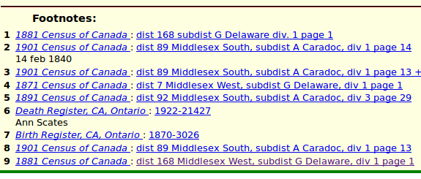
Clicking on the registration number link for the death registration displays:
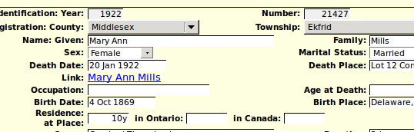
Note the link back to the page in the family tree.
Clicking on the link to the 1881 Census displays a summary of the whole matching page:
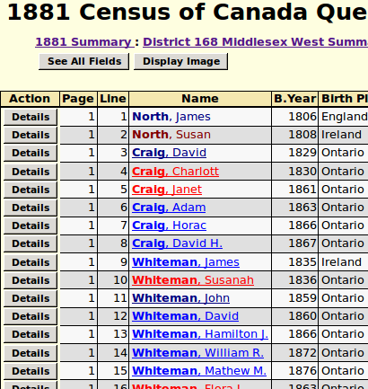
Observe how in those lines that have had linkages established to the family tree the name is a link to the family tree page for the individual, as indicated by the underlining and the brighter color. This is done for all report responses. For example if you search for marriages by a “John Cobban” the response is:
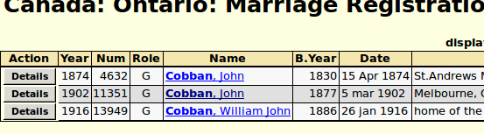
The hyperlinked names display the family tree information. If you click on the “Details” button, the marriage details page now shows:
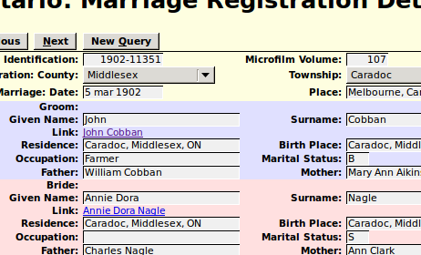
This shows the new links to the family tree for both the bride and groom.
I have attempted to automate the establishment of these linkages as much as possible, however there are a lot of places where a judgment call is required, and computers are notoriously lacking in their ability to make such decisions. The next section of this report discusses how to ensure that these features are available to users of the web-site.

Defining a Citation so it will be Interpreted as a Link
When you define a citation to one of the original source documents that are transcribed on the site you must use a fairly rigid format of the page number information, so the web server software can correctly interpret the linkage.
For Ontario Birth, Marriage, and Death registrations the page number should be the registration number stamped on the original document and the year of registration in the format yyyy-nnnnn, for example 1883-12345. The year must be 4 digits long, for obvious reasons. That must be followed by a hyphen with no spaces around it. The registration number is more fluid, since actual registration numbers have between 4 and 7 digits, and the registration number does not have to be the last thing in the page number, although anything following the registration number is ignored.
There are issues with the Ancestry indexes, and the associated images. The volunteers who created this database and assembled the images ignored the year of registration and the registration number when capturing the information. The images are organized by the year of the event, not the year of registration. Frequently events from previous years were registered in a later year. The Ontario Registrar even has a special procedure for handling this with registration numbers starting with a 9 for registrations delayed by one year, and 5 for registrations delayed more than one year. Less frequently sloppy township clerks did not forward the registrations until early in the new year, and therefore events registered in a particular year may have taken place early in the following year! Furthermore in the period around the “turn of the century”, from the 1890s to the 1900s, the standard forms required 2 pages to record all of the information, and frequently the image of the page containing the actual registration number is not even present on the Ancestry site.
For Canadian Census records a specific line, recording information about a single individual, can be uniquely identified in all censuses by:
- The district number, which is almost always an integer, but in a couple of cases sloppy administration led to districts with a “½” appended. It makes you wonder, how exactly does one miss an entire federal riding when organizing the census?
- The sub-district identifier. For 1851, 1861, 1906, 1911, and 1916 this is an integer, for 1871, 1881, 1891, and 1901 it is usually a letter, although various kluges were used to handle more than 26 sub-districts in a district.
- If a sub-district was too large to be handled by a single enumerator a division number. In some cases in the 1911 census, which officially had no enumeration divisions, some moron at the Dominion Bureau of Statistics lumped together sub-districts that had been handled by the same person, even if they were not contiguous geographically. This creates a problem that page numbers and family numbers repeat within the same sub-district. AutomatedAncestry.com tried handling this by adding a large number onto the page numbers and family numbers to make them distinct within the sub-district, but this creates a problem that the page numbers within the sub-district are not continuous. For example page 17 might be followed by page 101! Since my web-site uses a consistent implementation across all censuses, the division number is present in the internal implementation of the 1911 census, so I have chosen to invent division numbers to deal with this cock-up.
- Within a single enumeration division the pages are sequentially numbered. In most censuses the enumerator wrote the page number on each form, however in the pre-Confederation censuses this was not done consistently, and when the original documents were micro-filmed in the 1950s a number was rubber-stamped on each page. However since the original documents had not been bound into books, they are frequently not in any intelligible order, which creates chaos when families run over the end of a page. Moreover the technicians doing the micro-filming were not consistent in how they numbered the pages. The information about an individual is spread over the front and back (recto and verso) of the form and some technicians numbered both sides, which causes the page numbers to increment by 2 in the database.
So in citing a fact about an individual to a census it is necessary to provide all four pieces of information to identify where in the census the information is located. The web-site expects the citation page number for a census to look like:
dist 99 optional-dist-name, subdist X optional-subdist-name, div 9 page 99
If the sub-district is not organized into divisions the div portion may be omitted. For pre-Confederation censuses, a 2-character abbreviation for the colony name (e.g. CW) precedes the district portion.
For convenience an appropriate citation string appears at the top and bottom of the page whenever you are viewing a page of the transcription, or the detailed information from a single line of any census.

Linking from the Source Document to the Family Tree
All of the database tables recording source document transcriptions now support an explicit link to the associated individual in the family tree.
For Ontario Birth, Marriage, and Death registrations since the year of registration and registration number uniquely associate the registration with a single individual, who was born or died, or pair of individuals, who were married, the links from the transcriptions of the registrations to the associated individuals have been set up automatically for all citations that already used the proper form of identification as discussed above. Furthermore every time you add a new citation to a birth, marriage, or death using the proper format the transcription record is automatically linked to the family tree.
There are a few minor issues, however: Because of information missing from the Ancestry database some birth, marriage, and death citations do not currently have a proper page reference. In other cases there were typing errors in entering the page reference. A few page references have the year and number reversed, such as 12345-1874. Because of the way the server code is written if you determine the correct reference it is necessary to delete the old incorrect citation and enter a new citation with the correct page reference in order to establish the link.
For Canadian Census records such an automatic linkage is not possible, since the citation only identifies the page, and there are up to 50 individuals recorded on each page. It would be far too tedious to demand that every census citation identify the specific line in the census. Human intervention is required to introduce the necessary judgment into this process.
Some additional tools have been added to the page that is used for editing the transcription of a page of a census. Firstly at the top of the page there are now three buttons:
When you click on “Match Family Tree Citations” the site searches the family tree database for all citations to the current page for births or individual events and attempts to match the individual against the people recorded on the page. A report of successful matches is presented in a separate window. This is a relatively conservative process, that is the individuals must match fairly closely on name, gender, and age. As a result it is quite safe to click on this button.
Now look way to the right-hand edge of the page, which will probably require horizontal scrolling. There you will see a whole new column that looks like:
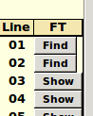
The column heading “FT” stands for “Family Tree” and this column displays the status of linkages to the family tree database on a line by line basis.
Clicking on a “Show” button opens a new window containing the standard display of information from the family tree about the individual associated with this line of the census. If there is no such linkage the button displays “Find”. Clicking on the “Find” button searches the family tree database for potential matches. This is a fairly loose search that will likely find multiple matches. For example a database surname of “Greggor” will match, among other things, “McGregor” It is your responsibility to examine the response to see if one of the responses actually is the individual described by the census.
For example the response might look like:
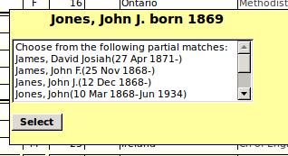
Select the line that you are confident matches the census:
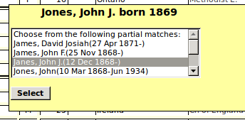
Then click on the “Select” button. If you do not choose a line first clicking on the “Select” button just closes the dialog without updating the database.
If no individual in the family tree database matches the line in the census the application displays:
