August 2012 Features Update
Most of the changes made to the web-site since April have been subtle.

New Entry Point on the Web
A new domain name, genealogy.jamescobban.net, has been created that provides a short-cut to the main entry point to the genealogical services. This does not affect any book-marked links.

Signon, Account Management, and Register Dialogs
The “sign on” button in the top right corner of each page has been relabeled as “contribute”. The dialogs reached through clicking on the contribute button have been cleaned up and made more consistent. They no longer have header sections since they are not part of the hierarchy of pages in the web-site. They now support context specific help balloons that pop-up when the mouse hovers over individual input fields and buttons. I apologize that there was a bug in the registration dialog that meant that nobody could register.
The Signon dialog now looks like:
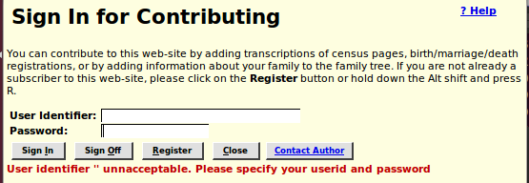Illustration 1: Signon Dialog
The Registration dialog now looks like:
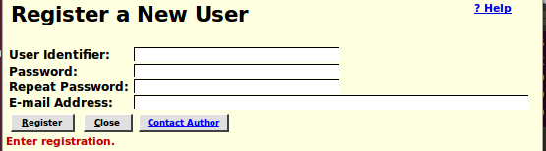Illustration 2: Register New User Dialog
The Account Management dialog now looks like:
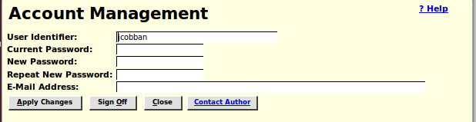Illustration 3: Account Management Dialog

Edit Individual
To simplify modifying existing facts or events it is now possible to modify the date, description, and location of an existing fact or event by modifying the fields on the main edit dialog. Previously these fields were read-only and “grayed-out”. However adding source citations and modifying any other attribute of a fact or event still requires clicking on the “Details” button.

Edit Family
A number of bugs relating to detaching children from a family have been resolved. For example detaching the last child of a family had no visual result. There was also a problem if as a result of previous problems, for example as a result of a merge, the same individual appeared twice as a child in the same family it was not possible to just detach one instance.

Edit Event
The title displayed in the dialog for editing a fact or event contains the name of the individual, or pair of individuals associated with the event. The name[s] are now hyper-link[s] to the main page for the individual[s]. For example all marriage events are now identified by the names of both partners.
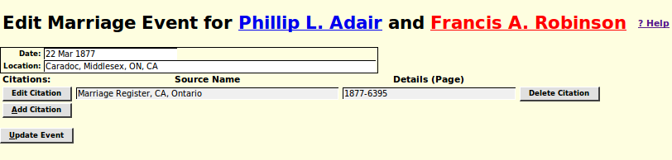Illustration 4: Edit Marriage Event with Names of Partners

Input Fields and Buttons in Forms
The appearance of input fields and buttons in many forms depended upon the operating system context within which the browser was running. This led to problems where in some contexts the input forms were visually rearranged in a confusing and unexpected way. All fields and buttons now use explicit presentation styles so that forms will appear the same in all browsers (that are compliant to CSS3, in other words everything except Internet Explorer release 8 and below) and on all operating systems.

Unknown Sex
A distinct color, green, is used for individuals whose sex is not known, as opposed to the red used for females and the blue for males. This applies to selection lists and reports.
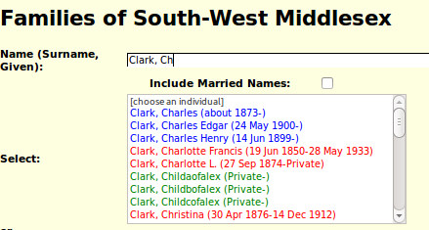Illustration 5: Unknown Sex

Recent Updates Tool
A new tool is added on the Services page. This tool generates a report of all new individuals that were added to the database during the last week. It includes a back link to the previous week's report.
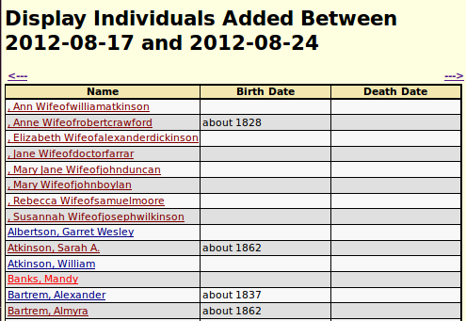Illustration 6: Report of Added Individuals

Tree Representation of Family
A new 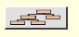 button is added to the details page for an individual for those who like graphical representations of family trees. This button displays a graphical tree showing the parents, spouses, and children of the current individual. You can navigate through the tree by clicking on any name to re-center the tree on the selected individual. For example clicking on a parent's name moves you back through time, while clicking on a child's name moves you forward down the generations.
Illustration 7: Family Tree Graphic

County and Town/Township Information
The information on the towns and townships comprising a county, which is used in the query forms for the Ontario birth, marriage, and death registrations, was previously maintained using a series of text files which could only be modified by the web-site administrator. This information has been moved to a database table, and a web application created to permit any appropriately authorized subscriber to update this information.
You can add an delete counties, and add, delete, or modify towns and townships within a county.
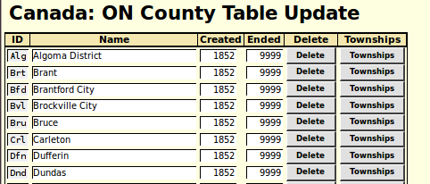Illustration 8: Counties Table

Ontario Birth Registration
The microfilm reel number assigned by the Ontario Archives is now made visible and may be set during updates of Ontario Birth Registrations. It defaults to the reel number of the next lower registration in the database. Also the action taken for clearing the form has been improved.
The birth registration status report for a year has been enhanced to report on the progress of linking birth registrations to the family tree.
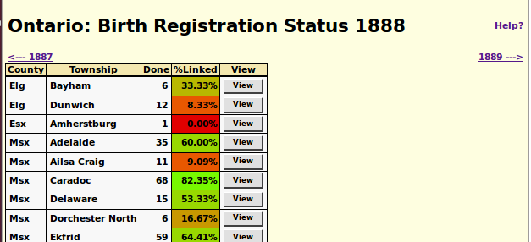Illustration 9: Birth Registration Summary
The progress of the linking is show as a color-coded percentage of the transcriptions for each township. For convenience arrow links have been added to proceed directly to preceding and following years.

Ontario Death Registration
The death registration status report for a year has been enhanced to report on the progress of linking death registrations to the family tree.
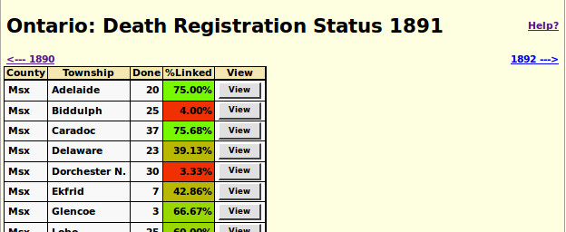
The progress of the linking is show as a color-coded percentage of the transcriptions for each township. For convenience arrow links have been added to proceed directly to preceding and following years.

Ontario Marriage Registration
The marriage registration status report for a year has been enhanced to report on the progress of linking marriage registrations to the family tree.
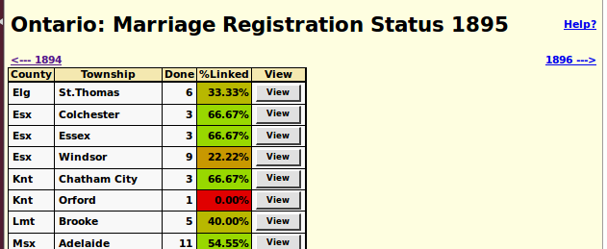
The progress of the linking is show as a color-coded percentage of the transcriptions for each township. For convenience arrow links have been added to proceed directly to preceding and following years.

Census Transcriptions
The status report for each census division now also reports the progress of linking lines of the census to individuals in the family tree.
