April 2013 Features Update

Table of Contents
March 2013 Features Update 1
Global 2
Field Value Warnings 2
Family Tree Enhancements 3
Individual Display 3
Edit Individual Improvements 5
Edit Marriage Improvements 5
Edit Event Notes 6
Edit Name Fact 7
Edit Picture Dialog 9
Merging Individuals 10
Edit Citation 12
Locations 15
Location 15
Temples 17
Addresses 19
Vital Statistics 21
Marriage Registration 21
Census Transcriptions 22
Census Query Dialogs 23
Bug Fixes 23

Illustration Index
Illustration 1: Invalid Date in Dialog 2
Illustration 2: Popup of Individual Information 2
Illustration 3: Popup of Location Information 3
Illustration 4: Popup Map of a Township 3
Illustration 5: Edit Name Fact Dialog 5
Illustration 6: Edit Picture Dialog 6
Illustration 7: Merge Individuals Dialog 7
Illustration 8: Full function editing of Citations 8
Illustration 9: Footnote Including Photograph 9
Illustration 10: Street Addresses In Order 10
Illustration 11: Display of Location to Visitor 11
Illustration 12: Editing the Boundary of a Township 12
Illustration 13: Dialog for Editing an LDS Temple 13
Illustration 14: Edit Address Dialog 14
Illustration 15: Marriage Registration Edit Dialog 16
Illustration 16: Progress of Linking to Family Tree 17
Illustration 17: District Status with Linking Progress 17
Illustration 18: Census Fields with Questionable Values 17
Illustration 19: Census Query Dialog 18

Global Enhancements
A Facebook “like” button has been added to the bottom of each page.

Field Value Warnings
In many dialogs throughout the application the value entered into each field is now checked against a pattern to detect possibly erroneous values and questionable values are highlighted in red. For example if you enter a date and misspell the month name, or enter a 5 digit year, the text in the field is displayed in red.
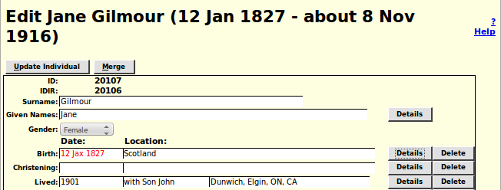Illustration 1: Invalid Date in Dialog

Family Tree Enhancements

Individual Display
The most popular type of page in the site is, of course, the page that displays the information on an individual and the immediate family of that individual. It is about time that I enhanced this most important aspect of the site.
For individuals referenced from the individual page, aside from the individual and the individual's spouses, only the names, and for children the birth and death dates, are presented in the basic text. Now if you hold the mouse cursor over a name a message balloon pops up that provides additional information about the individual so you do not have to follow the hyper-link.

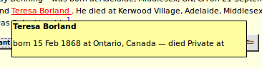Illustration 2: Popup of Individual Information
Notes pertaining to each location referenced on the page were formerly displayed as footnotes. However this put these notes out of context, that is they were not obviously associated with the place name, so the viewer would have to correlate the footnote number to understand its meaning. Now if you hold the mouse over any location name on the page for two seconds an information balloon pops up containing the location name in bold, any notes relating to it, and a button to request that a map of the location be displayed.
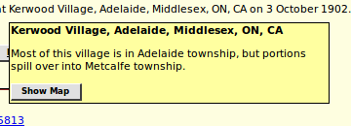Illustration 3: Popup of Location Information

For locations with a defined geographical border the database is gradually being enhanced to permit displaying the border. This is discussed further under the Location dialog on page 12.
If the “Never Married” flag is set for the individual, this is now reported.
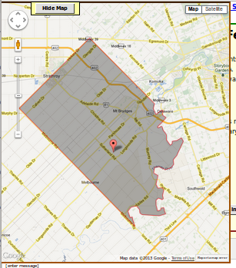Illustration 4: Popup Map of a Township
If you are signed on as a contributor there is an input area to post a blog relating to the page. This has now been made into a full graphical editor field which permits you to use text formatting, insert images, and add hyper-links.

Edit Individual Improvements
There are a few minor changes in the Edit Individual dialog:
- Four additional fields are exposed to the user: Privacy level, Never Married indicator, Ancestor Interest, and Descendant Interest.
- Less commonly used fields are moved to the bottom of the form: Edit Research Notes, Edit Medical Notes, User Reference, Ancestral File Reference.
- The gender selection list is color coded: Male, Female, Unknown.
- The appearance of selection lists is standardized.
- To support British public records where the only information freely available is the name of the registration office and the quarter within which the birth or death was registered 2 new event types are provided: Birth Registration, and Death Registration. Quarter dates may now be entered either as, for example, “2Q 1885” or “Q4 1876”.

Edit Marriage Improvements
The edit marriage and edit parents dialogs are improved to save effort:
- The preferred marriage is displayed for editing when the dialog opens, saving the need to select a marriage in the most common case where there is only one marriage.
- All of the marriage events are now displayed for editing.
- To support British public records where the only information freely available is the name of the registration office and the quarter within which the marriage was registered a new event type is provided: Marriage Registration. Quarter dates may now be entered either as, for example, “2Q 1885” or “Q4 1876”.
- The name fields for the husband and wife are now editable. For the common cases where you are adding a spouse or adding the names of parents with no other information you can just fill in the name(s) and click on “Update Marriage”. You will still need to edit the individual to add any other information or to provide a source citation.
- The dialog displayed as a result of clicking on the “Select Existing Husband” button now only includes male individuals, and that displayed as a result of clicking on the “Select Existing Wife” button now only includes female individuals. Similarly when editing parents the dialog displayed as a result of clicking on the “Select Existing Father” button now only includes male individuals whose surname is equal to that of the child or greater, and that displayed as a result of clicking on the “Select Existing Mother” button now only includes female individuals.
- The LDS temple where the spouses were sealed to each other is now always presented in this dialog as a selection list.
- The given name, surname, birth date, and death date fields for each child are now editable input fields. If you change any of these fields and then click on “Update Marriage” the changes are applied to the individuals.
- The actions of changing the order of children, or deleting a child, or adding a child do not cause the database to be updated until you click on the “Update Marriage” button. If you just close the dialog any changes are lost.

Edit Event Notes
The edit dialog for the notes portion of any event is enhanced to provide additional capabilities such as: paragraph alignment, explicit font specification, font and background color, numbered and unnumbered lists, insert an image, and explicit definition of hyper-links. An example of the appearance of this enhanced field edit is shown in the next section.

Edit Name Fact
The edit dialog for a personal name fact, which pops up when you click on the Details button at the end of the Given Names input field on the Edit Individual dialog, is enhanced to permit editing all of the information about a personal name.
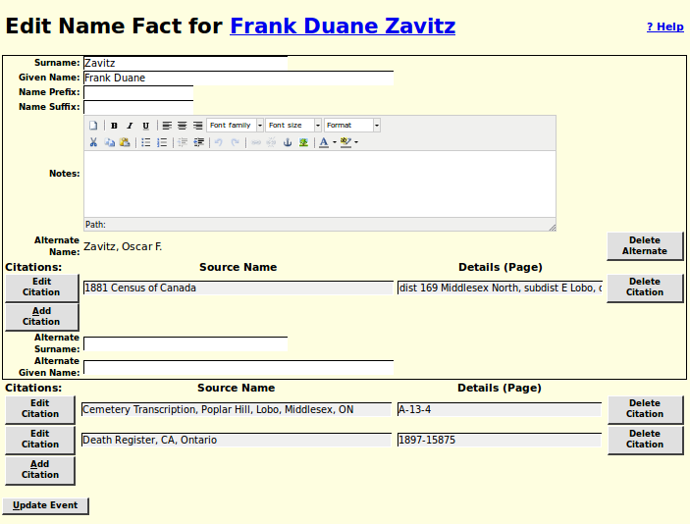Illustration 5: Edit Name Fact Dialog
In particular:
- For symmetry with the other events, you can now change the surname and given name of the person from this dialog. Any changes to these fields are reflected in the main edit dialog for the individual.
- It is now possible to add a new alternate name for the individual. Previously the alternate name(s) were displayed and could be deleted, but there was no way to add a new alternate name.
- It is now possible to add, edit, or delete source citations to each alternate name.

Edit Picture Dialog
The dialog for adding or changing an image document that is associated with a record in the family tree has been enhanced.
Input fields now conform to the standard appearance. Another enhancement is that this dialog now has pop-up help for each input field and button.
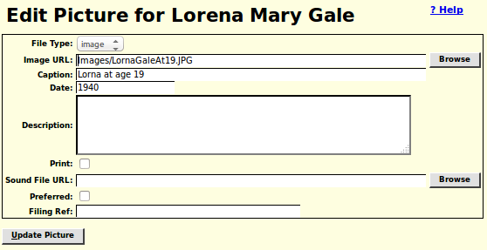Illustration 6: Edit Picture Dialog

Merging Individuals
The merge individuals dialog no longer displays the gender of the individuals, since in order to merge two individuals they must have the same gender. The dialog that is displayed as a result of clicking on the “Choose Second” button on the merge individuals dialog now only includes individuals whose gender matches that of the first individual, and also this list no longer includes the first individual or any individual who has previously been identified as not equivalent to the first individual. Since you are likely to want to merge with an individual who has the same name and birth date this avoids accidentally trying to merge the individual with him/herself.

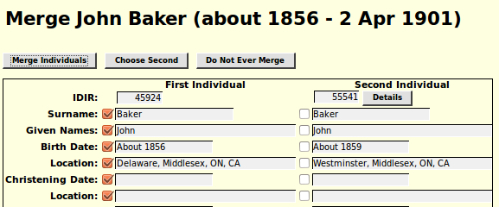Illustration 7: Merge Individuals Dialog
There are two new buttons in this dialog:
- At the top there is a “Do Not Ever Merge” button. Click this if you are very confident that the two individuals displayed below are different people. In future these two individuals will not be offered for merging.
- The second new button is the “Details” button on the Second individual. If you are still uncertain of whether the two individuals are the same, click on this button to see the main display page for the second individual.

Edit Citation
The text and comments fields of a citation are now supported by a full function editor to provide additional capabilities such as: paragraph alignment, explicit font specification, font and background color, numbered and unnumbered lists, insert an image, and explicit definition of hyper-links. The following illustration demonstrates the use of this capability, together with the “Gravestone Photo” source to document a death. Having copied the URL of the image file onto the clipboard, usually by selecting the complete value and then pressing Ctrl-C, click on the insert image tool, which looks like a picture of a tree. This opens a dialog into which you paste the URL of the image file, by Ctrl-V, control how the URL will be displayed, and add an optional description of the image, which will be displayed if the URL becomes invalid.
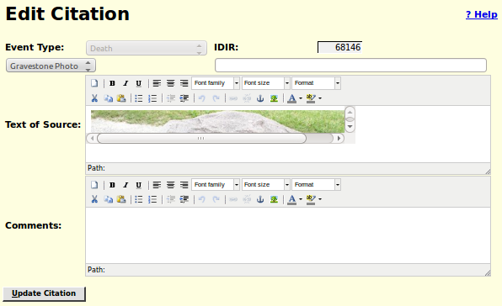Illustration 8: Full function editing of Citations
This citation generates a footnote such as:
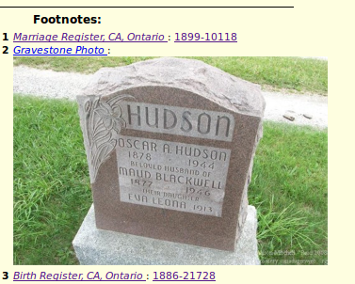Illustration 9: Footnote Including Photograph

Locations Dialog
The sort order for locations containing a lot number is changed so that all of the addresses on a particular street, or within a particular concession, are presented together in order by lot number. Numbered concessions are displayed in order:

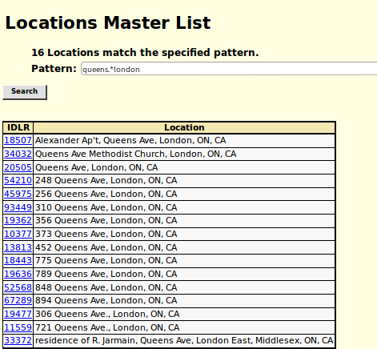Illustration 10: Street Addresses In Order
As you can see from the example, this depends upon the street name being spelled exactly the same way in all cases, although case is ignored.

Edit/Display Location Dialog
The input fields in the Location dialog now conform to the standard appearance. The latitude and longitude fields, which are normally set using the graphical map display, are now displayed and updated as degrees with decimal fractions, rather than in the internal format used by the Legacy Family Tree application. This makes them more compatible with the Google Geocoder tool. The FS Resolved and VE Resolved fields are now selection lists limiting input to the supported values. If the user has authority to update locations then the Notes field is a full graphical text editor, which supports, as shown in the example, the definition of hyper-links, and also insertion of images. otherwise the contents of the field are presented as text, which permits clicking on hyper-links defined within the notes. For visitors, who are not signed on as contributors, the display of information about a location is simplified and the input fields are visually identified as not modifiable:
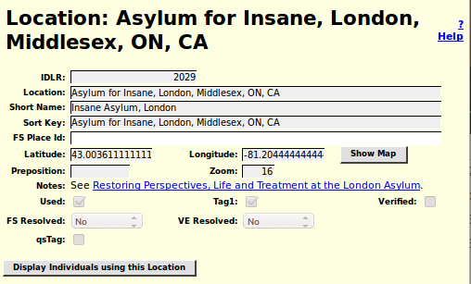Illustration 11: Display of Location to Visitor
Editing the map associated with a location has been enhanced. Previously all you could do was change the center of the displayed area and the zoom level. Now you can define the boundary of an extended geographical area such as a township, county, province, state, or country. Adding this functionality has changed the behavior of the mouse while over the map. Previously the mouse cursor appeared as a hand, indicating its purpose was to drag the map to a new location. Now it appears as a cross-hair. If you do a simple click anywhere in the displayed map, other than on an existing marker or vertex, it adds a vertex onto the boundary line of the geographical area. You can still drag the map by holding the mouse button down while dragging it. When the map is displayed to a visitor to the web page for an individual the boundary line is completed to a polygon by connecting the last point of the boundary line to the first point.
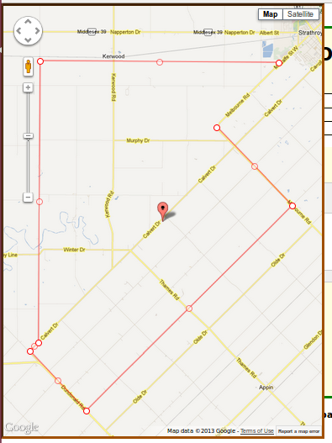Illustration 12: Editing the Boundary of a Township
Observe that when editing a map you can grab the existing vertices of the line to reposition them. You can also grab the marker at the center of each line segment and drag it to create a new vertex. Clicking anywhere on the map except on a marker adds a new vertex to the end of the border. Note that the final segment of the polygon is not connected until the map is displayed to the user as shown in Illustration 4 on page 5.

Edit/Display Temple Dialog
The user interface to the table which contains information about the temples of the Church of Latter Day Saints at which LDS ordinances are consecrated is improved. The locations of the temples have also been edited to make them conform to the appearance of location addresses, in particular by adding commas between the components of the temple location, and adding “USA” to the end of temple locations in the United States of America, so they are consistent with temple locations in other countries.
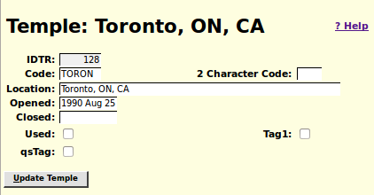Illustration 13: Dialog for Editing an LDS Temple
Forty-Six of the temples have 2 character abbreviations that were implemented by application logic in Legacy Family Tree which was copied into this site. Those 2 character abbreviations are now explicitly manipulable through the management interface. The dates on which the temple opened and closed (if relevant) are now displayed in human readable format, and may be edited by entering a date in human format. All of the input fields and buttons now have pop-up help balloons.

Addresses Dialog
The Address table provides a superset of the capabilities of the Location table. In particular it is used to represent structured postal addresses where the Location table provides only a string.
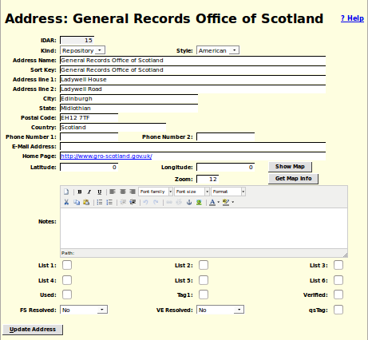Illustration 14: Edit Address Dialog
As you can see this is a much more detailed dialog than the one for editing Locations as discussed on page 13. There are a number of enhancements:
- The Show Map and Get Map Info buttons and the Zoom level input field are added to permit using Google maps to update the latitude, longitude, and zoom level fields using a graphical user interface.
- The Notes field is now a text editor with the ability to set fonts, insert images, define links, and control text alignment.
- Clicking on the Home Page text input field opens that page in a new window or tab. You are warned of this by the highlighting of the value. Note that this may be startling if you only clicked in the field with the intention of editing the value. To avoid this click in the preceding field and then tab into the Home Page field.
- All input fields use standard presentation on all platforms.
- All input fields and buttons have pop-up help balloons.
- The dialog for editing a documentary source now has the ability to create a new repository address or to find a repository address by name entered as a string, rather than only by selecting an already existing repository.

Vital Statistics

Marriages List
To assist the user more in identifying key marriages the list of marriages returned from a Marriage Query now includes the names of both spouses:
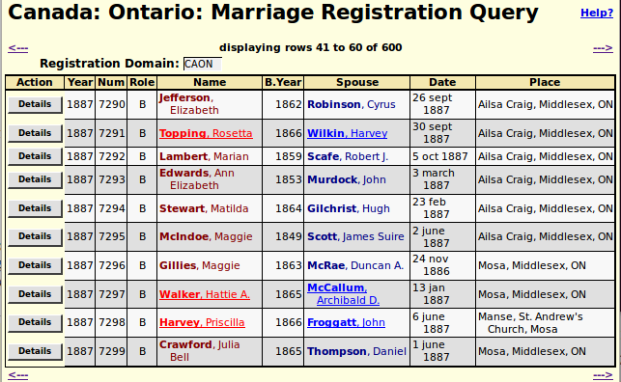Illustration 15: List of Marriages with Both Spouses Shown

Marriage Registration Dialog
To match the existing support for birth and death registrations the marriage registration edit dialog now presents a selection list of possible matches from the family tree to the bride and groom. Also a bug in the presentation of mouse over help is corrected. If you held the mouse over the resolved link for the bride or groom an error message popped up instead of the help bubble.
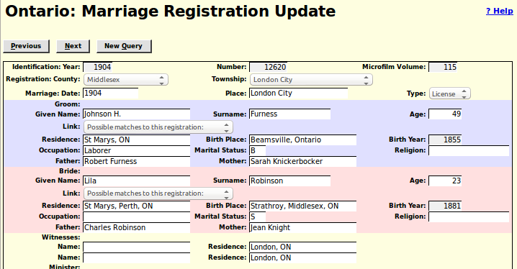Illustration 16: Marriage Registration Edit Dialog

Census Transcriptions
The status report for each census division now also reports the progress of linking lines of the census to individuals in the family tree on a page by page basis.
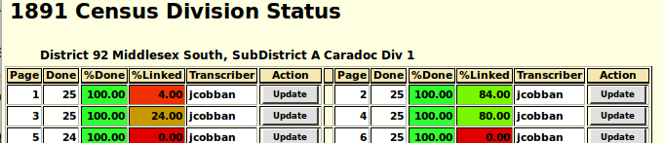Illustration 17: Progress of Linking to Family Tree
Similarly the status report for a census district not reports the progress of linking lines of the census to individuals in the family tree for each census division.
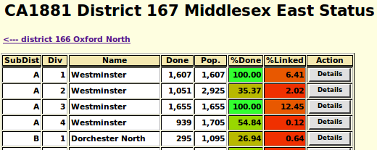Illustration 18: District Status with Linking Progress
In census forms entering an invalid or very questionable value into any field is reported by setting the text color to red. This replaces a previous implementation that reported such problems only by a dialog that popped up when you tried to submit the form. Since this dialog was not always visible within the browser window this could result in an inexplicable inability to update the database.
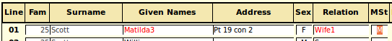Illustration 19: Census Fields with Questionable Values

Census Query Dialogs
The census query dialogs are improved to use standard style for input fields and to make the selections for gender and marital status into selection lists instead of text input fields.
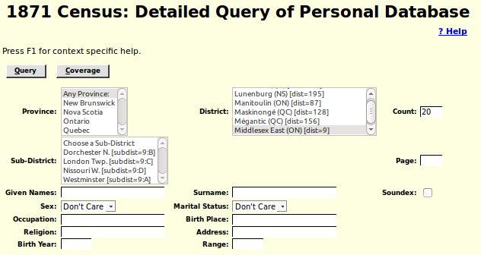Illustration 20: Census Query Dialog

Bug Fixes
- When editing a child from a family the options to set the relationship of the child to each of its parents now works.
- When adding any record, for example a new individual, to the database the syntax of the SQL INSERT statement now conforms to the SQL standard, rather than exploiting an extension supported only by MySQL.
- When updating any database record, including an individual or a family, the SQL UPDATE command now only sets the values of those fields that have changed since the record was last read from the database, rather than setting all fields in the record.
- In all dialogs the text input fields limit the number of characters that you can enter to the maximum number that can be stored in the database record.
- The pop-up help for each field now reports the maximum number of characters that you may enter into the field.
- When you request the addition of a new individual to the database, for example by adding a spouse, child, or parent, the actual insertion of the record into the database is deferred as late as possible to avoid doing an insert of an essentially blank record followed by an update to set all of the changed field values.
- When editing a family the “Edit” button for a spouse that is not yet created or selected is disabled until the spouse is added.
- The table for matching given names in a census record for a loose match against the table of individuals is expanded. For example “Bessie” will now match against a family tree record with given name of “Elizabeth”.
- The algorithm for matching surnames in a census record for a loose match against the table individuals is enhanced to significantly reduce the number of unlikely responses.
- The hang that occurred if you cleared the contents of an input text field that contained a location is fixed. Clearing the input field now properly returns the default, empty, location, instead of returning a selection list of every location in the database! Also the maximum number of matching locations that will be returned for an extremely vague location value, for example a single character, is limited to 30 to keep the application responsive.
- In the 1871 Census form setting the “Can't Read” field to on is corrected to also set the “Can't Write” field to a default of on. Note that there is at least one individual in this census who could write but not read because he had learned to write before he became blind.
- When changing the name of an individual the nominal index and marriage references are now correctly maintained.
- Many addresses which violated the convention that the rural lot number precedes the concession that it is in have been amended.
- There were a few internal tables that used the Western European character set to store text. That would have made it impossible to enter text into some fields that had characters not used by Western European countries; for example Polish, Russian, Greek, Hebrew, Japanese, Chinese, or Arabic. These tables now support the full ISO 10646 (Unicode) character set.
- No internal table yet has over a few hundred thousand entries in it. In particular there are less than 100,000 individuals defined in the family tree. However the internal key used to uniquely identify these records was originally defined as the default, a signed integer, even though obviously there will never be any negative numbers used to identify records. All such keys have been changed to use an unsigned integer key, which permits up to 4 billion entries in each table.
- The implementation of the button on each line of a census form that invokes a search for individuals in the family tree who match the name and approximate birth year of the individual in the census is corrected to avoid getting NaN as the result when an age in months is specified. The interpretation of the age field is modified to ignore extra characters around the actual age value to permit the transcriber to, for example, enter “[43]” where the original form has left the age blank but the transcriber knows, from some other source, what the individuals age was at the time of the census. Another example is to permit the transcriber to add a question mark when the actual age is hard to decipher.
- If the first HTML element under a table cell was not a form input field, such as a text input, button, check box, or selection list, holding the mouse over the cell would result in an error message.
- The script handling the response to a query of the death registrations table did not handle SQL errors correctly. The scripts handling the response to queries of the birth, death, and marriage registration tables did not give a clear error response if the scripts were invoked with no parameters.
- I was unaware that the SOUNDEX algorithm as implemented by MySQL does not produce the same results as the SOUNDEX algorithm as implemented by PHP (which is the algorithm implemented by all other procedural languages). As a result over 1000 surnames were encoded in such a way that a vague search using the SOUNDEX algorithm would fail to find people with these surnames. The implementation has been changed to always invoke the MySQL version of the algorithm and all of the existing SOUNDEX codes in the database have been corrected.

