May 2013 Features Update

Table of Contents
Family Tree Enhancements 3
The “Contact Author” E-Mail Link 3
Database Contents 3
Individual Display 3
Edit Individual Improvements 3
Edit Family Improvements 4
Edit Event 4
Master Locations List 6
Edit Location Dialog 6
Display LDS Temple 7
Display Master Source 7
Edit Master Source 7
Census Database Enhancements 8
Query Surnames by District and Enumeration Division 8
Enhancement to Name Matching 12
Vital Statistics Enhancements 13
Bug Fixes 14

Illustration Index
Illustration 1: Locations Master List Add Location 6
Illustration 2: Census Transcription Progress by District 9
Illustration 3: Census Transcription Surnames by First Letter 9
Illustration 4: Surnames Starting with 'F' 11
Illustration 5: People with the Surname "Fillmore" 11
Illustration 6: Census Match to Family Tree with Birth Date 12

Family Tree Enhancements

The “Contact Author” E-Mail Link
Up until now the “Contact Author” e-mail link at the bottom of every page was hard-coded with my e-mail address as the creator of the software. This is now changed so that the table of Users is interrogated to obtain the e-mail address of the user, or users, who has administrator authority. In addition for those pages which display or permit editing information about an individual the email is also sent to all of the individuals who have been granted permission to modify that individual. So those of you who have asked for access to particular families may now start receiving copies of the e-mails regarding individuals.

Database Contents
Many locations in the location database now have more precise geographic coordinates and, where appropriate, boundaries. For many locations in the townships of Caradoc and Ekfrid the geographic coordinates have been set based upon a formula from the lot and concession numbers. This feature will be extended to other townships.

Individual Display
The main page for displaying information about an individual has minor enhancements:
- The invisibility option was previously ignored. Now if the individual has been flagged as invisible then nothing is displayed about the individual, and the individual does not appear in any lists except if the viewer is an owner of the individual.
- The cremated option on the burial event is now reported. That is if this flag is set then it will be reported as the last fact about the individual that “He was cremated on <date> at <location>.” rather than, as previously, “He was buried ...”.
- The family group fact (IDET 65) is now displayed as such.
- The subject line on the e-mail sent by clicking on the “contact owner” link now also includes the internal record number of the individual. This e-mail is now sent to all users identified as administrators in the table of Users, and also to all users who are identified as owners of this individual in the RecOwners table.

Edit Individual Improvements
The edit individual dialog has minor changes:
- The dialog is shrunk vertically to save space by reducing the height of “buttons”.
- The subject line on the e-mail sent by clicking on the “contact owner” link now also includes the internal record number of the individual. This e-mail is now sent to all users identified as administrators in the table of Users, and also to all users who are identified as owners of this individual in the RecOwners table.
- If the dialog is invoked as a result of clicking on an “Edit Child” button in an Edit Family dialog then the “Edit Families” button, which sometimes appears as “Add Spouse or Child”, is disabled. To avoid making the interface excessively complicated only one Edit Family dialog at a time is allowed to be open. If this button were not disabled, the page for the family of the child would replace the parents' family.
- If merging two individuals results in an individual with two families with the same spouse then the two families are also merged
- If a location is entered for a fact or event that has not previously been used in the family tree then instead of using the built-in alert capability of the browser, which varies in behavior between browsers and is sometimes quite ugly, the application uses a template driven dialog capability so the actual appearance of the warning dialog is governed by a template that is defined in the web page.

Edit Family Improvements
The edit marriage/family and edit parents dialogs have minor changes:
- The dialogs are shrunk vertically to save space by reducing the height of “buttons”.
- The terminology used in the Edit Marriage Dialog is changed to “Family” since not all such relationships involve a marriage.
- The “Never Married” and “No Children” facts are now properly supported, including the ability to cite documentary support.
- The Help page is updated to match functionality added during the past year.
- The help page summarizing the process for adding a new child was missing.
- The subject line on the e-mail sent by clicking on the “contact owner” link now also includes the internal record number of the individual.
- The “Edit Husband” or “Edit Wife” button is disabled, and marked grey, for the individual for whom the marriage dialog was invoked. The Edit Individual dialog for that spouse is already open, so there is no point in permitting it to be opened.
- If a location is entered for a fact or event that has not previously been used in the family tree then instead of using the built-in alert capability of the browser, which varies in behavior between browsers and is sometimes quite ugly, the application uses a template driven dialog capability so the actual appearance of the warning dialog is governed by a template that is defined in the web page.

Edit Event
The Edit Event dialog has minor changes:
- A bug in the handling of fields whose value was displayed in a checkbox led to incorrect database settings.
- It is now possible to add a new master source as part of the process of adding a citation. It is no longer necessary to go to the administration dialog for Master Sources to add a new source. Adding a new master source is as simple as pressing the “A” key while the list of master sources has the input focus.
- Popup help is now properly activated for the fields displayed during the addition of a citation.
- New event types are defined to permit documenting the registration of a birth, marriage, or death, since frequently that is all you know about an event obtained from the British BMD records.
- The “cremated” indicator can be set on a “Burial” event to show that the individual was cremated rather than interred.
- If a location is entered for a fact or event that has not previously been used in the family tree then instead of using the built-in alert capability of the browser, which varies in behavior between browsers and is sometimes quite ugly, the application uses a template driven dialog capability so the actual appearance of the warning dialog is governed by a template that is defined in the web page.

Master Locations List
The administration dialog for managing the list of locations referenced by facts within the family tree has been enhanced to permit defining new locations. This would be done in anticipation of a location being used at some time in the future, so the correct spelling and attributes are associated with the location. In the following example the administrator has noticed that the townships of Easthope North and South have not been previously defined, so for completeness the administrator adds them.
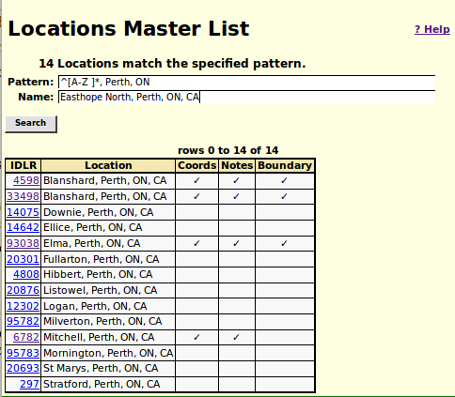Illustration 1: Locations Master List Add Location

Edit Location Dialog
The dialog for editing a location record has been enhanced:
- When you click on the “Merge” button a loading indicator pops up to let you know that the program did see the button click. This clears and the dialog is refreshed once the merge is complete.
- When merging locations if any of the information fields in the first record are empty, their values will be filled in from the non-empty information fields in any merged records.
- The subject line on the e-mail sent by clicking on the “contact owner” link now also includes the internal record number of the individual.

Display LDS Temple
The dialog for displaying a Church of Latter Day Saints temple has been enhanced:
- The subject line of the e-mail sent when you click on “Contact owner” now includes the internal record number of the Church of Latter Day Saints temple.

Display Master Source
The dialog for displaying a master source has been enhanced:
- The information is laid out more clearly in columns.
- More information is displayed from the record.
- The subject line of the e-mail sent when you click on “Contact owner” now includes the internal record number of the master source.

Edit Master Source
The dialog for editing a master source has been enhanced:
- When you change the name of a new master source, the name is copied to the title field to simplify the creation and ensure that the title is not accidentally left blank. The name is how the master source is identified internally, for example in the selection list. The title is how the master source is identified externally, for example in the footnotes on an individual.
- This dialog is now invoked during the creation of a citation if the user requests adding a new master source.
- The subject line on the e-mail sent by clicking on the “contact owner” link now also includes the internal record number of the master source.

Census Database Enhancements
Miscellaneous minor features:
- In the 1891 and 1916 censuses the default values for the “can read” and “can write” columns are set to empty if the individual is less than 5 years old.
- The height of each row in the census edit forms is reduced to the minimum by shrinking the vertical height of the action buttons at the end the row. This permits seeing more rows in the window and reduces the thickness of the lines between rows.
- Briefly there was a bug that all of the provinces of Canada were displayed in the menu for editing the 1906 and 1916 censuses, rather than just the prairie provinces.
- The validation for the “Speaks English” and “Speaks French” columns of the 1916 census is corrected to treat the values as Yes/No flags.
- For a list of typical foreign birthplaces the father's and mother's birthplaces in the 1891 census and the immigration year column in the 1901 and 1911 censuses are initialized with appropriate default values if they are not already set.

Query Surnames by District and Enumeration Division
Surnames in a census transcription can be badly mangled either as a result bad handwriting or limited literacy of the original enumerator or misinterpretations by the transcriber. It is therefore sometimes desirable for a researcher to be able to see a list of all of the surnames in a portion of the census transcription.
On the census query dialog click on the “Coverage” button. This takes you to a summary of the progress of the transcription on a district by district basis:
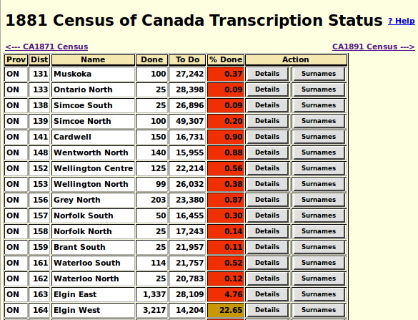Illustration 2: Census Transcription Progress by District
Click on the “Surnames” button for a district, in this case district 164 “Elgin West”:
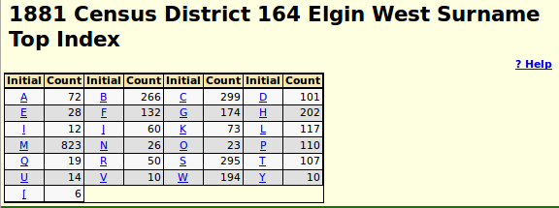Illustration 3: Census Transcription Surnames by First Letter
This page displays, for each distinct letter with which a surname begins, the number of individuals within the specified district whose surname begins with that letter. For example there are 266 individuals in the transcription whose surname starts with the letter “B”. Note that each initial letter is a hyper-link to a more detailed report. For example if you click on the underlined letter “F” you will see a report like:
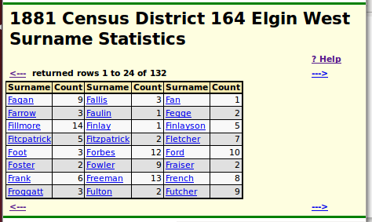Illustration 4: Surnames Starting with 'F'
The forward and backward arrows at the top and bottom of the table can be used to scroll forward and backward through the list of surnames if there are more than 60 surnames to display. Observe that each surname is a hyper-link. Click on the underlined name to see a list of the individuals with that surname in the selected district. For example:
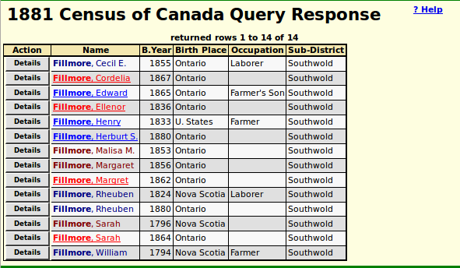Illustration 5: People with the Surname "Fillmore"
This is an example of a standard response to a census query. Clicking on the “Details” button associated with a name will display the contents of all of the information recorded about that individual in the census transcription. If the name is underlined, then it is a link to the page for that individual in the family tree.
The same functionality is also provided at the level of an individual census enumeration division.

Enhancement to Name Matching
One of the objectives of the web-site is to tie each line in every census to the matching individual in the family tree. This is, unfortunately, not a process that can be automated: there are just too many variations in how names are spelled and too many times when individuals gave false testimony to the census enumerator about their age or date of birth. So human verification is required for each link. There are two ways that the researcher can supply this connection:
- When a researcher cites a particular page of a particular census as evidence for the date of birth of an individual, the web-site searches the identified page for a match, and if one is found, inserts the link back to the family tree. This works most of the time, but cannot work all of the time because no computer program can be expected to be as knowledgeable as a human researcher.
- When editing a page of a census a researcher can explicitly define a link from a line to an individual in the family tree by clicking on the “Find” button at the end of the line. This pops up a list of potential matches using a fairly broad algorithm, and identifies the key elements of the search pattern: the name of the individual as it appears in the census, and their estimated birth date, usually calculated from the age since that information appears in all censuses from 1851 on. To assist the researcher in confirming the appropriate match the popup dialog listing the matches now reports the year and date of birth from the census line for those censuses that provide this information in addition to the age, that is the decennial censuses from 1901 on.
So the user knows that something is happening, while this dialog is being populated from the family tree database a “loading...” icon pops up.
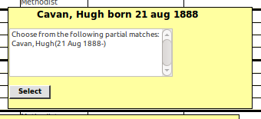Illustration 6: Census Match to Family Tree with Birth Date

Vital Statistics Enhancements
Various minor enhancements:
- In the query of the Ontario Cemetery Finding Aid database while waiting for township information from the database a “loading...” indicator is now displayed.
- In the death registration data entry form the place of death now defaults to the current township, rather than to the place of death from the preceding record.
- In most of the years 1870 through 1872 instead of having sequential registration numbers assigned to marriages the only identifying information is the page number within a volume. For this period the registration number in citations is given as the concatenation of the volume number, the page number (padded to 3 digits), and the column number on the page (1 to 3). This means that for these years the registration numbers are not sequential. For example in 1871 volume 17 page 32 column 3 is followed by volume 17 page 33 column 1. This appears in citations to the marriage registration database as 1871-170323 followed by 1871-170331, rather than the expected 1871-170324.

Bug Fixes
- One of the URLs in the documentation for how to add a new individual to the database was spelled incorrectly.
- A misleading warning message is no longer popped up by the page that displays all of the individuals with a particular surname if there are no individuals with that surname.
- The application no longer fails during the display of a list of individuals if the cookie for the last individual referenced is improperly formatted.
- The “received a degree” fact is now correctly presented. Previously it displayed as “received a received a degree”.
- In a census form if you hid and then redisplayed a column the dynamic behavior of the input fields in the column was not restored properly. In particular the handling of arrow keys, tabs, and the enter key for moving around the form and the special actions taken when the value is changed.
- The help text which pops up when the mouse is held over input fields or buttons was missing for some elements on some forms.
- The file legacyIndex.html is just a redirect to legacyIndex.php, so all internal references to legacyIndex.html have now been changed.

