June 2013 Features Update

Table of Contents
Family Tree Enhancements 3
Edit Individual 3
Display Individual 3
Cemetery Sources 3
Census Database Enhancements 5
Database Implementation Change 5
Choose Matching Individual from Family Tree Dialog 5
Vital Statistics Enhancements 6
Ontario Cemetery Finding Aid 6
Birth Registration 6
Marriage Registration 7
Death Registration 7
Wesleyan Methodist Baptisms 8
XML Access 9
Bug Fixes 10

Illustration Index
Illustration 1: Birth Registration with Link in Remarks as Viewed by a Visitor 6
Illustration 2: Birth Registration with Link as Viewed by Editor 7
Illustration 3: Query of Wesleyan Methodist Baptisms Database 8
Illustration 4: Response to Query of Wesleyan Methodist Baptisms Database 8

Family Tree Enhancements

Edit Individual
The list of given names that are identified as female, and which automatically change the sex of the individual when they are entered has been expanded by about 4 times. You should therefore have to manually set the sex of a new individual less often.
When invoked to create or edit a spouse or child, from the Edit Families dialog, or a parent, from the Edit Parents dialog, the “Edit Families” button is disabled to prevent accidentally overwriting the dialog from which the Edit Individual dialog was invoked.
The user can no longer modify the gender of the male partner in a family when the Edit Individual dialog is invoked from the Edit Families or Edit Parents dialogs. This was previously only true for the female partner.
If this dialog is invoked through the Edit Husband, Edit Mother, Edit Father, or Edit Mother button on an Edit Families or Edit Parents dialog, changes made to the spouse are reflected back in the originating dialog. This corrects a problem where changing the name of the spouse in the Edit Individual dialog did not take effect because the name in the Edit Marriages/Parents dialog was not changed, so the name change was overwritten by the old value when the family was saved.

Display Individual
If you hold the mouse over a cause of death a yellow “sticky” pops up to interpret terms in the description that may be unfamiliar or which had a different meaning in the past than at present.
In the footnotes clicking on the hyper-link for a source now opens a new window or tab to contain the description of the source, rather than overwriting the page for the individual.
If you hold the mouse over the title of a source a yellow “sticky” pops up to display summary information about the source. If the contents of the source are available on a web-site a link to that site is included in the display, so you can immediately view the original document.

Cemetery Sources
I have long been pondering the question of how to share the personal transcriptions I have made of a number of the cemeteries. On these transcriptions I have made a lot of notes:
- Adding estimated dates of birth where the original only has a date of death and an age.
- Adding surnames, particularly of spouses, where these are known from other sources.
- Adding relationship information to clarify why all of those people are commemorated on the same gravestone.
- Etc.
I also wanted to extend to the cemetery transcriptions the functionality I have for censuses and BMDs of connecting individuals as recorded in those documents to the corresponding individuals in the family tree.
Check out my transcription of the John Lamont Cemetery in Lobo as my first presentation of this capability. Note how each individual commemorated in this cemetery is presented with a hyper-link to the corresponding individual in the family tree. As I proliferate my transcriptions onto the web site you will see that when you click on the hyper-link in the footnotes for a source that is a census transcription that the Call Number field in the description of the source will be a hyper-link to the transcription. Because of the way these transcriptions are therefore pointed to by the rest of the web-site, they should shortly be indexed by the major search engines.

Census Database Enhancements

Database Implementation Change
The support for editing database transcriptions was the very first part of the site that I wrote, and I have learned a lot along the way since. In particular as I wrote the support for the family tree I introduced an object-oriented interface that separated the application logic from the process of actually applying the changes to the database. So if the application logic required changing the value of a single field in a single record that is what the application logic would do. It would then save the updated record to the database, leaving the details of how that was done to the support code.
By contrast the census code used a rather brute force approach. When the user requested that an updated census page be applied to the database the application code deleted every record pertaining to the page, and then inserted new records into the database. So even if the user had not changed the value of a single field on the page, the entire page was deleted and then recreated. This imposed a design limitation, however, that the census page, as displayed to the user for editing, had to include every single field in the associated database record. Hence the rather enormous pages for some of the later censuses, requiring many columns on the form and consequently lots of horizontal scrolling of the window.
By modifying the implementation to use the more sophisticated support layer from the family tree the user can be presented with a choice of multiple views of a particular census with varying numbers of columns depending upon what the user wants to work on. In particular this permits the site to finally support all of the columns in the 1901 census while retaining the option of continuing to view the existing narrower form. So when you go to update or view a page in the 1901 census you will see a new button “See All Fields”. When you click on this button an additional 17 columns are added to the display. On this extended page there is a button “See Standard Fields” which removes the 17 columns from the display.

Choose Matching Individual from Family Tree Dialog
The dialog that is popped up as a result of clicking on the “Find” button at the end of a line of a census is enhanced to make the operation easier to understand. When the dialog first pops up the button now displays “Cancel” until you actually select an individual from the list, at which point the button changes to say “Select”. If you then change your mind and do not want to select the individual you have clicked on in the list, just click on the first line; the one that reads “Choose from the following partial matches:” and the button reverts to saying “Cancel”.

Vital Statistics Enhancements

Ontario Cemetery Finding Aid
The back door to the Ontario Cemetery Finding Aid database has been improved to order the response by name.

Birth Registration
When viewed by a visitor the contents of the birth remarks are displayed as text instead of in a text area. When viewed by an authorized subscriber the birth remarks are displayed in a WYSIWYG editor providing the ability to control the appearance of the remarks, insert images, and add hyper-links to other web pages. For example the remarks on a stillbirth would typically include a link to the associated death registration. The field for reporting the relationship of the informant to the child has been simplified to a text field with appropriate expansion of abbreviations, rather than the combination of a text field and a selection list for common values.
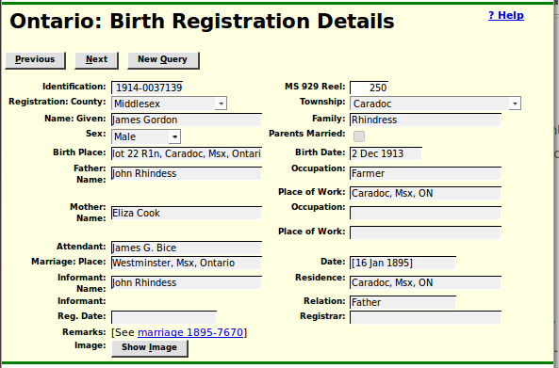Illustration 1: Birth Registration with Link in Remarks as Viewed by a Visitor

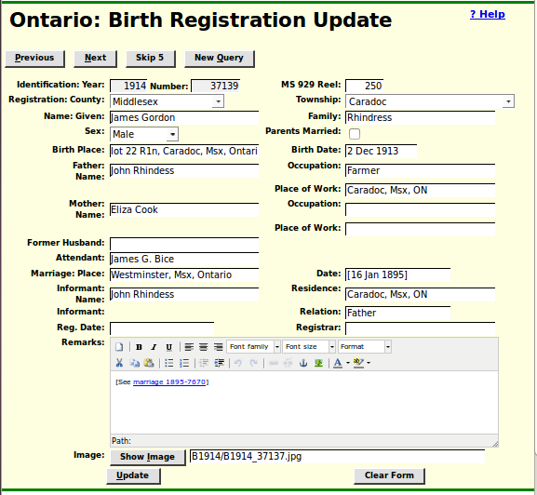Illustration 2: Birth Registration with Link as Viewed by Editor

Marriage Registration
When viewed by a visitor the contents of the marriage remarks are displayed as text instead of in a text area. When viewed by an authorized subscriber the marriage remarks are displayed in a WYSIWYG editor providing the ability to control the appearance of the remarks, insert images, and add hyper-links to other web pages.

Death Registration
When viewed by a visitor the contents of the death remarks are displayed as text instead of in a text area. When viewed by an authorized subscriber the death remarks are displayed in a WYSIWYG editor providing the ability to control the appearance of the remarks, insert images, and add hyper-links to other web pages. For example the remarks on a stillbirth would typically include a link to the associated birth registration. The field for reporting the relationship of the informant to the deceased has been simplified to a text field with appropriate expansion of abbreviations, rather than the combination of a text field and a selection list for common values.

Wesleyan Methodist Baptisms
For many years there has been a site on Rootsweb where Bill Martin put up an HTML version of Ida Reed's transcription of the Wesleyan Methodist Baptisms. In my opinion the static user interface is an obstacle to productivity, so I have copied those records into a database table and provided a flexible search tool.
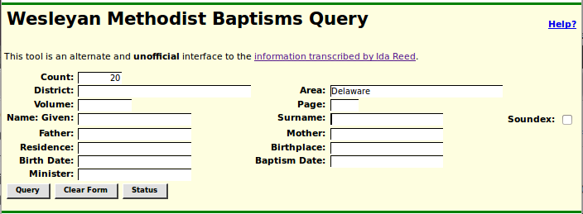Illustration 3: Query of Wesleyan Methodist Baptisms Database
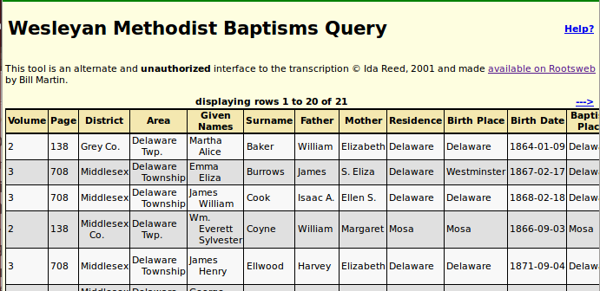Illustration 4: Response to Query of Wesleyan Methodist Baptisms Database
With the addition of this table the footnotes display on a page displaying an individual now will include a hyper-link to the identified page in the transcription for citations to the Wesleyan Methodist Baptisms.

XML Access
It is now possible to retrieve the detailed contents of the vital statistics transcription database records as XML using a browser and URLs such as:
http://www.jamescobban.net/Ontario/getRecordXml.php?Table=Births&Year=1879&Number=17741
http://www.jamescobban.net/Ontario/getRecordXml.php?Table=Marriage&Year=1884&Number=7123
http://www.jamescobban.net/Ontario/getRecordXml.php?Table=Deaths&Year=1896&Number=6852
http://www.jamescobban.net/Ontario/getRecordXml.php?Table=Deaths&BirthDate=1879&Surname=Campbell

Bug Fixes
- The word “inflammation” was misspelled in many causes of death because all of the township clerks that I had copied from had misspelled it. The spelling of all existing occurrences are corrected and the spelling will be auto-corrected in future if anyone enters “inflamation” by mistake.
- Several of the pages for manipulating the census database, including all of the Census page forms referenced an obsolete URL for explicitly selecting the next page to edit.
- The “Delete” button displayed to authorized users on the master sources page for unreferenced sources did not work because it was incorrectly defined as a submit button.
- If the “Delete” button for a source had worked on the master sources page it would not have removed the deleted source from the display after deleting the record. Now it does.
- There were a couple of minor HTML syntax errors in the master sources page.
- The cursor keys did not work when entering data into a line that was added to a census page because the original had more than the standard number of rows. There were also a couple of minor inconsistencies in the handling of input fields in an added line compared with an original line.

