August 2013 Features Update

Table of Contents
Global 3
Family Tree Enhancements 4
Date Support 4
Title of the Edit Individual and Edit Families Pages 4
Merge Individuals Dialog 4
Edit Event Dialog 5
Census Database Enhancements 6
All Censuses 6
1921 Census of Canada 6
1861Census of Canada 6
District Table 6
Sub-District Table 7
Vital Statistics Enhancements 8
Bug Fixes 9

Illustration Index
Illustration 1: Clear Notes Button 5
Illustration 2: District Table with Sub-District Progress Indicator 7

Global
Internally now that the Census and Vital Statistics tables all share the same base class implementation with the family tree, that base class is renamed from LegacyRecord, which implied that the class was only used for those tables imported from Legacy Family Tree, to the simple Record.

Family Tree Enhancements

Date Support
The internal implementation of the support class LegacyDate has been significantly altered to facilitate upgrading. The first enhancement to take advantage of this new design is the addition of support for the French Republican Calendar. You can now enter dates such as “12 Pluviôse 13” or “27 Germinal VII”. French Republican month names may be entered either with or without accents and the date is recognized as being in the French Republican Calendar because of the presence of such a month name. The last date on which it was legal to use this calendar was “10 Nivôse XIV” which was immediately followed by “1 Janvier 1806”. Later dates may be entered but the conversion of the resulting date to the common calendar is ambiguous because the exact manner of determining when a leap-year day, La Fête de la Révolution, was to be inserted was never clarified due to the abrupt termination of use of the calendar. In practice the leap year day was inserted at the end of the 3rd, 7th, and 11th years and was intended to be inserted at the end of the 15th and 20th years.
Roman numerals may now be used any place that a decimal number may be used. For example you can specify “VI June MCMXLIV” or even “VI/VI/MCMXLIV” for 6 June 1944.
The classical Roman calendar days, Kalends, Ides, and Nones, are recognized. So if you put Gaius Julius Caesar into your family tree you can record that he died on “Ides of March DCCXIII AUC”.
An additional formatting tag “[xxxx]” is supported in the date output template to request that the common era year number be displayed in Roman rather than Arabic numerals.
If you wish to play around with dates and see exactly how they are handled internally point your browser at the Test Date Application. Further information is available on the Entering Dates Help Page.

Title of the Edit Individual and Edit Families Pages
The title of the Edit Individual and Edit Families page is enhanced to include the name prefix and suffix if known. So for example the Edit Individual page might display Edit Rev. David Ryan (25 Dec 1830 - 24 Mar 1915). When creating a new father for an individual the page title now includes the surname.

Merge Individuals Dialog
Previously the initial list of potential duplicates for merging with an individual contained individuals whose surname and given name were equal to or greater than the initial individual. However frequently the target individual has a name that is slightly different and sorts just before the name of the first individual. To address this the search is slightly amended so that the initial list includes individuals whose given name starts with the same first two letters. So for example searching for matches for “Smith, Anne Margaret” will display women such as “Smith, Angela” or “Smith, Annie”.

Edit Event Dialog
If the event includes a notes text area, then a button is now presented in the dialog to permit clearing the area, deleting all existing text.
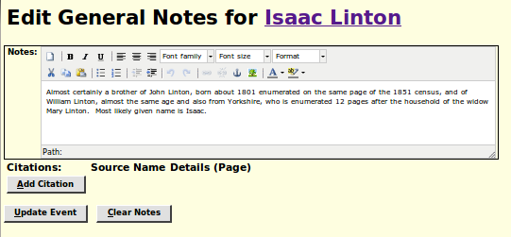Illustration 1: Clear Notes Button

Census Database Enhancements

All Censuses
The use of the keyboard for moving around within a census page edit form has been improved slightly. There was a deficiency that if you had hidden a column, by clicking on the column header, the left and right arrow keys would not move past that barrier. Nor could you use the right arrow key to move from the last data column to the first data column, because the buttons at the end of the row formed a similar barrier to movement.

1921 Census of Canada
Library and Archives of Canada has released the raw images of the 1921 Census of Canada now that the 92 year privacy exclusion has expired. These images are available for free viewing at Ancestry.ca. That is you do not need a subscription to view them.
This census is supported in the same manner as the 1851 through 1916 censuses. In the page which lists all of the censuses a new section has been added for the 1921census. The three options provided here are:
- View the page images geographically using the Ancestry.ca web site.
- Search the accumulated index by name, occupation, etc. just as you can for the other censuses. The only restriction is that it will take some time, possibly years, for the database to become well populated.
- Contribute to the transcription by editing any page in the 1921 Census. The effectiveness of this will depend upon filling in the support tables. At present the table of districts is complete for all of the provinces and territories. The Sub-District table has only been populated for a few districts in Ontario, but as soon as possible all districts will be filled in. This includes associating each page in the census with its image on the Ancestry site. This will take a few weeks to complete. In the mean-time if you try to edit a page within a district, and you are not presented with an appropriate choice of sub-districts, just let me know and I will fill in that part of the table to let you continue.

1861Census of Canada
Library and Archives of Canada has released the raw images of the 1861 Census of Canada, along with free access to the nominal index accumulated by Ancestry. It is necessary to associate each page in the nominal index on my site to the appropriate image that has now been made available. I have done this so far for every page in Westminster township. Any assistance with this tedious task would be appreciated.

District Table
The table of census districts dialog has been enhanced for easier use, although this applies only to the administrator of the census transcription system. In particular the user can now use the enter key and arrow keys to move around the table, just like in a spreadsheet. Furthermore the values entered into all of the input fields are now validated and flagged in red if they fall out of expected ranges. If the French name of a district has not been initialized then changing the English name causes the French name to be set to the same value, with a handful of geographic terms translated from English to French. District names in both languages are adjusted to proper case. Province codes are validated and made all upper case. The maximum length for names and province code is now enforced.
Furthermore two additional columns are now displayed which describe the state of the Sub-District table entries for each district. The first new column, entitled “Count” displays the number of sub-districts in the district. The second column, entitled “%Done” displays the percentage of the sub-district entries that are complete. The percentage is color-coded as in other status tables. If this is not 100% then before editing any pages within that division you should either add the missing information to the Sub-district table yourself or contact the administrator.
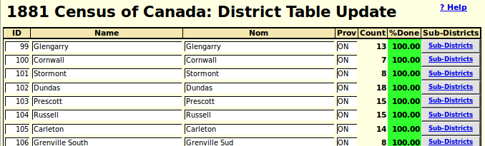Illustration 2: District Table with Sub-District Progress Indicator

Sub-District Table
The table of census sub-districts within a district dialog has been enhanced for easier use, although this generally applies only to the administrator of the census transcription system. In particular the user can now use the enter key and arrow keys to move around the table, just like in a spreadsheet.
The capitalization of the sub-district name is now made selective so that connecting words, such as “and” are not capitalized.
A new column is added to contain remarks, particularly to describe more precisely the geographical location of the sub-district.
In the header and footer of the sub-district table edit form and the page that is displayed to report that the update has been performed, the link to the form for selecting the next district to edit is enhanced so that when you follow it, the form is pre-initialised to point at the district you are editing, or have just edited. This saves time when editing a number of districts in the same census and province.

Vital Statistics Enhancements
There are no significant changes in functionality, although some bugs are fixed.

Bug Fixes
- Several bugs in the interpretation of dates are fixed.

