September 2013 Features Update

Table of Contents
Global 3
Registration Process 3
Account Management Dialog 4
Family Tree Enhancements 5
Edit Citation Dialog 5
Edit Individual Dialog 6
Census Database Enhancements 7
1921 Census 7
Districts Table 7
Census Update Request Form 7
Vital Statistics Enhancements 9
Bug Fixes 10

Illustration Index
Illustration 1: Registration Dialog with E-mail Option 3
Illustration 2: Registration Complete Notification 3
Illustration 3: Account Management Dialog with E-mail Option 4
Illustration 4: Account Updated Notification 4
Illustration 5: Edit Citation Dialog 5
Illustration 6: Main Page for Editing 1921 Census 7
Illustration 7: Transcription Status for 1921 Census for Ontario 8
Illustration 8: Census Transcription Status of a District 8

Global

Registration Process
The process for registering a new user for the web-site is improved.
- An option is now provided to opt out of receiving the monthly status message at your e-mail address. I should have addressed that earlier. If you un-check the option the only e-mail that will ever be sent to the e-mail address you supply when you register is the one used to validate your account. If you chose not to receive the monthly notice, you can still see what is changed on the web-site.
- The password on your account was previously protected using the old standard Message Digest 5 (MD5) algorithm. However this algorithm can be cracked so the web-site is migrating to the better Secure Hash Algorithm 512 as recommended by the good folks at the US National Security Agency. Note that with either algorithm the web-site does not store your password, only the result of applying the hash algorithm to the password. What this means is that if you leave your password alone it will continue to be validated using the MD5 algorithm. However if you change your password the new password is validated using the SHA-512 algorithm.
- When you complete the registration process the site now simply presents you with an acknowledgement of that. Previously it left you looking at the registration form with a bogus error message.
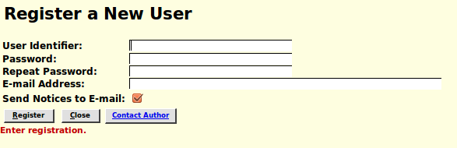Illustration 1: Registration Dialog with E-mail Option
Illustration 2: Registration Complete Notification

Account Management Dialog
The account management process has similarly been updated to provide you the ability to use the new capabilities.
- An option is now provided to opt out of receiving the monthly status message at your e-mail address. If you un-check the option then you will no longer receive the monthly notice message in your e-mail. If you chose not to receive the monthly notice, you can still see what is changed on the web-site.
- The password on your account was previously protected using the old standard Message Digest 5 (MD5) algorithm. However this algorithm can be cracked so the web-site is migrating to the better Secure Hash Algorithm 512. If you change your password using the account management dialog the new password is validated using the SHA-512 algorithm.
- When you complete the account management process the site now simply presents you with an acknowledgement of that. Previously it left you looking at the account management form.
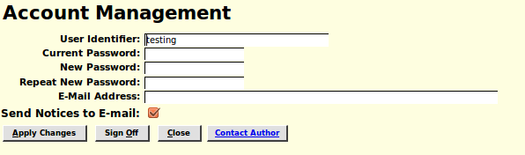Illustration 3: Account Management Dialog with E-mail Option
Illustration 4: Account Updated Notification

Family Tree Enhancements

Edit Citation Dialog
The Edit Citation Dialog has had a number of minor improvements and bug fixes.
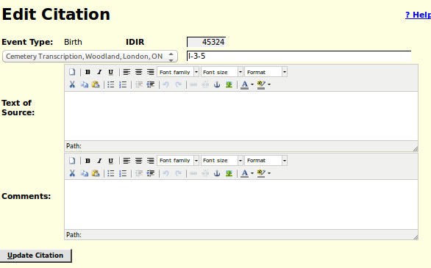Illustration 5: Edit Citation Dialog
Formerly the type of event or fact which was being documented by the citation was presented as if it was a selection list. However the selection list was disabled so it was functionally dead, and yet the complete HTML for the selection list was present. This was clearly pointless, so the dialog now simply displays the event type as text. The citation detail field, which usually contains some equivalent of the page number within the source document, was displayed with the default presentation for the environment, unlike almost all other input fields. If you clicked on the source name it expanded into a drop-down selection list of the titles of all of the source documents defined in the database. That triggered the browser into significantly and unnecessarily reformatting the presentation of the dialog. This is now prevented. The bugs that are fixed were that two of the elements of the dialog, the Event Type field at the top, and the “Update Citation” button at the bottom, did not have pop-up help balloons defined.

Edit Individual Dialog
If you add an address to an individual the text on the request button changes from “Add Address” to “Edit Address”. This makes it obvious what action will take place when you click on the button again.
If you add the first family to an individual by clicking on the button “Add Spouse or Child” the text on the button changes to “Edit Families”. If you delete the last family for an individual the text on the request button changes to “Add Spouse or Child”. This makes it obvious what action will take place when you click on the button again.

Census Database Enhancements

1921 Census
The support tables are now filled in for Alberta, Nova Scotia, and Ontario. This means that you can transcribe any census page in any of these provinces.

Districts Table
Although this page is primarily used by the site administrator it can actually be updated by any contributor. For example it is incomplete for several censuses for provinces other than Ontario/Canada West. Contributors are invited to complete the information.
The page is enhanced by the addition of forward and backward arrows that permit you to move sequentially through the entire table from Canada East in the 1851 census through the Yukon Territory in the 1921 census.

Census Update Request Form
The page for each census which provided the ability to explicitly identify a page to update by selecting a province, a district, a subdistrict, a division, and a page has been completely redesigned to take you directly into the census transcription status hierarchy. For example the request page for the 1921 census now looks like this:
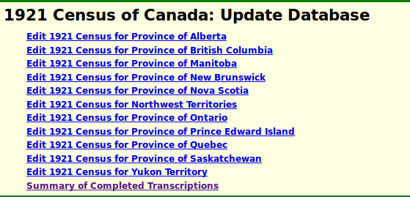Illustration 6: Main Page for Editing 1921 Census

Clicking on the link for a province or territory takes you to the transcription status page for that province or territory:
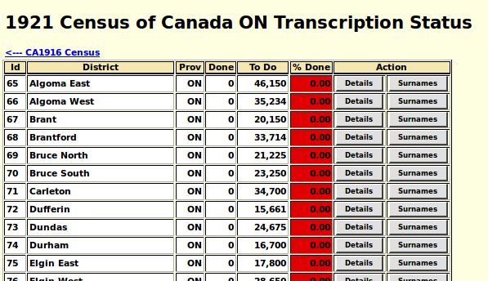Illustration 7: Transcription Status for 1921 Census for Ontario
This displays every district in the province with the state of the transcription effort for that district presented both numerically and as a colour-coded percentage of the population of that district. Clicking on the “Details” button for a district presents a sub-district by sub-district status of the progress of the transcription effort.
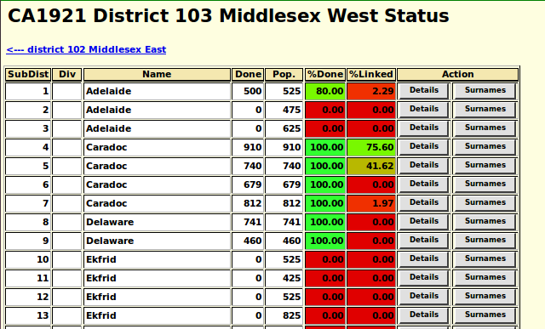Illustration 8: Census Transcription Status of a District
And so on down to the individual page.

Vital Statistics Enhancements
The script getRecordXml.php, which provides explicit access to all of the internal information about any record in the vital statistics section of the database now requires that the requestor be signed on.
There are no other significant changes in functionality, although some bugs are fixed.

Bug Fixes
- Several bugs in the interpretation of dates are fixed.
- There was a bug in the validation of new account registration with regard to the passwords.
- The script EditIndivid.php after determining that the IDIR parameter did not reference a valid database record, went on to try to invoke methods of the instance of LegacyIndiv, which failed.
- The forms for the 1901, 1911, and 1921 censuses did not correctly initialize the presentation classes for the Origin, Religion, and Nationality columns. Whenever an input field in these columns has a different value from the field immediately above it, the text is supposed to be displayed in black, whereas if it is the same it is displayed in gray. More significantly when editing any of these fields any new value is only supposed to ripple down the column as long as the value remains the same, however because of the incorrect setting of the presentation class the ripple ran all the way to the bottom of the column, wiping out old values.
- Two of the elements of the Edit Citation dialog, the Event Type field at the top, and the “Update Citation” button at the bottom, did not have pop-up help balloons defined.
- A missing $ sign in the implementation of methods LegacyAddress::setLatitude and LegacyAddress::setLongitude caused defining the address to fail.

