April 2014 Features Update

Table of Contents
Global 3
Family Tree Enhancements 4
Census Database Enhancements 7
Vital Statistics Enhancements 8
Bug Fixes 9

Illustration Index
Illustration 1: Enhanced Request Report on Individuals 4
Illustration 2: Edit Name Fact with Enhanced Support for Alternate Names 5
Illustration 3: Edit Alternate Name Dialog 5

Global
All of the functionality formerly included in the include file formUtil.inc has been superseded by functionality in various classes, in particular the class Page and the file is no longer referenced. A dummy file remains to record the update history.
The method Record::save which updates or inserts a record into the database on behalf of most classes now updates the logged version of an INSERT command that updated the auto-increment key of those classes that use one, which is most of the classes in the family tree portion of the database, so the logged version of the command contains the actual key value assigned, rather than the expression to calculated the key value. The expression returns a different value each time it is called, so the version of the INSERT command containing the expression was not reproducible when the SQL command log is used to restore or synchronize the database.

Family Tree Enhancements
The process of creating and updating citations is improved. As soon as you click on “Add Citation” a partial selection list for sources now appears containing the last used source. You no longer have to wait for the complete selection list to be populated with information from the database server if that source is desired. Furthermore the citation page identification field may now be modified directly, saving the effort of clicking on “Details”. Any changes made to the page identification field in any citation are applied to the citations when the rest of the updates on the form are applied.
The script reqReportIndivids.php, used to display a selected set of fields from instances of LegacyIndiv matching a set of conditions, is enhanced to add the ability to search based upon christening date, buried date, or the date of an individual event as recorded in a LegacyEvent record.
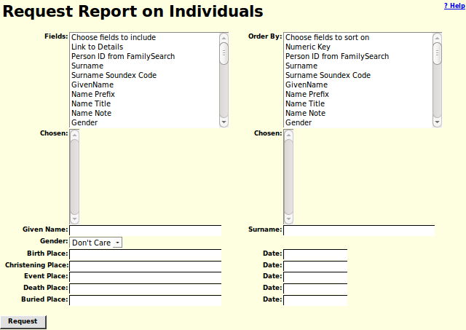Illustration 1: Enhanced Request Report on Individuals
A button is added to the Edit Name Fact dialog to permit explicitly editing an alternate name. Prior to this you could only delete and add an alternate name.
The functionality for editing an alternate name is in a new script editName.php.
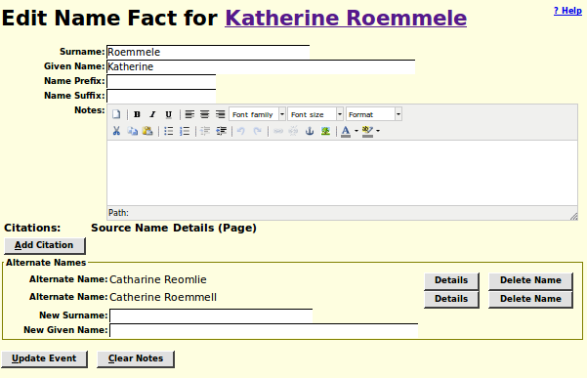Illustration 2: Edit Name Fact with Enhanced Support for Alternate Names
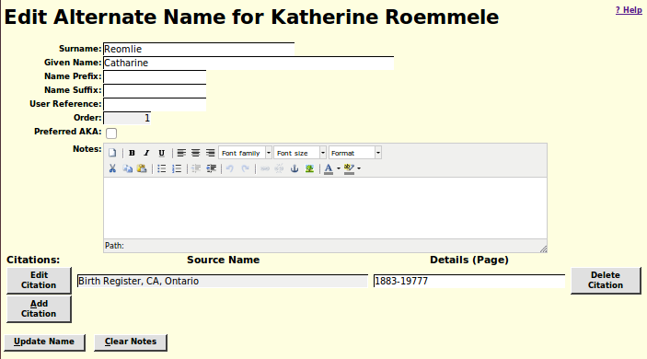Illustration 3: Edit Alternate Name Dialog
A new script updateName.php is created to apply the updates to a specific instance of LegacyName entered on the Edit Alternate Name Dialog and return an XML document.
The performance of the method by which the list of locations which start with particular text was identified has been improved.
The class LegacyAltName is renamed to LegacyName to more accurately represent the use of this class. When constructing an instance of LegacyName with Order=0, which is the index entry for the primary name of the individual, the field AKANote is set to match the field NameNote from the individual. It is intended to eventually eliminate the duplication of information between the instance of LegacyName with Order=0 and the instance of LegacyIndiv that it is associated with. This is a first step. The method LegacyName::getNames now returns an associative array indexed by IDNX.
A method getName is added to the classes LegacyEvent and LegacyFamily so that it may be called to obtain a string description of the event or family, just as the method getName is already provided by the classes LegacyIndiv, LegacyName, LegacyLocation, LegacyAddress, LegacySource, and LegacyTemple.
The class LegacyCitationList is replaced by an associative array of instances of LegacyCitation returned by LegacyCitation::getCitations or deleted by LegacyCitation::deleteCitations.
The script getIndivXml.php, which returns an XML document containing information from an instance of LegacyIndiv and associated records, is enhanced to have an additional parameter includeNames=Y which causes all of the associated instances of LegacyName to be presented in the output. This includes the married names, the primary name, and the alternate names.
The script addCitXml.php, which is invoked to add a citation to the database and return an XML document describing the update, is enhanced to validate the associated record key value to ensure that the resulting XML is always well formed.

Census Database Enhancements
The constructor for the class SubDistrict now fully validates the census identifier parameter.
The method Page::save is changed to conform to the save methods in the other classes in logging the database update command. The value of the field PT_Population is also corrected. In the past since the update command was not logged, changes to the Pages table were lost when performing recovery or synchronizing databases.

Vital Statistics Enhancements
On the Death Registration dialog the line containing the time that the individual lived at the place of death, in Ontario, and in Canada is not displayed for registration years prior to 1909 when a new form was introduced. The husband's name input field is initialized with the surname of the deceased if the deceased is a married woman. The father's name input field is initialized if the informant is the father of the deceased.
You can now do a death registration query with match on place of death.

Bug Fixes
- As a result of an error in the implementation of the constructor for an instance of LegacyCitation introduced in March new citations were created when an existing citation should have been modified.
- An “undefined variable” error in the constructor for LegacyName is fixed.
- Debugging code in the global function logSqlUpdate that was trying to identify the cause of incomplete SQL commands failed because of an error in the throw of an exception.
- The incomplete SQL commands were the result of a problem in the code for replacing the expression used to assign a new auto-increment key in an INSERT command with the actual key value before logging the INSERT.
- The informant name on the Birth Registration dialog was not validated when the informant was set to match the father's name. This meant a valid informant name was displayed in red.
- Potential name matches on the Birth Registration dialog and the Death Registration dialog are now sorted.
- The validation of parameters to the script MarriageRegUpdate.php, which actually applies updates to the database, is enhanced to prevent damage to the database.
- The presentation of the year and registration number fields was incorrect in empty rows of the response to a Death Registration Query.

