July 2014 Features Update

Table of Contents
Global 3
Family Tree Enhancements 4
Census Database Enhancements 5
Vital Statistics Enhancements 6
Bug Fixes 7

Illustration Index
Illustration 1: Advertisement 3
Illustration 2: Account Management Dialog with Popup Help Suppression 3
Illustration 3: Open Subordinate Window Warning 5

Global
To support the continued operation of the web-site I am soliciting advertising. A space is reserved at the top and bottom of every page for advertising. The bottom space currently displays the Facebook Like button. The top currently displays an invitation to advertise.
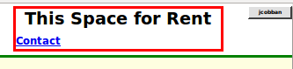Illustration 1: Advertisement
The application uses the Javascript alert function to display warning messages. However the appearance of such a message is dependent upon the browser you are using to see the web-site. Support for alert messages that conform in appearance to the rest of the site has been moved into common code so that such warning messages will appear in a more consistent way, and positioned close to the item that triggered the message.
The handling of the debug parameter used on scripts to activate diagnostic features has been changed so that it is case free. For example you can enter 'DEBUG=Y' or 'debug=y' or 'Debug=Y'.
Popup messages and dialogs, including help text about a form element, are now scrolled completely into view if necessary. Since this can make popup help somewhat more intrusive there is now an option on the Account page to turn off popup help.
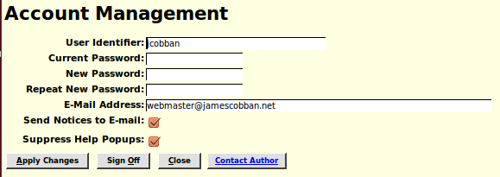Illustration 2: Account Management Dialog with Popup Help Suppression
The main entry point page to the site was previously genealogy.html. This is now invisibly replaced with genealogy.php, which automatically updates the newsletter and monthly update report lists.
The monthly update reports are now stored in the sub-directory MonthlyUpdates and the newsletters, which are copies of the monthly e-mails, are in the sub-directory Newsletters. The individual file names have been changed so the reports can be sorted by date.
To facilitate handling users who forget their password the main User administration dialog used by the site administrator now has a button to reset the password of the user to a new random password. The value of the new random password is displayed to the administrator, and also mailed automatically to the requesting user. The User administration dialog, and all supporting scripts, is now moved to the top level of the web site file hierarchy.

Family Tree Enhancements
The textual interpretation of event types has been moved from the class LegacyEvent to the individual page scripts that display information about events. This is in order to support internationalization.
When creating a new location that includes the text ' st,' or ' rd,' or ' ave,' the initial zoom level is set higher so when displaying the location you should be able to see the exact street.
When editing a family on either the script editMarriages.php or editParents.php unexpected results tended to occur if you clicked on the “update” button while there were subordinate windows open to edit information about any of the members of the fammily. One of the most noticeable undesirable results was that you could end up with two copies of a new child, one added because of its presence in the list of children displayed on the main family edit page, and a second added when you eventually closed the open edit window. Each of the two copies of the child contained some of the information about the child. The implementation has been changed so that when you click on the “update” button it warns you of any open windows. If this happens just complete the operations and close the open edit windows, and then click the “update” button again.
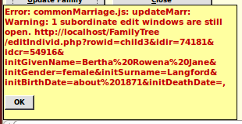Illustration 3: Open Subordinate Window Warning
In the main display page for an individual any notes associated with an event are no longer preceded by the label 'Note:'. In most cases such notes contain merely additional details about the event and more naturally flow as part of the description, rather than being set apart.
On the main display page for an individual, the ability to post a blog is now always present, rather than only being present for already logged on contributors. This is to encourage new contributors.

Census Database Enhancements
There are no significant changes to census support, although some bugs are fixed.

Vital Statistics Enhancements
There are no significant changes to vital statistics support.

Bug Fixes
- Parameters to the constructor for LegacyEvent are all validated before throwing an exception so that all problems are reported at once, not just the first problem encountered.
- There was a flaw in the algorithm for invoking the Google maps geographic location interpretation (geo-coding) that resulted in wildly inappropriate locations. The issue was that Google does not include county names in its geographical database so they needed to be removed from the location name before the Google geolocation function was invoke. The lookup logic now explicitly identifies known county names within a location name and just removes those before calling Google.
- The function LegacyCitation::getCitations(), used to obtain an array of instances of LegacyCitation matching certain criteria now treats a zero length value for srcdetail (usually the page number) as putting no limitation on acceptable values of srcdetail, rather than matching only citations with a zero length srcdetail value.
- The function LegacyCitation::getCitations() now accepts the special parameter values 'limit', and 'offset' to permit browsing through a large number of citations a few at a time.
- The function LegacyCitation::getCitations() now returns the total number of citations that would match the specified parameters (except 'limit' and 'offset') in the 'count' field of the input array.
- If the scripts editMarriages.php or editParents.php are invoked by a hyperlink from another page, instead of being opened as a child window from Javascript, clicking on the “Update Family” button appeared to do nothing. Actually the update had been applied but the script could not close the window because it had not been opened from Javascript. This is changed so that if the window was opened by following a link, once the family is updated the application retraces the link back to the page that invoked the family edit.
- There was missing help text for the “Order Events” button on the edit Families and edit Parents scripts.
- The script Status.php now uses the class LegacyCitation to get information about citations rather than querying the database directly.
- The script LegacyCitations.php uses the class LegacyCitation to get the required information about citations to display rather than querying the database directly.
- In the script LegacyCitations.php the selection lists for event type are now initialized in the server rather than by code running in the browser.
- The script deleteEventXml.php uses the class LegacyCitation to delete the event rather than updating the database directly.
- The script SqlCommand.php did not handle string constants that included escaped quote characters. For example you could not search for text containing 'Father\'s'.
- In the response to a SELECT request SqlCommand.php now interprets the primary keys IDSX and IDCR. Note that you can use an 'AS' command to activate this interpretation. For example 'SELECT IDIME AS IDIR FROM tblER WHERE ….'
- There was an HTML syntax error in the query script 'ReqUpdateSubDists.html' that was silently ignored by most browsers.
- The script CensusUpdateStatus.php, which displays the district level progress of census transcription has been redesigned to that help will popup if the cursor is held over any field in any column.
- The account administration dialog did not correctly set the option to suppress bulk e-mails.

