December 2014 Features Update

Table of Contents
Global 3
Family Tree Enhancements 5
Census Database Enhancements 9
Vital Statistics Enhancements 11
Bug Fixes 13

Illustration Index
Illustration 1: Editing with Preferred Events 5
Illustration 2: Split Screen Census Transcription Editing 9

Global
Although the functional changes this month are not dramatic almost every single file in the site has been changed, particularly to increase the consistency with which different classes perform similar functionality. This makes the implementation easier to follow and avoids potential future programming mistakes.
The database layout that I borrowed from the Legacy Family Tree application on Windows while functional had some features that are problematic on a shared service. I used it because Legacy on Windows could import family tree files from a number of other genealogy products, in particular Family Tree Maker, and the database design was available from the vendor. So I could use Legacy to transform genealogy data from multiple sources into a common form that I could export to the web server. Legacy on Windows was useful for this because unlike some other products it used a relational database supporting Structured Query Language (SQL), in this case Microsoft Access, to record the information. It was therefore easy to mechanically translate the Legacy on Windows database to a different database manager, MySQL, which could be run on a web server.
In designing a relational database it is recommended that the record structure be normalized. Normalization is a systematic way of ensuring that a database structure is suitable for general-purpose querying and free of certain undesirable characteristics, insertion, update, and deletion anomalies, that could lead to a loss of data integrity. In a fully normalized design each unit of information exists in only one place in the database, so changing that information can be done as a simple operation. If the information exists in multiple places then the possibility exists that only some of the locations are changed by an update, creating a situation where multiple different values exist for the same unit of information. This was not an issue for the original implementors of Legacy Family Tree on Windows because their application only supported a single user, whereas a web site based solution needs to consider simultaneous updates by multiple users.
As a specific example the main name and primary birth date are recorded in the basic record for an individual, an instance of LegacyIndiv, in each family record to which that individual belongs, instances of LegacyFamily, and in the primary name record for the individual, an instance of LegacyName. Also the married name of an individual is present both in the family record for the marriage, an instance of LegacyFamily, and in a married name record, an instance of LegacyName. The name information is therefore moved to exist exclusively in the LegacyName record, although it can be logically accessed through either the LegacyIndiv or LegacyFamily record using existing methods.
Similarly information about facts and events is in general recorded in the table of events, as instances of LegacyEvent. However some events, such as the primary birth event and the primary death event, are recorded in the instance of LegacyIndiv, while a marriage event is recorded in an instance of LegacyFamily, and an LDS sealed to parents event is recorded in an instance of LegacyChild. However secondary versions of the birth, death, marriage and other events are recorded in instances of LegacyEvent. Some events, such as adoption, do not even have a legitimate method to be recorded in this design since an instance of LegacyEvent must be associated with either an instance of LegacyIndiv or an instance of LegacyFamily, but an adoption should be associated with an instance of LegacyChild, since that record identifies both an individual and the family in which that individual is a child, and an adoption must be associated both with the individual and the adoptive parents. Therefore all fact and event information is now recorded in instances of LegacyEvent, which may also be associated with an instance of LegacyChild, providing support of adoption and LDS sealed to parents events.
There are 4 textual notes in LegacyIndiv and one in LegacyFamily that can have citations. In the future those will be represented by separate instances of a new class LegacyNote. This will also permit modeling more completely the implementation of textual notes in the industry standard Genealogical Data Communication file transfer format (GEDCOM 5.5). GEDCOM 5.5 permits more than one note of a particular class associated with an entity in the family tree which, among other advantages, permits each note to have separate citations. Most user interfaces provided by genealogy applications do not actually support multiple notes of a particular class because that would complicate the user interface and make the application harder to use.
This restructuring significantly simplifies the implementation of a source citation, represented by an instance of LegacyCitation. In the original implementation each instance of LegacyCitation contains a field `Type` which in addition to identifying the type of record containing the fact or event, also identifies which fact or event within the associated record the citation applies to. For example there are 8 different events and 5 different facts within an LegacyIndiv instance alone that can have citations, including the birth event and the primary name of the individual. Moving all of the events in LegacyIndiv, LegacyFamily, and LegacyChild into instances of LegacyEvent, recognizing that the primary name is already unnecessarily duplicated from the primary instance of LegacyName for the individual, which can already have citations, and adding the proposed LegacyNote class, leaves no remaining facts in the LegacyIndiv record, and only two flags in LegacyFamily, and three status fields in LegacyChild that require being distinguished.
The script confirmUserXml.php, which is invoked when a new user clicks on the link in the confirmation e-mail, is updated to output diagnostic information when requested by the debug option to the variable $warn, and to include that diagnostic information in the XML response to Javascript.
The script deleteUser.php, which is used by the administrator to manually delete a registered user, is updated to output diagnostic information when requested by the debug option to the variable $warn, and to include that diagnostic information in the XML response to Javascript.

Family Tree Enhancements
The handling of events in the page editIndiv.php has been extensively rewritten. The key driver for this was to make the function of the “Reorder Events by Date” button much faster. This button now updates the display, and the events are not reordered in the database until you save the individual. Since the primary events for an individual are being moved the handling of these events is now the same whether they are actually stored inside the instance of LegacyIndiv or in separate instances of LegacyEvent. This means that the instance of LegacyEvent now distinguishes between the preferred version of each event, and any other instances by means of a “Preferred” flag.
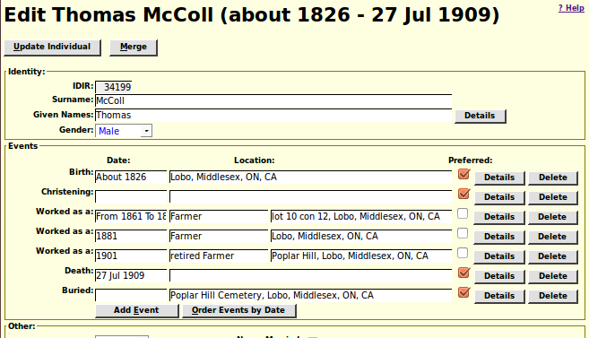Illustration 1: Editing with Preferred Events
You cannot click on the “Preferred” check-box to turn the flag off, because that would leave no preferred instance of the class of events. However if there are multiple instances of a particular event type, for example multiple birth events, then you can click on the unchecked check-box of another instance and make it the preferred instance.
Classes LegacyAddress, LegacyChild, LegacyCitation, LegacyDontMergeEntry, LegacyEvent, LegacyFamily, LegacyHeader, LegacyIndiv, LegacyLocation, LegacyName, LegacyPicture, LegacySource, LegacySurname, and LegacyTemple are changed to redirect diagnostic information to $warn.
The functionality of ensuring that the names and birth dates of the spouses in a family match the names and birth dates in the associated LegacyIndiv, LegacyEvent and LegacyName records is moved to LegacyFamily::__construct. Through database normalization the only authoritative copy of the primary name of the individual is not in the instance of LegacyName identified by Order 0. The only authoritative version of the primary birth date of the individual is in the preferred instance of LegacyEvent with event type 'birth'.
The method LegacyChild::getParSealEvent is added so that the information about the LDS sealed to parents event in the LegacyChild record can be managed as an instance of LegacyEvent. The existing fields 'parseald', 'parsealsd', 'idtrparseal', 'parsealnote', and 'ldsp' are deprecated and should not be accessed using LegacyChild::getField, but rather as the 'eventd', 'eventsd', 'idlrevent', 'desc', and 'ldstempleready' fields of the instance of LegacyEvent returned by LegacyChild:: getParSealEvent.
The constructor for the class LegacyEvent is enhanced to support the LDS sealed to parents event. Instances of LegacyEvent may now be associated with instances of LegacyChild to support the LDS sealed to parents event, and the adoption event.
The method LegacyEvent::getDate now accepts a privacy year limit parameter.
The class LegacyFamily adds a method LegacyFamily::getSealEvent which permits accessing the LDS sealed to spouse event as an instance of LegacyEvent. The existing fields 'seald', 'sealsd', 'idtrseal', 'sealnote', and 'ldss' are deprecated and should not be accessed using LegacyFamily::getField, but rather as the 'eventd', 'eventsd', 'idlrevent', 'desc', and 'ldstempleready' fields of the instance of LegacyEvent returned by LegacyFamily:: getSealEvent.
For improved performance references to the instances of LegacyIndiv for the two spouses are kept in the LegacyFamily instance.
Additional diagnostic output is generated by LegacyFamily::__construct.
The static method LegacyFamily::getFamilies now supports the limit and offset parameters for consistency with other classes. The associative array returned by this method is now indexed by the key IDMR. The method now takes a third parameter which, if true, results in XML output being generated if this method is called from a script that produces XML.
The LegacyIndiv methods to get preferred instances of LegacyEvent now uses the associative array of parameters method to invoke the constructor for LegacyEvent to make the code easier to maintain and understand.
The class LegacySource has added a method LegacySource::getCitations which provides an associative list of instances of LegacyCitation that reference this instance of LegacySource.
If the browser is pointed at the folder /FamilyTree/testscripts on the site the browser is redirected to display the menu of test scripts if the current user is an administrator, or else an error message, instead of the contents of the folder.
The script addCitXml.php which is invoked by Javascript on the browser to add a citation to a fact or event is enhanced to ignore zero length parameter values. Its invocation of LegacyName:: getNames is changed because the function signature has changed to permit feeding back the number of matching names.
The script mergeUpdIndivid.php is changed because the method LegacyIndiv:: getFamilies now returns an associative array indexed by IDMR.
The script orderMarriagesByDate.php is renamed to orderMarriagesByDateXml.php. It is enhanced to validate that the IDIR parameter passed to it is numeric and greater than 0.
The script mergeIndivid.php is enhanced to pass the debug flag to the script mergeUpdIndivid.php.
The script editMarriages.php is changed because the method LegacyIndiv:: getFamilies now returns an associative array indexed by IDMR.
The script editParents.php is changed because the method LegacyIndiv::getParents now returns an associative array indexed by IDMR.
The script editEvents.php is changed to add a row number parameter to the eventFeedback method of the invoking form.
The script editIndivid.php is significantly changed to support the new model of events. All events and facts now have the same layout, with the exception of the names for the date, location, and description field which are different for some events in order to display field specific popup documentation, and induce the browser auto-complete functionality to treat them distinctly. Each row now has the following additional fields, most of which are hidden from the user if the debug option is not specified:
- checkbox for preferred status
- the IDER value (which is zero for events that are still in LegacyIndiv)
- the IDET value
- the citation type (usually 30)
- the order in which the events are displayed
- the sorting form of the event date (so browser resident code can reorder the events)
- the event changed indicator
The script deleteSourceXml.php is enhanced to ignore a request to delete any master source that still has citations referencing it. The script that invokes this does not provide a delete button, but I always believe in the value of both a belt and suspenders.
The script descendantReport.php is changed because the method LegacyIndiv:: getFamilies now returns an associative array indexed by IDMR.
The script ancestorReport.php is changed because the method LegacyIndiv:: getParents now returns an associative array indexed by IDMR.
The script legacyIndivid.php, which displays the main page for an individual, is changed to always use LegacyIndiv::getBirthEvent and LegacyIndiv::getDeathEvent to get the birth and date information to display, particularly in the title of the page. The script is also changed because the methods LegacyIndiv::getFamilies and LegacyIndiv::getParents now return an associative array indexed by IDMR. The script also now handles an exception thrown if the wife's IDIR was invalid.
The script getIndivSvg.php which displays a graphical family tree is substantially rewritten. The use of deprecated methods of LegacyFamily is brought up to date. The XML and PHP code is separated, which makes the implementation easier to maintain. Unique id attribute values are now supplied for all SVG elements. Error messages, for example to report bad parameters to the script, are now displayed in bold red text. A title is not displayed for the page including the name and dates of the key individual.
The script getFamilyOfXml.php is changed because the method LegacyIndiv:: getFamilies now returns an associative array indexed by IDMR. It is also changed to use LegacyIndiv::getBirthEvent to get birth information.
The script deleteNameXml.php, used to delete an instance of LegacyName from the database, is enhanced to ignore a request to delete a primary name record if the associated instance of LegacyIndiv is still present, or a married name record if the associated instance of LegacyFamily is still present in the database.
The script addFamilyOfXml.php is changed to use LegacyIndiv::getBirthEvent to get birth information.
The script addDontMergeXml.php is changed to include the actual SQL command used to update the database, and the contents of the inserted record in the response.
The script detChildXml.php, which permits browser code to delete an instance of LegacyChild from the database, is changed to perform additional parameter validation, to include the contents of the child record being deleted, include the actual SQL command used to update the database, and include diagnostic messages if present as a result of the debug option.
The script orderEventsByDate.php is obsolete and no longer performs any function.
The script GedcomUpdate.php is not yet functional, but it has been updated to use current interfaces to the various classes.
The script updateEvent.php, which is used by browser code to update an event record in the database, is changed to use LegacyIndiv::getBirthEvent to get birth information.
The script getIndivNamesXml.php, which is used by browser code to get information to populate selection lists of individuals, is changed to use LegacyIndiv::getBirthEvent to get birth information. It also now handles an exception thrown by LegacyFamily for a bad spouse IDIR value.
The browser script locationCommon.js, which provides automatic completion assistance for fields containing values that map to instances of LegacyLocation, is enhanced to support any field whose name contains the text 'Location'.

Census Database Enhancements
In the past when you clicked on the button to display the original census image, a new window was opened to display the image. This then required that the user rearrange and resize the two windows in order to take advantage of the full screen space available. Through years of experimentation I have found that the most efficient way to transcribe censuses is a column at a time, with the screen split with the input form using one half of the screen and the original image using the other half of the screen, side by side. The implementation of the display image button is therefore changed to facilitate this. Just make the census window full screen, and clicking on the display image button splits the screen for you into left and right halves.
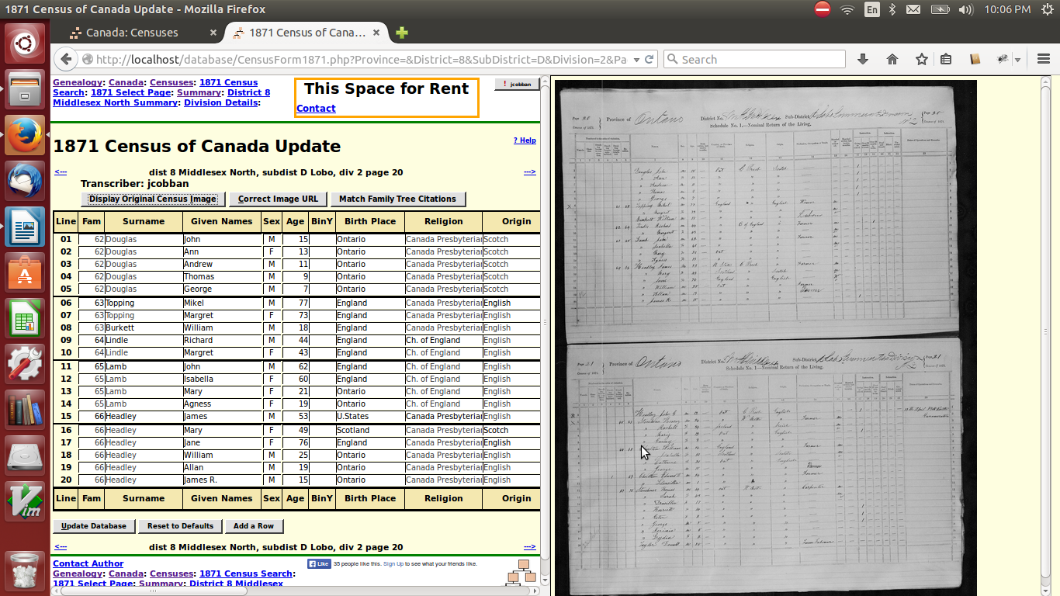Illustration 2: Split Screen Census Transcription Editing
Classes CensusLine, District, Pages, and SubDistrict are changed to redirect diagnostic information to $warn.
The implementation of the class District is changed to improve the clarity of the implementation of District::getField, improve the clarity of the implementation of District::setField, and improve the efficiency of District::getSubDistricts by saving the previously obtained value, so subsequent calls do not require accessing the database. Methods District::getSdCount and District::getFCount are removed. The information these methods returned is still available through District::getField with field names 'd_sdcount' and 'd_fcount' and these two methods were unused.
The implementation of the class SubDistrict, representing a single enumeration division, is enhanced. If an instance of District is passed to the constructor then the census identifier from that instance is used. A new method SubDistrict::getPages is added to obtain an array of instances of Page for the sub-district.
The implementation of the class Page, representing a single page from a census, is enhanced. The constructor now accepts an associative array of parameters, while remaining backwards compatible. Invoking the constructor using an associative array makes the invocation more self-explanatory. A static method Page::getPages is added to encapsulate obtaining an array of instances of Page.
If the browser is pointed at the folder /database on the site the browser is redirected to display the menu of censuses of Canada instead of the contents of the folder.
If the browser is pointed at the folder /database/testscripts on the site the browser is redirected to display the menu of test scripts if the current user is an administrator, or else an error message, instead of the contents of the folder.

Vital Statistics Enhancements
Classes Birth, County, Death, Marriage, MarriageParticipant, and Township are changed to redirect diagnostic information to $warn.
The table recording information about Counties is changed to remove the column Prov which is redundant since the same information is contained in the column Domain. To ensure no loss of functionality in code which uses the class County the method County::getField returns the correct value derived from the column Domain. The static method County::getCounties is changed to conform to the behavior of similar methods in other classes by accepting the parameters limit and offset on input and return the count of matching rows in the 'count' field of the parameter array.
All of the pages on the site that are specific to Canada, with the exception of the pages that apply only to Ontario and for censuses, are moved to a new folder /Canada. This includes the pages genCanMilitary.html, genCanCom.html, genBritCol.html, and genManitoba.html. For provinces that do not have a specific page of links a generic page, created by the new script /Canada/genProvince.php, is implemented to provide the ability to transcribe and search vital statistics records for those provinces.
The pages on the site that are specific to the United States of America are now all moved to the folder /USA.
The scripts BirthRegDetail.php, BirthRegStats.php, BirthRegQuery.php, BirthRegResponse.php, and BirthRegUpdate.php are enhanced to support displaying and updating the transcriptions of birth registrations for all provinces, and are consequently moved from the /Ontario folder to the /Canada folder. The former page BirthRegQuery.html, which only supported Ontario, is replaced by BirthRegQuery.php?domain=CAON which generates a query page specific to any defined domain.
MarriageRegDetailLib.php is changed to use LegacyIndiv::getBirthEvent and getDeathEvent because those events are no longer always present within the instance of LegacyIndiv.
If the browser is pointed at the folder /Canada on the site the browser is redirected to display the menu of services for Canada instead of the contents of the folder. If the browser is pointed at the folder /USA on the site the browser is redirected to display the menu of services for the United States of America instead of the contents of the folder. If the browser is pointed at the folder /Ontario on the site the browser is redirected to display the menu of services for Ontario instead of the contents of the folder.
If the browser is pointed at the folder /Ontario/testscripts on the site the browser is redirected to display the menu of test scripts if the current user is an administrator, or else an error message, instead of the contents of the folder.
The response from the script deleteDeathRegXml.php now includes the number of records deleted. This is 1 if the parameters identified an existing record, or 0 if there was no existing record.
When a user submits updates to the transcription of a birth or death registration and there are no error messages or debugging output to display to the user, the form to update the next sequential birth or death registration is displayed instead of a dialog asking the user what to do next. This facilitates transcribing a series of birth or death registrations.

Bug Fixes
- Method Record::dump did not correctly encode the values of text fields for the case where it was called to generate debugging information in an XML document.
- The method LegacyIndiv::getEvents failed if called for a new instance before it was associated with a record in the database.
- The method LegacyEvent::delete did not pass the second parameter to the method LegacyCitation::deleteCitations. This meant that information about the deletion of citations associated with an event did not appear in the XML output of the script FamilyTree/deleteEventXml.php.
- The static method LegacyIndiv::getWhere generated a syntactically invalid WHERE clause if invoked with both the IDIR and limit parameters.
- The static method LegacyIndiv::getIndivs returned a count of 0 if it was invoked with an IDIR parameter and limit set to 0. It now returns $parms['count']=1 if the supplied IDIR exists in the database and 0 if it does not.
- When adding early childhood events, such as christening, they were added after all midlife events, rather than between birth and the first midlife event by the methods LegacyIndiv::getBaptismEvent,LegacyIndiv::getConfirmationEvent,LegacyIndiv::getInitiatoryEvent,and LegacyIndiv:: getChristeningEvent.
- In the output of LegacyLocation::dump the label was incomplete.
- The constructor LegacyLocation::__construct called itself if invoked with an associative array of parameters.
- The exception thrown by the static method LegacyPicture::getPictures identified the wrong method name.
- There was an invalid operator in the SQL generated by the script orderChildrenXml.php. It is fixed, but this script is no longer used because events are now reordered only by updateIndividXml.php.
- The global $debug was not declared in function getDateAndLocation in script editEvent.php.
- There was a missing parameter to LegacyTemple::getTemples in script editEvent.php.

