January 2015 Features Update

Table of Contents
Global 3
Family Tree Enhancements 8
Census Database Enhancements 10
Vital Statistics Enhancements 11
Bug Fixes 12

Illustration Index
Illustration 1: Individual Page with Descendant Tree in Split Screen 4
Illustration 2: Edit Dialog with Edit Event in Split Screen 5
Illustration 3: Edit Individual with Edit Families Dialog in Split Screen 5
Illustration 4: Edit Individual with Grant Access in Split Screen 6
Illustration 5: Search Popdown Menu 6
Illustration 6: Edit Individual with Census Search in Split Screen 7
Illustration 7: Edit Individual with Ancestry.ca Search in Split Screen 7

Global
The usability of the web-site is a major focus this month.
In the past whenever you requested a new service one of three things would happen:
- The page displaying the results of the request completely replaced the requesting page. This is appropriate when the user no longer needs to see the requesting page, particularly when the original page is used simply to request the results of a report.
- The page displaying the results of the request is opened as a new tab with the same dimensions as the requesting page. Both pages are still available, but only one of the pages can be seen at a time because they both occupy the same space on the screen.
- The page displaying the results is opened as a new window with different dimensions and overlaying only part of the original page. This new window can be dragged around by the mouse and changed in size. There are two issues with these little windows: They can quickly clutter up the screen creating a messy desk, and they may only be displayed if you the user have permitted the browser to open such windows. Typically this permission is withheld because this sort of “popup” window is frequently used by advertising spammers.
This month the site attempts to reduce the clutter and confusion of your screen desk-top by replacing many of the instances of popup windows by explicitly managing the screen space which you have allocated to the web-site. This new implementation works particularly well when you have your browser window occupying the full screen. This adds a new function openFrame to the common library in jscripts/util.js.
This new support currently applies to the main page for displaying information about an individual and the associated page for editing the information about the individual. On the main page there are four buttons displayed to casual visitors, plus an Edit button displayed to authorized registered users. The “Descendant Tree”, “Ancestor Tree”, and “Relationship Calculator” buttons formerly opened new small windows, now they split the browser window horizontally, squeezing the original page information so it is all still visible in the left side of the window, while the report is displayed in the right side of the window. The display tree graphic button and the “Edit Individual” button are unchanged.
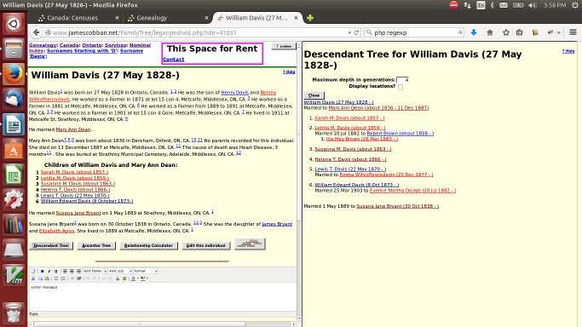Illustration 1: Individual Page with Descendant Tree in Split Screen
On the Edit Individual page all of the “Details” and “Edit” buttons, as well as the “Merge” and “Grant Access” buttons now split the screen in the same way instead of opening new window. In addition there is a new “Search” button which pops down a list of searches which can be performed for matches in the supporting databases or in Ancestry.ca. These also split the screen. For example clicking on a “Details” button for an event appears as:
Similarly clicking on the “Edit Families” button displays the Edit Families dialog in the right side of the window.
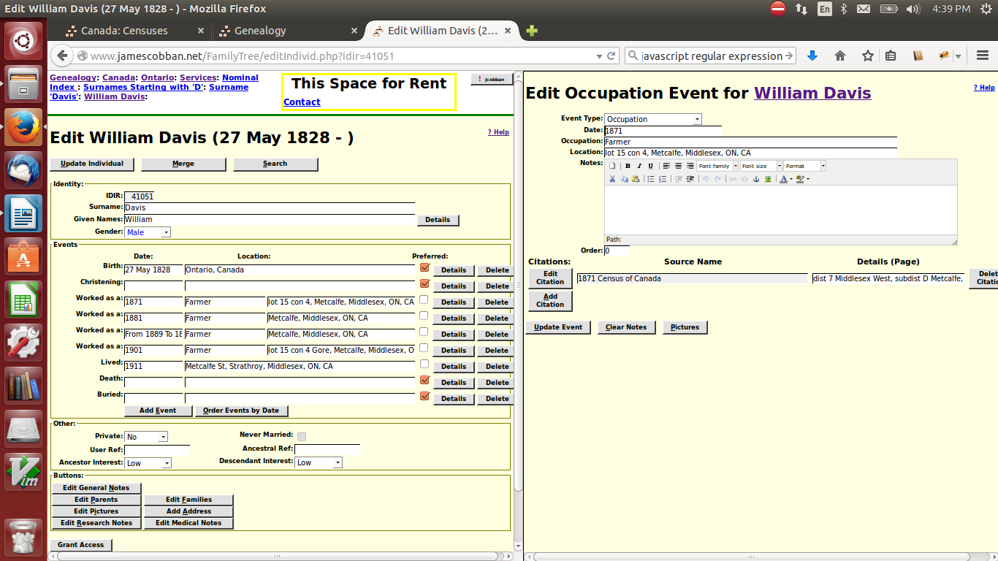Illustration 2: Edit Dialog with Edit Event in Split Screen
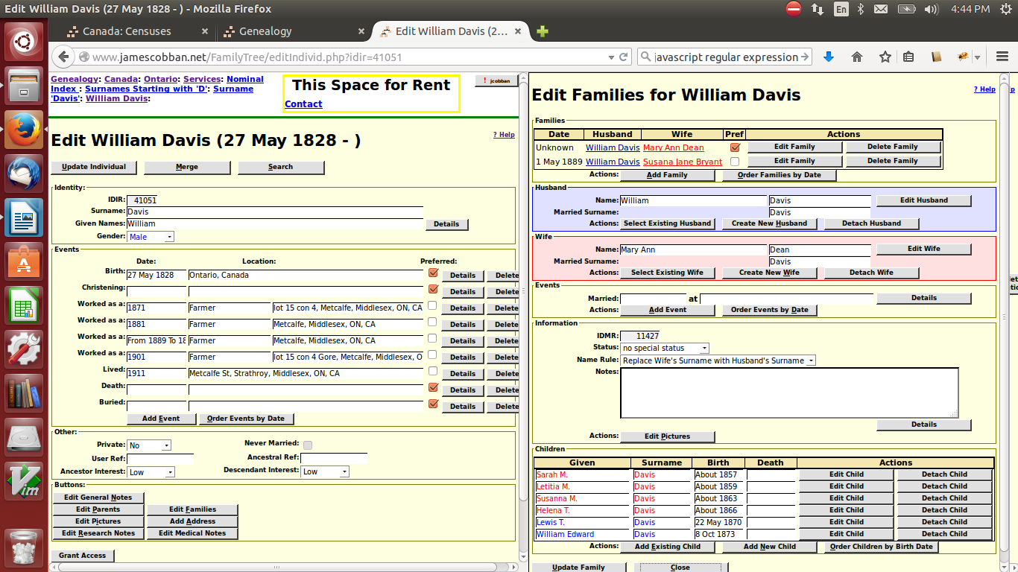Illustration 3: Edit Individual with Edit Families Dialog in Split Screen
Clicking on the “Grant Access” button to authorize another user to contribute to your family tree also opens in the split screen:
The new “Search” button simplifies performing a quick search of either the supporting documents tables on the site itself or of Ancestry.ca, for records which match the individual. When you click on this button three new buttons appear in a drop-down menu.
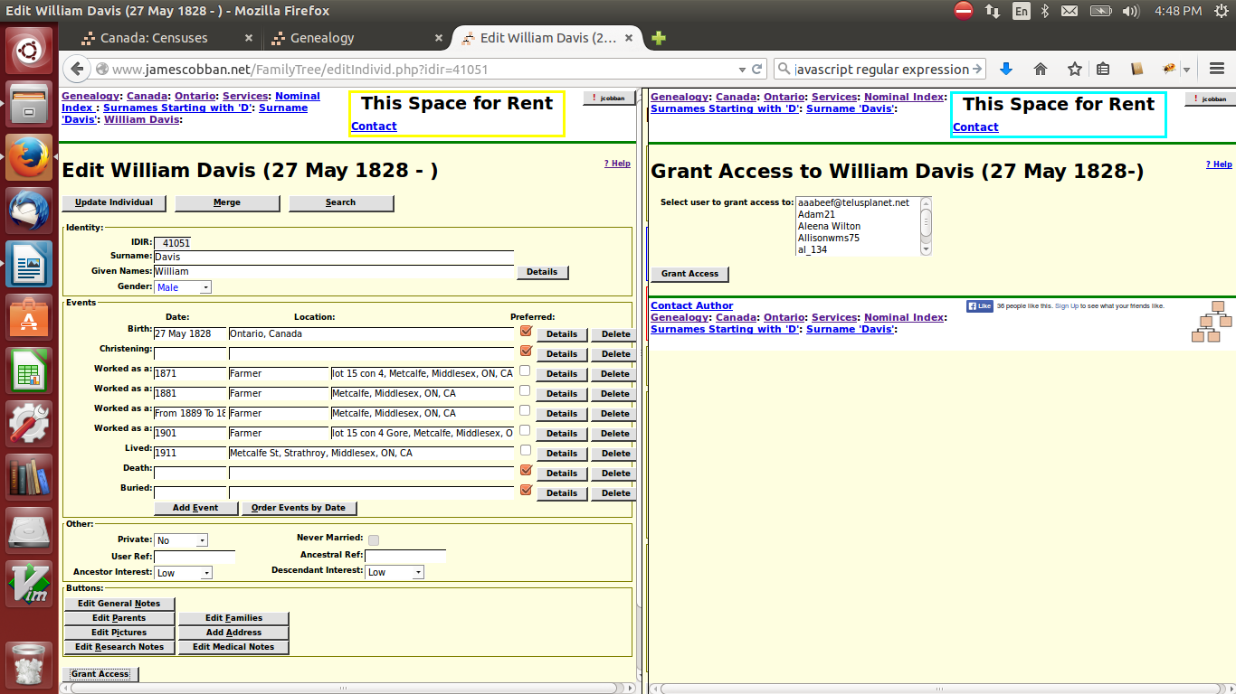Illustration 4: Edit Individual with Grant Access in Split Screen
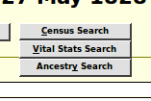Illustration 5: Search Popdown Menu
The “Census Search” button performs a consolidated search of the 1851, 1861, 1871, 1881, 1891, 1901, 1911, and 1921 Census of Canada transcription tables for individuals with similar names and birth years. The “Vital Stats Search” button will eventually perform a consolidated search of the Birth, Marriage, and Death registration tables. At the moment it searches only the Birth registration tables while I add additional information to the other two tables to permit them to be searched in a similar manner. The “Ancestry Search” button requests a search of Ancestry.ca. If you are not a subscriber to Ancestry this will only show you what types of information is available.
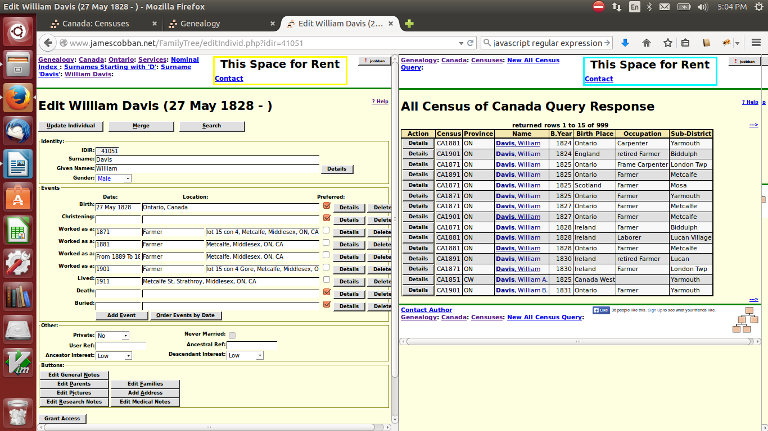Illustration 6: Edit Individual with Census Search in Split Screen
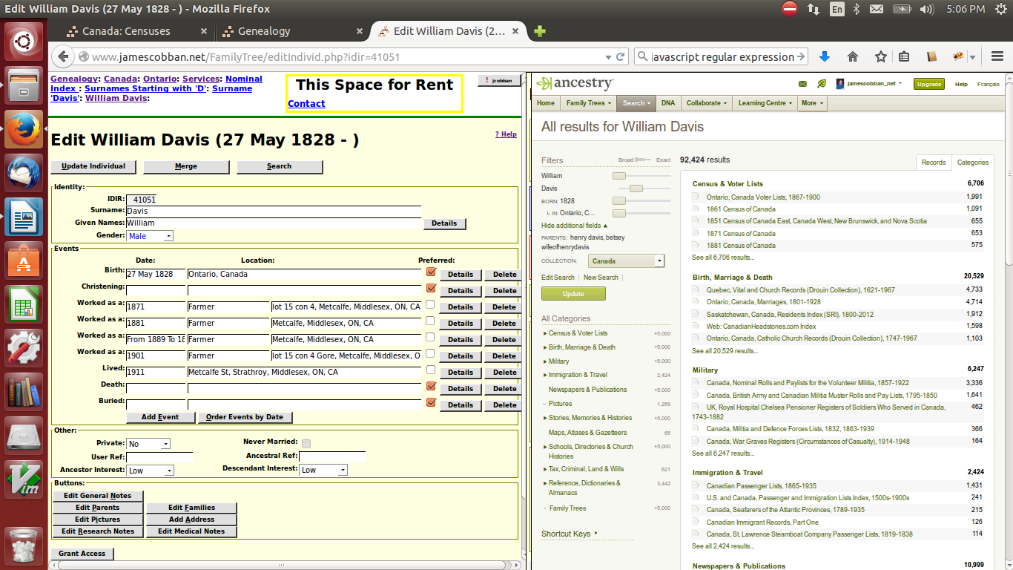Illustration 7: Edit Individual with Ancestry.ca Search in Split Screen

Family Tree Enhancements
Enhance method LegacyIndiv::getName to provide options to include birth and death dates, and/or to put the surname first.
Add methods LegacyIndiv::getBirthDate and LegacyIndiv::getDeathDate to ensure that these values are always obtained in a consistent way, including privatization.
Add method LegacyIndiv::getPreferredParents.
Add a parameter to LegacyIndiv::getNames to limit the type of name records returned. The definition of this parameter is the same as the parameter to LegacyName::getNames except that the IDIR parameter is provided.
When updating the database LegacyIndiv::save uses LegacyName::updateNames to update the given name of the individual in all relevant records, rather than applying individual updates to each instance.
Add method LegacyIndiv::clearEvent to permit LegacyEvent::save to remove fields pertaining to an event when that event is moved from LegacyIndiv to an instance of LegacyEvent.
Add method LegacyChild::getName to display a string containing the name of the child and the names of the parents.
Add method LegacyChild::clearEvent to permit LegacyEvent::save to remove fields pertaining to an event when that event is moved from LegacyChild to an instance of LegacyEvent.
Add methods LegacyFamily::getHusband, LegacyFamily::getWife, LegacyFamily::getHusbName, and LegacyFamily::getWifeName.
Add method LegacyFamily::clearEvent to permit LegacyEvent::save to remove fields pertaining to an event when that event is moved from LegacyFamily to an instance of LegacyEvent.
Add static method LegacyName::updateNames to support applying a change to a set of instances.
To make the LegacyName constructor more consistent with other classes in the support of an associative array parameter, it now supports passing an instance of LegacyFamily as the value of the parameter named MarriedNameMarIdId. This eliminates the need for a special set of parameters used only to synchronize the married name entry corresponding to a spouse in a marriage.
The LegacyName constructor and the static methods LegacyName::getNames, LegacyName::updateNames, and LegacyName::deleteNames now accept 'IDMR' as a synonym for the easily misspelled and non-intuitive field name 'MarriedNameMarIdId'.
Add method LegacySurname::getName for symmetry with other classes.
In the script editIndivid.php the table of event type names, which are displayed at the beginning of each event row, is moved to a set of <span> elements identified by the event type key value. This ensures that the event type names are identical in displayed events whether the event is generated when the page is first displayed, or whether it is added by dynamic code running in the browser.

Census Database Enhancements
In the past each census of Canada had a separate script to display the response to a query. For example a query of the 1891 census used script QueryResponse1891.php. Now a single script CensusResponse.php is used to generate the response to any census query.
A new script QueryCensusAll.php is added permitting a consolidated search of all censuses.

Vital Statistics Enhancements
The table of Births has been updated so that every record which contains a birth date has a valid value of the field B_CalcBirth, which is used to determine the difference between two dates, so that the Birth query dialog can search for approximate matches on births. The method Birth::setField('B_BirthDate',date) is changed to ensure that it always initializes the field B_CalcBirth with a valid value even if the supplied date is invalid.
The method Death::setField('D_BirthDate',date) is changed to ensure that it always initializes the field D_CalcBirth with a valid value even if the supplied date is invalid. However until all of the existing values of D_CalcBirth are corrected the Death query dialog cannot support a search for an approximate match on birth date.
The script MarriageRegDetailLib.php, which displays an individual participant in a marriage registration, is enhanced to fill in the birthplace and parents' names for a new marriage registration which is already cited by the family tree. Also a “Clear” IDIR association button is added to permit correcting an improper association to the family tree.

Bug Fixes
- The addition of the page index.html to the Advertisements folder, which was done to hide the contents of the folder directory from prying eyes, resulted in occasional errors in the advertising field at the top of each page.
- The copyright notice generated for all script based pages is updated to 2015.
- Method LegacyIndiv::toXml displayed two birth events when there was only one defined.
- Method LegacyIndiv::save ensures that the married name records for the individual are created.
- Method LegacyIndiv::setField no longer updates the LegacyName records for the individual. This is now done in LegacyIndiv::save.
- Methods LegacyIndiv::getXxxxxEvent were using the wrong method to determine whether or not an event actually existed.
- When the date in an instance of LegacyEvent which represents a preferred birth event was changed the value of the field BirthSD in the associated instances of LegacyIndiv and LegacyName was not updated to permit searches base on birth date.
- LegacyEvent::save did not update the order field properly for events associated with a new individual.
- There was an extra space character at the end of the textual names of some events in the table LegacyEvent::$eventText.
- The LegacySource constructor failed with some inputs.
- The method Record::displayPictures, which generates the HTML to display the pictures associated with any record type, threw an exception if it was called for a record which had not yet been created in the database. Such a record cannot have any pictures associated with it yet.
- In the script editIndivid.php updating an event sometimes added a row to the display when it shouldn't have.
- In the script editIndivid.php the wrong event order was set for a birth event when Debug was not specified.
- In the script editIndivid.php some form elements did not have id= attributes.
- In the script editIndivid.php use CSS to style the width of buttons associated with individual children. For some reason this still does not work with Firefox.
- In the browser script editIndivid.js the method eventFeedback added a new row when it should have matched an already displayed event. The method now also supports feedback for the LDS Sealed to Parents event in LegacyChild.
- The feedback routine to update the display of information about a child from an instance of editIndivid.php, temporarily displayed blank dates because the name of the displayed row had changed.
- The original implementation of the new dynamic event sort feature did not reactivate the Details and Delete buttons for each event. The Sort Events button is now disabled after being used once.
- In the browser script editIndivid.js the field validation function was not called for most input fields, so invalid input was not flagged to the user.
- In the script mergeUpdIndivid.php the birth date was accidentally deleted from the merged individual.
- In the browser script legacyIndivid.js the edit and delete blog buttons dynamic functionality was not activated because the code only supported 2 digit blog record identifiers.
- If the script relationshipCalculator.php is called without the parameter idir2, instead of failing just redirect back to LegacyIndex.php with the updated name parameter.
- The accessKey attribute is added to all buttons in the script legacyIndivid.php to exploit the browser support for key shortcuts.
- In the browser script editEvent.js pass the name of the temple as well as the IDTR value to eventFeedback in the invoking script so the name of the temple can be displayed without requiring the invoking script to do a database lookup.
- In the browser script editEvent.js do not refresh the dialog when the event type changes except if the change requires it.
- In the browser script editEvent.js the field validation method was not invoked for most fields, particularly dates, so invalid input was not flagged to the user.
- A number of PHP scripts used require when they should have used require_once, which resulted in duplicate definition errors.
- Common function chkDate in CommonForm.js did not support date ranges.
- “Constants” are added for each of the letters of the alphabet as they are seen by keystroke handlers. Note that the Microsoft implementation of dynamic browser functionality, which it calls Jscript, does not support declaring constants, so these “constants” are just ordinary variables which the application code must be careful not to modify.
- In MarriageRegDetail.php an invalid, Methuselan, age was set for a participant with an undefined birth date, because the year in an undefined date is -9999.

