March 2015 Features Update

Table of Contents
Global 3
Family Tree Enhancements 4
Census Database Enhancements 8
Vital Statistics Enhancements 9
Bug Fixes 10

Illustration Index
Illustration 1: Explicit Instructions to Casual Visitors on Viewing a Private Individual 5
Illustration 2: Explicit Instruction to Signed On User About Accessing a Private Individual 5
Illustration 3: Warn User When Attempting to Update Individual While Subordinate Edit Is Incomplete 6
Illustration 4: Enhancement of Report on Granting Access to a Family 7

Global
The usability of the web-site continues to be a major focus this month.
The static method User::getUsers, which is used to obtain a list of registered users who match a set of criteria, is altered so that the 'Auth' parameter must match a complete token in the list of authorizations.
Many pages still reference the page 'genealogy.html' as the top of the page hierarchy when this has been 'genealogy.php' for several years now. This is only an efficiency improvement because the page 'genealogy.html' redirects to 'genealogy.php'.
The page 'contactAuthor.php', which is used to internally queue a message to the owners of the current page, is rewritten to separate the initialization logic from the HTML presentation.
The History of Scotland page is enhanced to use CE/BCE notation and to add and correct some facts.

Family Tree Enhancements
To make the display of the identification information about an individual more consistent the LegacyIndiv method getName is enhanced to offer the option of including the locations of birth and death. This greatly simplifies the ancestor and descendant reports and ensures that they are entirely consistent in appearance. Further the character separating the birth and death dates is changed from a hyphen to an M-dash, that is a dash which is as wide as the letter M, which is the industry standard.
To avoid displaying an error to end users which they can do nothing about, if the record for a child contains an invalid reference to a set of parents the record is silently deleted and the issue is reported to the site administrator for action.
The functionality for selecting a list of individuals who match a a particular requirement, including the main index of individuals, the selection list for merging individuals, the selection list for determining the relationship between two individuals, and the searches to find matches in the family tree to vital statistics and census records, are all now centralized in the method LegacyIndiv::getIndivs. This method now performs name comparisons against the nominal index records, not the given name and surname in the LegacyIndiv record. Those two fields are now deprecated and will be removed in a future version of the product to simplify management of the database.
The class LegacyEvent adds a method addCitations which facilitates merging the citation sets for two events.
The method LegacyPicture::delete now supports a string parameter as well as a boolean to permit control of the tag name generated in XML output. This makes this method consistent with the delete method of other classes.
The method Record::save now supports a string parameter as well as a boolean to permit control of the tag name generated in XML output. This makes this method consistent with the save method of derived classes.
In the class LegacyCitation shortcut methods that returned information extracted from the associated master source record are removed.
A new method LegacyCitation::getRecord is added to ensure that all users of a citation obtain the associated record containing the fact details in a consistent manner.
The method LegacyCitation::getName is altered to make it more consistent with the getName method of other classes by returning a descriptive string for the citation.
The script updateSource.php, which applies changes to a LegacySource record, always set the main repository to “(unpublished)”.
Clicking on the “Edit Pictures” button when editing an event now opens the dialog in the other half of the browser window.
The “Edit Event” dialog now displays a “Close” button if errors are identified while creating the dialog. This button just closes the frame.
The names and birth and death dates of children on the page describing an individual are now printed using the LegacyIndiv::getName method for consistency in appearance.
If a casual visitor attempts to view an individual whose information is private either because an owner has flagged the individual as private or because the birth and death dates are private, the page now presents more explicit instructions on how to access the individual.
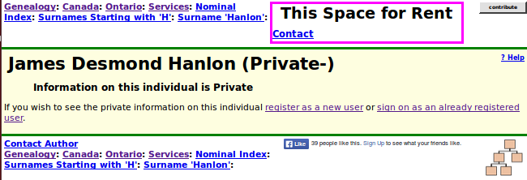Illustration 1: Explicit Instructions to Casual Visitors on Viewing a Private Individual
If a signed on registered user views such an individual the page appears as:
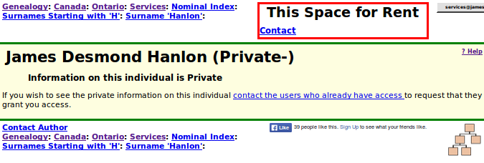Illustration 2: Explicit Instruction to Signed On User About Accessing a Private Individual
If you attempt to update the individual by clicking on the “Update” button of an Edit Individual while the right half of the window is being used to edit an event or the family information, the request is now ignored with a popup that warns the user that the edits in the right half must be completed first. Similarly if you try to edit a second event while editing an event you will be warned. Also if you are editing a member of a family you will be warned if you attempt to update and close the edit family dialog. This makes the behavior of editing much safer and easier to understand.
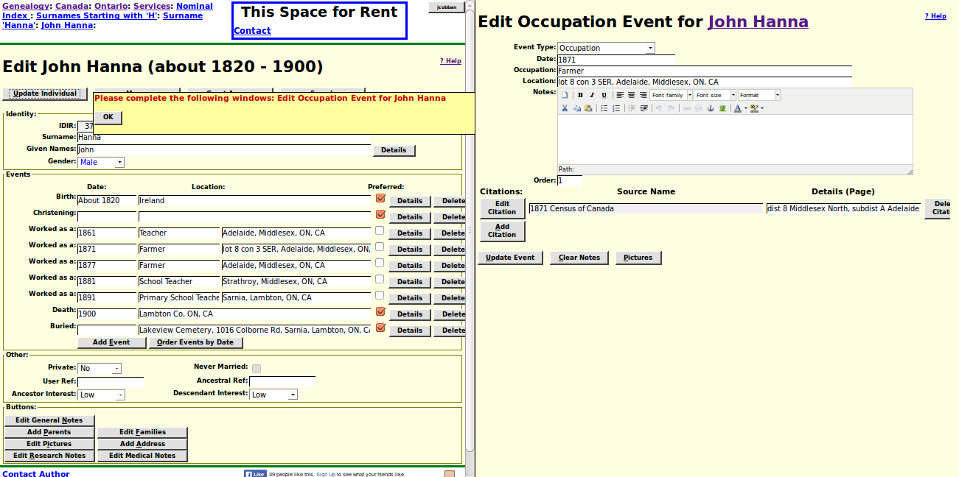Illustration 3: Warn User When Attempting to Update Individual While Subordinate Edit Is Incomplete
When adding a new child the Edit Individual dialog now includes the relationship to parent fields.
The functionality for merging two individuals has been enhanced so that all of the citations for events are merged.
When granting access to a family to another registered user the output is enhanced so that the birth and death dates of all identified family members is displayed. This uses the common LegacyIndiv::getName method. In displaying generations the qualifier “great” is used for the third and subsequent generations. Each family member in the report is now presented as a color-coded hyperlink to the main display page for that individual.
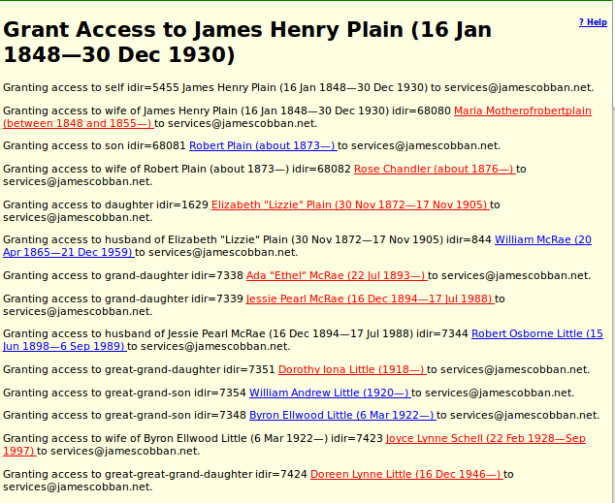Illustration 4: Enhancement of Report on Granting Access to a Family
The list of individuals referencing a particular location now includes the birth and death dates of the individuals.

Census Database Enhancements
The tabular form for editing the information recorded about the sub-districts or enumeration divisions of a census district is enhanced. If the user right clicks on a column header, the column width is increased by 50% which allows viewing unusually wide field values, particularly for the sub-district name column. This complements the existing use of left button click to hide a column. When a new value is entered in a column where values repeat down the column now clears the error flag in all changed rows. In the 1861 census the population column is now auto-corrected to correspond to the number of pages column if it was not explicitly set by an administrator.
The query page to display the sub-district table for a particular district is redesigned so that all text strings, including province names, are contained in the HTML page, rather than some being in the Javascript program. This supports internationalization. This technique will eventually be spread throughout the site in order to support alternate language access.
The URL and description for the Library and Archives Canada 1851 census finding aid are updated to match the new behavior of that site.

Vital Statistics Enhancements
The enhanced functionality of LegacyIndiv::getName and LegacyIndiv::getIndivs are exploited in all vital statistics registration scripts. In the latter case this avoids creating an explicit SQL request.
The method Death::setField now permits the intuitive synonyms `d_deathdate` and `d_deathplace` for the fields `d_date` and `d_place`. This makes the class Death behave the same way the class Birth does.
The page header and footer for displaying the details of a Death Registration has an added link to the summary of transcriptions for the township. The page now searches for citations to the registration from both the old and new location for death events, and fills in the hyperlink to the individual. This prevents inadvertently adding duplicate citations to the registration.

Bug Fixes
- Eliminate duplicate matching individuals from loose name matches in the method LegacyIndiv::getIndivs.
- The method District::getDistricts returned null rather than an array when the limit parameter was not specified.
- The method District::getSubDistricts did not return the counts because the interface in class SubDistrict had been changed.
- In class District methods of the class SubDistrict were invoked without the class definition being included.
- In static method SubDistrict::getSubDistricts the value of the 'fcount' return parameter was not set correctly.
- Class LegacyName referenced deprecated name fields in LegacyFamily. These fields are no longer reliably maintained.
- The LegacyName constructor did not ensure that `Order` was set to -1 for married name records.
- LegacySource::setField put the new value into an undefined field 'fldname' instead of the field name passed as the first parameter.
- The script for editing an event now merely closes the edit dialog if the user has not yet selected an event type.
- A design error arose in the script getIndivNamesXml.php because in some cases the 'idir' parameter was used to exclude a particular individual and in other cases it was used to implicitly provide name, gender, and birth date information to limit the search. To eliminate the resulting incorrect output the 'idir' parameter now is used only to exclude, and the given name, surname, gender, and birth year information required to limit the response must always be passed explicitly.
- Adding a birth citation did not set the sex of the implicitly created birth registration record.
- Many more fields are initialized when adding a death citation implicitly creates a death registration record.
- The PHP variable $individ was not initialized when adding a death citation which resulted in bad XML in the response.
- The script editIndivid.php formerly accessed the deprecated husband and wife name fields in the LegacyFamily record.
- The script editIndivid.js, which performs the dynamic functionality of editing an individual, did not pass the IDCR value in the feedback parameters to editMarriages.js. This caused editMarriages.js to erroneously add a new child record to the display.
- When an edit individual page was resized only the visible half-window frames were resized.
- Edit Individual did not pass the debug flag to the dialogs for editing a Marriage or a set of Parents.
- The temple identifier was not initialized when creating a new LDS sacrament event.
- It is now valid to add a child to a family which is not yet saved in the database and therefore does not have an IDMR value.
- The page FamilyTree/index.html, which is the old entry point to the Cobban family, still contained references to the old generated HTML pages, rather than the new pages built from the database on the fly. Also the reference numbers were wrong.
- Add an alert in commonMarriage.js for a bad return value from function addChildToPage.
- In commonMarriage.js the value of field 'birthsd' was not passed to function addChildToPage. This meant that the reorder children feature did not work for newly created children.
- In commonMarriage.js the debug flag is now passed to the editIndivid.php script when updating a family member.
- In chooseIndivid.js the value of field 'birthsd' was not passed to function addChildToPage. This meant that the reorder children feature did not work for existing individuals added as children.
- The script chooseIndivid.php now accepts a Sex parameter to limit the response by gender.
- The script chooseIndivid.php rejected a maximum birth year in the 1700s.
- The script orderMarriagesByDateXml.php ordered the marriages by the husband's marriage order when asked to order by the wife's order.
- In BirthRegResponse.php the variable $birthDate was not created if it was not set.

