April 2015 Features Update

Table of Contents
Global 3
Family Tree Enhancements 4
Census Database Enhancements 5
Vital Statistics Enhancements 6
Bug Fixes 7

Illustration Index
Illustration 1: Image Displayed Beside Birth Registration 3

Global
The major focus this month was on fixing flaws in the user interface rather than on significant new functionality.
The support for displaying images associated with census pages and birth registrations is enhanced. The birth registration enhancement is in support of a project to transcribe all of the birth registrations for 1914, 1915, and 1916 for Middlesex county. Previously the birth registration dialog opened the image in a new browser tab, which required the user to manually rearrange the desktop to make both the transcription and the image visible at the same time. Now birth registration dialog splits the window and displays the image in the right half of the window. The actual display, for both birth registrations and censuses, is enhanced to permit more control over zooming into the image and to support moving backwards and forwards within the set of images.
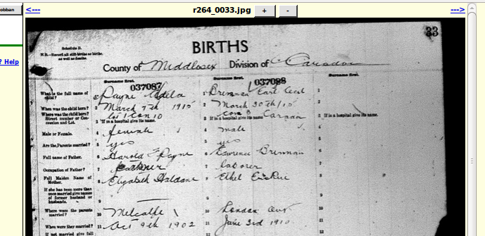Illustration 1: Image Displayed Beside Birth Registration
The “+” and “-” buttons are used to zoom in or out. The <--- and ---> hyperlinks are used to move backward and forward through the set of images, much as if you were viewing them at a microfilm reader.

Family Tree Enhancements
The static method LegacyIndiv::getIndivs is enhanced to permit searching for individuals who have events matching a condition. The method now returns the maiden name as an additional pseudo field. This is used to permit the method LegacyIndiv::getName to return a name including the maiden name. The support for privatizing dates of events when viewed by a casual user is not centralized in the class LegacyIndiv.
Wherever an individual is identified by their full name with birth and death dates the birth and death dates are now separated by an m-dash instead of a hyphen. An m-dash is a dash that is as wide as the letter “m” in the font.

Census Database Enhancements
The census image is displayed using the new tool.

Vital Statistics Enhancements
In the edit dialog for a new birth registration the URL of the associated image now defaults to the value from the preceding birth registration in registration number sequence.

Bug Fixes
- In the static methods LegacyCitation::updateCitations, LegacyEvent::updateEvents, LegacyFamily::updateFamilies, and LegacyIndiv::updateIndivs the XML and HTML output did not escape the characters <, >, and &, where they occurred in the SQL UPDATE command, as required by the XML and HTML standards.
- The static method LegacyIndiv::getIndivs generated an invalid SQL expression if the given name contained certain special characters such as a quote.
- In the static method LegacyIndiv::getIndivs the JOIN clauses to tblNX and tblER could appear more than once.
- If the browser window was scrolled to bring a form element into view any dialog that was popped up to contain information about the element, or to request action with regard to the element was incorrectly positioned, forcing the user to have to scroll the window to see the dialog.
- In the dialog to choose an individual for a relationship check or for merging is now corrected to permit you to change the name that is searched for.
- In the edit event dialog the event is now updated and the dialog closed if you press the enter key in any text field.
- The edit individual dialog did not pass the debug flag to the MergeIndivid.php script.
- The implementation of delete event in the edit individual dialog for events that have not yet been moved from the instance of LegacyIndiv to an instance of LegacyEvent did not reflect the new implementation. This resulted in an alert for bad row name and the event was not deleted.
- The edit individual dialog, when invoked to edit a member of a family, did not reflect birth and death dates that had been changed in the edit family dialog.
- The edit parents dialog permitted editing the child on behalf of whom the edit parents dialog had been invoked, even though there was, of course, already an open dialog for that child. The dialog now pops up a warning dialog.
- If you deleted the last family from an edit family dialog, the dialog remained open with a damaged copy of the information for the deleted family. The dialog is now closed when the last family is deleted.
- In the edit marriage registration dialog the registration domain was not defined in the form.
- In the edit death registration dialog there was an undefined variable error message if viewed by a casual user.
- In the edit marriage registration dialog the implementation of displaying the list of potential matches to a marriage participant is corrected to use LegacyIndiv::getIndivs to obtain the list of matches and LegacyIndiv::getName to display the names in standard format.
- The edit birth registration dialog could fail with an exception thrown by LegacyIndiv::getIndivs.
- The URL for the Library and Archives of Canada 1901 Census database is corrected.
- The contact author link at the bottom of a page displaying the detailed contents of a single row of a census now includes the identification of the row.

