May 2015 Features Update

Table of Contents
Global 3
Family Tree Enhancements 4
Census Database Enhancements 9
Vital Statistics Enhancements 10
Bug Fixes 11

Illustration Index
Illustration 1: Using Rich Text Editor for Event Description 4
Illustration 2: Link to Member of Family Tree from Event Description 5
Illustration 3: Button to Request Permission to Modify the Family Tree 5
Illustration 4: Edit Surname Record Button on Names List Page 6
Illustration 5: Edit Surname Notes 6
Illustration 6: Edit Address Form 7

Global
The major focus this month was on fixing flaws in the user interface rather than on significant new functionality.
All contacts to the administrator, represented in a link in the footer of each page, are now changed to use the internal messaging feature of the web-site rather than sending an e-mail. This means that the messages are directed to any user(s) who are designated as administrators, not directly to the personal e-mail address of the software developer.
The top page of the family tree hierarchy is the page genealogy.php. This is a script rather than a hard-coded HTML page because the list of services that it provides access to depend upon the authorizations of the user who is accessing the site. In particular registered users have access to more functionality than casual visitors. However a large number of pages, particularly help pages, still pointed at the old hard-coded page genealogy.html. This page itself redirected all requests to the new page, but it is more efficient if every page in the site references the correct page name in the first place.
The script contactAuthor.php has a new parameter, text=, which permits adding default initial text to the message to be sent in addition to the subject line.
In the HTML header generated for all pages the URLs of the referenced Javascript files are generated as absolute URLs within the site, rather than relative URLs to where the script is located.
Several help pages have been improved.

Family Tree Enhancements
The old-style URLs referencing the original static implementation of the family tree are translated internally to references to the dynamic implementation so that users who have saved old URLs will not miss the new functionality. The old style addresses looked like:
http://www.jamescobban.net/FamilyTree/Web/I@I81666@.html for an individual record.
http://www.jamescobban.net/FamilyTree/Web/Surname_Riddell.html for a family overview
http://www/jamescobban.net/FamilyTree/Web/IndividualR.html for a list of surnames starting with 'R'
http://www.jamescobban.net/FamilyTree/Index.html for the top level nominal index
The implementation of the popups on the main legacyIndivid.php page is changed to improve performance and flexibility. Instead of being built on the fly when you move the mouse over an item, by interrogating the database server and formatting the response as HTML, all of the possible responses are constructed when the page is laid out, and merely made visible when required.
There is a little trick that you can use in the case where the description of an event includes the name of an individual who is already in the database. For example Joseph Robinson is recorded as working for Darius Coleman, another member of the family tree, in the 1901 census of Caradoc. The event description field, which is used for the description of an occupation in the Occupation event, is now displayed in the Event form using the rich-text editor. This permits you to paste a link to a member of the family tree instead of just typing the name. You can copy the name with its link from any page that references the individual.
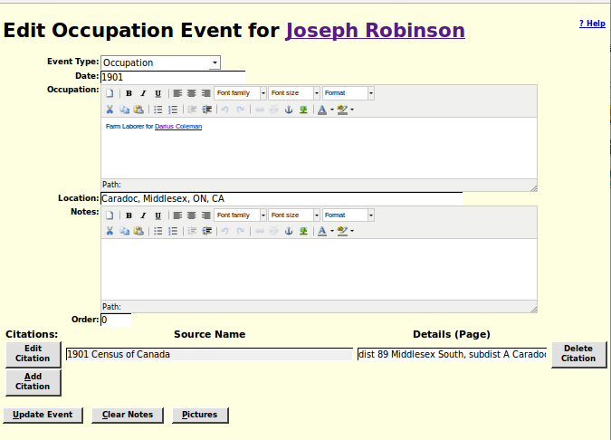Illustration 1: Using Rich Text Editor for Event Description
The name of the associated individual then appears as a link on the page for the individual, and all of the services associated with such a link, including the descriptive popup, apply:
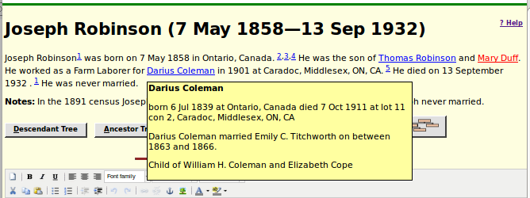Illustration 2: Link to Member of Family Tree from Event Description
To further encourage users to contribute to the site and simplify the process for obtaining permission to see private data a new button is added to the main display page for an individual in the family tree:
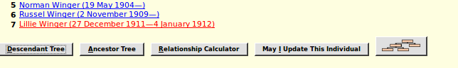Illustration 3: Button to Request Permission to Modify the Family Tree
The script LegacyNames.php uses LegacyIndiv::getIndivs to obtain the list of matching individuals. This required enhancing LegacyIndiv::getIndivs to support all of the function formerly hard-coded in LegacyNames.php.
The script LegacyNames.php, when called to display all of the individuals who share a surname provides a new feature: the “Edit Surname Record” button.
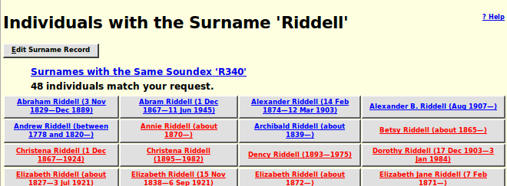Illustration 4: Edit Surname Record Button on Names List Page
Clicking on this button expands the form to provide access to the contents of the surname record:
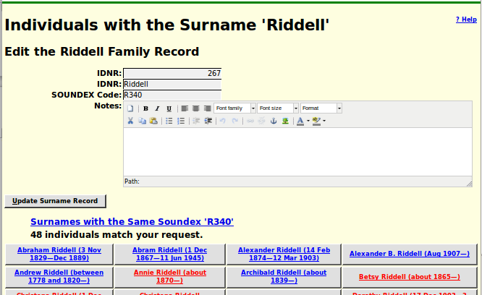Illustration 5: Edit Surname Notes
The Surname notes can be modified using the rich-text editor panel. You can include anything that is relevant to describing the family: the origin of the name, the history of the portion of the family described by this family tree, even photographs, sound recordings, or video clips. For example I have added some notes to the “Cobban” family record.
The script LegacySurnames.php now uses LegacySurname::getSurnames to get the list of matching surnames rather than hard-coded SQL.
The script LegacyCitations.php, which is used to obtain a list of citations matching a particular pattern, for example all citations to a particular page of a census, is enhanced so that the second column of the display shows not only the value of the internal record key (IDIME) but also the descriptive name of the specific record.
Address records are used to represent detailed contact information about an individual or an institution which holds source documents. In particular as an owner of an individual in the family tree you can add an Address record to an individual by clicking on the “Add Address” button. This button appears as “Edit Address” if there is already an Address record for the individual This button opens a form in the right half of the window to permit managing this information.
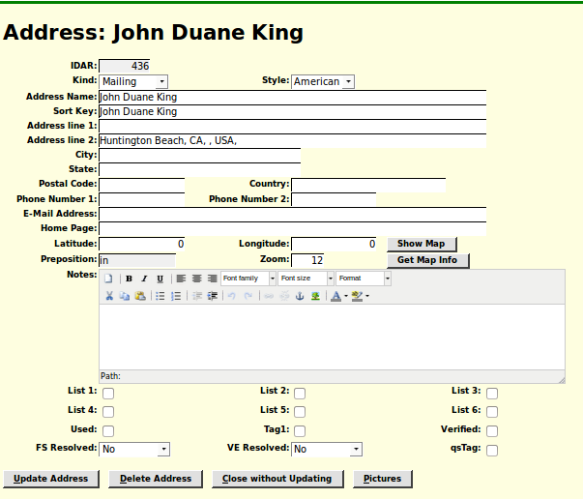Illustration 6: Edit Address Form
The improvements to the functionality of this form are with respect to the four buttons at the bottom of the form.
The “Delete Address” button is added to permit an authorized user to remove address information from the associated individual. If you click on this button you will see the text on the “Edit Address” button in the left hand side of the window change to “Add Address”. Note, however that although clicking on the “Delete Address” button actually deletes the record out of the database, you have to click on the “Update” button for the individual in the left hand side of the window to remove the reference from the record of the individual.
The “Close without Updating” button is added to permit you to change your mind as to whether you wish to make changes to the Address record.

Census Database Enhancements
The census image is displayed using the new tool. The URL of the image associated with a census page that is being edited, which is only displayed if you click on the “Correct Image URL” button, is updated if the transcriber uses the forward or backward arrows in looking for the correct image to associated with the page. So just make sure that the correct image is displayed in the right half of the window when you click on the button to update the census database.
The dialog for editing the Census Page table, PageForm.php, is enhanced to eliminate internal use of SQL and to exploit the functionality of the new image display capability to simplify the administration of image URLs.
These two features are discussed in more detail in the May 1915 newsletter.

Vital Statistics Enhancements
In the edit dialogs for deaths and marriages now split the window when displaying the associated image. If the forward or backward arrows within the image display frame are used, the image URL associated with the birth, death, or marriage registration is updated.

Bug Fixes
- The page for contacting the administrator is now frequently opened in a half-frame instead of in a separate page. The page is now aware of this and uses the closeFrame method to hide the frame rather than closing the window.
- A new style div.article is added to support formatting user guides in HTML documents rather than PDFs. This is used in the articles on Digital Representation, French Occupations, Reading Handwriting, and using Spreadsheets.
- The script deleteIndivid.php displayed a poor title because it escaped the M-dash between the birth and death dates of the individual.
- The scripts editEvent.php, editPicture.php, editSource.php, editName.php , and LegacyLocation.php mangled the rich-text notes areas by escaping the HTML control characters in the <textarea>.
- The script editMarriages.php failed because it did not handle the exception thrown for a bad value of idlrmarr in the instance of LegacyFamily.
- In the output from legacyIndivid.php there was a missing space after the closing period if only the father was defined.
- In the output from legacyIndivid.php there was a missing comma between the footnote reference for the name and the footnote references for the name citations.
- In legacyIndivid.php all of the Javascript file references and all of the URLs in the page header and footer are changed to absolute references within the site.
- In the script updateIndividXml.php, which is used by Javascript to update the database as a result of user action, the event description variable was not cleared between processing events, which resulted in a spurious description being copied from the last life event to death or burial events.
- Numerous pages had improperly specified H1 sections.
- The script PageForm.php improperly used an HTML <table> to layout some portions of the page that did not contain tabular information. It also did not specify that the link to the help page should open the page in a new tab or window.
- There was a misspelled variable name in the script PageUpdate.php which caused a bad district name to be displayed.
- The script SubDistForm.php improperly used an HTML <table> to layout some portions of the page that did not contain tabular information.
- In the scripts CemeteryResponse.php, DeathRegResponse.php, MarriageRegResponse.php, OcfaDoQuery.php, and WmbDoQuery.php PHP print statements were corrupted causing incorrect output.

