June 2015 Features Update

Table of Contents
Global 3
Family Tree Enhancements 4
Census Database Enhancements 8
Vital Statistics Enhancements 10
Bug Fixes 11

Illustration Index
Illustration 1: Display of a Temple of the Church of Latter Day Saints 4
Illustration 2: Rich Text Editing of Occupation or Description Field of an Event 5
Illustration 3: Editing a Family with Rich Text Notes 6
Illustration 4: Choose Relative Dialog with relationship information displayed 7
Illustration 5: Simple Report on Individuals Born in Delaware who Worked as a Teacher 7
Illustration 6: Census Form showing warning about incompatible sex and relationship columns 8
Illustration 7: Census District Table Update showing sub-district count 9

Global
The major focus this month was on fixing flaws in the user interface rather than on significant new functionality.
The default font-size in rich text editor fields was too small, making them hard to read and manipulate. The font-size is now made the same as the font-size in all other input fields.
The common date handling class now accepts dates of the numeric format YYYY/MM/DD, for example 2005/06/21.
The last few places where page scripts opened dialogs in new windows have been addressed. All pages now open child dialogs in the other half of the window.

Family Tree Enhancements
There was a minor problem when editing a family. If you changed the birth or death date of a child and then clicked on the “Edit Child” button the edit dialog that appeared in the left hand side of the window sometimes did not reflect the changes. This was a difficult problem to track down and revealed a basic design flaw in support for managing an individual record. Basically there were two ways that a page script could obtain a copy of the record for an event in the life of the individual. There was a function to return the specific event record, for example LegacyIndiv::getBirthEvent, and there was a function to return the complete set of event records, LegacyIndiv::getEvents. Both methods returned an object that contained the information from the database record, but they were two different objects, so that a change made to one of the objects was not reflected in the other. They both started the same but since only one or the other was actually updated, they ended up out of synch.
The LegacyEvent class implements the interface to a record containing a fact or event. There was a problem that when lists of citations were merged as part of the merging of two individuals that the `order` field was not adjusted so that the citations would be in order when displayed. Also a method LegacyEvent::compare is added. This returns information about the relative order by date of two events. It is used to permit page scripts to sort events by date without having to know the internal representation of the object.
The LegacyTemple class, which implements the interface to a record describing a Temple of the Church of Latter Day Saints, is enhanced so that from the external view the start and end dates of the activity of the temple are displayed as ordinary dates. For example as “21 June 2005” instead of “20050621”.
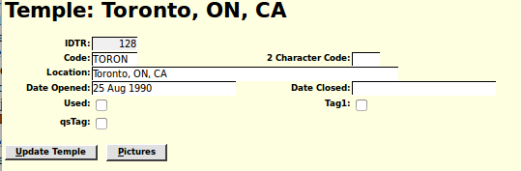Illustration 1: Display of a Temple of the Church of Latter Day Saints
The event description field is changed to support much longer text and is now accessed by a rich text editor so that it can contain more structured information, such as hyper-links to individuals in the family tree. This field is also the “Occupation” field of an Occupation event.
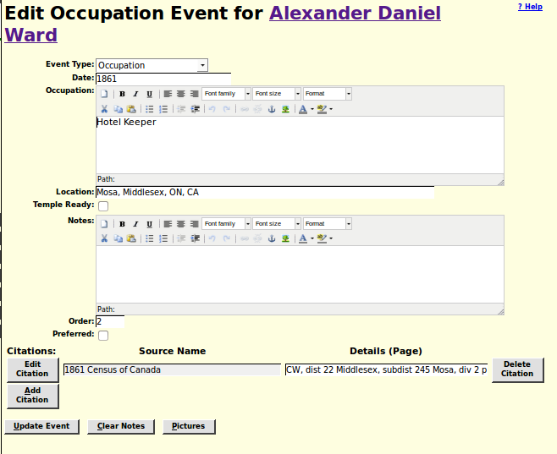Illustration 2: Rich Text Editing of Occupation or Description Field of an Event
On the page for editing an individual the events are now sorted by date when first presented. The “Order Events by Date” button is re-enabled any time a new event is added. When invoking the child dialog to edit the details of an event only relevant parameters are passed. If a parameter is passed with an empty value the Edit Event dialog assumes that the value of that field in the event is to be cleared.
The “Edit Location” script now retains only 6 digits after the decimal point in all coordinates. That is coordinates are only memorized to 1 millionth of a degree, which is about 0.1 metres. This makes them easier to read and cuts the amount of database memory required for recording boundaries about in half.
The Notes field of an edit family or edit parents dialog is made a rich-text editor. Since this fields is frequently used to identify the witnesses and the minister, those references can now be made links to the corresponding records in the family tree.
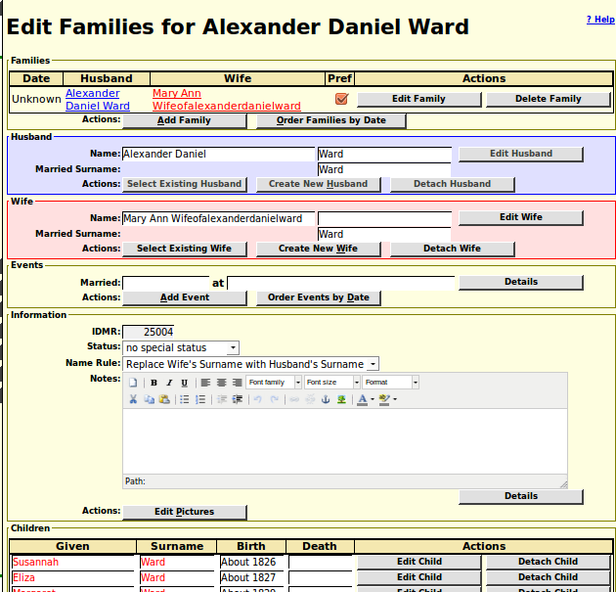Illustration 3: Editing a Family with Rich Text Notes
The edit child buttons on a family dialog are now disabled if either parent is being edited or created. As a convenience if you click on an “Edit Spouse” button and the spouse has not yet been created the dialog to create the spouse is displayed. It is desirable to fill in the name of the spouse being added for two reasons: the first is that you can use the “Select Existing Husband/Wife” button to search to see if the individual is already present in the database, and the second is that the information is copied to the creation dialog.
To make editing of the set of children on a family page more intuitive the script now takes action on more keystrokes. Pressing the Enter key while in one of the fields for a child moves the active field to the first input field (given name) of the next child. If there is no next child one is added. Also the up and down arrow keys now permit moving up and down in the current column so you can, for example, fill in all of the birth or death date fields for a set of children without lifting your hands off the keyboard.
The Choose Relative dialog now includes the names of parents and spouses in the description of the individuals in the selection list.
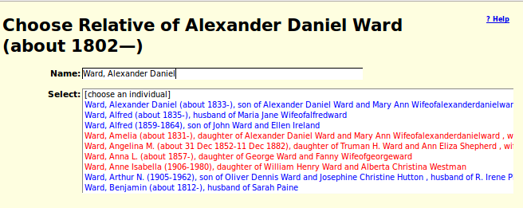Illustration 4: Choose Relative Dialog with relationship information displayed
The tool for creating a simple report of information from the family tree database is enhanced to support reports that combine information from the table of Individuals and the table of Events. You do not have to worry about exactly which table the information you are looking for is located, just ask for the fields you are interested in and the tool figures it out.
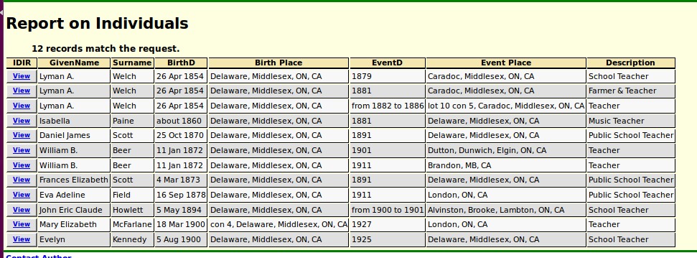Illustration 5: Simple Report on Individuals Born in Delaware who Worked as a Teacher

Census Database Enhancements
A new global table $censusInfo is used to consolidate information about censuses such as the number of lines per page, and the set of states or provinces to which the census applies.
The array returned by method District::getDistricts is now indexed by the district identifier.
When editing a census page which contains information on the relationship of each individual to the head of household, that is for 1891, 1901, 1911, and 1921, if the relationship is inconsistent with the sex of the individual then the relationship is displayed in red. This may be an actual mistake by the original enumerator, in which case it should be left as is, but if it was a data entry error by the contributor this warns you to correct it.
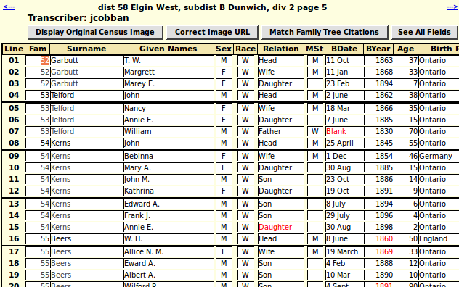Illustration 6: Census Form showing warning about incompatible sex and relationship columns
The script DistForm.php which presents the form for managing the description of census districts now uses the class District instead of explicit SQL commands to make changes to the database. As a result of using the class interface changes to the table are now made as updates where the old implementation deleted the entire section of the Districts table and then replaced it.
The script DistForm.php now presents the count of the number of sub-districts within the district in a read-only input field which makes its appearance more consistent with the other columns of the table.
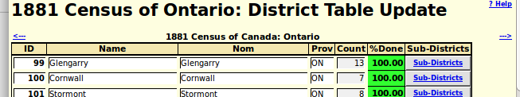Illustration 7: Census District Table Update showing sub-district count

Vital Statistics Enhancements
The only changes to vital statistics support this month are fixes for implementation errors.

Bug Fixes
- The LegacyEvent class had a problem that when lists of citations were merged as part of the merging of two individuals that the `order` field was not adjusted so that the citations would be in order when displayed.
- There was a misspelled field name in the SQL where expression generated by District::getDistricts.
- The Edit Marriages dialog failed if the IDMRPref field in the individual was bad.
- The Edit Parents dialog failed if the IDMRParents field in the individual was bad.
- The loading indicator was not displayed above the selection list of individuals in the “Choose Relative” dialog because of a misspelled field name in the script.
- Selection dialogs displayed information on parents and spouses even on private individuals.
- When resetting a census page to its default values the “can read” and “can write” indicators were set to “1”. They are now set to “Y”.
- The <input> tags in the script DistForm.php were missing the id= attribute.
- The script DistForm.php did not pass the debug flag to the script DistUpdate.php.
- The script ReqUpdatePages.html is renamed to ReqUpdatePages.php so the functionality can be made conditional on the authorizations of the current user.
- The script ReqUpdateSubDists.html is renamed to ReqUpdateSubDists.php so the functionality can be made conditional on the authorizations of the current user.
- The HTML generated by the include script MarriageRegDetailLib.php was missing a clear option, so the Religion prompt would appear on the same line as the occupation and marital status fields if the window was wide enough.
- The scripts BirthRegDetail.php, MarriageRegDetail.php, and DeathRegDetail.php incorrectly escaped HTML options in the value of <textarea> tags, which broke the functionality of the rich-text editor.
- Accented characters were incorrectly flagged as incorrect in text input fields for names, occupations, and locations.
- The signon script incorrectly validated a change password request.
- The signon script did not honor whether the “Remember” checkbox was checked. It always remembered the requested user-name and password.

