July 2015 Features Update

Table of Contents
Global 3
Family Tree Enhancements 4
Census Database Enhancements 8
Vital Statistics Enhancements 9
Bug Fixes 10

Illustration Index
Illustration 1: Displaying Descriptive Information about a Surname 5
Illustration 2: Editing Descriptive Information about a Surname 6
Illustration 3: Order of Information Display Changed for Individual 6
Illustration 4: Location Popup for Registered Subscribers 7

Global
The major focus this month was on fixing flaws in the user interface rather than on significant new functionality.
There is a new category of tools on the top level page: Video Tutorials. Clicking on this takes you to a list of video tutorials on the more effective use of the site.
The navigation trail displayed in the header and footer of each page has an option added to define items that do not have an associated link address.
The page is now defined with explicit <header>, <main>, and <footer> sections as defined by HTML5 to support assistance technologies.
All PHP include files are now referenced using paths based on the PHP include_path. Some include file references formerly used absolute file names. This makes the implementation more portable.
All references to the script getRecordXml.php are consolidated in a single instance at the top level which in addition to the existing support for tables in the family tree and census portions of the database now also supports the Births, Marriage, Deaths, Counties, Townships, Users, and Blogs tables.
The script Users.php, which is used by a designated administrator to manage the table of registered users, now uses the class User for all manipulation of the database instead of direct SQL statements. The ability for the administrator to manually correct usernames and email addresses is added. A debug trace is displayed if the debug option is passed to the script.
The width of the border around the advertisement in the header is set to an explicit value to avoid different browser interpretations of “thick” that caused Chrome, for example, to not be able to fit the advertisement in the available space.
If a guest, that is a user who has not signed on as a registered user, clicks on the “Contact Author” link at the bottom of the page the only way that the Author, that is an administrator or a registered user who is an owner of the page, can reply is by e-mail. To simplify this the created blog post contains a “mailto” link. This “mailto” now has a default subject and body text extracted from the blog post so the Author no longer needs to manually copy this information before replying to the message.
The browser functionality to widen a displayed column in a table by 50% when the right button of the mouse is clicked on the column header is moved to the common library.

Family Tree Enhancements
There was a performance problem due to a missing index on the table of LegacyEvents which meant that it took over a second to obtain the list of events associated with a particular individual.
The static method LegacyIndiv::getIndivs now extracts the birth and death dates from the table of LegacyEvents and appends them as additional columns.
In preparation for the removal of the field `birthsd` from LegacyIndiv the field is now referenced only if there is no preferred birth instance in the table of LegacyEvents even for sorting individuals by birth date.
A new method LegacyEvent::setAssociatedRecord is added to deal with the situation where the record with which the event is associated did not exist when the instance of LegacyEvent was created.
The functionality of LegacyCitation::getName is enhanced so it can be used by the script legacyIndiv.php to obtain a unique key for merging equivalent citations in the footnote table. Functionality is also added to LegacyCitation::getCitations so that if it is called to find all the citations to the primary name, LegacyCitation::STYPE_NAME, and the 'namenote' field of the individual is not empty, a special instance of LegacyCitation is added to the beginning of the returned list that makes the 'namenote' look like a citation. This eliminates the need for the script legacyIndiv.php to include a significant amount of special code just to add a footnote reference including the 'namenote' information.
The script LegacyLocations.php, which displays a list of locations matching a pattern, now has a 'close' button added so it can be invoked in a half window.
The script getIndivNamesXml.php is changed to use LegacyIndiv::getIndivs instead of raw SQL to get the list of matching individuals. This required significant enhancement to LegacyIndiv::getIndivs.
The script LegacyNames.php, which is used to display all of the individuals in the family tree with the same surname has a couple of enhancements. It can now be invoked using the numeric key of the record in the table tblNR for the surname. Also a long text field is added to the record in tblNR. The script LegacyNames.php accordingly now permits any registered user to add descriptive information about the family. Furthermore the ability to post blog messages for the family is added.
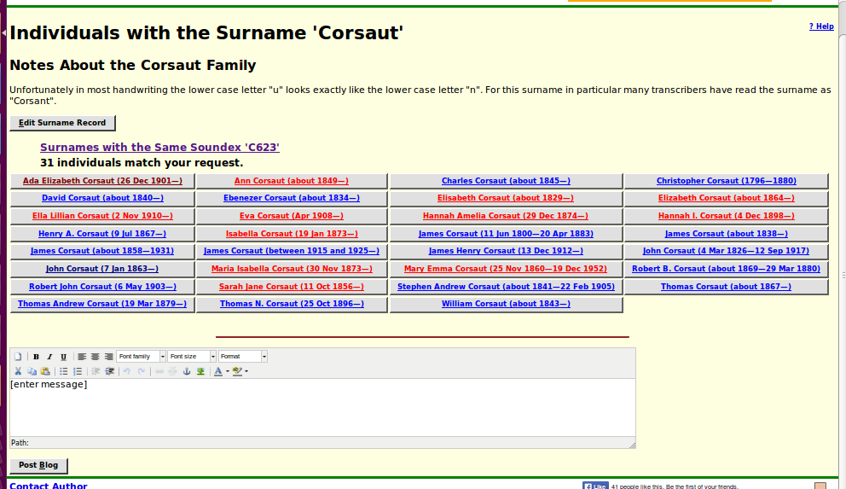Illustration 1: Displaying Descriptive Information about a Surname
Click on the “Edit Surname Record” button to create or edit information about a surname.
The information is entered in a rich-text editor, so you can use highlight text, insert hyper-links, and include images. It does not make sense to permit the user to change the surname or SOUNDEX code.
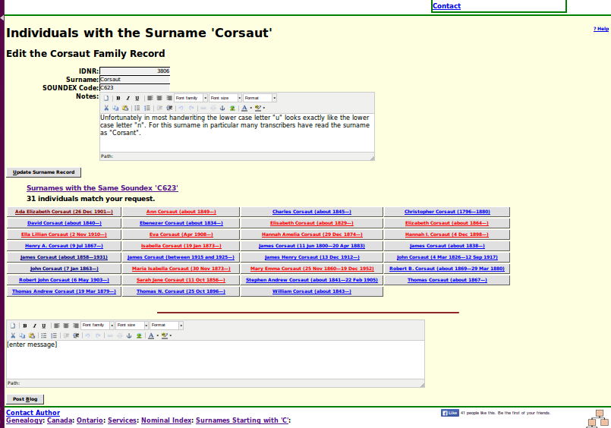Illustration 2: Editing Descriptive Information about a Surname
The order of information displayed in the main page on an individual about either the main individual or a spouse is changed for clarity and simplification. The order of display is now:
- The name of the individual, with all of its citations, including the special citation for a name note.
- The names of parents of the individual. This information formerly followed the birth event.
- Information on alternate names by which the individual is known in the sources. This was formerly presented in a separate paragraph before the main paragraph.
- All of the events, normally in chronological order starting with birth.
Illustration 3: Order of Information Display Changed for Individual
If you are signed on as a registered user, the popup containing information about a specific location that appears if you hold the mouse over a location name now contains a button that permits you to edit the description of the location. As a registered subscriber you can change any information about a location, including the spelling and capitalization of the name, the geographic coordinates, the boundary of administrative areas such as townships, counties, and states, and the descriptive text.
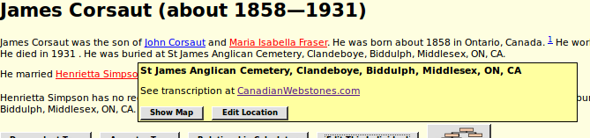Illustration 4: Location Popup for Registered Subscribers

Census Database Enhancements
The script CensusUpdateStatus.php, which summarizes the progress of the transcription effort for a particular census and province, is enhanced to add support for the 1831 census of Quebec, correct the ordering of censuses as implemented by the forward and backward hyper-links, and to popup a description of where those links will take you if you click on them.
On all censuses if you enter a “+” in the family number column it will now search back over empty rows to find the last valid family number instead of setting the field to '1' when the preceding line was blank. If you do a right button mouse click on the header of any column the width of that column is increased by 50%, permitting you to see longer values. In the 1851 and 1861 census years if the sex changes and the individual was born in the past 12 months, the sex is adjusted in the born this year column.

Vital Statistics Enhancements
The minimum column widths are explicitly set for the fields in the response to a query of the Wesleyan Methodist Baptisms table, so the text in each field will not be wrapped to try and squeeze as much into the width of the page as possible.
The only other changes to vital statistics support this month are fixes for implementation errors.

Bug Fixes
- There was an unclosed tag in the diagnostic output from the constructor for class Marriage which resulted in invalid XML output.
- The constructor for class Blog is corrected to accept a key value that is a numeric string as well as integers.
- Diagnostic output from class County is redirected to $warn to maintain valid HTML.
- The constructor for class User is corrected to accept an id value that is a numeric string.
- The static method User::getUsers is altered to require the parameter to be passed by reference so the count can be returned, and to support searching for users based upon the Options value.
- In class LegacyIndiv the internal pointer to the associated record was not set in basic events if they already existed as records in tblER.
- In method LegacyIndiv::getName remove a reference to the obsolete field 'birthd'.
- LegacyIndiv::getWhere constructed a bad expression for IDIR exclusion and for unusual given name expressions.
- LegacyIndiv::getWhere constructed a bad expression for OR expressions.
- The browser script Users.js, which implements the dynamic functionality of the administrator script for managing users previously issued an incorrect error message if the script deleteUserXml.php was not found on the server.
- There was an extra semicolon in the text generated by the browser script locationCommon.js.
- In the script getIndividualsByLocation.php the parameters created to combine fields by 'or' was wrong.
- In the script LegacyNames.php the header link to the nominal index searched for the surname '$surname' instead of the surname being displayed in the page.
- In legacyIndiv.php when the implementation of location popups was changed to expand at page build time the descriptive text was accidentally omitted.
- In legacyIndiv.php the expansion failed if an invalid birth or death location identifier was present in the database.
- In legacyIndiv.php there was a syntax error in the header and footer page hierarchies if the surname contained a quote.
- In BirthRegDetail.php, the script that displays an individual birth registration, the search for potential matches in the family tree would not work as expected if the given names contained any special characters.
- When a marriage registration is deleted from the list presented by MarriageRegResponse.php the HTML of the page is updated instead of refreshing the whole page from the server.
- The forward and backward links on the page MarriageRegDetail.php were missing the domain name field.

