August 2015 Features Update

Table of Contents
Global 3
Family Tree Enhancements 4
Census Database Enhancements 9
Vital Statistics Enhancements 10
Bug Fixes 11

Illustration Index
Illustration 1: Nominal Index with Tree Name Selection Option 4
Illustration 2: Nominal List after Clicking on Tree Name Selection 5
Illustration 3: Nominal Index for Selected Family Tree 6
Illustration 4: Page for Individual from an Alternate Tree 7

Global
The only major new functionality this month is the ability to define multiple family trees. This is discussed in the Family Tree section of this report.

Family Tree Enhancements
The major new functional enhancement of the site this month is the ability to define and manipulate multiple unrelated family trees. Another point of view on this is that it can be used to manage multiple largely independent research projects.
The existing family tree contains information about families that passed through south-western Ontario, and in particular through Middlesex County. Admittedly you can add anyone to to this tree, regardless of where and when they lived, but this new feature permits a user to choose to perform research on a family or group of families that are unlikely to have any connection to the existing research project. So a new “Tree Name” selection item appears on the main nominal index page:
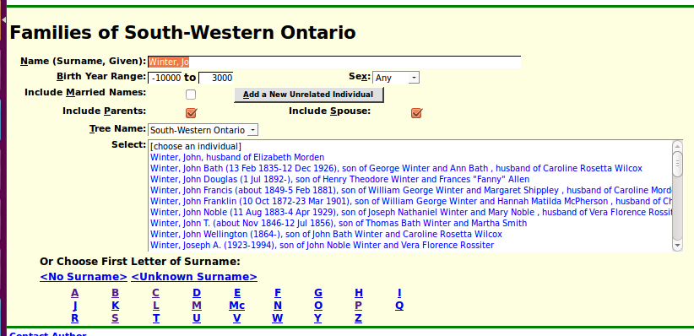Illustration 1: Nominal Index with Tree Name Selection Option
The new selection item, just above the list of names, permits you to select an alternative family tree, to create a new family tree, or to search all of the trees in the database:
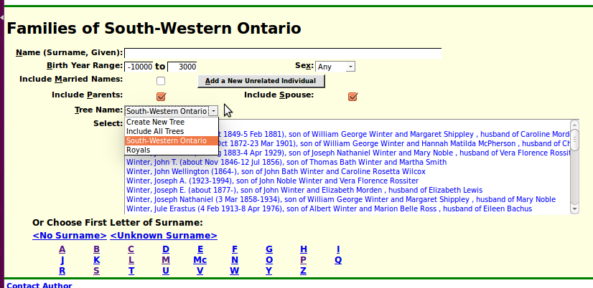Illustration 2: Nominal List after Clicking on Tree Name Selection
This selection list provides two fixed options: to create a new family tree, or to have the displayed list of names include all individuals in all trees, plus one item for each family tree that has been previously defined. The main existing tree is now labeled “South-Western Ontario” and just for fun I have added a demonstration tree, entitled “Royals” which is populated with a few individuals from the Royal Family of Scotland. This is just to demonstrate the ability to use this web-site for a radically different kind of research. As registered contributors any of you can create your own family tree that may or may not be connected to another family tree on the site. For example some of you may be descended from royalty, in which case there would be links from the “Royals” tree to the tree containing your more recent family.
When you choose, or create, a new tree the title of the page, and the list of displayed individuals changes to show the individuals in the selected tree:
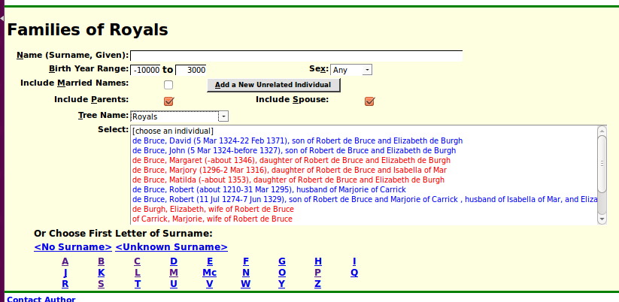Illustration 3: Nominal Index for Selected Family Tree
The title of the page changes to reflect the selection of a new tree. When you select an individual from the list there is also a slight change to the title of the displayed page:
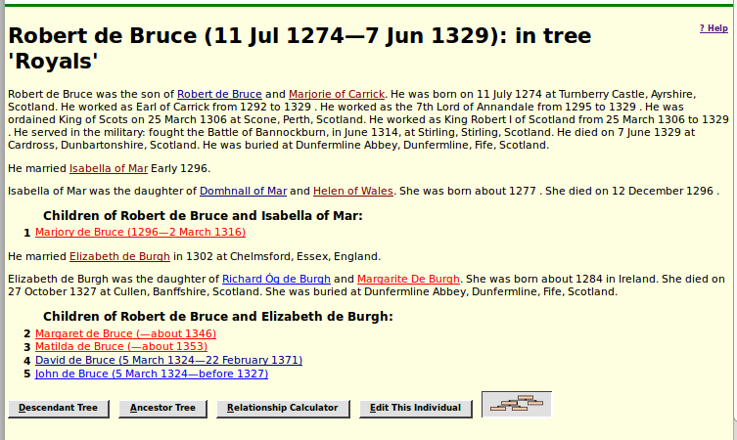Illustration 4: Page for Individual from an Alternate Tree
For individuals in alternate trees the name of the tree is included in the page title.
When you add relatives to an individual in a tree, for example children, spouses, or parents, those individuals are added to the tree that the original individual belongs to. The only exception is if you add an existing individual, who already belongs to another tree. That is how linkages between trees are created.
I hope this new functionality will open up new opportunities for research.
In support of this new functionality the class LegacyIndiv adds new methods getTreeName and setTreeName to manage the association between the individual and a tree. The actual relationship is defined in the class LegacyName by the new field named 'treename'.
Obviously the script legacyIndex.php and its associated dynamic code in legacyIndex.js are updated to implement access to multiple trees. Similarly legacyIndivid.php is changed to display the name of the tree the individual belongs to if it is not the default tree. The script chooseIndivid.php, used for example in merging duplicate individuals, is enhanced to take the name of the tree to search as a parameter. The range of birth years that the chooseIndivid.php script accepts is broadened so that historical individuals can be searched for without an error message. The script mergeIndivid.php is also enhanced to support trees.
There are cases in the tree where it is known that individuals are siblings but where there is no known information about their parents. In this case the description of the individual in the main page generated by legacyIndivid.php indicated only that the individual had parents, but provided no method to realize that there were known siblings. And in particular no hyper-link that you could follow to see the connection. So now in this special case the main page for an individual provides the links to the siblings where the links to parents would normally be presented. In another case the information displayed for a woman with an illegitimate child and no known father for the child is now clearer.
When entering a surname in editIndivid.php it is now recognized that name prefixes such as 'de', 'of', and 'von', which typically begin surnames of noble families, are not capitalized.
When creating a new unrelated individual to a tree the title of the page starts out as the uninformative “Edit (–)”. This is improved by dynamically changing the title of the page, in this case, as you enter information about the new individual. Also fixed is the process for adding a spouse and children or a set of parents onto a new unrelated individual. Previously the name of the new unrelated individual was not copied over to the page for editing the family or parents, so you had to manually copy that information. If you failed to copy the name, then when you saved the family it would wipe out the name of the primary individual.

Census Database Enhancements
The script CensusUpdateStatus.php, which summarizes the progress of the transcription effort for a particular census and optionally a province, is improved to not issue an error message if it is called without a province code, and in that case to also display summary statistics about the census as a whole.

Vital Statistics Enhancements
The only changes to vital statistics support this month are fixes for implementation errors.

Bug Fixes
- The method LegacyIndiv::getNames had a bug that it set the internal attribute altNames to the return value of the function, rather than the complete set of instances of LegacyName associated with the individual.
- There was a bug in the script legacyIndex.php which caused the Sex prompt to start on a new line, rather than on the same line as the birth date range fields.
- There was temporarily a bug in updateLocation.php if you invoked the editLocation.php script in its own window, that the window did not clean up properly.
- There has for some time been a bug while editing a family. If you used the Delete button for the family whose details were currently displayed, then attempting to close the dialog would fail, leaving the update of the primary individual hung. The implementation is fixed to ensure that after a family is deleted one of the remaining families is made the actively displayed family.
- There is an obscure implementation issue in Firefox 40 and Chromium that results in attempts to change the current selection in any of the popup dialogs failing. A workaround is implemented which is transparent to the user. Also the <select> in these dialogs is now given the focus which means that the user can use the keyboard to make a selection rather than needing to use the mouse. This issue revealed a number of opportunities for improvement of the implementation which were taken advantage of.
- Not all pages in the database section had been updated to reflect that the dialog for requesting an update of the Pages table had been moved to a PHP script from an HTML template.

