October 2015 Features Update

Table of Contents
Global 3
Family Tree Enhancements 4
Census Database Enhancements 5
Vital Statistics Enhancements 6
Bug Fixes 8

Illustration Index
Illustration 1: Death Registration Status for a Year 6

Global
There are no significant global changes this month.

Family Tree Enhancements
The nominal index page, a common entry point to the site, was becoming arthritic because its implementation required a linear search of the database, and as the number of individuals in the database grew the time to complete the search became several seconds. To speed this up the search is now done in little bite-sized chunks, each of which takes a fraction of a second, which are performed until 50 individuals have been accumulated or the end of the database is reached. This makes the page look even more responsive because you see the names start appearing almost immediately, rather than waiting until the entire query was completed.
When you cite as evidence for a marriage a marriage registration which has not yet been transcribed, an estimation of what the transcription should contain is created from the facts already recorded about the marriage.
Information on children and event citations is included in the XML document created by getRecordXml.php?idmr=...

Census Database Enhancements
There are no changes to census support.

Vital Statistics Enhancements
Support is added for original document images which are accessed using secure HTTP, indicated by a prefix of https: on the URL. This is to support the free image which are now available through FamilySearch.org. These images have been acquired by the Family History Library of the Church of Latter Day Saints through a new agreement with the Archives of Ontario, and are obtained by scanning the original paper documents rather than the microfilm created starting in the 1950s. They are therefore generally superior in legibility to the images available on Ancestry.ca which are also only available through a paid subscription.
The transcription progress summary displayed for Death registrations has been enhanced to include three additional columns.
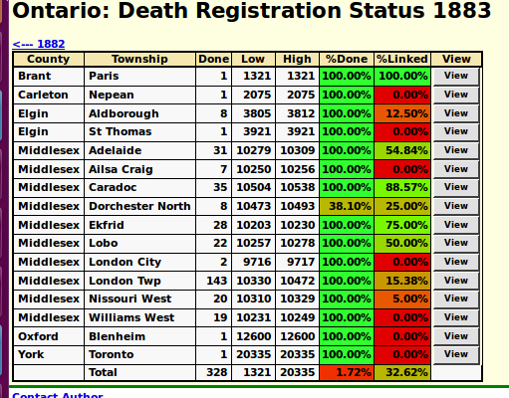Illustration 1: Death Registration Status for a Year
The new columns are: the lowest registration number in the township, the highest registration number in the township, and the percentage completion of the transcription effort, which is the number of records transcribed in the township divided by the number of records between the lowest and highest registration numbers. This last number may be misleading. For example the City of London in this example shows 100% completion, even though only 2 records have been transcribed. However in this year the City of London records actually extend from 9716 tp 9996, for a total of 281 birth registrations.
The script for displaying information about a participant in a marriage record is slight changed to compensate to changes made to the support in class LegacyIndiv for searching the table of individuals.

Bug Fixes
- There was a problem in the script for displaying the statistics of death registrations if the death registration did not have the name of the county or the name of the township filled in, and the user clicked on the button to see the details for the township.

