January 2016 Features Update

Table of Contents
Global 3
Family Tree Enhancements 4
Census Database Enhancements 5
Vital Statistics Enhancements 6
Bug Fixes 8

Illustration Index
Illustration 1: Census Table Administration 5
Illustration 2: Summary of County Marriage Reports 6
Illustration 3: County Marriage Report Details 6
Illustration 4: Citations to County Marriage Registration 7

Global
The sub-script common.inc that performs common initialization for all web page scripts is changed to store information about the current user in a hidden portion of the web page so that it is available to the dynamic functionality running in the client's browser.
All of the pages are changed to use a common PHP routine showTrace to display debug trace information. This ensures that all of them do it exactly the same way, and the new method gives an identifier to the division containing the trace information, which is then available to the dynamic code running in the client browser which can now add lines to the displayed trace information using a Javascript function traceAlert rather than using popup alerts to report events which are requested by enabling debugging for the script. All debugging information, whether generated by the PHP script on the server or the Javascript running in the browser, now displays in the same place on the page.

Family Tree Enhancements
On the main page for an individual extended notes are now displayed with a “block quotation” style, that is indented from both the left and right margins relative to the main text flow. Citations to pre-Confederation marriage registrations are now recognized and converted to links to the transcription if possible.
The explanation of a new death cause “Ascites” is added.
Support for detailed information of a source not supports the https: and ftp: protocols for URL references as well as :http.

Census Database Enhancements
All of the common information about the censuses supported by the site is moved from hard-coded tables in the common startup script to a new table in the database. This permits an administrator manage this information explicitly rather than by editing a text file. Non-administrators can view, but not alter, this information. The concept of a virtual or collective census is used to provide a consistent view for pre-Confederation censuses.
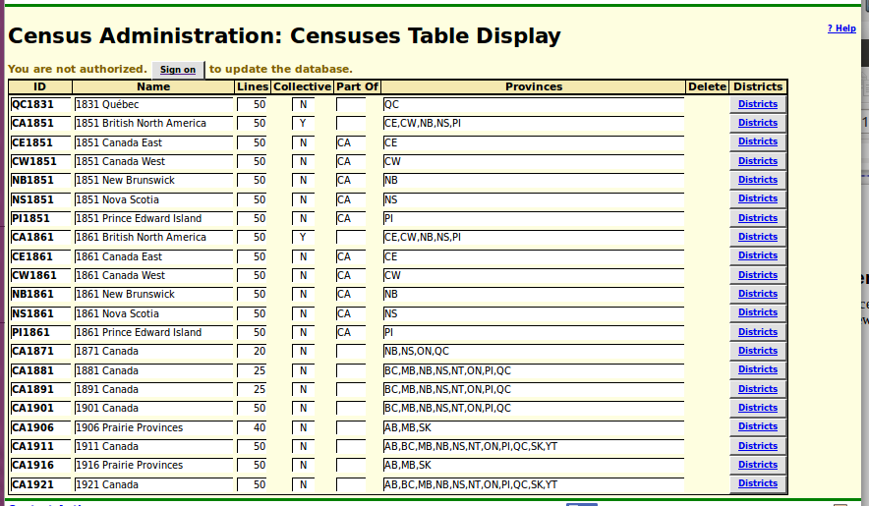Illustration 1: Census Table Administration

The method CensusLine::isValidCensus is removed because the functionality is provided by Census::isExisting.

Vital Statistics Enhancements
A new set of tables is introduced to support transcribing and more accurately citing pre-Confederation marriage registrations in Ontario. These transcriptions are not identified by the year plus a sequential registration number like the post-Confederation registrations, but rather by the number of the volume in which the original registrations are kept, the sequential report number assigned to each annual report from a minister of religion when it was copied into the volume, and the sequential item number within each report. This introduces two tables:
A table describing each individual report by a minister of religion:
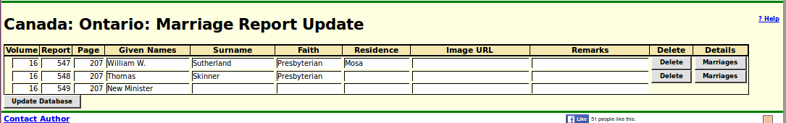Illustration 2: Summary of County Marriage Reports
And a table containing the individual marriage registrations. If the marriage registration has been cited then the buttons in the Link column display the entries in the family tree. Otherwise the buttons perform a search for potential matches to the individual in the family tree.
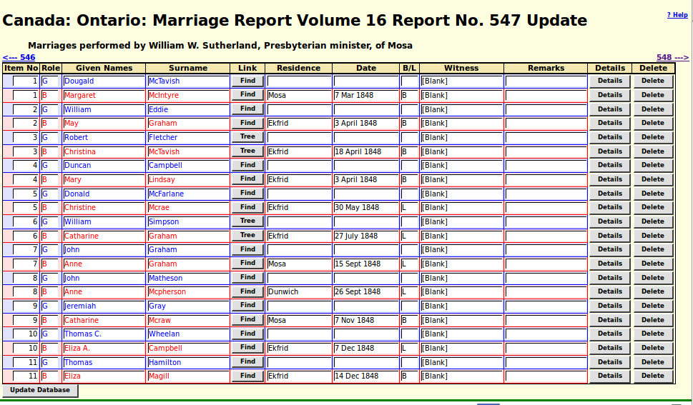Illustration 3: County Marriage Report Details
When a citation to a County Marriage includes the volume, report number, and item number then the reference displayed in the footnotes of the page for the happy couple includes a link back to the transcription of the registration. The following example demonstrates that some flexibility is permitted in the way that the citation is entered.
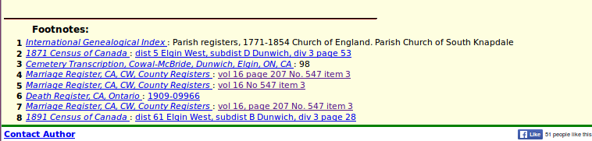Illustration 4: Citations to County Marriage Registration

Bug Fixes
- There was an error message displayed by common.inc before the HTML header.
- There were temporary bugs in changing the signon implementation that prevented casual visitors from accessing the site.
- The obsolete cookie “dboptions” is removed from the client browser if present.
- The constructor for class User did not correctly initialize the record when a new instance was created by user name.
- The method User::getUsers did not return the correct results for a combination of user name and authorization.
- The method Record::save did not support tables where the primary key was not a number.
- The method Township::delete had a missing ? in the prepared statement.
- There was a bug when editing children on a family that changing the sex of the child was ignored when the user clicked on the update family button. This was because the sex was represented in two ways in the page, one by the color style for presenting the name, and the other by a numeric internal code. When the sex was changed in the Edit Individual dialog the numeric code was not changed in the edit family dialog.
- Script CensusUpdate.php, which reports the results of updating a page of a census, was missing help popups for some of the buttons.

