February 2016 Features Update

Table of Contents
Global 3
Family Tree Enhancements 4
Census Database Enhancements 5
Vital Statistics Enhancements 6
Bug Fixes 9

Illustration Index
Illustration 1: Ancestor Tree 4
Illustration 2: Summary of Wesleyan Methodist Baptisms Matching a Search 6
Illustration 3: Detailed View of a Single Wesleyan Methodist Baptism Record 7
Illustration 4: Summary of Marriage Registration Transcription and Linking Progress for a Year 8

Global
It is not possible to view any of the information in the census transcription portion of the database as XML by using the command /database/getRecordXml.php with appropriate identification. This facilitates the use of the census information by 3rd parties, for example by smart-phone apps, who can analyze the information or display it in another format.
A new class MethodistBaptism was created this month to encapsulate the information on baptisms, to provide an improved user interface to this table, and to permit making the information in this table exportable as XML.

Family Tree Enhancements
If you cite a pre-Confederation marriage registration as evidence for a marriage, the pre-Confederation transcription record is updated to add links to the records in the family tree.
The handling of children within an invalid internal key within the Edit Marriages dialog is improved. They are now silently deleted from the family.
When editing dates of events for an individual a space is automatically inserted between numeric and no-numeric parts of the date. For example if you typed in '11Mar1915' it is now automatically changed to '11 Mar 1915'.
The order of the lines that are displayed for a report on the ancestors of an individual is changed so the display looks more like a tree:
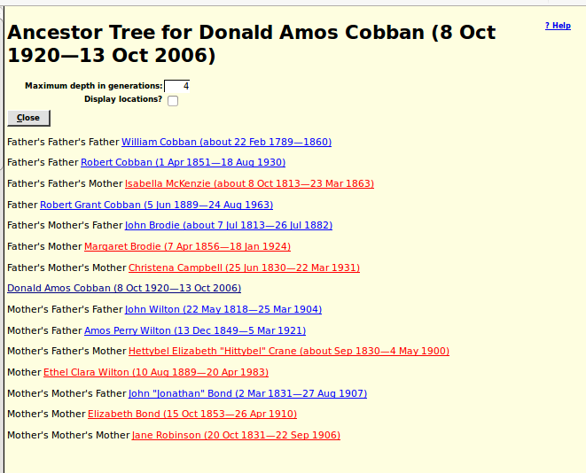Illustration 1: Ancestor Tree

Census Database Enhancements
The set of links in the top and bottom portion of the surname summary for an enumeration division is improved to contain all of the higher level stages of the hierarchy of pages.
The script /database/getRecordXml.php was added to permit access to all of the information in the census transcription database in the form of XML documents. This permits 3rd parties, such as smart-phone app developers, to work with the information in a more direct way, rather than limiting them to the way that the information is presented on web-pages designed for human consumption.
The handling of the column in the 1901 census that contains the birth date is improved by automatically separating the numeric day of the month from the month abbreviation with a space if the transcriber omits it.

Vital Statistics Enhancements
The display of records from the Wesleyan Methodist Baptisms table was inconvenient, because each line of the display was much wider than a browser window. So the display is now divided into a summary report and a detail view:
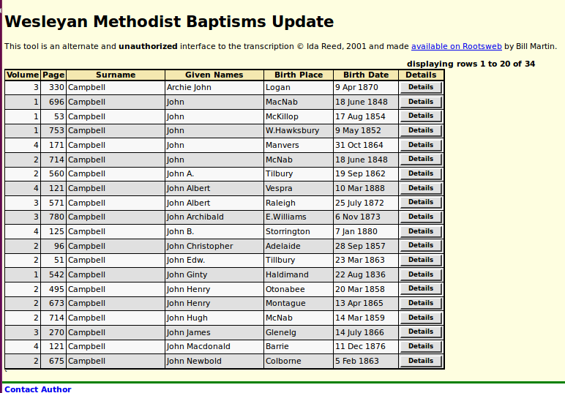Illustration 2: Summary of Wesleyan Methodist Baptisms Matching a Search

When you click on a Details button you see all of the information from the record in a compact form:
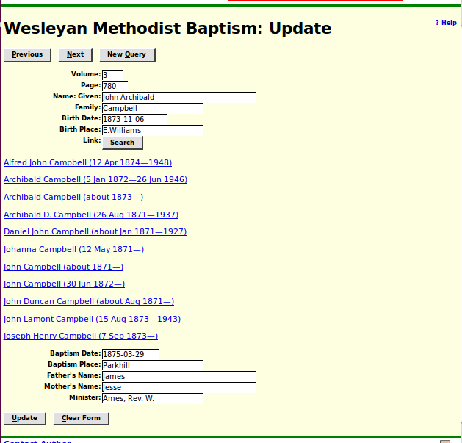Illustration 3: Detailed View of a Single Wesleyan Methodist Baptism Record
A list of potential matches in the family tree is presented as part of this response.
The summary display of information about marriage registrations transcribed for a particular year is now improved to contain the additional status information previously added to the same reports for birth and death registrations:
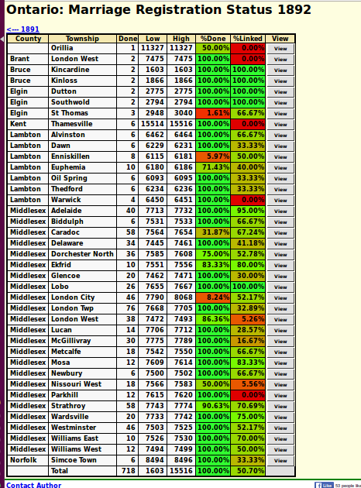Illustration 4: Summary of Marriage Registration Transcription and Linking Progress for a Year

Bug Fixes
- The user information <div> was missing from dialogs.

