March 2017 Features Update

Table of Contents
Global 3
Family Tree Enhancements 4
Census Database Enhancements 5
Vital Statistics Enhancements 6
Bug Fixes 12

Illustration Index
Illustration 1: Pre-1873 Marriage Registration 6
Illustration 2: County Marriage Volume Summary 7
Illustration 3: County Marriage Report Details 7
Illustration 4: List of Marriages in a County Marriage Report 8
Illustration 5: Volume Summary for Wesleyan Methodist Baptisms 8
Illustration 6: Wesleyan Methodist Baptisms Volume Summary 9
Illustration 7: A Full Page of Transcriptions from the Wesleyan Methodist Baptisms 10
Illustration 8: Individual Wesleyan Methodist Baptism Transcription 11

Global
The sudden death of my wife interrupted the focus I required to maintain this log of changes, so this report covers an entire year of enhancements.
Originally the Javascript files that implemented the dynamic functionality of the pages were included at the top of the file. This delayed the display of the page until all of those files had been loaded. Therefore the Javascript files are now included at the very bottom of the page after all of the HTML has been included. The contents of the page are displayed more quickly, although the user still has to wait until the dynamic initialization code has completed before some of the functionality is available.
To make the code more compact and easier to read the class methods used to get and change the value of individual fields in a record are renamed to get and set from getField and setField.
There is a new script in the top level directory, getRecordJson.php which is run to obtain the contents of an object as a JavaScript Object Notation (JSON)/ document. This is a more efficient way for other web-sites to access the information on this site through Asynchronous JavaScript and XML (AJAX), since the resulting JSON document can be embedded directly into a JavaScript file as an object. The script getRecordJson.php, and the existing script getRecordXml.php are extended to support almost every table on the web-site. These two scripts share functionality in the script getRecordCommon.php. The former distinct implementations of getRecordXml.php in the /database and /Ontario directories are removed. See getRecordXmlHelp.html and getRecordJsonHelp.html for instructions on how to use the scripts.
All classes, including the base class Record, which implement a method toXml which is called to obtain the contents of the object as an eXtended Markup Language (XML) document, now also implement a method toJson which is called to obtain the contents of the object as a JavaScript Object Notation (JSON) document in support of the new script getRecordJson.php.
The global function getSurnameChk has been superseded by Record::getSurnameChk.
The information in the global array of vital statistics administrative domains has been replaced by the class Domain which loads its information from the new database table `Domains`. A new table management page is added so support managing this table.
The information in the global array of countries has been replaced by the class Country which loads its information from the new database table `Countries`. A new table management page is added so support managing this table.
If the maiden surname of a person is not known it is set to “Wifeof<husband’sname>”. Previously this was set as the “middle” given name and the surname was left empty, but this made searching difficult.
SQL commands are migrating to the use of prepared statements to provide greater data integrity.
In preparation for migration to PHP 7 all remaining uses of the obsolete POSIX compliant extended regular expression support, typically through functions starting with ereg, is replaced by the equivalent Perl Compatible regular expression (PCRE) support, typically using functions starting with preg. Perl-compatible regular expression syntax supports non-greedy matching, assertions, conditional sub-patterns, and a number of other features not supported by the POSIX-extended regular expression syntax.

Family Tree Enhancements
The display of a list of individuals, which is presented in a number of selection dialogs, is improved in performance by ensuring that the surname of the first individual displayed is a surname defined in the database, even if the surname requested in the search is not in the database. This avoids an occasionally extended retry sequence as the script searches for the first individual to display.
The note associated with an alternate name is now displayed on the main page for an individual if one is present.
There are a number of idiosyncrasies to the Google® Maps geo-location algorithm. In particular to include a county name in a search the word “county” must be included after the county name. This is now addressed in the initial search.
The deprecated original interfaces to the LegacyIndiv and LegacyFamily constructors now generate warning messages and all known uses of those interfaces have been replaced with use of the preferred parameters.
If the LegacyNames.php script is invoked with a given name prefix parameter then the list of breadcrumbs in the header and footer include an extra entry link to the complete list of individuals with that surname.
The editMarriages.php and editParents.php scripts now permit defining a family with no husband/father, and detach husband/father can be used to remove the male spouse without forcing creation of a dummy male spouse. In a genealogical context there is no meaning to a family does not have a mother.
When you delete a family from the point of view of one spouse, the other spouse is deleted from the database if the family was the only connection the other spouse had to the family tree. If the spouse whose family was deleted no longer has any other connections to the family tree then a button appears permitting immediately deletion of the individual. This is a common situation where the parents of an individual were initially created based upon the parents named in a marriage license or registration who were later determined to match an already existing couple.
The also known as note is displayed for alternate names on the main page for an individual.

Census Database Enhancements
When you link a row of a census page to an individual in the database then in addition to defining the link from the census to the individual, a citation to the census page is added to the birth event of the individual.
The birth year column in the 1901 and 1911 censuses can be explicitly set to blank.
Flag columns are changed so they can only be set to ‘Y’ or ‘N’. Any value entered other than ‘N’ is converted to ‘Y’.
The new class Country is used to validate census identifiers.

Vital Statistics Enhancements
For efficiency a method County::getDomainObj was added so that scripts that have an instance of class County do not have to create a new instance of class Domain. The Domain class represents an administrative domain for vital statistics, such as a Canadian Province or US State.
The Ontario Registrar of Vital Statistics did not assign registration numbers to marriages registered prior to 1873. In addition there are a handful of marriage registrations from 1873 on which were accidentally never numbered. These marriage registrations can only be identified by the original bound volume number, the page within the volume, and the column number on the page. Index fields for the original volume, page, and item number on the page are added to the Marriage record and displayed in the detailed page for each Marriage registration. Marriage records can now be identified by the volume number, page, and item.
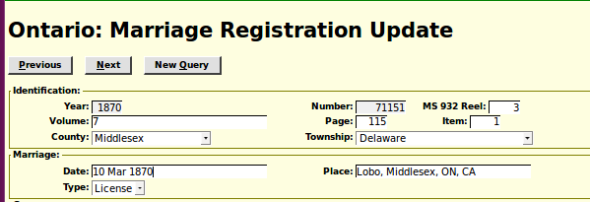
Illustration 1: Pre-1873 Marriage Registration
Observe that each marriage registration that does not have a registration number assigned by the Ontario Registrar is assigned an internal identifier which can also be used to uniquely identify the marriage registration transcription. The above transcription can therefore be cited either as “1870-71151” or by “Vol 7 page 115 item 1”. For marriage registrations after 1872 if the Ontario Registrar did not assign a registration number you can cite the transcription as “1899 Vol F Page 598 Item 1”. The year is necessary to qualify volume identifiers for these later registrations. In theory this support could be used for transcribing marriage registrations from administrative domains that do not assign registration numbers, but does require page numbers.
The year of birth calculated from the age for each spouse is now displayed as straight text rather than in a read-only input field. This saves a little bit of time when tabbing through the fields.
Prior to 1869 Ontario marriage registrations were administered at the county level, from 1852 to 1868, or at the militia district level prior to 1852, as annual reports from ministers of religion, which were bound into volumes. The site organizes these by volume number, sequential report number within the volume, and item number within the report. Two columns have been added to the display of reports within a volume to display the number of marriages transcribed for each report and the percentage of the marriages that have been linked into the family tree. To avoid the volume summary from becoming excessively wide to conveniently display, some of the less important columns have been moved to a separate detailed edit/display page. The volume summary now looks like:
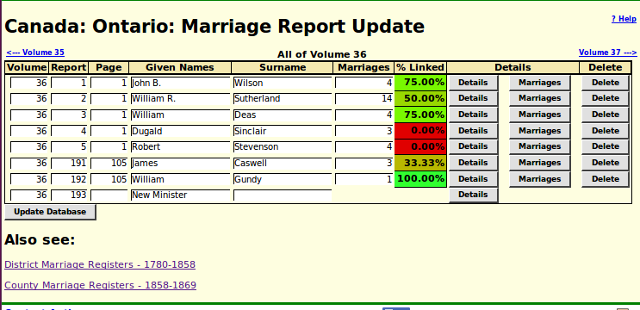
Illustration 2: County Marriage Volume Summary
Clicking on the “Details” button displays the following new edit/display page.
This permits you to see and modify the details about the marriage report including the image of the original page.
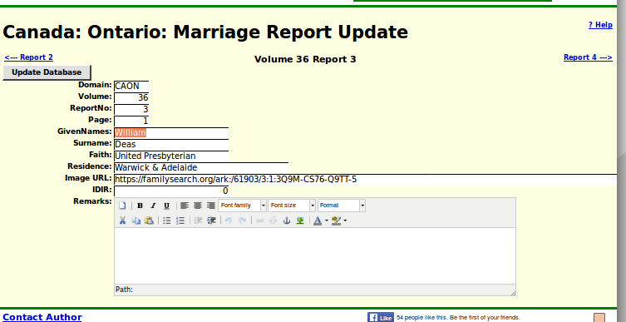
Illustration 3: County Marriage Report Details
Additional information is now recorded about the individual marriage registrations because the later reports included information about the age of the spouses, their birth places, and their parents.
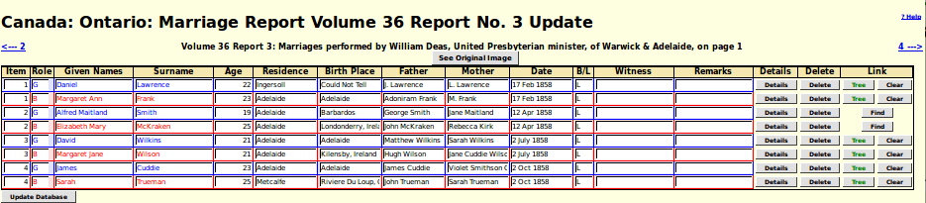
Illustration 4: List of Marriages in a County Marriage Report
The “Link” column contains a button which will search the family tree for potential matches or, if a match has already been found, display the individual.
A button has been added to the Wesleyan Methodist Baptisms query page to display a high-level summary of the transcription effort.
This displays the number of the original hard-copy volume, the highest page number in each volume, and the number of baptisms transcribed from that volume. When you click on the “View” button you see:
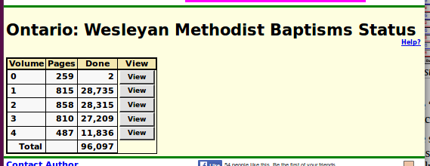
Illustration 5: Volume Summary for Wesleyan Methodist Baptisms
This displays a row for each page in the original volume, the number of baptisms transcribed from each page, the number of baptisms that are linked to an individual in the family tree, the percentage of the baptisms on that page that are linked, and a button to see all of the baptisms on that page. When you click on that button you see the following:
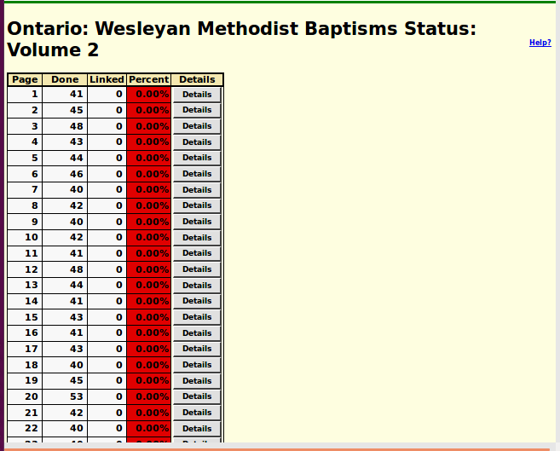
Illustration 6: Wesleyan Methodist Baptisms Volume Summary

As previously mentioned the baptisms are displayed in alphabetical order, not the original order on the page. I have interrupted the display, which would not fit on this page, so you can see how baptisms that are linked to the family tree appear as hyper-links into the tree. The left and right arrows at the top permit browsing to the preceding and following pages of the transcription. When you click on the “Details” button you see the following dialog:
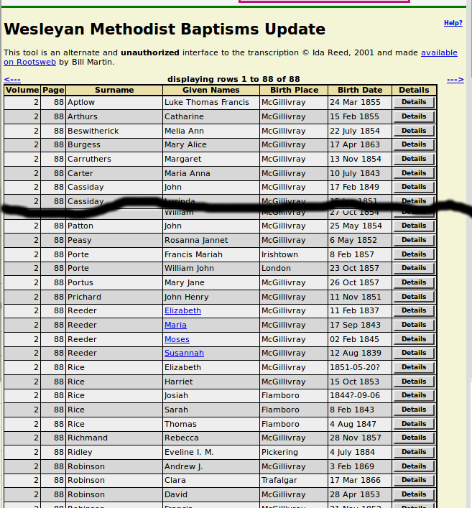
Illustration 7: A Full Page of Transcriptions from the Wesleyan Methodist Baptisms
On this page the hyper-link to the family tree is color-coded by gender.
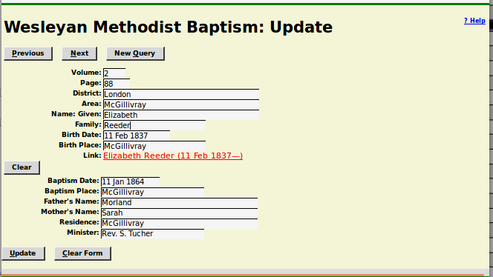
Illustration 8: Individual Wesleyan Methodist Baptism Transcription
The duration of cause of death field on the death registration transcription page is expanded to 64 characters maximum length.
The Birth Registration and Death Registration status reports add a column to report the percentage of transcribed registrations that are linked to the family tree.
A form is added to manage the table of countries.

Bug Fixes
- CountyMarriageReport::toXml did not output the document when requested.
- Index response to District::getDistricts by district id.
- LegacyIndiv::getName sometimes returned a null birth date.
- Surnames starting with “Wifeof” and “Motherof” are excluded from surname searches.
- Field values containing an ampersand (&) were sometimes converted to &amp;.
- The value of field eventsd was incorrect in death and buried events built from an individual record.
- Null events were saved creating a need to clean them up.
- The search for individuals by a name including a nickname in quotes (“) did not honor the table of commonly misspelled given names.
- Several class implementations of method toXML did not handle the second parameter option to print the output correctly. Also some implementations did not return the contents of the generated document.
- In LegacyIndiv::save the INSERT statement formerly used an SQL subquery to initialize the ID and IDIR fields, but this is not supported by MySQL after release 5.6.
- The MySQL SOUNDEX function can return a value that is more than 4 characters long, but the database search only uses 4 characters.
- In LegacyIndiv:getWhere the empty surname is treated as a search for individuals with no surname.
- In LegacyIndiv:getWhere if multiple given names are supplied then for the specific surname only individuals who have all of the given name strings present match. For example "Ma Jane" might match "Mary Jane" or "Emma Jane" or "Margaret Jane" or "Jane Maria" but not just "Mary" or "Jane".
- Invalid call to method getMessage in common.inc.
- Do not check $_SERVER['HTTP_USER_AGENT'] if not invoked from browser in common.inc.
- Fix undefined $stylesheet in common.inc.
- Debug output from class Township was immediately printed rather than saved in $warn for display by function showTrace.
- County constructor supports being called with just county code or with Canadian province or US state plus county to avoid confusing $dbrow not defined error.
- The fields husborder and wifeorder were not set correctly when a new instance of LegacyFamily was created.
- LegacySurname::getSurnames now supports searching on any combination of fields.
- Do not throw exception for bad IDLR value in class LegacyLocation.
- There was an undefined $unknownChildRole reference in legacyIndivid.php.
- Undefined IDIR values in events are handled better in legacyIndivid.php.
- Null status value is handled better in legacyIndivid.php.
- Buried events sometimes displayed before the death event in editIndivid.php.
- The length of the date input fields in added children was slightly shorter than in children who already existed when the editMarriages and editParents pages were displayed. This threw off the appearance.
- The calculated birth date for each of the spouses in a transcribed marriage registration, although not editable, since it is calculated from the age, is now displayed as text rather than an input field, so it is skipped when tabbing through the input fields, and cannot be selected by the mouse.
- The method LegacyEvent::updateEvents did nothing when called. As a result any function which called it would generate incorrect output. The most important consequence was that when two individuals were merged none of the events, other than vital statistics, were copied from the deleted individual.
- You can now create a family with only one spouse by leaving the name of the other spouse blank.
- The detach spouse function on the edit families and edit parents dialogs now permits you to change a family to have only one spouse.
- The variable $unknownChildRole was undefined in legacyIndivid.php
- legacyIndivid.php did not handle a null status value
- legacyIndivid.php now handles an invalid IDIR in function showEvent.
- Pad short SOUNDEX values in LegacySurnames.php to avoid error.
- Handle exception thrown by LegacyLocation::getLocations in LegacyLocations.php script.
- Handle exception from LegacyEvent::getAssociatedRecord in getIndividualsByLocation.php.
- Activate edit and delete citation buttons in the editName.php script.
- Choose Mother didn't work in editParents script.

