February 2018 Features Update

Table of Contents
Global 3
Templates 3
Enhancements to Common Record Support 4
Support for Sets of Records 6
Support for Geographical Entities 7
Videos 13
Style Classes 13
Surnames 14
Given Names 15
Family Tree Enhancements 16
Census Database Enhancements 17
Vital Statistics Enhancements 18
Bug Fixes 19

Illustration Index
Illustration 1: Example of output of $record->dump showing identification of fields depending upon their role 6
Illustration 2: Country Table 7
Illustration 3: The United States of America in Multiple Languages 8
Illustration 4: Management Page for States/Provinces within a Federal State 9
Illustration 5: Managing Counties in Ontario 10
Illustration 6: Form for Managing the Towns and Townships for which there were Division Registrars of Vital Statistics 11
Illustration 7: The Form for Managing Languages 12
Illustration 8: Sorry Canada does not support Spanish 12
Illustration 9: Manage Tutorial Videos 13

Global
The sudden death of my wife interrupted the focus I required to maintain this log of changes, so this report covers almost two years of changes to the services and implementation.

Templates
The major implementation change is in more completely following the Model-View-Controller (MVC) design model. In the context of this site:
- The Model is the database of family tree and document transcriptions and the mechanism by which that information is organized for use by applications.
- The View is the web page layouts which make the information on the Web server accessible to users.
- The Controller is the interactive features of the web pages which are performed within the client's browser.
In the original implementation there was not a clear separation of the Model and the View. The same web server based scripts both extracted information from the database and created the HTML pages which are sent to the browser. That functionality is now clearly split: the application scripts running on the server no longer contain any code for laying out HTML, instead the application scripts use a template engine which takes logically structured information and inserts the values into specific points in a template.
At the moment you can see the templates by pointing your browser at https://www.jamescobban.net/templates/. Eventually the contents of that directory will be hidden because there is nothing that can be directly meaningful to clients of the database. This directory is only normally accessed by the application logic running on the web-server, not by the browser, however it will help you to understand the change in design paradigm if you look at some of these templates in your browser. As you can see these are just partial HTML pages which your browser will display visually.
A particularly important template is the master page template. This template controls the appearance of the common portion of all pages. When an application script prepares a page for presentation to your browser it supplies substitution values for each of the variables identified within the template by being preceded by a dollar sign ($), most importantly the variable $MAIN is where the entire body of the page is inserted. In the original implementation the presentation information contained in this template was generated in dozens of different files on the server. In the new implementation the appearance of the common portions of all of the pages is derived only from this single template. That means that if the site management decided to change the appearance of the header and footer of all pages on the site only this single template file needs to be changed.
Similarly the contents of the main section of each page comes from another template file. Each application script on the server typically selects from a set of templates based upon information about and from the client. For example the main page for each supported country is generated by the application script /FamilyTree/genCountry.php, based upon the parameters: CC which identifies the country by its ISO country code, and lang which identifies the preferred language of presentation of the client by its ISO identifier. The application script selects one of the template files "genCountryccll.html" where "cc" is the ISO country code and "ll" is the ISO language code. As a result adding support for another country or another client language is reduced to simply creating a new template file.
Once you have selected a preferred presentation language that information is passed between scripts by a lang= parameter. Not all pages support every possible language. There are 182 languages recognized by the application. At the moment many parts of the system have been translated into French, and a few pages into German and Spanish.

Enhancements to Common Record Support
There have been a lot of improvements to the common handling of database records:
- Change method toXML in all database record classes to always accept a single options parameter and always return the XML and only print it by default.
- Permit a derived class to insert a record with a known primary numeric key if the class has identified that the record is improperly missing.
- Assume a default behavior for a table with no defined characteristics. In particular if the table does not have a defined set of fields with default values and data types, the contents of the very first record in the table is used in its place.
- Rename method getField to get and method setField to set to improve the readability of application code.
- Add method toJson parallel to toXML.
- Add support for new tables `Countries`, `CountryNames`, `Languages`,`Domains`, `Nicknames`, `FieldComments`, `Concessions`, and `Videos`.
- Do not throw an exception if method save is called by a client who is not authorized to update the database. Just ignore the request.
- Do not throw an exception if there is no record in the database corresponding to the identification fields passed when creating the an instance. If there is no matching record in the database $record->isExisting() returns false.
- Do not throw an exception if the field requested by either $record->get($name) or $record[$name] does not exist. Instead display a warning message to the user, log the error for the administrator, and return null.
- Do not throw an exception if the field requested by either $record->set($name, $value) or $record[$name] = $value; does not already exist. These operations now define the value of a a temporary field in the record. This temporary field can be accessed like the existing permanent fields either by methods get and set or by subscripts but their values are discarded when the record is saved to the database. These extra fields are used to support using the template engine to lay out the contents of a portion of a database table.
- The table SqlLog which is used to track every change made to the database is changed to record before and after images of each record changed by the request. This will permit backing out changes to the database. The associated global function logSqlUpdate is changed to support the new parameters and is deprecated in favor of a new method $record->log.
- Adding support for the new SqlLog created the opportunity to implement a standard mechanism which permits the application to allow the client to change fields in the primary key of a record when saving the record back to the database. In essence an application can now move a record from one part of the database table to another location.
- All of the classes representing records from the family tree which formerly included "Legacy" as part of the name are renamed to remove that prefix. For example class LegacyCitation is renamed to class Citation. This improves the readability of the application code and reflects the fact that although some portions of the database definition were derived from the database implemented by the Legacy Family Tree application on Windows, none of the code came from that product and the database definitions have substantially deviated from the original over the last fifteen years. Internal references to the database documentation obtained from Millenium Corporation maintain the copyright notices.
- Surname matching patterns were defined in an internal table in the Record class definition. These have been moved to the enhanced Surnames table where they can be maintained more easily by the administrator and are visible as part of the Surname object.
- The Record class implements the interfaces Iterator and ArrayAccess which permit the application code to access the contents of a record by using either foreach or by subscripts as if it was an array.
- The translation between user-friendly external table names and the internal names used by the SQL server was moved into the class Record. All tables whose internal name is not an English description of the contents is assigned a meaningful external name which is a plural noun.
- Access by application code and derived classes to the internal implementation of class Record is limited by changing the access mode of internal fields and in their place defining new techniques such as method Record::getInformation($tableName) which consolidates read-only access to the definition of a table, and static::getRealFieldName($fieldname) has consolidates standard translation of field names from external to internal names.
- Improve method $record->postUpdate including support for field name synonyms.
- Method $record->getId is extended to support primary keys that are not AUTOINCREMENT integers and to report problems by returning null rather than throwing an exception.
- All SQL read, update, delete, and inserts are now protected against hackers by using prepared statements which separate the definition of the structure of the request from the specific values used with the request. Since this would have made the debugging output generated for errors harder to read add a global function debugPrepQuery which takes the prepared statement and the parameters passed to it and constructs a string which represents what the command would have been if prepared statements had not been used.
- Improve support for tables without a table specific class implementation. In particular it is now possible to create new records within such a table.
- The method dump now uses highlighting and different styles of quote marks to distinguish between those fields in a record that are part of the unique key of the record, ordinary data fields from the database, and extra fields set to support the template engine. In this output the unique key fields of the record are in italics, the permanent fields are enclosed in back-ticks (AKA left single quotes), and temporary fields are enclosed in vertical apostrophes.
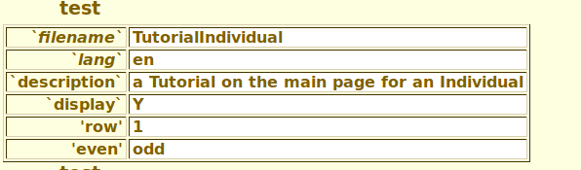Illustration 1: Example of output of $record->dump showing identification of fields depending upon their role
- add default support for tables with multiple primary keys

Support for Sets of Records
A new class RecordSet is defined as a standard representation of a portion of a table. This replaces a lot of code throughout the system where individual applications created an array of records from a table, deleted a subset of records from a table, or updated a set of records. Formerly many classes defined static methods for performing these functions, which is a sub-optimal design. Ordinary class methods could not be used because these functions did not act on an individual record. Defining the class RecordSet permits sharing more code between classes. Most classes derived from RecordSet only redefine the construction of the WHERE clause and do so exploiting common tools provided by the base implementation. Furthermore the base class implementation can be used for many classes that do not have special requirements for parameter validation. The template engine supports RecordSet as if it was an array of arrays. An example of its use is:
$parms = array('limit' => $limit,
'offset' => $offset,
'order' => 'SrcName');
if (strlen($pattern) > 0)
$parms['SrcName'] = $pattern;
$sources = new RecordSet('Sources', $parms);
$numRecs = $sources->count(); // number in the set
$information = $sources->getInformation();
$count = $information['count']; // if "limit" omitted
$query = $information['query']; // SQL SELECT generated
foreach($sources as $idsr => $source)
{ // act on each individual $source
...
} // act on each individual $source
$template->updateTag('source$idsr', $sources); // template insert

All displays of the contents of tables now support restricting the number of rows displayed and to browse through the table one page at a time, with the default page size being 20 rows.

Support for Geographical Entities
A new table Countries has been added and is managed by a class Country which represents the behavior of an individual country. This table contains information about every country recognized by the United Nations including the English language name of the country. This table is viewed and managed through the Countries Management Page.
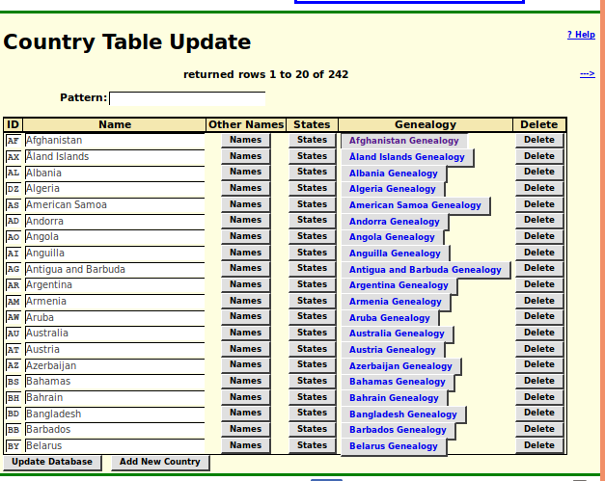Illustration 2: Country Table
Most registered users have permission to update this table although I trust you to use that privilege wisely. The main table has been completely populated with all 238 countries recognized by the United Nations. This page is a portal to two extensions:
- You can choose to supply the spelling of the name of a country in another language by clicking on the "Names" button. Casual visitors can see the information but cannot modify it. For example the name of the United States of America is at this moment defined for four languages:
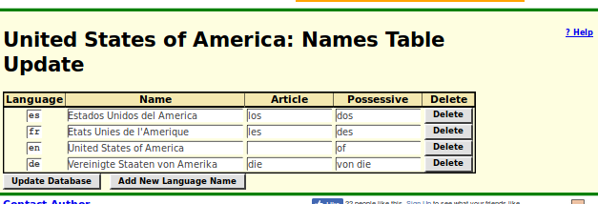Illustration 3: The United States of America in Multiple Languages
- As a registered contributor you can supply or manage the names of component states or provinces of a federal state by clicking on the "States" button. Each "State" is represented in the database by a record in the "Domains" table. The following shows the table of states and territories in the United States of America as currently defined based upon the US Postal Service addressing table. Casual visitors can see this table but cannot make any changes.
Clicking on the "Details" button displays a page of genealogical resources specific to the state, which is customized by the genProvinceccssll.html template where "cc" is the country code, "ss" is the 2 or 3 character unique identifier of the state, province, or territory, preferably as defined by the federal state, and ll is the language of display so the information can be presented in the language of the viewer.
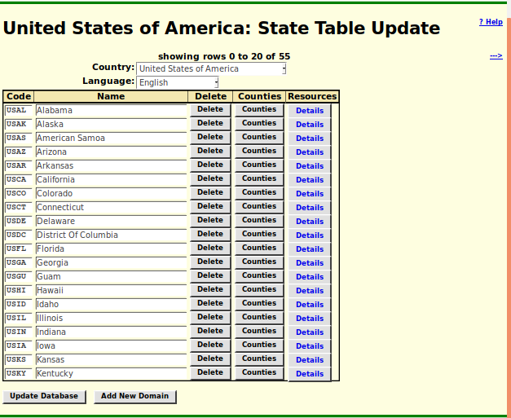Illustration 4: Management Page for States/Provinces within a Federal State
Clicking on the "Counties" displays a page of information about lower level administration regimes as used for recording vital statistics. In Ontario and Michigan, for example, these are counties, in Manitoba they are urban and rural municipalities, and in England they are registry offices as organized for the convenience of the General Records Office and which do not correspond to the civil administration districts or shires. This table is only sparsely filled in as research requires it. For example for Ontario, Canada you will see:
This table is well populated with respect to the post-Durham Report administration of Ontario, which is why all of the counties are currently labeled as starting in 1852. Clicking on the "Location" button takes you to the Location record named "countyname Co, ON, CA" which is the standard name to be used in family trees when identifying that you only know which county an event took place in. As a registered contributor you can update the description of the location entry for the county, for example by adjusting the Google® maps description or adding genealogically significant information about the county. Clicking on the "Townships" button takes you to a page for managing the list of lower level registration administrations for vital statistics. This list should include every township and town in the county for which there was a division registrar for vital statistics. If you have permission to contribute transcriptions of vital statistics then you have the authority to add any missing towns or townships to this list.
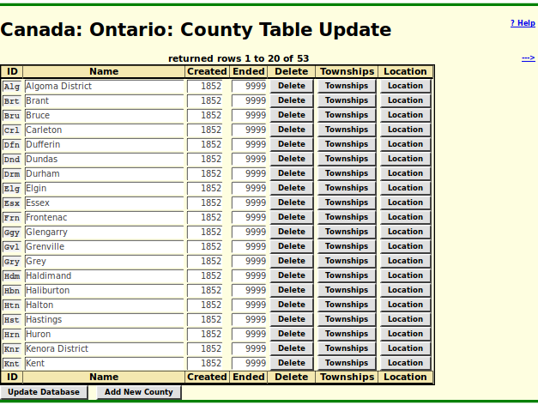Illustration 5: Managing Counties in Ontario
In this table the first column represents the way that the town or township is recorded in the transcription of each vital statistic, while the Name column shows how it is displayed in the selection menu for greater clarity for the transcriber. All of these fields can be modified by a registered user and the changes are applied if you either click on the Update Database button or press the Enter key while in one of the input fields. The final column is part of a feature that is still under construction which is intended to assist the site to identify more closely the location of a property identified by lot number and concession.
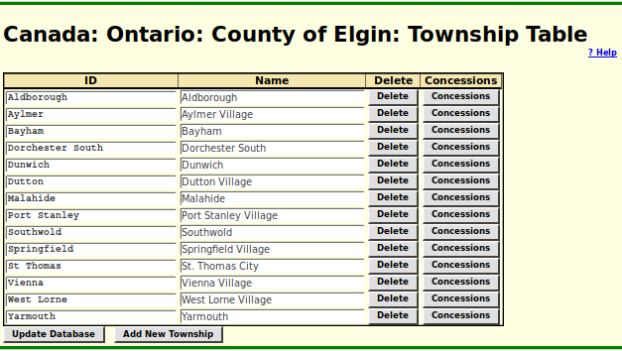Illustration 6: Form for Managing the Towns and Townships for which there were Division Registrars of Vital Statistics
There is also a table of Languages which exists to populate selection lists in places like the alternate country names table, and interpret user-selected presentation languages.
There should be no need to do anything with this information as 182 languages are supported. These are all of the languages which have a 2-character ISO identifier. This table is used among other places where an apology is issued for displaying the English version of a page where no version has been defined in the user's preferred language. For example if you ask to see the main page for Canada in Spanish (lang=es) you will get:
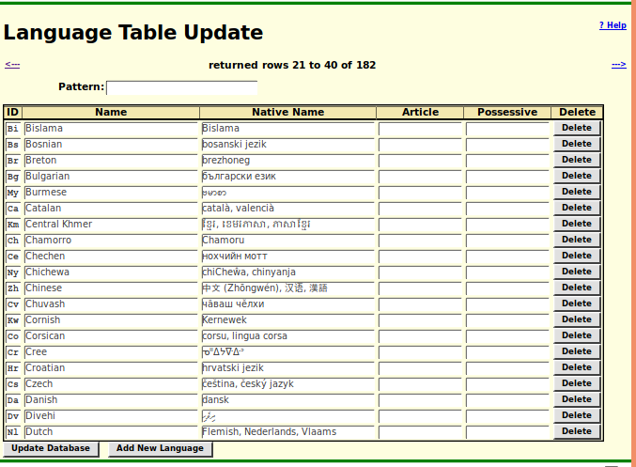Illustration 7: The Form for Managing Languages
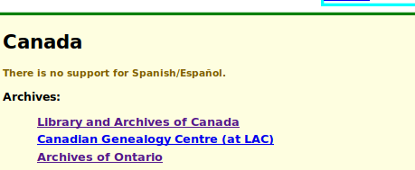Illustration 8: Sorry Canada does not support Spanish

Videos
A table is added to organize information for the display of tutorial videos providing the name of the tutorial to be displayed to users depending upon their preferred language.
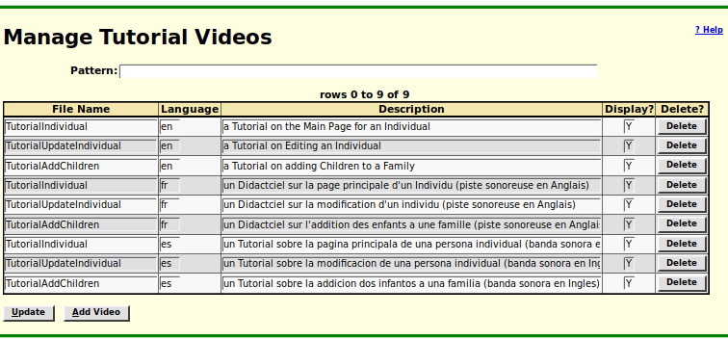Illustration 9: Manage Tutorial Videos

Style Classes
The original implementation defined a large number of style classes that combined styles that pertain to different aspects of the presentation. That is being replaced by combining separate simpler styles. For example:
Text color styles:
black | black
same | grey, used in columns to indicate values that are the same as the value of the preceding row in the table
male | dark blue
female | dark red
unknown | dark green
error | red
warning | dark yellow

Styles for the background color of a cell.
white | white background in input fields the user has permission to modify
odd | very bright gray almost white
even | gray, alternating with "odd" to make tables easier to read
ina | bright gray indicating the user does not have permission to modify
balloon | bright yellow PostIt Note
body | bright yellowish background used for displaying genealogical information
help | bright bluish backgound used for help pages

As and example where a field previously had a compound class like "actleftncerror" indicating that the data was to be displayed in such a way as to indicate that the user had permission to modify the data, was left aligned in the field, words are not capitalized, and the text is displayed in red to indicate that the value does not match the expected contents of the field, this field now has a class "error white leftnc".

Surnames
The table of surnames now consolidates information used throughout the application, not just in the Family Tree.
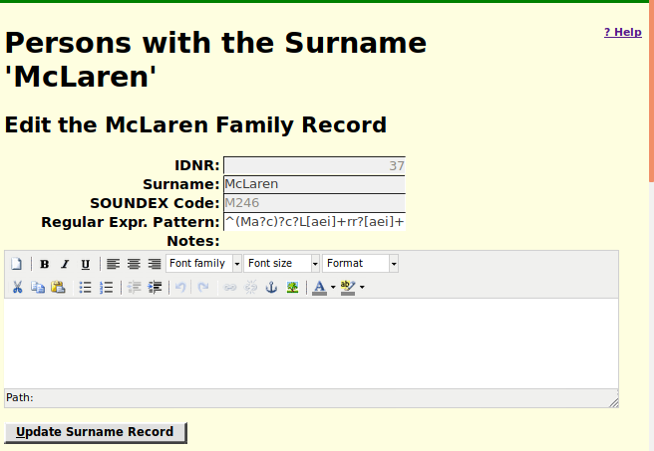
Surnames are frequently spelled in many different ways either through misunderstanding by the creator of the original document or because members of the family chose to use a traditional spelling. The Surname record supports two methods for performing a search for similar surnames. One is the SOUNDEX algorithm, originally created by American Telephone & Telegraph to support "operator assistance" calls and adopted by North American law enforcement particularly for traffic offences. This code ignores vowels and groups all consonants by broad classes except for the first letter in a name. For most names this is a useful tool. However it assumes English pronunciation and for many common names, particularly Scottish names, it matches too many surnames. The SOUNDEX code M246 matches Mackellar, Maclaren, McClarty, McClary, McClear, McCleary, McClery, McClure, McClurg, McClurtin, McElroy, McIlhargey, McIlroy, McIlwraith, McKellar, Mckeller, McLaren, McLarty, McLaurin, McLeary, and McLurg. Therefore a new mechanism has been added using the "regular expression" language to define a tighter but still loose search. The expression shown above will match "McLaren", "McClaren", "MacLaren", "MacLarren", "McLeran", and also the same names without the "Mc" prefix, which was discouraged by the English after the 1745 Jacobite rebellion.

Given Names
A similar problem arises when searching for a match on given names. Someone christened "Elizabeth" might be known as "Lizzie", "Betty", or "Bessie". In the west of England "Peggy" and "Polly" are popular for girls christened "Margaret" and "Mary" because of the way the vocative case is formed in Welsh and Cornish. "James" is the Sassenach spelling of "Seamus", but the vocative case of that Gaelic name is "Hamish". So a table has been added to permit defining alternative searching of the family tree for matches against given names as found in original documents.
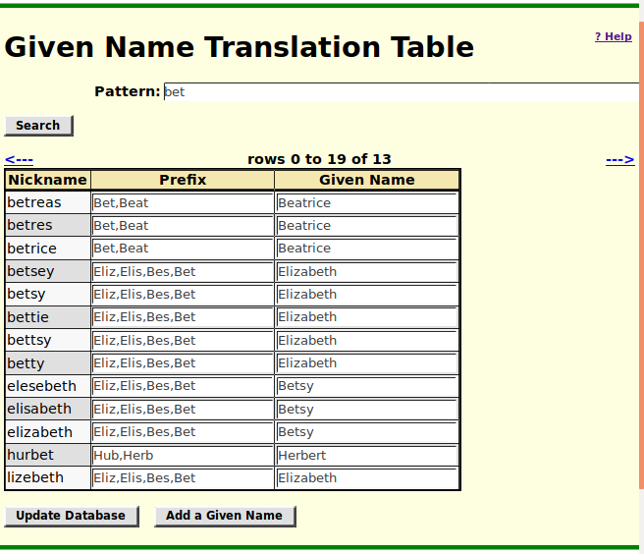

Family Tree Enhancements
The family tree portion of the site is the most developed so most of the changes had to do with exploiting the redesign of the core. Other minor issues:
- Delete citations when deleting events from from main individual record
- Blank out cause of death when deleting death
- Support abbreviations in event fields
- Correct popup of "Loading..." indicator when deleting an event that requires database action before updating the display
- Simplify addition of new events
- New events are added in chronological order so the user only has to request that events be sorted if they are out of order to begin with.
- Correct handling of updated Name event
- Suppress meaningless alerts from eventFeedback
- Ensure that when clicking "Update Person" the oldest child frame is brought to the front so it can be saved.
- Track all child frames. In particular while the "Edit Families" frame was tracked, the "Edit Parents" frame was not.

Census Database Enhancements
Previously there was a separate script for displaying the pages used for editing, proofreading, and viewing the full contents of a census page for each of the censuses. Now there is a single script which uses separate templates for each census.
In the response to a census database query correct the sex display of name and include the requested language code in the hyperlink to Person page.
All of the pages for editing, proofreading, or displaying a full page from a census now have a button "Show Important" which hides all but the most important lines of the transcription to permit operating on a summary of the contents of the page.

Vital Statistics Enhancements
- use class Domain to validate domain code
- use class Country to validate country code
- add fields OriginalVolume, OriginalPage, and OriginalItem to Birth and Marriage registrations to handle registrations that did not have registration numbers assigned by the Registrar.

Bug Fixes
There are thousands of bugs fixed in the past two years and it would be pointless to list them.

Actually this template has a partner which handles the presentation for those clients who are still running Windows XP with Internet Explorer 7 because IE7 does not support HTML5. If you are among them please upgrade. Windows XP is a security nightmare because the hacker-verse knows every weakness in that system and Microsoft stopped shipping security fixes years ago. There is also a template dialog.html which handles pages which are displayed only as subordinate pages of a main editing dialog, for example the page for adding a citation to an event. To avoid clutter and minimize scrolling these subordinate pages do not have a header section.

