October 2013: Newsletter

Individual Page: User Guide
This article is an overview the features of the page describing an individual on the site:

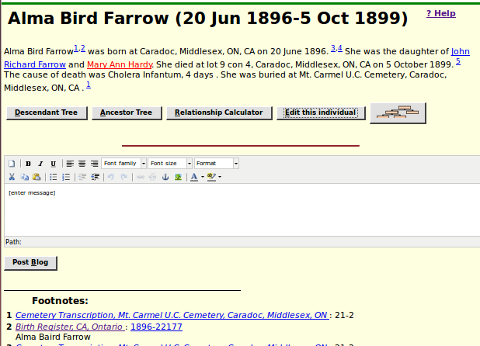Illustration 1: Individual Details Page
The title of the page is the name of the individual and the birth and death dates.

The following text organizes all of the facts and events recorded about the individual as a narrative. Each fact has footnote references, identified by superscript numerals, identifying the footnotes at the bottom of the page which record the supporting documentation. Within this narrative the names of other individuals are generally hyperlinks to the detailed information on the other individual, color coded as to gender. This narrative is followed by a row of buttons:

- A button to display a summary of information about the descendants of this individual.
- A button to display a summary of information about the ancestors of this individual.
- A button to pop up a dialog for calculating the family relationship between this individual and any other individual in the database.
- If you are authorised to update this individual a button to switch to the edit page for modifying or adding to the information about this individual.
- A button to display a graphical family tree centered on this individual.

This is followed by any messages submitted about this individual. This is followed by an editor panel to add your own messages. A message may include formatted text, pictures, and links to other documents on the web. Anyone who is willing to supply their e-mail address can post a message regarding this individual.

The list of footnotes. Most footnotes are citations identifying a source document and the location within that source document. Within this list the name of the source document is a hyperlink to further information about the document. In many cases the location information is also a hyperlink. Clicking on this hyperlink takes you to a transcription of the original document, which my in turn provide a link to an image of the original document if that is available on the web.

There are many mouse “hot-spots” on the page. For example if you hold the mouse cursor over the name of another individual that appears as a hyperlink a memo pops up with further information about the individual. This avoids having to actually follow the link to get basic information.

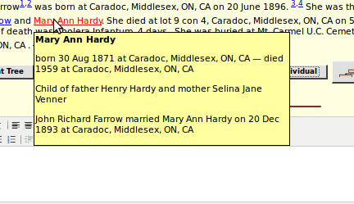Illustration 2: Individual Information Popup
If you hold the mouse over a location name a memo pops up with further information about the location:

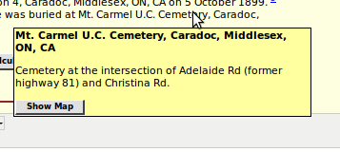Illustration 3: Location Popup
Note the “Show Map” button. Clicking on this pops up a Google® map of the location.

If you hold the mouse over a cause of death, a memo pops up with explanations of obsolete or unfamiliar terms in the description:

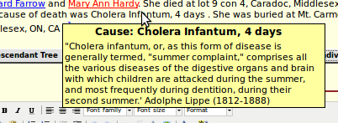Illustration 4: Cause of Death Popup
If you hold the mouse over the name of a document in the footnotes a memo pops up with more information about the source document:

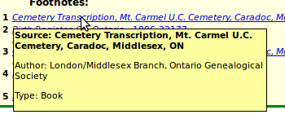Illustration 5: Source Document Popup
And, of course, if you hold the mouse over any button or input field a memo pops up to explain the use of the element. There is also a page of overview information about each application page on the site, accessed by clicking on the ? Help link at the top right of the body of each action page.

