Newsletter: December 2013
There are no significant enhancements to the functionality of the web-site this month, just fixes to a number of bugs. You can see the details on the web-site. So I will take this opportunity to begin a tutorial on editing the family tree.
In order to modify an individual in the family tree you must have been granted shared ownership of the individual by an existing owner, or by a site administrator. To request a grant of shared ownership just click on the “Contact Author” link in the page footer of the main page for the individual. This sends an e-mail to all existing owners of the individual as well as to all designated site administrators. You should include in the text of this e-mail your justification for being granted ownership. Since ownership of an individual includes the ability to see the private data for the individual and the individual's descendants, ownership should normally only be granted to users with a reasonable connection to the family.
If, as an existing owner, you receive an e-mail request for a grant of ownership, click on the “Edit this individual” button.
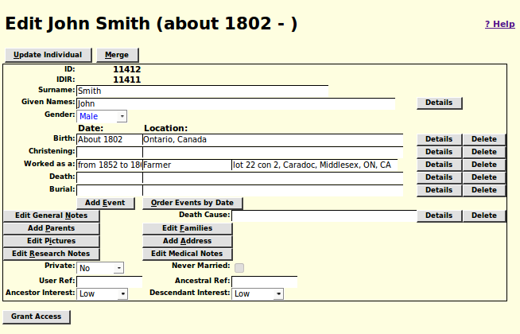Illustration 1: Edit Individual Dialog
At the bottom left of the resulting dialog is the “Grant Access” button. Click on this button:
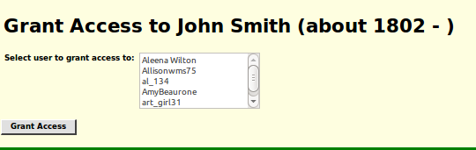Illustration 2: Grant Access Dialog
Select the userid of the individual you wish to grant access to and then click on the “Grant Access” button. This function grants access not only to the specific individual but also to all ancestors and all descendants of the individual, and their spouses. A report is produced listing all of the individuals for whom the grant is issued and their relationship to the primary individual.

Editing an Individual
There is a lot of information that can be recorded about an individual. Lets look at the edit individual dialog again:
Illustration 3: Edit Individual Dialog
This dialog lists all of the information recorded about this individual as an individual, as opposed to information about this individual's relationships with other people in the family tree. Let's focus on the input fields on this form:
- Surname
- Given names
- Birth date and place
- Christening date and place
- Event date, qualifier, and place
- Death date and place
- Burial date and place
- Cause of death
- Privacy flag
- Never married checkbox
- User reference field
- LDS Ancestral File reference
- Ancestor Interest level
- Descendant Interest level
You can modify any of these using the keyboard and mouse and then either click on the “Update Individual” button at the top, or press enter while in a text input field to apply the changes to the family tree.
These input fields only provide access to the most common information. Beside most of these input fields there is a “Details” button, which provides access to all of the information that can be recorded about a fact or event, and to document the source of your knowledge of the facts. For example if you click on the “Details” button to the right of the birth date and place input fields a dialog pops up which provides access to more information:
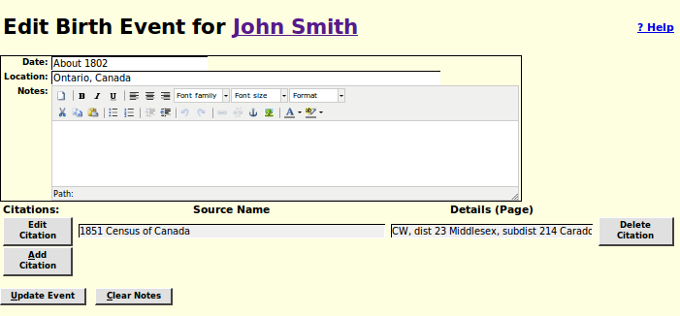Illustration 4: Edit Birth Event Dialog
In addition to the ability to modify the birth date and location there is also a free format text input field. This is a word processor style editor with a wide range of tools such as the ability to use bulleted or numbered lists, bold italicized or underlined text, hyper-links to web pages, insert images, and change the text colour, background colour, font family, and font size.
You can also add, delete, or modify citations to source documents backing up the information.
When you have made all the desired changes, click on the “Update Event” button.
Returning to the main edit dialog observe that in addition to the common events that are always present you can add any number of additional events or facts by clicking on the “Add Event” button. That pops up a dialog that permits you to add any of the supported event or fact types. All events follow the same basic structure as shown above for the birth event.
New events and facts are added just before the death event. To put them in chronological order click on the “Order Events by Date” button.
There are also three buttons to add extended notes to the individual: “Edit General Notes”, “Edit Research Notes”, and “Edit Medical Notes”. These are handled very similarly to an event or fact except that they only have a notes field. Since there is only one set of General Notes for each individual if at all possible you should use an event, which has the further advantage of having a date associated with it, to associate notes with.

Pictures
As discussed above you can imbed a picture or image as part of the notes on any fact or event, including in the General Notes field and in a source citation. However there is another feature specifically for associating captioned images with the individual. This is accessed by clicking on the “Edit Pictures” button. This pops up a dialog to manage the list of pictures.
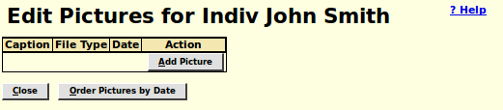Illustration 5: Edit Pictures Dialog
Clicking on the “Add Picture” button pops up an Edit Picture Dialog:
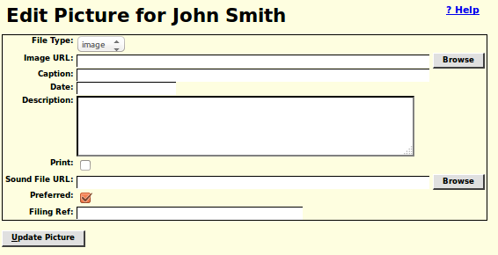Illustration 6: Edit Picture Dialog
The picture is identified by its URL and therefore must be available on the web.

