June 2014 Newsletter

Happy Canada Day!

Remember that you have the legal right to control the e-mail that you receive. There are a couple of methods that you can use with respect to this site:

- Under account management you can select to not receive any broadcast e-mails related to this site. The account management dialog is presented when you first register as a user, and can be displayed by clicking on the button with your user name in the top right of any page.
- In your e-mail user agent you can set up a rule to automatically file any message with "[JamesCobban.net]" in the subject line into a specified folder, including the trash folder. This is the recommended method since it means that although you are not required to take any manual action on any specific message as it is received, you can at any time decide to review past messages.

One of the objects of my web-site is to create as complete a family tree of every family that passed through or had a relationship with anyone in south-western Middlesex County. To achieve this goal it is necessary to be able to identify what we don't know, so we can collectively focus effort on filling in those blanks. That is the significance of the colour coded completion cells in the pages that track the degree of completion of the effort in transcribing censuses and BMDs. For example:

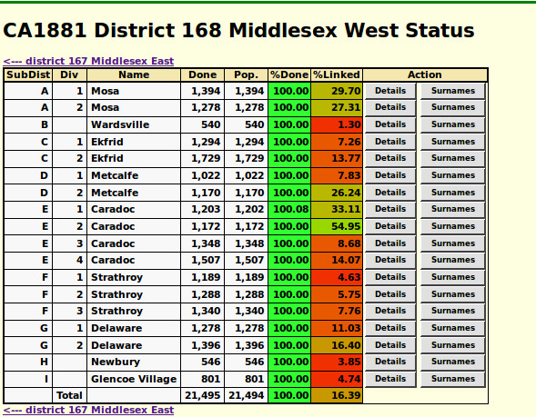

This page shows that all 21,495 individuals enumerated in the district of Middlesex West have been transcribed into the database but only 16.39% of them have been linked to specific individuals in the family tree. This low percentage is primarily a consequence of incomplete effort. Linkages between census lines and individuals in the family tree must be explicitly defined either by citing the census as a source for a fact about an individual in the family tree, or by performing a manual search for a line in the census. Human intervention is required to establish these linkages because there is simply too much variability in the way that individuals are described in the various sources.

A secondary issue is that the functionality to link the census and BMD records to the family tree, and vice versa, was only implemented several years after the site came into existence. So, in particular, source citations made from the family tree to the census only started automatically creating the back link from the census a couple of years ago, after tens of thousands of citations had already been recorded. There is a tool on each detailed census transcription page to partially deal with this: If you view a transcription of a census page observe the buttons at the top of the transcription:

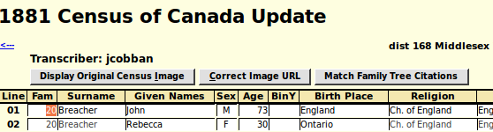

Clicking the "Match Family Tree Citations" button identifies all existing citations to the current census page from the family tree, and then searches the page for the closest match to each individual that has such a citation and creates the matching link to the family tree. On the detailed transcription page established links and individuals that are not yet linked to the family tree show up appropriately labelled buttons in the far right column:

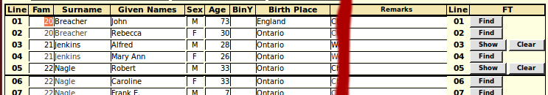

Note that on this particular page the only citations in the family tree were for the occupations of heads of household. So the linkage method linked Alfred Jenkins to the corresponding individual in the family tree, but not his wife Mary Ann Jenkins. If you click on the "Show" button the family tree page for that individual as a head of household is displayed so you can verify that the linkage is correct. If the automatic linkage was incorrectly made because of the limited intelligence of the matching algorithm, just click on the "Clear" button to remove the linkage.

Linkages to the family tree may also be established manually, which provides for more human intervention and establishes links in which there is no corresponding citation from the family tree. For example if we click on the "Find" button for Mary Ann Jenkins you are presented with a list of probably matches based upon name similarity, gender, and birth date:

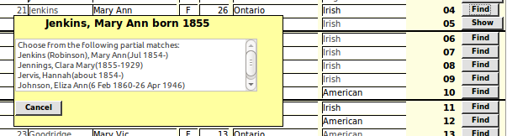
In this case the first entry is the obvious match, as can be verified by clicking on the "Show" button for her husband. When you click on the matching row the dialog changes to:

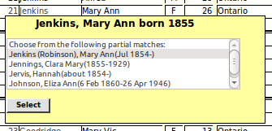

Clicking on the "Select" button in the dialog changes the "Find" button for this individual to a "Show" button.

The example page demonstrates some of the limitations of any automatic algorithm for matching names as entered by a human being. The family which appears on this page with the surname "Goodridge" actually spelled their name "Goodrich", like the tire company. But this match is missed both by the "Match Family Tree Citations" button, and by by the "Find" button. To complete linking this page it is necessary to temporarily "correct" the surname of the family in the census to match the family tree, click on the "Find" buttons, and then reset the surname to the value entered by the census enumerator. The final result is that 23 of the 25 lines on this page, or 92%, correspond to individuals in the family tree. For Caradoc township, which is the township that I have been researching for the longest time, this is a typical result. Probably 90% of the individuals appearing in at least the later censuses of Caradoc are already in the family tree:

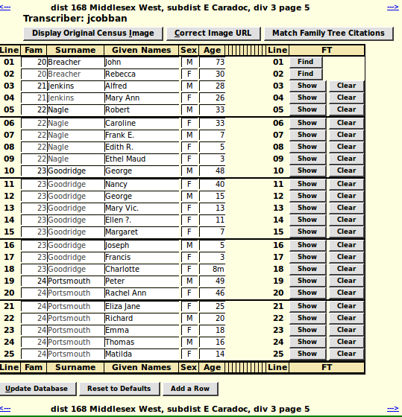

If you search for individuals on this page using the census query capability the result shows the linked individuals using hyper-links to the family tree:

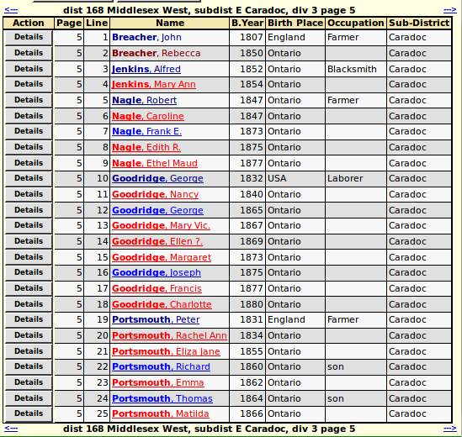

This exercise has demonstrated that there is a family that probably should be in the family tree. When we do a quick search for John Breacher/Bracher we find him already in Caradoc in the 1842 census at lot 24 R1S, in the 1852 census at lot 17 R1S (CW, dist 23 Middlesex, subdist 214 Caradoc, div 1 page 2), in the 1861 census at S ½ lot 17 R1S (CW, dist 22 Middlesex, subdist 238 Caradoc, div 1 page 23), in the 1871 census (dist 7 Middlesex West, subdist E Caradoc, div 3 page 5), and in the 1881 census (dist 168 Middlesex West, subdist E Caradoc, div 3 page 5). His wife Jane died at Caradoc on 17 Sept 1873 (death registration). John died on 24 Nov 1890 at the age of 84 yrs. 9 ms. 15 ds (census transcription) and was buried in Christ Church Cemetery in Delaware. So this is definitely a family that should be in the database, but which would have been missed if it were not for this exercise in checking for linkages.

You are invited to try your hand at filling in the linkages, one census page at a time. Many hands make light work.

--

Jim Cobban webmaster@jamescobban.net
Web-site: www.jamescobban.net
34 Palomino Dr.
Kanata, ON, CANADA
K2M 1M1
+1-613-592-9438

